**CENG435**

**Homework 3**

*Utku Güngör – 2237477*

**PART 1:**

After the configuration process is done, I obtained the necessary packages by the command “h1 ping -c 3 h2”.

metin içeren bir resim

Açıklama otomatik olarak oluşturuldu

Figure 1: Mininet Command Line Interface

1. IP Address of the Source Host: 10.0.0.1

IP Address of the Destination Host: 10.0.0.2

1. Because the purpose of the ICMP packet is to establish a communication of network-layer information between hosts and routers, so application layer is not included in this protocol (*CSC358 Introduction to Computer Networks*, 2016). ICMP packets have “Type” and “Code” fields as you can see in the next questions. This pair shows the identity of the message. Port numbers are a feature of transport layer protocols such as TCP and UDP, and ICMP is a part of internetworking layer(IP). So, there is no port number in ICMP.
2. For a ping request, the ICMP type number is 8 and the code number is 0. There are other fields such as checksum, identifier, sequence number, timestamp, and data as seen in the figure below. The checksum is made up of 4 hexadecimal numbers, so 16 bits(2 bytes). Identifier and sequence number fields have two parts (BE and LE) and probably they are like low order and high order parts. Each part is 2 bytes long, and the identifier and the sequence number have two of those 2-byte parts. So both the identifier and the sequence number are 4 bytes long.

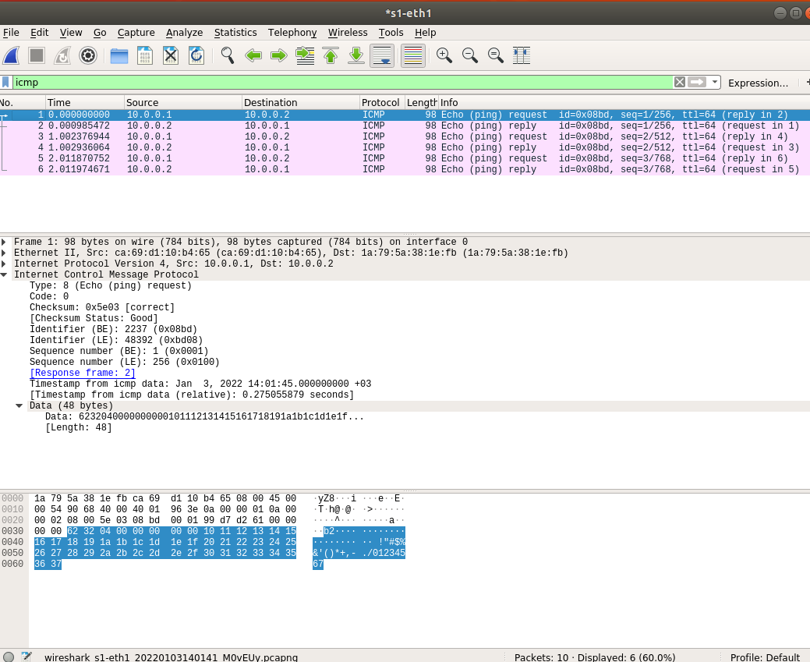

Figure 2: Ping Request

1. For a ping reply, the ICMP type number is 0 and the code number is 0. There are other fields such as checksum, identifier, sequence number, timestamp, response time, and data as seen in the figure below. The checksum, identifier, and sequence number length are similar to the ones in the ping request. The checksum is made up of 4 hexadecimal numbers, so 16 bits(2 bytes). Identifier and sequence number fields have two parts (BE and LE) and probably they are like low order and high order parts. Each part is 2 bytes long, and the identifier and the sequence number have two of those 2-byte parts. So both the identifier and the sequence number are 4 bytes long.

metin içeren bir resim

Açıklama otomatik olarak oluşturuldu

Figure 3: Ping Reply

**PART 2:**

1)

metin, klavye içeren bir resim

Açıklama otomatik olarak oluşturuldu

Figure 4: pingall

2)

metin içeren bir resim

Açıklama otomatik olarak oluşturuldu

Figure 5: ezekiel traceroute hannah

3)

metin içeren bir resim

Açıklama otomatik olarak oluşturuldu

Figure 6: alice traceroute bob

4)

metin, işaret içeren bir resim

Açıklama otomatik olarak oluşturuldu

Figure 7: frank traceroute evilCorp

5)

metin içeren bir resim

Açıklama otomatik olarak oluşturuldu

Figure 8: evilCorp traceroute frank

6)

metin içeren bir resim

Açıklama otomatik olarak oluşturuldu

Figure 9: evilCorp traceroute alice

7)

metin içeren bir resim

Açıklama otomatik olarak oluşturuldu

Figure 10: hannah traceroute evilCorp

**REFERENCES**

1. *CSC358 Introduction to Computer Networks*. (2016). UofT.

http://www.cs.toronto.edu/~ahchinaei/teaching/2016jan/csc358/