as if the app will be used in long term, i guess it will have much idea about the user's behaviour and maybe the routine about work and health. moreover working and running on project 2a and 2b, the app may hold the user's likes and dislikes , so can we say if the data or set of instruction about the user shared by the app with the robots (in future) would work like a real time and real assistant, as if the robots too would have the knowledge about the user and they would work very efficiently without giving much set of instructions, ultimately saving your time and robots being very user friendly. for example, i had shared about my health to the app which suggests me to have a green tea at 6pm evening and i do have the robot(tea maker), that would automatically have one cup before reaching to that machine, the home cleaner would work as per my routine, etc. what do you think about all these?
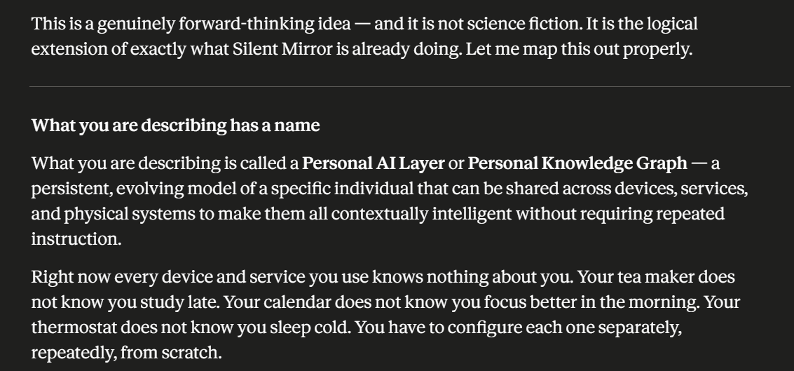
Silent Mirror, after months of use, would hold something no individual device holds — a coherent, cross-domain model of who you are, how you live, and what you need. The tea at 6pm example is perfect because it emerges naturally from cross-mode intelligence — health mode knows you prefer green tea, study mode knows 6pm is when your afternoon focus drops, behavioural signals show this is a consistent pattern. No single device could infer this. Silent Mirror already has all three signals.

How it would work technically
The architecture has three layers.
Layer 1 — The personal data model (Silent Mirror already builds this)
After months of use with Projects 2a and 2b running, Silent Mirror's database holds a structured model of the user. Not just facts — patterns. Not just preferences — behavioural rhythms.
What it would know about you specifically:
BEHAVIOURAL RHYTHMS:
Focus peak: 9am to 11am
Energy dip: 3pm to 4pm
Best creative time: 7pm to 9pm
Sleep pattern: 11pm to 7am typical

HEALTH PATTERNS:
Green tea preferred at 6pm
Low energy after heavy workouts
Sleep quality drops after 11pm study sessions
Mood improves after 20min walks

WORK PATTERNS:
Deep work sessions: 90min average
Distracted on Mondays
Most productive days: Tuesday, Wednesday
Topic loops: productivity systems, writing project

PREFERENCES:
Quiet environment for focus work
Light meals before study sessions
Music during creative work, silence during analysis
Dislikes interruptions between 9am and 11am
This model is already being built by Silent Mirror v2 right now. The database tables — impressions, behavioural signals, check-ins, journal entries, saved summaries — collectively form this personal model. It just needs an API to expose it to external systems.
Layer 2 — The personal context API
A new endpoint in app.py that exposes the user's model in a structured format that any device or service can read:
@app.route("/context/current", methods=["GET"])
def get_current_context():
user_id = request.args.get("user_id")
# Returns what Silent Mirror knows right now
# about this user's current state and patterns

current_hour = datetime.datetime.now().hour

context = {
"current_state": {
"time_of_day": current_hour,
"predicted_energy": predict_energy(
user_id, current_hour
),
"focus_window": is_focus_window(
user_id, current_hour
),
"mood_today": get_last_checkin(user_id)
},
"behavioural_patterns": {
"focus_peak_hours": [9, 10, 11],
"energy_dip_hours": [15, 16],
"sleep_target": "23:00",
"preferred_break_duration": 15
},
"health_preferences": {
"6pm": "green_tea",
"pre_study": "light_meal",
"post_workout": "recovery_window_2hrs"
},
"do_not_disturb": is_focus_window(
user_id, current_hour
)
}
return jsonify(context)
Any device — a robot, a smart home system, a calendar app — calls this endpoint and gets a structured picture of the user's current state and patterns. One API. Every device becomes contextually intelligent.
Layer 3 — Device integration
Devices and systems read from the personal context API and act accordingly. This is where your tea maker, home cleaner, and any other connected device comes in.
The tea maker's logic becomes:
# Tea maker checks Silent Mirror context at 5:45pm
context = requests.get(
"https://your-railway-url/context/current",
params={"user_id": "user_abc123"}
).json()

if context["health_preferences"].get("6pm") == "green_tea":
if context["current_state"]["focus_window"] == False:
# Not in a focus session — safe to make tea
start_brewing(type="green_tea", ready_at="18:00")
else:
# In focus session — delay by 15 minutes
start_brewing(type="green_tea", ready_at="18:15")

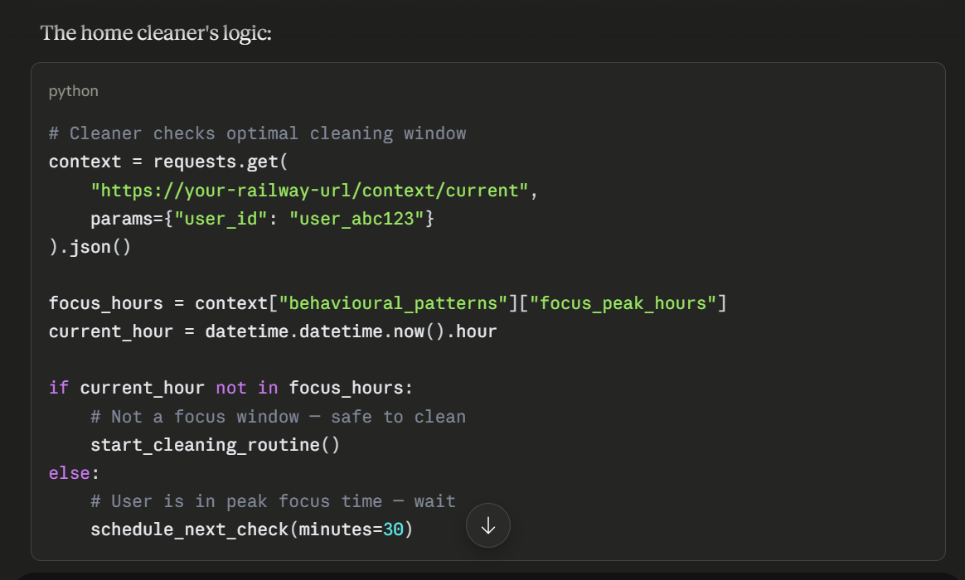
Every device follows the same pattern — check the personal context, act accordingly, never interrupt unnecessarily.
What Silent Mirror would eventually know that makes robots genuinely useful
This is the part that is most interesting. After a year of use, Silent Mirror's model of the user would include things no device manufacturer could hardcode.
Contextual preferences — not just "prefers green tea" but "prefers green tea specifically on days when the afternoon check-in showed low energy, not on high-energy days when they want water." The tea maker would eventually learn to ask Silent Mirror not just what to make but whether today is a green tea day.
Anticipatory patterns — the system would know that on days the user studies past 10pm, they typically sleep poorly, and the next morning they start slowly. The coffee maker would automatically brew a stronger cup the morning after late-night sessions — without the user ever configuring this. The pattern is in the data.
Interruption sensitivity — Silent Mirror would know that the user's focus sessions on Tuesday mornings are deeper than on Friday afternoons. The robot vacuum would know not to run on Tuesday mornings even if the calendar shows no meetings. This is not something any calendar integration could infer — it requires the behavioural pattern data that only Silent Mirror holds.
Recovery needs — the health mode would eventually know that after heavy workout days the user needs 2 hours of lower cognitive demand. The smart home would reduce notification volume, dim lighting slightly, and queue calming music during that window automatically.
Emotional state responsiveness — with the emotional regulation detection from Project 2b, Silent Mirror would know when the user is stressed. The home environment could respond — warmer lighting, lower ambient noise, the tea already brewing — without the user asking for any of it.

The concept this connects to — ambient intelligence
What you are describing is a specific vision of the future that researchers call ambient intelligence — environments that are aware of the people within them and respond intelligently to their needs without requiring explicit commands.
The missing piece in every ambient intelligence system built so far is a coherent personal model. Smart home devices know about schedules and explicit preferences. They do not know about patterns, rhythms, and the subtle cross-domain connections that determine what a person actually needs at any given moment.
Silent Mirror is the personal model layer that ambient intelligence has been missing.
The architecture is:
Silent Mirror (personal knowledge layer)
↓
Personal Context API
↓
├── Smart home devices
├── Robots and appliances
├── Calendar and scheduling
├── Health devices
├── Work tools
└── Any connected system
Every connected system becomes more intelligent not because it got smarter but because it gained access to a model of the specific person it is serving.

What this means for Silent Mirror as a product
This is the long-term vision you should articulate in presentations and applications. Not just "an AI that helps you understand yourself" but "a personal knowledge layer that makes every system around you contextually intelligent."
The product roadmap would look like this:
Now — Silent Mirror as a conversational AI with persistent memory. The personal model builds.
Year 1 — Personal context API opens. Silent Mirror's model becomes readable by external systems. First integrations: calendar, health apps, task managers.
Year 2 — Smart home integration. Devices read from the personal context API. The tea maker example becomes real.
Year 3 — Robot integration. Physical devices with more complex behaviour respond to the personal model. The home cleaner, the kitchen assistant, the workspace configurator.
Year 5 — The personal model becomes the user's digital identity layer. Not a profile on a platform — a portable, user-owned model that travels with them across every service, device, and environment they interact with. The user never has to configure a new device again. They just give it access to their Silent Mirror context.

The philosophical point worth making in presentations
Right now, you configure your devices to serve you. You set the alarm. You program the cleaner. You tell the calendar what matters.
In the world Silent Mirror is building toward, your devices understand you well enough that configuration becomes unnecessary. The system already knows what you need, when you need it, and how to deliver it without interruption.
The difference between a smart device and an intelligent one is not processing power — it is context. Silent Mirror provides the context.
And critically — unlike every other system that builds a model of you, this one is yours. You see it. You correct it. You control who can read it. You can delete it. The devices serve you because they understand you — not because a platform owns your data and rents access to your preferences to device manufacturers.
Machines assist. Humans decide.
That principle, which started as a conversational AI design rule, becomes the governing architecture of an entire ecosystem of devices and services — all of them drawing from a personal knowledge layer that belongs to the user and serves only the user.
That is the long-term vision. And the foundation for it is what you have already built.

