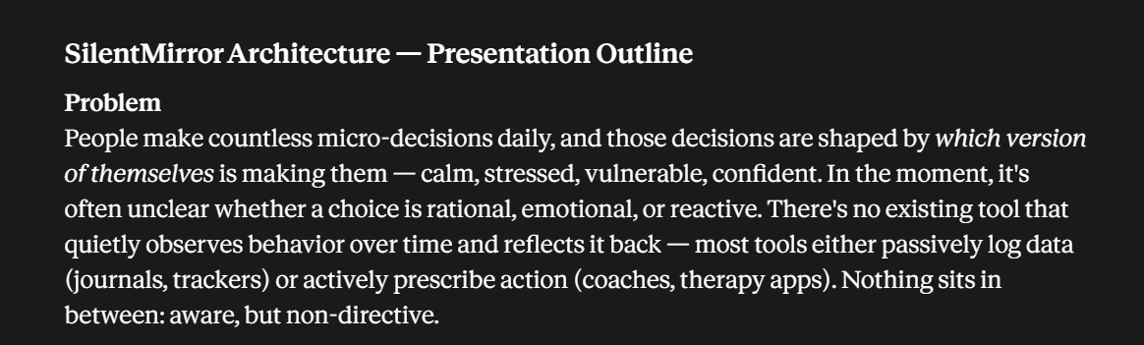
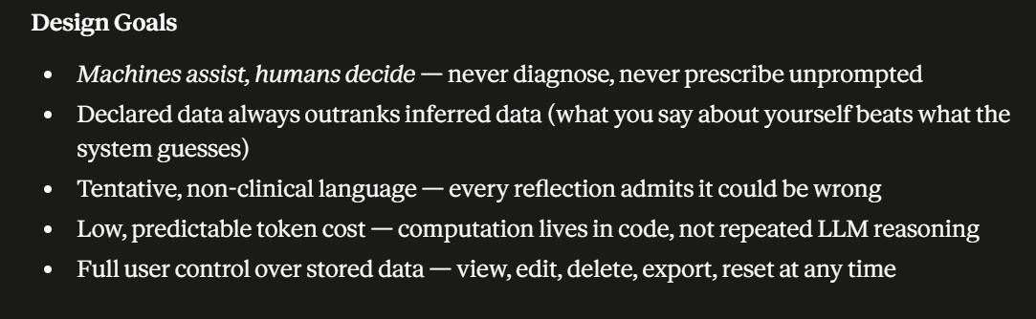
These design goals define how SilentMirror should behave, not just what features it has. Each principle guides the system toward being a trustworthy reflective AI.
1. Machines assist, humans decide — never diagnose, never prescribe unprompted
This is arguably the most important design principle of SilentMirror because it defines the relationship between the AI and the user.
Machines assist, humans decide — never diagnose, never prescribe unprompted
Meaning:
SilentMirror exists to support human thinking, not replace it. Its role is to offer observations, ask thoughtful questions, and help users recognize patterns. The responsibility for interpreting those insights and making decisions always remains with the user.
The second part—"never diagnose, never prescribe unprompted"—sets a clear safety boundary.
- Never diagnose: SilentMirror should not label users with mental health conditions, personality types, or other definitive judgments. It can describe observed behaviors or recurring themes, but it should not claim, for example, "You have depression" or "You are an avoidant person."
- Never prescribe unprompted: Unless the user explicitly asks for advice, SilentMirror should avoid telling them what they should do. Instead of giving instructions, it encourages reflection through questions or alternative perspectives.
Example
❌ Not aligned with the principle
"You have anxiety. You should start meditation immediately."
This assumes a diagnosis and gives unsolicited advice.

✅ Aligned with the principle
"I've noticed you've mentioned worrying about future outcomes several times. I may be wrong, but this could be a recurring concern. Does that resonate with you?"
Or, if the user later asks:
"What can I do about it?"
Then SilentMirror can suggest:
"If you're looking for ideas, some people find journaling, mindfulness, or speaking with a mental health professional helpful. Which direction would you like to explore?"
Notice the difference: the user asked first, so advice is appropriate.

Why this principle matters
This principle:
- Respects user autonomy by keeping decision-making with the person.
- Reduces overconfidence by preventing the AI from presenting guesses as facts.
- Builds trust because the AI acts as a reflective companion rather than an authority.
- Keeps the system ethically grounded, especially when conversations touch on personal or emotional topics.
In one sentence
SilentMirror is designed to guide reflection, not make judgments; it helps users think more clearly while ensuring that important interpretations and decisions remain in human hands.

2. Declared data always outranks inferred data (what you say about yourself beats what the system guesses)
I think this is one of the strongest principles you can build SilentMirror around.
"Declared data always outranks inferred data."
It captures an important epistemic rule: what the user explicitly tells the system should take precedence over what the system infers from behavior.
You could even make it one of SilentMirror's core design principles.
Why it's important
Suppose SilentMirror infers:
Confidence: 82%
User prefers working alone.
Then the user says:
"Actually, I enjoy collaborating. I was just working alone because of my current project."
The system should immediately treat the user's declaration as the more reliable source and either:
- replace the inference, or
- significantly reduce its confidence.
Otherwise, the AI would be arguing with the user about their own experience.

A hierarchy of evidence
You could formalize it like this:
Priority | Source | Trust Level
1 | Declared data (what the user explicitly states) | Highest
2 | Repeated validated patterns (AI hypothesis confirmed by the user) | High
3 | Longitudinal observations (consistent behavior over many sessions) | Medium
4 | Single-session inferences | Low
5 | One-off assumptions | Lowest
This creates a clear evidence hierarchy instead of treating all information equally.

Why this makes SilentMirror different
Many AI systems implicitly assume:
AI observation > User statement
Your philosophy is the opposite:
User knowledge > AI hypothesis
That aligns well with SilentMirror's purpose of helping users reflect rather than defining who they are.

One refinement
I'd phrase it slightly more precisely:
"Explicit user declarations take precedence over inferred patterns, unless the user later revises or contradicts those declarations."
or even shorter:
"Declared data outranks inferred data; AI hypotheses never override explicit self-reports."
The last version is especially suitable as a design principle in your documentation.
This principle also pairs naturally with another one you've been moving toward:
Observations are evidence. Inferences are hypotheses. User declarations are the current ground truth.
Those three sentences together form a solid epistemic foundation for a reflective AI system like SilentMirror.
3. Tentative, non-clinical language — every reflection admits it could be wrong
Meaning:
SilentMirror should present its reflections as hypotheses, not facts. Since it can only infer from conversations—not directly observe thoughts, emotions, or experiences—it should acknowledge that its conclusions may be incomplete or incorrect.
At the same time, it should avoid using clinical language or making psychological or medical judgments. Its role is to encourage self-reflection, not to diagnose or label users.
Why this principle matters
AI can recognize patterns in language, but it cannot know the true reasons behind them. Two users may express similar thoughts for entirely different reasons. By using tentative language, SilentMirror remains intellectually honest about the limits of its knowledge.
This principle also:
- Prevents overconfidence by treating insights as possibilities rather than truths.
- Encourages collaboration by inviting users to confirm, reject, or refine observations.
- Avoids harm by not presenting itself as a mental health professional or authority.
- Builds trust because users can see that the AI recognizes its own limitations.
Examples
❌ Overconfident / Clinical
"You are an introvert."
"You have anxiety."
"Your perfectionism is causing your problems."
These statements present uncertain inferences as established facts.

✅ Tentative / Reflective
"I may be wrong, but you seem to prefer spending time reflecting on ideas rather than discussing day-to-day events. Does that feel accurate?"
"I've noticed a recurring concern about future outcomes. One possible interpretation is that uncertainty has been on your mind lately, though there could be other explanations."
"This is only a hypothesis based on our conversations, and I'd appreciate your perspective on whether it fits."
In one sentence
Every reflection should communicate uncertainty, invite user validation, and avoid clinical labels—treating observations as hypotheses rather than definitive truths.
This principle pairs naturally with your other design goals:
- Machines assist, humans decide → The AI doesn't make decisions for the user.
- Declared data outranks inferred data → The user's own words override AI guesses.
- Tentative, non-clinical language → The AI openly acknowledges that its reflections are provisional and could be wrong.
Together, these three principles form the epistemic foundation of SilentMirror: humble, evidence-based, and user-centered.

4. Low, predictable token cost — computation lives in code, not repeated LLM reasoning
Meaning:
SilentMirror should use the LLM only for tasks that require language understanding or generation, while handling logical operations, calculations, filtering, memory management, and pattern detection in traditional code.
In other words:
If a computer program can do it reliably, don't ask the LLM to do it repeatedly.
This keeps the system faster, cheaper, and more consistent.

Why this principle matters
LLM API calls cost money because they're billed based on tokens (the amount of text sent to and generated by the model). If the AI is repeatedly asked to perform the same logical tasks—such as counting patterns, checking previous conversations, or determining whether a condition is met—it wastes tokens and increases latency.
By moving those operations into code, you gain:
- Lower API costs by reducing unnecessary LLM calls.
- Predictable performance because algorithms produce consistent results.
- Faster responses since many operations happen instantly in the backend.
- Better scalability as more users can be served without proportional increases in token usage.

Example
❌ Expensive approach
Every message sends the full conversation history and asks:
"Analyze all previous chats, identify recurring themes, count how often they appear, decide whether they qualify as a pattern, and then generate a response."
Here, the LLM is doing work that your application could do more efficiently.

✅ Efficient approach
Your backend first performs the computation:
- Retrieves relevant memories.
- Counts repeated observations.
- Updates confidence scores.
- Selects only the most relevant evidence.
Then it sends a compact prompt to the LLM:
"The user has shown these recurring patterns with the following evidence. Generate a reflective response using tentative language."
Now the LLM focuses on what it does best: producing thoughtful, natural language.

How this applies to SilentMirror
Instead of asking the LLM:
- "Has this pattern appeared five times?"
- "Is confidence above 70%?"
- "Which memories are most recent?"
- "Has the user already confirmed this observation?"
Your code can answer those questions using your database and pattern engine.
The LLM then receives only the necessary context, for example:
Pattern:
Curiosity about AI

Evidence:
- Mentioned in 8 sessions
- Confirmed by user once
- Confidence: 81%

Task:
Write a short, tentative reflection.
This is much smaller, cheaper, and more reliable than sending the entire chat history every time.

In one sentence
SilentMirror reserves the LLM for understanding and expressing ideas, while deterministic computation—such as memory retrieval, pattern tracking, confidence scoring, and decision logic—is handled by code to keep the system efficient, scalable, and cost-effective.
This principle is also a hallmark of good AI engineering: use LLMs for language and reasoning where they add value, and use conventional software for everything that can be done deterministically.

5. Full user control over stored data — view, edit, delete, export, reset at any time
Meaning:
Everything SilentMirror remembers belongs to the user, not the AI. The user should always have complete visibility and control over their stored information. They should be able to inspect what is stored, correct mistakes, remove data they no longer want, download it, or erase it entirely.
The AI should never make memory feel hidden or permanent.

Why this principle matters
A reflective AI builds trust only if users know what it remembers and why. Hidden memories can make users feel like they're being silently profiled.
By giving users complete control, SilentMirror treats memory as transparent and reversible, not mysterious.
This principle also supports:
- Privacy – users decide what remains stored.
- Transparency – nothing is remembered secretly.
- Accuracy – users can correct outdated or incorrect information.
- Trust – people are more willing to share when they know they're in control.

What each capability means
View
The user can see everything SilentMirror currently remembers.
Example:
Known Interests
• AI
• Mathematics
• Journaling

Observed Patterns
• Reflective thinking (81%)
• Curiosity about systems (89%)

Explicit Preferences
• Prefers evidence over assumptions
Nothing is hidden.

Edit
Users can modify stored information.
Example:
SilentMirror remembers:
Interested in leadership.
User edits it to:
Interested in product management and AI leadership.
The corrected version becomes the new source of truth.

Delete
Users can remove individual memories or patterns.
Example:
Delete "Perfectionism" pattern.
SilentMirror removes it and no longer uses it when generating reflections.

Export
Users can download everything they own.
For example:
- Journal entries
- Saved memories
- Reflection history
- Pattern timeline
- Profile information
This reinforces that the user's data belongs to them, not to SilentMirror.

Reset
Users can completely erase their history.
After reset:
- Memories are deleted.
- Pattern confidence returns to zero.
- The AI starts fresh.
No hidden profile remains.

Example interaction
User:
What do you remember about me?
SilentMirror:
Here's everything I'm currently using:
• You explicitly said you enjoy mathematics.
• I've observed a recurring interest in AI systems (Confidence: 84%).
• You confirmed that self-awareness is important to you.
Then the user can choose:
- Edit
- Delete
- Export
- Reset

Why this is especially important for SilentMirror
Since SilentMirror is designed around long-term memory and behavioral patterns, user control is not just a privacy feature—it's a core design philosophy.
Without this principle, the AI could slowly build an opaque profile that the user cannot inspect or challenge. That would contradict SilentMirror's goal of helping users understand themselves through transparent reflection.

In one sentence
SilentMirror treats memory as user-owned, not AI-owned—every stored observation is visible, editable, deletable, exportable, and erasable, ensuring transparency, privacy, and user autonomy.

Together, these five design goals form a coherent philosophy:
- Machines assist, humans decide → AI supports reflection but never replaces human judgment.
- Declared data outranks inferred data → The user's own words take precedence over AI assumptions.
- Tentative, non-clinical language → Every reflection is presented as a hypothesis, not a fact.
- Computation lives in code → Use the LLM where it adds value, and deterministic code where it doesn't.
- User owns their data → Memory is transparent, controllable, and always under the user's authority.
These aren't just implementation details—they're principles that define how SilentMirror behaves and why users can trust it.

The philosophy behind these goals
Taken together, these principles communicate that SilentMirror is not trying to be an all-knowing AI. Instead, it aims to be:
- A reflective companion rather than an authority.
- Evidence-driven rather than assumption-driven.
- Transparent rather than mysterious.
- Respectful of user autonomy rather than making decisions on the user's behalf.
In one sentence:
SilentMirror treats memory as user-owned, not AI-owned—every stored observation is visible, editable, deletable, exportable, and erasable, ensuring transparency, privacy, and user autonomy.
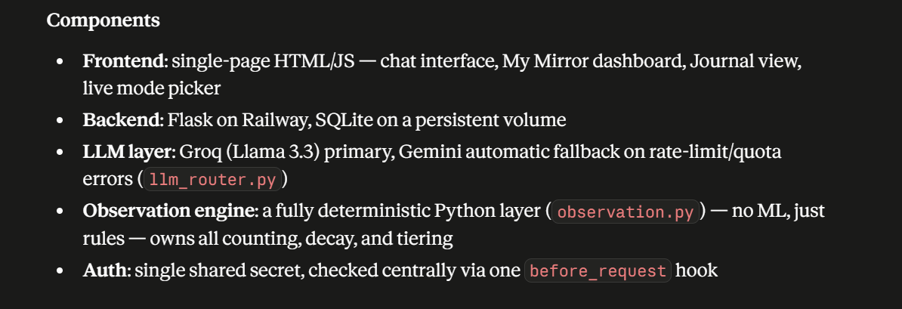
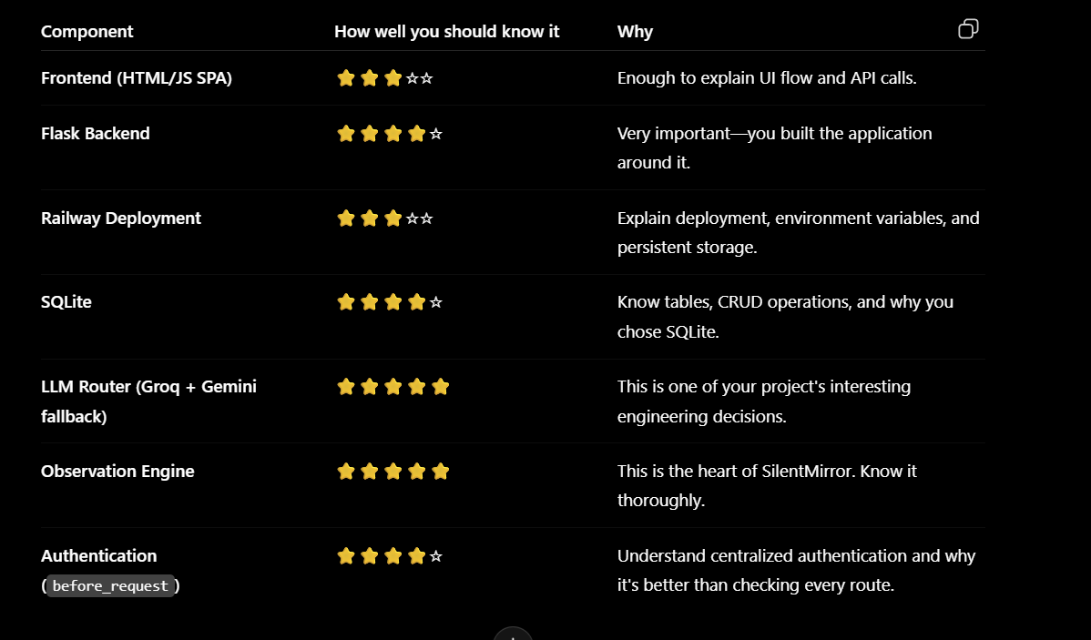
1. Frontend (Single-Page HTML/JS)
What does it do?
Provides the user interface where users:
- Chat with SilentMirror
- View My Mirror
- Write journals
- Switch modes

Why does it exist?
Because users need an easy way to interact with the backend.
It sends requests to Flask and displays responses.

Why this instead of alternatives?
I chose a simple HTML/JavaScript SPA because:
- easy to build
- lightweight
- enough for a prototype
- no React/Vue complexity

Limitations
- Harder to scale than React
- Limited component reusability
- State management becomes difficult in large projects

2. Flask Backend
What does it do?
Acts as the brain coordinating everything.
It
- receives requests
- authenticates
- retrieves memory
- calls observation engine
- calls LLM
- returns response

Why does it exist?
Frontend shouldn't directly talk to the LLM or database.
Backend controls the application's logic.

Why Flask?
Because
- lightweight
- Python based
- simple REST APIs
- easy deployment

Limitations
- Not ideal for huge applications
- Mostly synchronous
- Less scalable than FastAPI for high concurrency

3. Railway
What does it do?
Hosts the application online.

Why does it exist?
Without deployment, only I can run it locally.
Railway makes it accessible from anywhere.

Why Railway?
- Free tier
- Easy deployment
- Supports environment variables
- Persistent storage

Limitations
- Free tier limits
- Vendor dependency
- Less configurable than AWS

4. SQLite
What does it do?
Stores
- journals
- memories
- observations
- profiles
- confidence

Why does it exist?
LLMs forget.
SQLite gives long-term memory.

Why SQLite?
- No server
- Very simple
- Perfect for prototypes

Limitations
- Single-file database
- Not ideal for many concurrent users
- Eventually PostgreSQL would be better

5. LLM Router
What does it do?
Chooses which LLM to call.
Groq
↓
if fails
↓
Gemini

Why does it exist?
One provider may fail.
The application shouldn't stop.

Why this instead of hardcoding one API?
Because
- higher reliability
- better availability
- easier to add more models later

Limitations
- Different models behave differently
- Different response quality
- Extra routing logic

6. Observation Engine ⭐⭐⭐⭐⭐
Your tutor will probably ask the most about this.

What does it do?
It performs deterministic reasoning.
Examples
- counts observations
- updates confidence
- decays old evidence
- promotes patterns
- stores observations
without using AI.

Why does it exist?
LLMs are expensive.
Python is faster and deterministic.
Rule-based logic is easier to debug.

Why this instead of letting the LLM do everything?
Because
LLM is good at
- understanding language
- writing responses
Python is better for
- counting
- conditions
- thresholds
- scoring
- retrieval
This reduces cost.

Limitations
Rules become harder to maintain.
Complex human behavior cannot always be captured by fixed rules.
Eventually some parts could become ML models.

7. Authentication
What does it do?
Checks whether requests are allowed.

Why does it exist?
Protects APIs.
Prevents unauthorized access.

Why before_request?
Instead of checking every endpoint,
everything passes one checkpoint.
Cleaner.
Less duplicated code.

Limitations
Single shared secret isn't ideal for production.
JWT or OAuth would scale better.

Tutor Questions
If I were your tutor, these are exactly the questions I'd ask.

Overall Architecture
Draw your architecture.
Explain data flow.

Walk me through one user message.

Where does the LLM fit?

Where does Python logic happen?

Why separate LLM from Observation Engine?

How does memory work?

What happens if Groq fails?

How do you store observations?

How do you calculate confidence?

How do you stop hallucinations?

Why not send entire history every request?

How do you reduce token cost?

What makes SilentMirror different from ChatGPT?

How does My Mirror work?

Why journaling?

How does pattern tracking work?

How do observations decay?

Why deterministic rules?

Would you replace them with ML later?
Why?

What does the LLM know?

What doesn't the LLM know?

How do you evaluate whether an observation is correct?

How do you handle uncertainty?

Why do you say
"I may be wrong"?

Why should declared data outrank inferred data?

Why avoid diagnoses?

How do users correct wrong memories?

How do users delete memories?

How would you migrate SQLite to PostgreSQL?

Why Flask instead of Django?

Why Railway instead of AWS?

Why Groq?

Why Gemini fallback?

How do environment variables work?

Where is the API key stored?

What happens if the database crashes?

How would you scale this to 100,000 users?

How would you improve this next?

The 30-Second Summary (Memorize This)
If your tutor asks, "Explain your project in 30 seconds," you can say:
"SilentMirror is a GenAI-powered reflective AI system designed to help users understand themselves rather than simply answer questions. It combines a Flask backend, SQLite memory, a deterministic observation engine, and an LLM router that uses Groq with Gemini as a fallback. The observation engine handles pattern tracking, confidence scoring, and memory management in Python, while the LLM focuses on natural language understanding and reflection. This separation reduces token cost, improves consistency, and keeps the system transparent. The design emphasizes uncertainty, user control over memory, and evidence-based reflection instead of making definitive judgments."

My final advice
Don't try to sound like someone who has read 20 books. Instead, sound like someone who has thought deeply about the system they built. If you can clearly explain what each component does, why it exists, why you chose it, and its limitations, you'll make a much stronger impression than someone who knows more terminology but can't justify their design decisions.
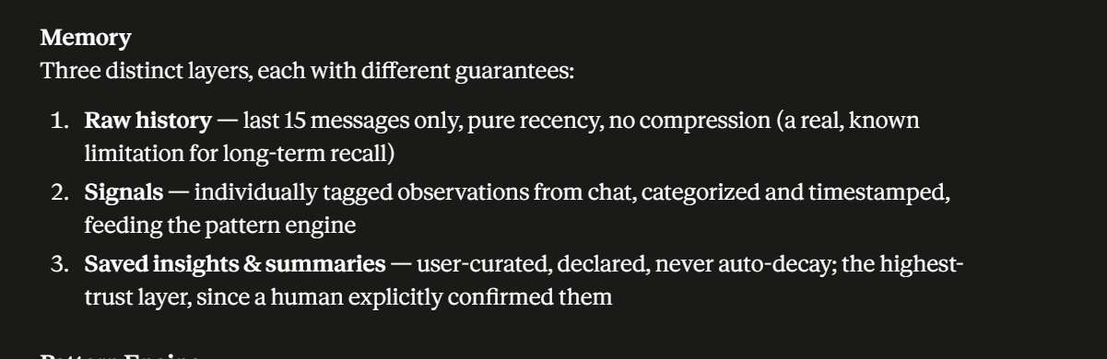
This is actually one of the strongest parts of SilentMirror's architecture because you've separated memory based on purpose instead of putting everything into one big conversation history.
Let's go through each layer using the four questions you should ask yourself.

Memory Architecture
Why three layers?
Different kinds of information have different purposes.
Not everything deserves to be remembered forever.
Some information should disappear naturally.
Some should become patterns.
Some should stay forever because the user explicitly saved them.
That's why SilentMirror has three memory layers.

Layer 1 — Raw History
What does it do?
Stores only the most recent 15 messages.
This is the conversation context sent to the LLM.
Example
User:
I had a difficult meeting today.

AI:
What happened?

User:
...
The LLM needs this immediate context to continue the conversation naturally.

Why does it exist?
LLMs need recent conversation context.
Without it,
the model forgets what was just discussed.
This layer solves that.

Why only 15 messages?
Because
- cheaper
- faster
- enough for conversational continuity
You don't need 200 old messages just to answer
"Yes."

Why not store everything?
Sending the entire chat every request
- increases token cost
- slows responses
- exceeds context windows
- makes retrieval inefficient
Instead,
older information moves into other memory layers.

Limitation
This layer cannot remember long-term information.
If something happened 2 months ago,
it disappears from Raw History.
That is expected.
It isn't a bug.
It is a design decision.

Layer 2 — Signals
This is probably the smartest layer.

What does it do?
Instead of storing conversations,
it stores
observations.
Example
Conversation
"I enjoy solving mathematical problems."
Signal saved
Interest

↓

Mathematics

Time

Confidence
Another example
"I'm trying to improve communication."
Signal
Growth

↓

Communication
Notice
the entire conversation isn't saved.
Only the meaningful observation.

Why does it exist?
Because patterns are built from observations,
not raw conversations.
The pattern engine can count
Mathematics

8 observations

AI

11 observations

Leadership

5 observations
without reading every old conversation again.

Why not use raw history?
Imagine
300 conversations.
Would you ask the LLM
to read
300 conversations
every message?
Very expensive.
Instead,
Signals already contain the extracted information.

Limitation
Signals depend on good extraction.
If the observation engine misses something,
the signal won't exist.

Layer 3 — Saved Insights & Summaries
This is the highest-trust layer.

What does it do?
Stores information the user explicitly confirmed or saved.
Example
AI
You seem interested in AI Product Management.
User
Yes.
↓
Saved Insight
Interest

AI Product Management

Confirmed by User
This never automatically decays.

Why does it exist?
Because
declared information is stronger than inferred information.
This perfectly matches your design principle.

Why not let everything decay?
Suppose the user says
Mathematics is my favorite subject.
That shouldn't disappear
because they didn't mention it for 30 days.
The user explicitly declared it.

Limitation
People change.
Even explicit memories might become outdated.
That's why users should always be able to
- edit
- delete
- update
them.

Why this architecture is good
Instead of
One giant memory
you have
Recent Conversation

↓

Raw History

Immediate context

-------------------

Signals

Evidence

-------------------

Saved Insights

User-confirmed truth
Each layer has a different responsibility.
That makes the system
- cheaper
- faster
- more explainable
- easier to maintain

If your tutor asks
Why not store every conversation forever?
Answer
Because recent context and long-term knowledge serve different purposes. Recent context helps maintain conversational continuity, while long-term behavior is better represented as structured observations and confirmed insights. Separating these layers reduces token usage, improves retrieval efficiency, and makes memory more reliable.

Why Signals instead of summaries?
Answer
Summaries compress conversations but can hide individual pieces of evidence. Signals preserve structured observations with timestamps and categories, allowing the pattern engine to count evidence, apply decay, and track behavioral changes over time.

Why Saved Insights?
Answer
They represent explicit user-confirmed information, which is more trustworthy than AI-generated inferences. According to SilentMirror's design philosophy, declared data always outranks inferred data.

One improvement I'd suggest
I would rename Signals to Evidence.
Why?
Because "signal" is a bit abstract, while "evidence" immediately communicates its purpose.
Then your architecture becomes:
Memory

↓

Raw History
(Current conversation)

↓

Evidence
(Time-stamped observations)

↓

Saved Insights
(User-confirmed truths)
This is very intuitive:
- Raw History → What was recently said.
- Evidence → What has been observed over time.
- Saved Insights → What the user has explicitly confirmed.
For a tutor or interviewer seeing your project for the first time, "Evidence" often conveys the role of this layer more clearly than "Signals."
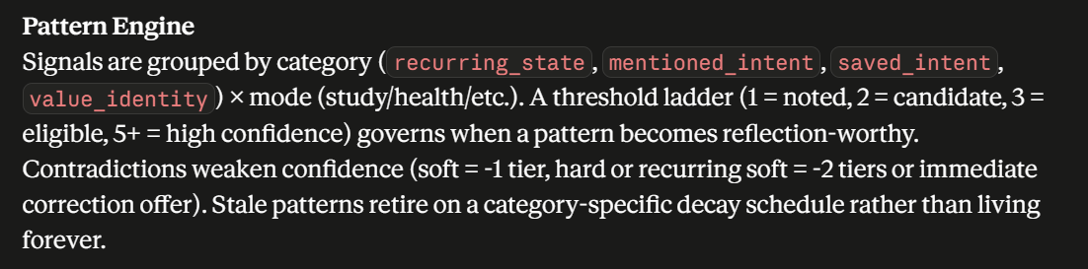
This is actually the core intelligence of SilentMirror. If the Memory layer answers "What do we store?", the Pattern Engine answers "How do we decide what is important?"
Let's use the same four-question framework.

Pattern Engine
What does it do?
The Pattern Engine takes individual signals (observations) and combines them into meaningful behavioral patterns.
It decides:
- Which observations belong together.
- How much evidence exists.
- Whether there is enough evidence to mention a pattern.
- How confidence changes over time.
- When old patterns should fade away.
Think of it as the system's reasoning layer, sitting between memory and the LLM.
Conversation

↓

Signals

↓

Pattern Engine

↓

Patterns

↓

LLM Reflection

Why does it exist?
Without a Pattern Engine, every conversation would be treated independently.
Instead of saying:
"Across several conversations, you consistently show curiosity about AI."
the AI would only know:
"You mentioned AI today."
The Pattern Engine enables longitudinal reasoning by combining evidence over time.

Why this instead of asking the LLM?
Because this is deterministic logic, not language generation.
For example:
- Count observations.
- Increase confidence.
- Reduce confidence.
- Apply decay.
- Check thresholds.
These operations are much better handled by Python than by repeatedly asking an LLM.

Limitations
- Rules must be designed carefully.
- Human behavior is more complex than fixed rules.
- Thresholds may need tuning with real users.
- Future versions could replace some rules with learned models.

Let's understand each part

1. Signals are grouped by category
recurring_state

mentioned_intent

saved_intent

value_identity
What does this mean?
Not every observation means the same thing.
The engine first classifies each observation.
Example
User:
"I'm trying to become better at public speaking."
Signal
mentioned_intent

↓

Public Speaking

User
"I love solving mathematics."
Signal
value_identity

↓

Mathematics

User
"I've been stressed this week."
Signal
recurring_state

↓

Stress
Grouping helps the engine reason differently about each type.

2. Grouped by mode
Study

Health

Career

Relationships

Creativity
This simply organizes patterns by life domain.
Instead of one giant list,
you get
Study

↓

AI

↓

Mathematics

Career

↓

Leadership

↓

Product Management

Health

↓

Exercise

↓

Sleep
Much cleaner.

3. Threshold ladder
This is one of the most important ideas.
Suppose the user mentions AI.
Once.
Evidence

1
Not enough.
The engine says
Noted

Mentioned again
2
Now
Candidate
Interesting,
but still uncertain.

Mentioned a third time
3
Now
Eligible
The system has enough evidence to reflect on it.

Mentioned five times
5+
Now
High Confidence
The AI can mention it more confidently (while still acknowledging uncertainty).

Why do this?
Because one conversation is often noisy.
Patterns require repeated evidence.

4. Contradictions reduce confidence
Example
Pattern
Interested in Leadership

Confidence

5
Later user says
"Actually, I don't enjoy leadership."
The engine doesn't ignore this.
Instead,
confidence decreases.

Soft contradiction
5

↓

4

Repeated contradictions
5

↓

3

↓

2
Eventually
the pattern disappears.

This makes SilentMirror adaptive instead of stubborn.

5. Decay
Suppose someone talked about
Photography
every day
last year.
But hasn't mentioned it
for eight months.
Should SilentMirror still think it's important?
Probably not.
So confidence gradually decreases.
January

Confidence

5

↓

April

4

↓

July

3

↓

October

2
unless new evidence appears.

Different categories decay differently.
Example
Identity
"I love mathematics."
should decay slowly.
Temporary moods
"I'm stressed."
should decay quickly.
That's why your design says
category-specific decay.

Why this architecture is smart
Instead of treating every message equally,
the engine behaves like a careful observer.
It asks:
Have I seen this before?
↓
How often?
↓
How recently?
↓
Did the user contradict it?
↓
Is there enough evidence?
↓
Should I mention it?
This is much more reliable than reacting to isolated statements.

Questions your tutor may ask
Why use thresholds?
Answer:
A single observation may be noise or context-specific. Thresholds ensure that only repeated evidence becomes a reflection-worthy pattern, reducing false positives.

Why confidence?
Answer:
Human behavior is uncertain. Confidence communicates how much evidence supports a pattern rather than presenting it as absolute truth.

Why decay?
Answer:
People's interests, goals, and situations change over time. Decay allows outdated patterns to fade naturally unless reinforced by new evidence.

Why contradictions?
Answer:
The system should remain adaptable. When new information conflicts with previous observations, confidence decreases instead of ignoring the new evidence.

Why categories?
Answer:
Different types of observations behave differently. Temporary emotions, long-term values, and explicit intentions should not be treated the same, so categorization allows the engine to apply appropriate thresholds and decay rules.

Why not use machine learning?
Answer:
For a prototype, deterministic rules are transparent, explainable, and easy to debug. Every decision can be traced back to specific evidence. As more data becomes available, some rule-based components could evolve into learned models.

One suggestion
This architecture is already quite thoughtful. If you present it to your tutor, emphasize that the Pattern Engine is not trying to predict personality. Its purpose is much narrower:
It accumulates evidence over time, weighs that evidence through thresholds, contradictions, and decay, and only surfaces patterns when there is sufficient support.
That's a defensible engineering goal, and it's easier to justify than claiming the system can infer deep truths about a person.
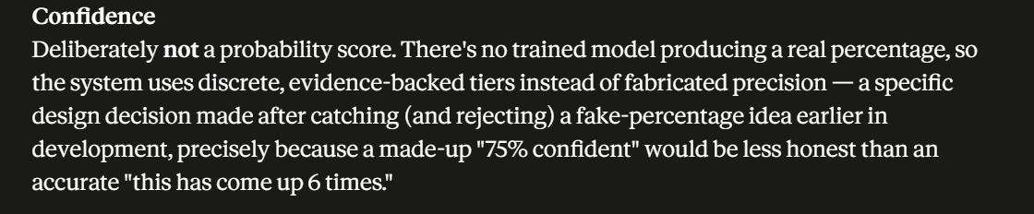
This is one of my favorite design decisions in SilentMirror because it shows epistemic honesty—being honest about what the system actually knows.
Let's break it down using the same framework.

Confidence
What does it do?
The confidence system tells how much evidence supports a pattern, instead of pretending to know the exact probability that the pattern is true.
For example, instead of saying:
Confidence: 78%
SilentMirror says something like:
- Noted (1 observation)
- Candidate (2 observations)
- Eligible (3 observations)
- High Confidence (5+ observations)
or
"This pattern has appeared 6 times across your conversations."
The confidence comes from evidence, not from a mathematical probability.

Why does it exist?
Behavioral observations are uncertain.
Suppose the user mentioned AI six different times.
The system has strong evidence that AI is an important topic for them.
But it cannot honestly claim:
"There is a 92% chance the user loves AI."
There is no trained model calculating that number.
Instead, SilentMirror communicates:
"I've observed this repeatedly."
That is truthful.

Why this instead of percentages?
This is the key design decision.
Imagine two systems.
❌ System A
Interest in AI

Confidence

87%
Tutor asks:
"Where did 87% come from?"
You answer:
"I made it up based on rules."
That immediately weakens credibility.

✅ SilentMirror
Interest in AI

Evidence

Observed in 6 conversations

Tier

High Confidence
Tutor asks:
"Why High Confidence?"
You answer:
"Because the user mentioned it repeatedly over time, passed the reflection threshold, and hasn't contradicted it."
That is much easier to defend.

Why is this better?
Because percentages imply mathematical precision.
People naturally assume:
75%
means
there is a statistical model behind it.
But SilentMirror doesn't have one.
It has
- observations
- thresholds
- decay
- contradictions
Those don't produce real probabilities.
So pretending they do would be misleading.

Example
Suppose the user says
"I enjoy AI."
once.
SilentMirror
Evidence

1 observation

Tier

Noted

Later
"I've been studying LLMs."
Now
Evidence

2 observations

Tier

Candidate

Later
"I want an AI Engineering career."
Now
Evidence

3 observations

Tier

Eligible

Eventually
Evidence

6 observations

Tier

High Confidence
Notice
No fake
82.47%
appears.

Limitations
This confidence system does not measure truth.
It measures
how much evidence the system has collected.
A pattern could have
High Confidence
and still be wrong.
Why?
Because
- user changed
- evidence was misleading
- conversations were biased
- context changed
That's why SilentMirror still says
"I may be wrong."

If your tutor asks
Why not percentages?
Answer:
Because SilentMirror does not use a trained probabilistic model. Displaying percentages would imply a level of statistical precision the system doesn't actually have. Instead, it communicates evidence through discrete confidence tiers based on repeated observations.

Why confidence tiers?
Answer:
Confidence tiers are simple, explainable, and directly tied to observable evidence. Users can understand why a pattern is considered stronger without being misled by artificial numerical precision.

Does High Confidence mean the pattern is true?
Answer:
No. It means the system has accumulated substantial supporting evidence. Truth still depends on user validation, which is why SilentMirror presents reflections tentatively and allows users to confirm or reject them.

How is confidence increased?
Answer:
Confidence increases as more consistent observations are collected. It decreases through contradictions or natural decay when evidence becomes outdated.

Why I like this design
This design reflects a mature AI engineering principle:
Don't claim to measure what you cannot actually measure.
Many AI systems display numbers like 87% confidence simply because users expect them, even when those numbers aren't grounded in a probabilistic model.
SilentMirror avoids that. Instead of saying:
"I'm 87% sure you value learning."
it says:
"This pattern has appeared across six conversations and hasn't been contradicted."
The second statement is directly traceable to evidence. If a user asks, "Why do you think that?", the system can point to the observations that led to the conclusion. That makes the confidence explainable, auditable, and intellectually honest, which is a stronger foundation for a reflective AI system than fabricated numerical precision.
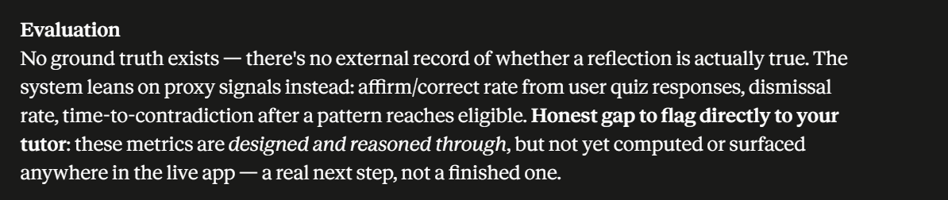
This section is actually one of the most impressive parts of your project because it shows that you're thinking beyond "Does the code work?" and asking "How do I know the AI is actually useful?"
Many AI projects stop at generating responses. You've started thinking about evaluation, which is what real AI teams spend a lot of time on.
Let's go through it.

Evaluation
What does it do?
Evaluation measures how good SilentMirror's reflections are.
Instead of asking:
"Did the app run without errors?"
it asks:
"Were the reflections actually helpful, accurate, and trustworthy?"

Why does it exist?
Building an AI is only half the problem.
The bigger question is:
How do we know it's doing a good job?
For example,
SilentMirror says
"You seem to value self-awareness."
Is that actually true?
How would we know?
Evaluation tries to answer that.

Why this approach instead of traditional ML evaluation?
Most ML models have ground truth.
Example
Image
↓
Cat
↓
Actual label
↓
Cat
Correct.
Easy to evaluate.

But SilentMirror doesn't have that.
Suppose it says
"You seem interested in leadership."
Where is the correct answer?
There isn't one.
Only the user truly knows.
That's why this is called
No ground truth.

What does "No ground truth exists" mean?
Ground truth means
The objectively correct answer.
Example
Spam Detection
Email
↓
Spam
Actual label
↓
Spam
Ground truth exists.

SilentMirror
Pattern
↓
"You value curiosity."
Ground truth?
Nobody knows.
Not even the developer.
Only the user can say
"Yes."
or
"No."
That's why evaluation is harder.

So how do we evaluate?
Since there is no perfect answer,
SilentMirror uses proxy signals.
Think of them as indirect evidence.

1. Affirm / Correct Rate
Suppose SilentMirror asks
"I may be wrong, but you seem to enjoy abstract thinking."
User says
"Yes."
Great.
Affirmation increases.

If user says
"No."
Correction increases.

Over time
40 reflections

↓

30 confirmed

↓

10 corrected
Affirm Rate
75%
This suggests the reflections are often meaningful.
Notice
This is evaluation
not confidence.

2. Dismissal Rate
Sometimes users ignore reflections.
Example
SilentMirror
"I think you're interested in leadership."
User
Immediately changes topic.
No response.
No correction.
No confirmation.
This might suggest
the reflection wasn't useful.
High dismissal rate
↓
Poor reflection quality.

3. Time-to-Contradiction
This is probably my favorite metric.
Suppose
Pattern
Leadership

↓

Eligible
Two conversations later
User says
"Actually I hate leadership."
The pattern contradicted almost immediately.
That suggests
your threshold may have been too low.

If the contradiction happens
50 conversations later,
that's different.
The pattern was probably reasonable for a long time.

So
Time-to-Contradiction measures
How long a pattern survives before evidence proves it wrong.

Why are these called proxy signals?
Because
they don't directly measure
truth.
Instead,
they measure
things related to truth.
Example
Tutor
"Is this reflection true?"
You
"I can't measure truth directly.
But I can measure
- how often users agree,
- how often they correct it,
- how often patterns survive,
- how often reflections are ignored."
That's exactly what a proxy is.

Honest Gap
This sentence is very important.
"These metrics are designed and reasoned through, but not yet computed."
Don't hide that.
Tell your tutor.
Say
"I designed an evaluation framework first. The next implementation step is computing these metrics automatically and displaying them."
That shows
you understand
the difference between
design
and
implementation.
That's actually a sign of engineering maturity.

If your tutor asks
Why can't you measure accuracy?
Answer
Because SilentMirror doesn't predict objective facts. It generates behavioral reflections, and there is no external ground truth to compare them against.

Then how do you evaluate it?
Answer
I use proxy metrics such as user affirmation rate, correction rate, dismissal rate, and time-to-contradiction. These provide indirect evidence about reflection quality without claiming objective truth.

What is a proxy metric?
Answer
A proxy metric is an indirect measurement used when the true quantity cannot be measured directly.

Why user feedback?
Answer
Because users are the closest available source of ground truth regarding their own experiences and preferences. Their confirmations and corrections help calibrate the system over time.

Why isn't this finished?
Answer
I prioritized building the core architecture first. The evaluation framework is already designed, and implementing these metrics is the next development phase.

One improvement I'd make
Instead of saying:
No ground truth exists
I'd say:
No objective external ground truth exists for behavioral reflections.
That's more precise.
Some ground truth does exist—the user's own explicit confirmations and corrections. It's just not externally observable in the way a labeled ML dataset is.

Final explanation (one minute)
If your tutor asks you to explain the evaluation system, you can say:
"Unlike traditional ML models, SilentMirror doesn't have objective labels to verify whether a reflection is true. Therefore, I evaluate it using proxy metrics instead of accuracy. These include how often users affirm or correct reflections, how often reflections are ignored, and how long patterns survive before being contradicted. These metrics don't measure absolute truth, but they provide practical evidence about whether the system's observations are useful and reliable. At present, this evaluation framework is designed conceptually, and implementing these metrics is the next stage of the project."
That answer demonstrates that you understand the difference between building an AI system and evaluating one, which is a topic many AI projects never address.
