MCQ MIRRABOOKA RESTAURANT
Daily Checklist & Prep Timetable Compliance Policy
Effective: 04 June 2026 | Location: MCQ Mirrabooka | Applies to: All staff
This document sets the mandatory daily checklist, prep timetable, temperature record and performance review requirements for all staff. The printed checklist and prep timetable are posted at each department station and must be followed every day.

Requirement | Deadline / Standard | Staff Action
Morning / Opening Checklist | Must be completed before 10:00 AM every day. | Complete each required opening task, then tick YES on paper. Mark X/NO and write a note if not completed.
Afternoon / Closing Checklist | Must be completed before 6:00 PM every day. | Complete each closing task, clean the station, and sign/initial the printed checklist before leaving.
Prep Timetable | Follow the current day and date on the printed weekly prep timetable. | Prepare only the items scheduled for that day unless the manager gives another instruction.
Temperature Records | Chef and Banh Mi must record required temperatures on paper daily. | Write temperature, time, staff initial and corrective action where required.

1. Daily Checklist Rules
- Each department has a morning/opening checklist and an afternoon/closing checklist. Both are mandatory and must be completed on time every day.
- The morning checklist must be completed before 10:00 AM. The afternoon/closing checklist must be completed before 6:00 PM.
- Staff must use a pen or highlighter on the printed checklist. Tick the YES box only when the task is fully completed. Mark X/NO if the task is incomplete or cannot be completed.
- If any task is not completed, staff must write a short note under the task or in the notes section and notify the manager or shift leader as soon as possible.
- Do not tick YES early, do not guess, and do not sign for another staff member unless the manager has approved it.
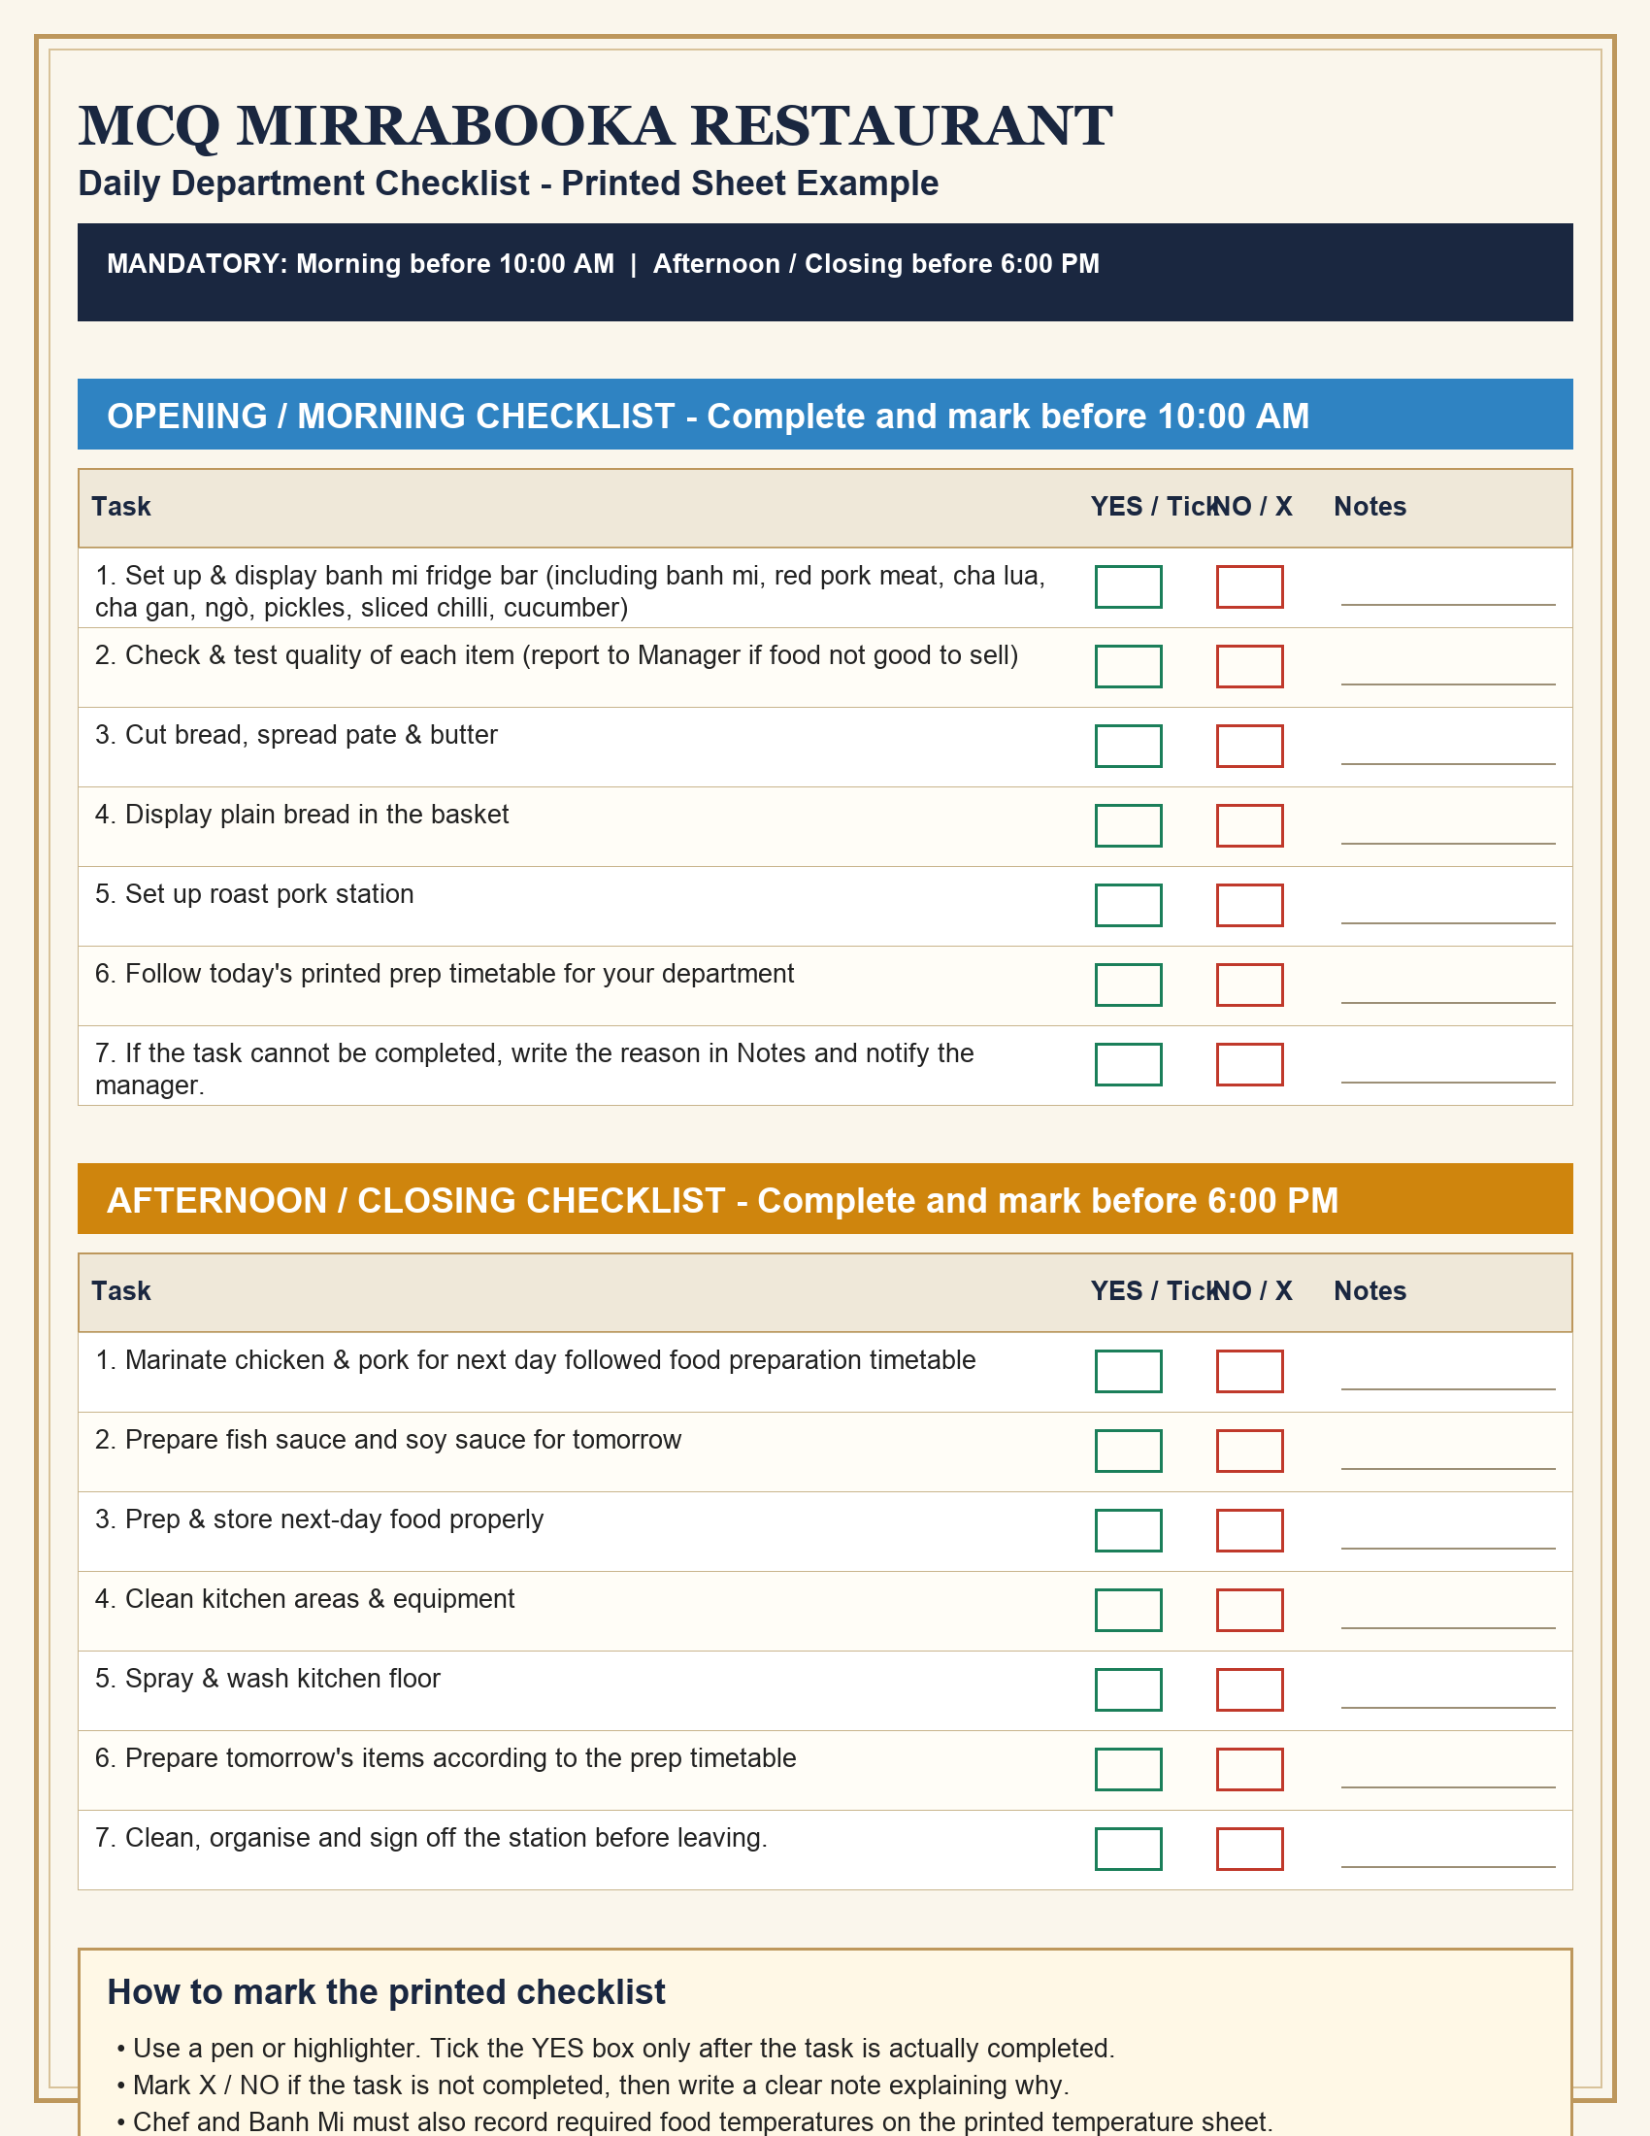

2. Department Checklist Focus

Cashier
Opening / Morning Examples | Closing / Afternoon Examples
Open till & check cash balance ($350) | Take orders & resolve service issues (during shift)
Uniform check (hat, shirt, apron) | Clean the counter area
Counter area ready for service, clean surrounding counter area | Clean display glass cabinets
Check the POS system - tills and EFTPOS all working | Clean Cold Unit 2 Soft Drink Fridge
Prepare vegetables & garnish for pho and bun bo hue | Clean Cold Unit 3 Rice Paper Roll Fridge

Banh Mi
Opening / Morning Examples | Closing / Afternoon Examples
Set up & display banh mi fridge bar (including banh mi, red pork meat, cha lua, cha gan, ngò, pickles, sliced chilli, cucumber) | Prepare next-day veg: coriander, cucumber, soy sauce follow prep timetable
Check & test quality of each item (report to Manager if food not good to sell) | Prepare food in the tray for tomorrow setup (include coriander, pickle, cucumber, sauce: soy, gravy, mayo)
Cut bread, spread pate & butter | Defrost pate (move from freezer to fridge for tomorrow)
Display plain bread in the basket | Clean up banh mi station
Set up roast pork station | Sanitise the roast pork table & chopping board

Chef
Opening / Morning Examples | Closing / Afternoon Examples
Turn on lights and ventilation/exhaust fan | Marinate chicken & pork for next day followed food preparation timetable
Turn on gas & all kitchen equipment | Prepare fish sauce and soy sauce for tomorrow
Cook rice | Prep & store next-day food properly
Make savoury sticky rice | Clean kitchen areas & equipment
Grill the pork chop | Spray & wash kitchen floor

Kitchen Hand
Opening / Morning Examples | Closing / Afternoon Examples
Roast pork (10-15/day, 15-20 weekends) | Check & refill seasonings
Grill chicken (2 trays/day, 3-4 weekends) | Prepare food for next day when time allows
Stir-fry beef / pork / tofu | Clean the preparation area
Slice beef ~5 kg for pho & banh mi | Empty rubbish bins
Slice pork & char siu meat | Wash dishes

Serve Order / Drinks
Opening / Morning Examples | Closing / Afternoon Examples
Prepare black iced coffee base (at least 2 jars) | Peel & prepare fruit for juice (next day): orange, apple, watermelon, etc.
Prepare watermelon / tropical / sugarcane juice | Refill fruit containers, lids clean & covered
Prepare smoothie base mix | Set up & check quality, clean fruit juice in the fridge
Wash sugarcane | Check enough coffee / condensed milk
Prepare fresh rice paper rolls for the day | Clean fruit juicer

3. Prep Timetable Rules
- The prep timetable shows what each department must prepare on each weekday and date. Staff must follow the task assigned to the current day.
- Example: if Monday shows Start the pho broth, Finish/strain pho broth, Peel prawns, Prepare pork hock / ribs, Prepare goi cuon, or Prepare com tam meat, those items must be completed on the correct scheduled day and ticked on the printed timetable/checklist.
- Examples of prep tasks include finishing/straining pho broth, peeling prawns, preparing goi cuon, slicing cucumber, preparing pickles, preparing sauces, marinating chicken, cutting spring onion, soaking noodles, and preparing drink bases.
- When the scheduled prep item is completed, tick/check the YES box on the printed paper. If the item is not completed, mark X/NO and write the reason in Notes.
- The printed checklist and weekly prep timetable have been printed and posted at each department station. Staff must check the posted sheet before starting prep work.

Prep Timetable - Banh Mi Station
Source PDF: docs/prep_timetables/MCQ_Prep_Timetable_Banh_Mi_Station_2026-06-01.pdf
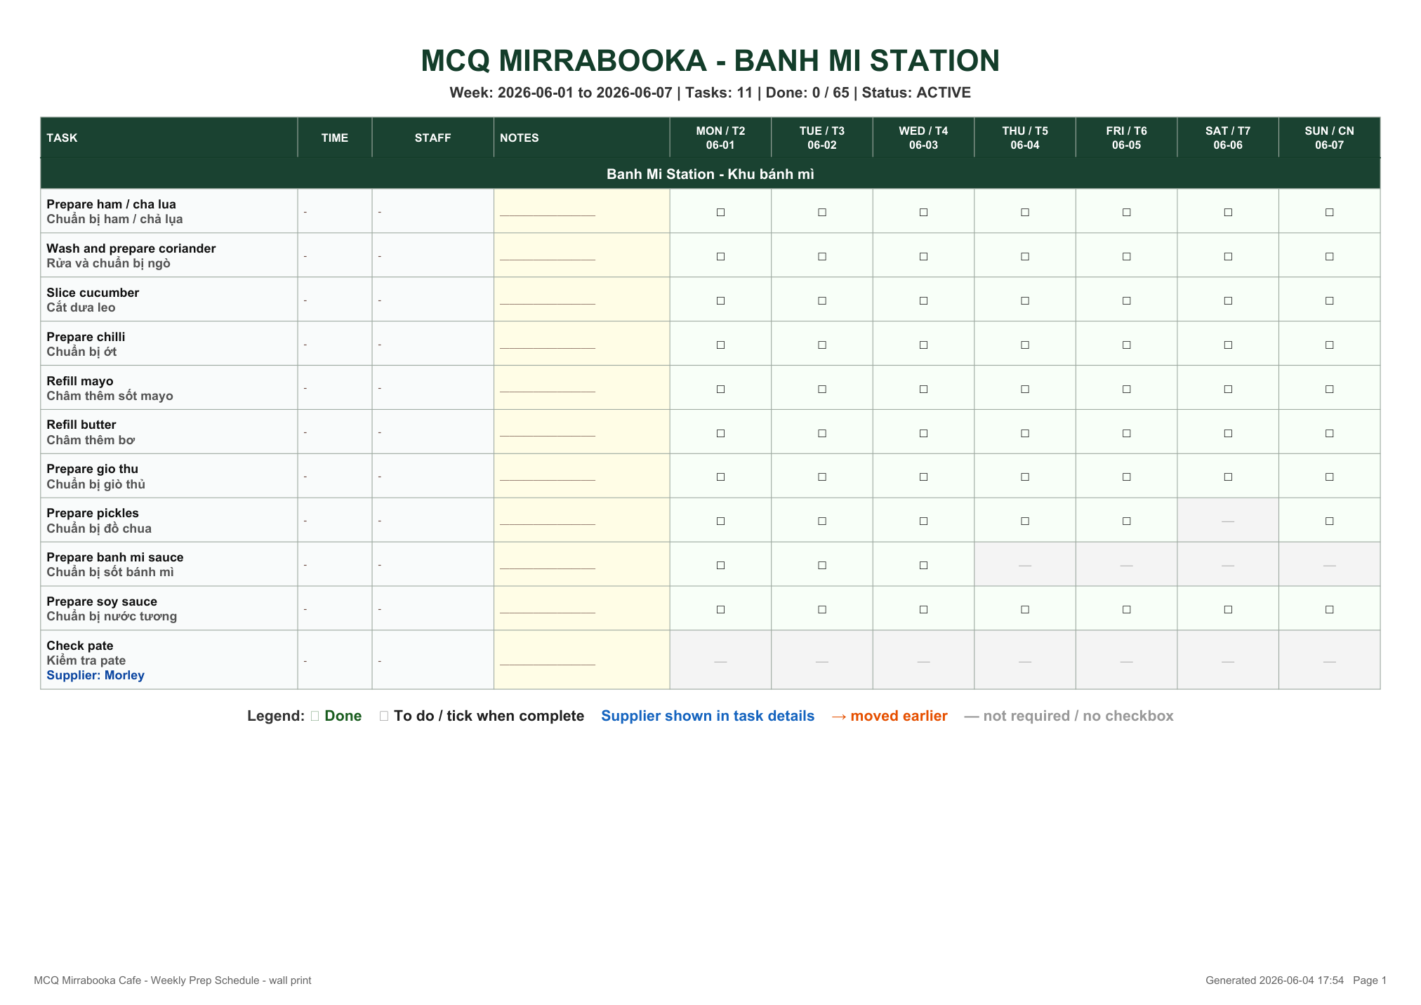

Prep Timetable - Pho / Kitchen Station
Source PDF: docs/prep_timetables/MCQ_Prep_Timetable_Pho_Kitchen_Station_2026-06-01.pdf
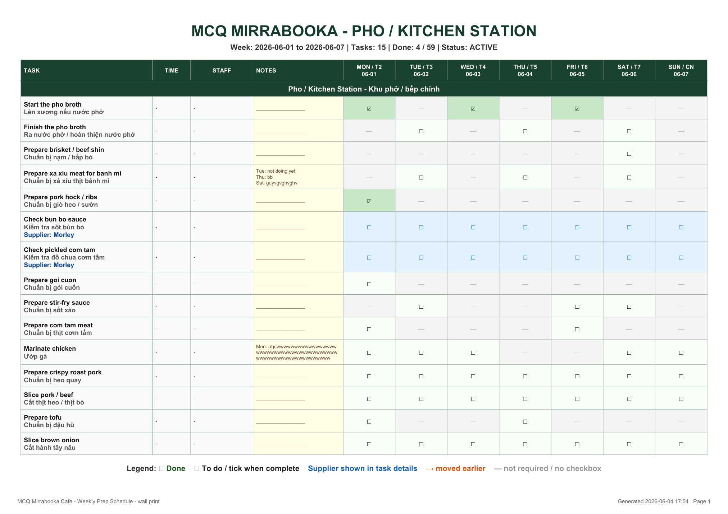

Prep Timetable - Drink Station
Source PDF: docs/prep_timetables/MCQ_Prep_Timetable_Drink_Station_2026-06-01.pdf
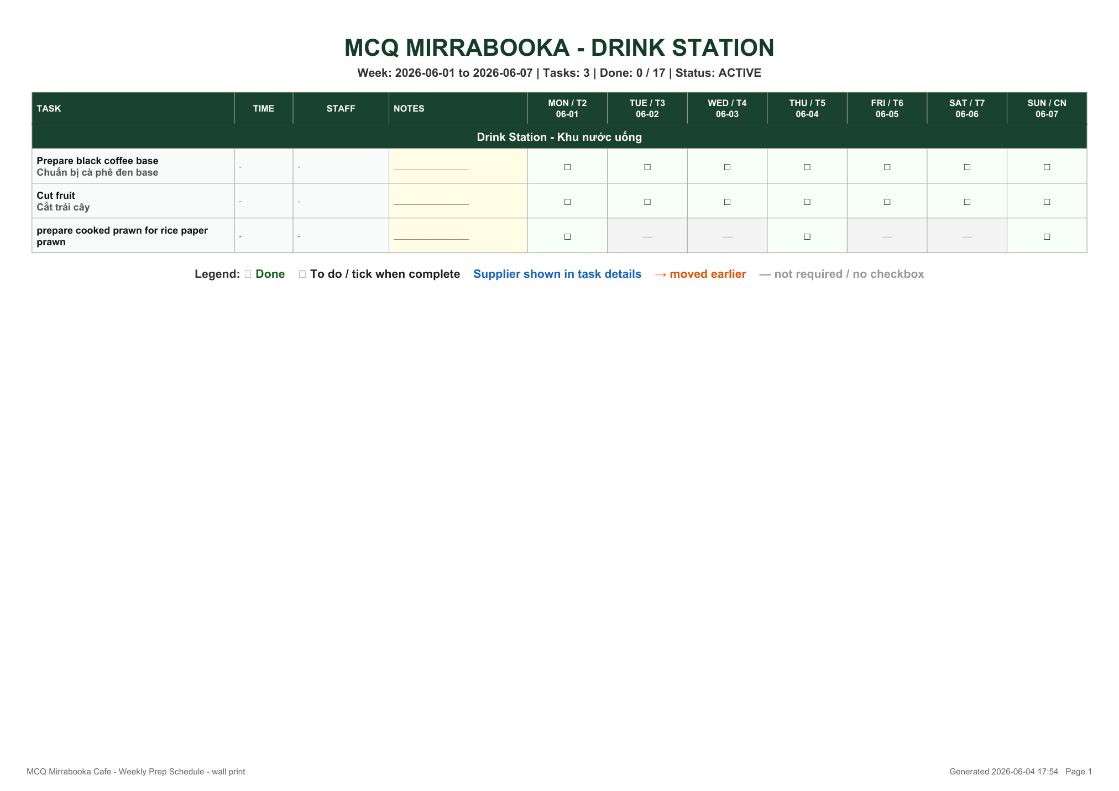

Prep Timetable - Chef / General Prep
Source PDF: docs/prep_timetables/MCQ_Prep_Timetable_Chef_General_Prep_2026-06-01.pdf
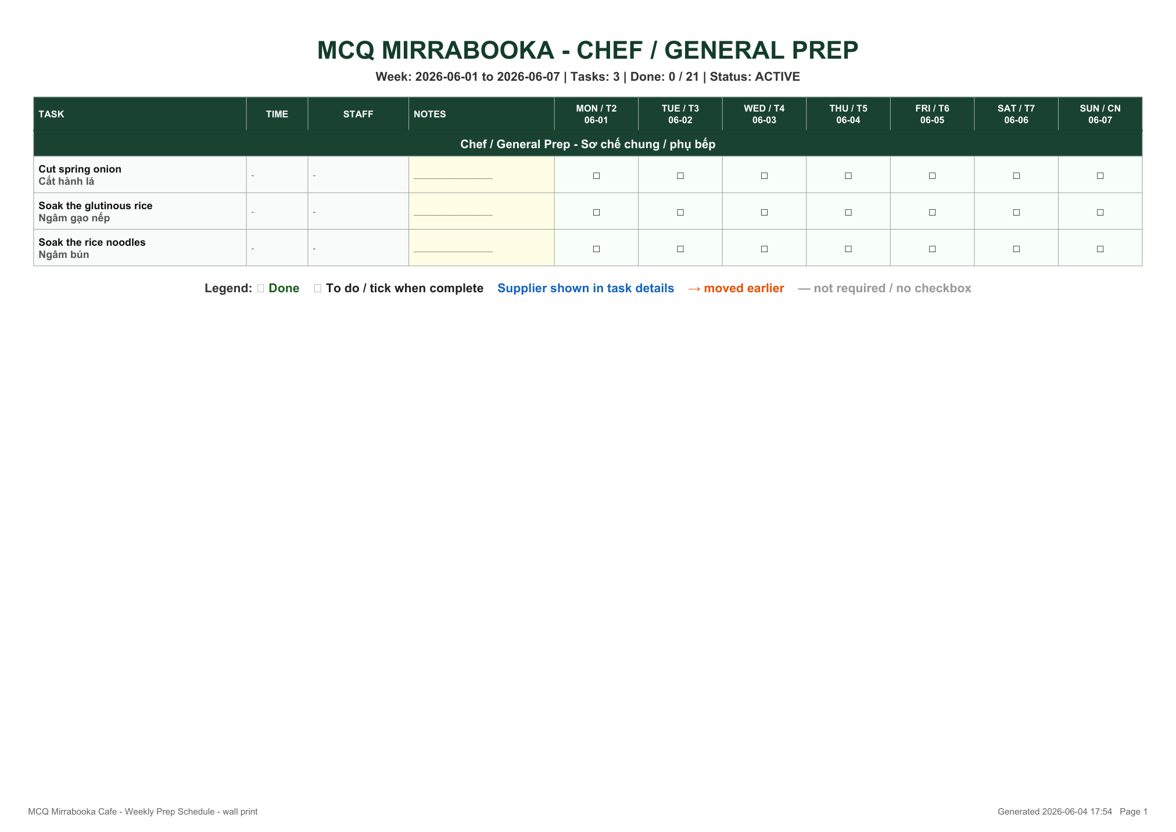

4. Temperature Record Rules
- Chef and Banh Mi staff must record food temperatures on the printed temperature record sheet every day where required.
- Banh Mi temperature records include hot foods and cold foods. Hot foods must be held at 60°C or above. Cold foods must be held at 5°C or below.
- Chef temperature records are cold storage records. Cold items must be held at 5°C or below.
- If a temperature is outside the safe limit, staff must notify the manager immediately, record the corrective action, and must not sell unsafe food.
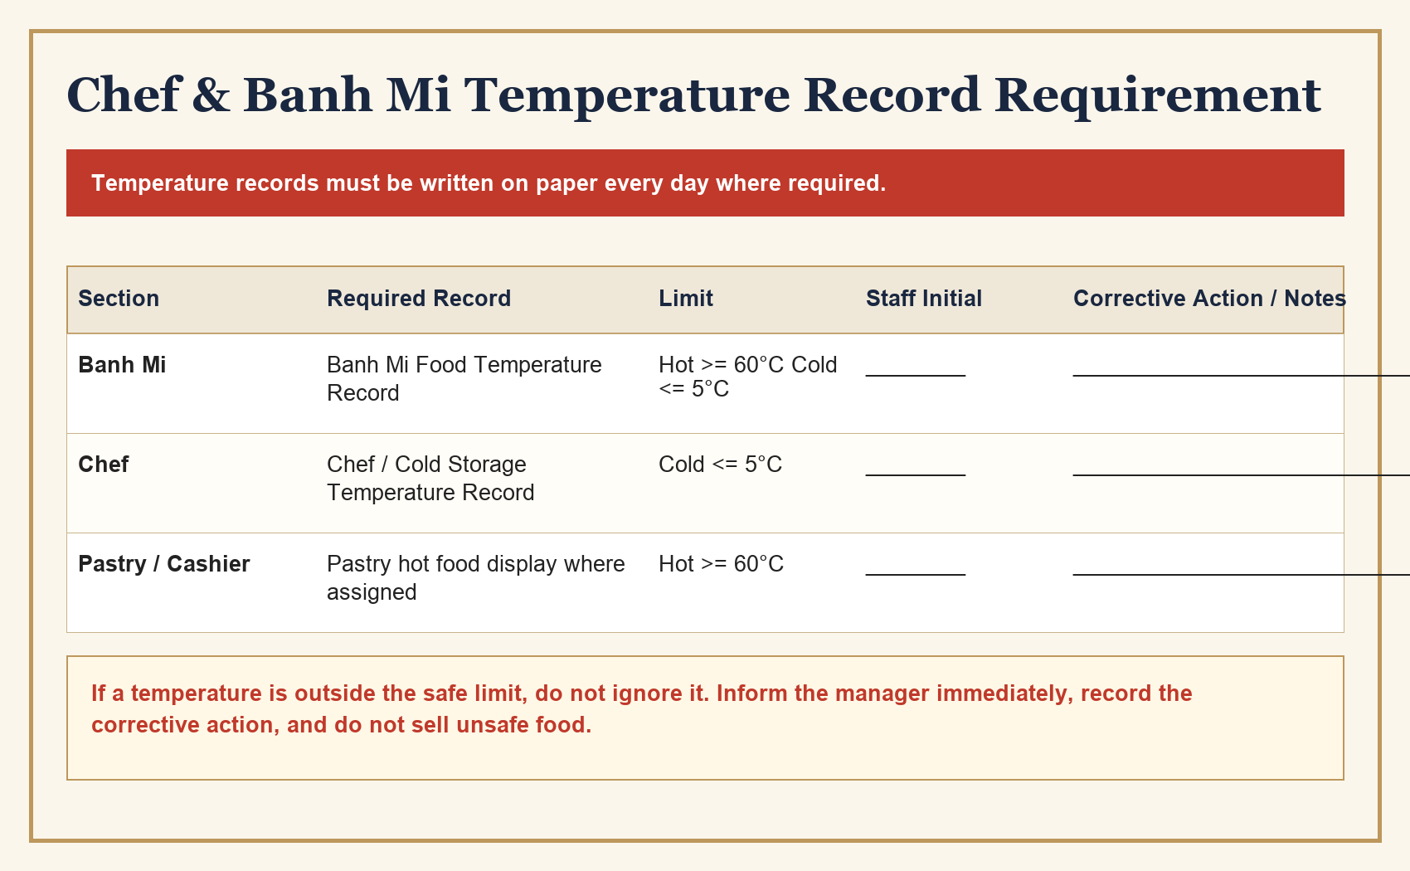

5. Performance, Wage Review and Discipline
- Checklist completion, prep timetable completion, temperature record accuracy, notes and manager verification are used as part of staff performance review and wage increase review.
- Late, incomplete, false or careless checklist records may affect wage increase approval during each wage review period.
- If a checklist or prep timetable is missed, completed incorrectly, or not completed on time, the staff member may receive a reminder or warning from management.
- If a staff member receives more than three reminders/warnings for the same or similar checklist/prep/temperature issue, management may review their employment. This review may result in further discipline, reduced shifts, or termination depending on the seriousness and history of the issue.
- Managers may check the printed papers, app records, camera/photo evidence and station condition to verify completion.

6. Staff Structure and Reporting Line
Staff must follow the reporting line shown below. Department leads are responsible for checking that their station checklist, prep timetable and temperature records are completed correctly.
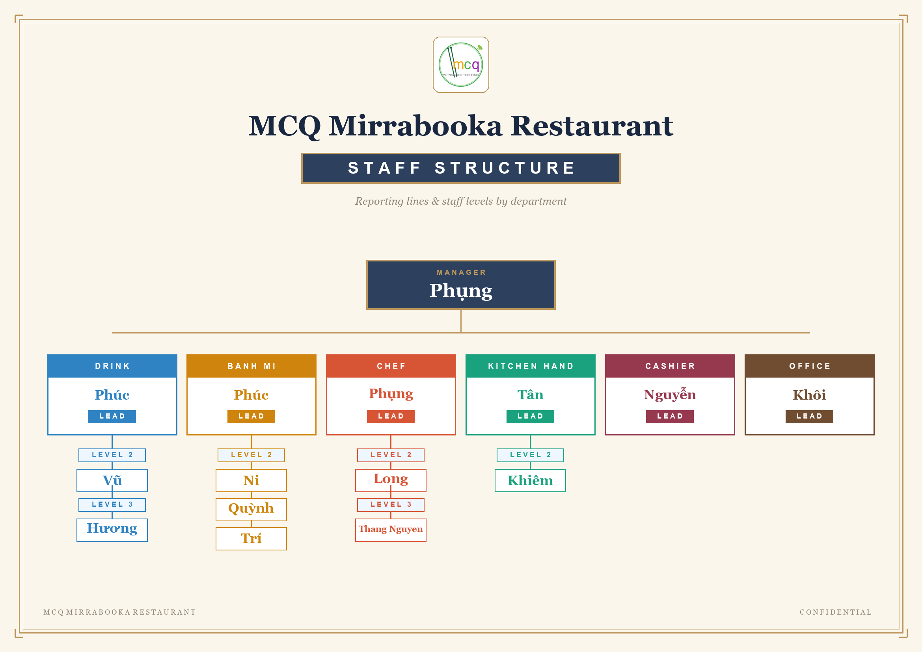

Staff Acknowledgement
I confirm that I have read and understood this Daily Checklist & Prep Timetable Compliance Policy. I understand that checklist completion, prep timetable completion and temperature records are mandatory and may be used for wage review and employment review decisions.
Staff Name | ____________________________________________
Signature | ____________________________________________
Date | ____________________________________________
Manager / Witness | ____________________________________________

