Case Study for Migration from On-premise to Amazon Web Services (AWS)

Khairi bin Md.Juri
School of Computing Faculty of Engineering
University Technology Malaysia
Johor Bahru, Malaysia
khairij@gmail.com
Muhammad Nabil Bin Noh
School of Computing Faculty of Engineering
University Technology Malaysia
Johor Bahru, Malaysia
mrnabilnoh@gmail.com
Muhamad Aiman Aliff Bin Adzmi School of Computing Faculty of Engineering
University Technology Malaysia
Johor Bahru, Malaysia
aliffaiman984@gmail.com

Abstract—Cloud computing is influencing all facets of the IT world. It has become quite easy to deploy applications on the cloud. Storage is available based on the user's needs and can be scaled up or down as required by the user. Computing resources are available on virtual machines. Furthermore, applications are available to users supplied by cloud providers. All these have made migration to the cloud desirable to most organizations. Adopting the cloud is expected to reduce cost and the need for investment in IT infrastructure. However, most organizations are still concerned about migrating to the cloud. The goal of this paper is to provide an insight into migrating to Amazon Web Services (AWS). The paper discusses cloud computing and the benefits of migrating to AWS. It also examines the challenges of migration to AWS.
Keywords—Cloud Migration, Cloud Computing, Software Migration, Amazon Web Services, AWS, Web Service, On-Premises to Cloud, Cloud Architecture

Introduction
Cloud computing is the on-demand delivery of computing power, storage, applications, and different IT services which can be made available through a cloud services platform via the internet with pay-as-you-go model.
“Cloud computing is a model for enabling convenient, on-demand network access to a shared pool of configurable computing resources (e.g., networks, servers, storage, applications, and services) that can be rapidly provisioned and released with minimal management effort or service provider interaction.” [1].
Despite the description by analogy, it is difficult to give a unique and precise definition. One of the main ambiguities to define cloud computing is the fact that it is still evolving and taking its shape. The definitions proposed in the cloud computing community are often focused on different perspectives and do not have common baselines. Analyzing existing sources in order to identify common characteristics.
On-premises data centers are managed by the customer themselves. They are responsible for the development, deployment, stacking and a whole lot of the activities required to maintain the infrastructure. On premise are primarily used to run private clouds, in which the resources are same as that of a public cloud but are kept out of reach for public access. On premise are mostly used by government agencies and large enterprises who want to keep their critical data private. This data can include biometrics scans, salary statements of the employee, or an organization business models and other critical data.
Drawbacks of on-premise networks include large capital expenditures; customers have to provide huge upfront capital expenditures in order to purchase, support, upgrade and maintain network infrastructure. Maintenance responsibility, customers have to take full responsibility for the management of networks. For small size businesses and start-ups this can be an issue as they have limited budgets. Less services, on premise won’t run as efficiently as AWS because the latter has more services to make the process more efficient.

Related works

A typical physical host in a cloud data center has a hypervisor that enables diverse Virtual Machines to run over the same host hardware. In order to offer a stronger interworking and interoperability between system and network elements, the virtualization of networking resources within a cloud infrastructure is becoming a very important requirement. In this way, the hypervisor is also associated with a virtual switch. This device switches layers of traffic among the VMs running in the same physical server.

Amazon Web Service is a comprehensive and evolving cloud computing platform that separates into different services; each can be configured in different ways based on user needs. It offers many different tools and solutions for enterprises and software developers that can be used in data centers in up to 190 countries. Groups such as government agencies, education institutions, nonprofits and private organizations can use Amazon Web Services services. Users should be able to see configuration options and individual server maps for Amazon Web Service.

Amazon Web Services provides services from multiple data centers spread across availability zones (AZs) in regions across the world. An AZ is a location that contains multiple physical data centers. A region is a collection of AZs in geographic proximity connected by low-latency network links.

A business will choose one or multiple availability zones for a variety of reasons, such as compliance and proximity to end customers. For example, an Amazon Web Services customer can spin up virtual machines (VMs) and replicate data in different AZs to achieve a highly reliable infrastructure that is resistant to failures of individual servers or an entire data center.

Amazon Elastic Compute Cloud (EC2) is a service that provides virtual servers called EC2 instances -- for compute capacity. The EC2 service offers dozens of instance types with varying types and sizes, suitable to specific workload types and applications, such as memory-intensive and accelerated-computing jobs. Amazon Web Services also provides an Auto Scaling tool to dynamically scale capacity to maintain instance health and performance.

Amazon Simple Storage Service (S3) provides scalable object storage for data backup, collection and analytics. An IT professional stores data and files as S3 objects, which can range up to 5 gigabytes (GB) inside S3 buckets to keep them organized. A business can save money with S3 through its Infrequent Access storage tier or by using Amazon Glacier for long-term cold storage.

Amazon Elastic Block Store provides block-level storage volumes for persistent data storage when using Amazon EC2 instances. Amazon Elastic File System offers managed cloud-based file storage.

A business can also migrate data to the cloud using storage transport devices, such as Amazon Web Services Snowball and Snowmobile, or use Amazon Web Services Storage Gateway to enable on-premises apps to access cloud data.

The Amazon Relational Database Service which includes options for Oracle, SQL Server, PostgreSQL, MySQL, MariaDB and a proprietary high-performance database called Amazon Aurora provides a relational database management system for Amazon Web Services users. Amazon Web Services also offers managed NoSQL databases through Amazon DynamoDB.

An Amazon Web Services customer can use Amazon ElastiCache and DynamoDB Accelerator as in-memory and real-time data caches for applications. Amazon Redshift offers a data warehouse, which makes it easier for data analysts to perform business intelligence (BI) tasks.

Amazon Web Services includes multiple tools and services designed to help users migrate applications, databases, servers and data onto its public cloud. The Amazon Web Services Migration Hub provides a place to monitor and manage migrations from on premises to the cloud. Once in the cloud, Amazon EC2 Systems Manager helps an IT team configure on-premises servers and Amazon Web Services instances.

Amazon Web Service also has partnerships with several technology vendors that ease hybrid cloud deployments. VMware Cloud on Amazon Web Services brings software-defined data center technology from VMware to the Amazon Web Services cloud. Red Hat Enterprise Linux for Amazon EC2 is the product of another partnership, extending Red Hat's operating system to the Amazon Web Services cloud.

An Amazon Virtual Private Cloud (Amazon VPC) gives an administrator control over a virtual network to use an isolated section of the Amazon Web Services cloud. Amazon Web Services automatically provisions new resources within a VPC for extra protection.
Admins can balance network traffic with the Elastic Load Balancing (ELB) service, which includes the Application Load Balancer and Network Load Balancer. Amazon Web Services also provides a domain name system called Amazon Route 53 that routes end users to applications.

An IT professional can establish a dedicated connection from an on-premises data center to the Amazon Web Services cloud via Amazon Web Services Direct Connect.

Backgrounds
MediHealth Sdn Bhd. is one of Malaysia's largest suppliers of medical supplies. To handle the largest order of medical devices and medicine, they have their own on-premises big network to handle all the requests. This causes an issue because of on-premises hardware need for yearly expansion and underutilization of hardware capabilities that affect company ROI. To solve this issue, MediHealth Sdn Bhd. plan for migrating on-premises to cloud computing providers such as Amazon Web Services (AWS).

Reason for migrating to Amazon Web Services is also based on successful stories from other companies such as Netflix, Chainstack and Nissan.

Netflix uses Amazon Web Services because it helps them to quickly deploy thousands of servers and terabytes of storage within minutes. Users can stream Netflix shows and movies from anywhere in the world, including on the web, on tablets, or on mobile devices such as iPhones.[2]

Netflix is the world’s leading internet television network, with more than 200 million members in more than 190 countries enjoying 125 million hours of TV shows and movies each day. Netflix uses Amazon Web Services for nearly all its computing and storage needs, including databases, analytics, recommendation engines, video transcoding, and more hundreds of functions that in total use more than 100,000 server instances on Amazon Web Services.

Netflix entertains the world, providing a wide variety of TV shows, movies, and documentaries to hundreds of millions of members across the globe in over 30 languages. Netflix builds diversity, inclusion, equity, and a global outlook into everything it does, and by fostering a culture of courage, empathy, and curiosity, Netflix can move faster to develop new stories and better ways of sharing them with its members around the world.

Netflix relies on Amazon Web Services to help it innovate with speed and consistently deliver best-in-class entertainment. Amazon Web Services provides Netflix with compute, storage, and infrastructure that allow the company to scale quickly, operate securely, and meet capacity needs anywhere in the world. Moreover, Netflix, a leading content producer, has used Amazon Web Services to build a studio in the cloud. This virtual studio enables Netflix to engage top artistic talent, no matter the location, and Netflix artists and partners have the freedom to collaborate without technological or geographical barriers.

Chainstack use Amazon Web Services to Help Thousands of Web3 Developers Reliably Scale Blockchain Applications.[3]

On Amazon Web Services, Chainstack can quickly scale its application environment, which has helped the company accelerate business growth. “I can get a virtual machine up and running in 5 minutes to test something new on Amazon Web Services. We have the elasticity to scale up as required, when required,” says Aseev. With these capabilities, Chainstack has grown its revenue by 50 times over the past year and increased its workforce from 15 employees to 50 in the same period. “Our team is still relatively small, and a service like Amazon EKS helps us maintain our Kubernetes environment without worrying about managing underlying technology.”[3]

Chainstack organization can also support any blockchain protocol with a variety of Amazon EC2 instance types. “If we need to support a protocol with unique requirements, we can quickly and easily find something to suit that use case because there are so many ways to run Amazon EC2,” explains Aseev. “We don't need to reinvent the wheel or invest significant time and money into building and configuring a custom solution.”[3]

Nissan in Europe Achieves Faster Processing, Lowers Recovery Time for SAP System Using Amazon Web Services EC2.[4]

Nissan in Europe built its solution on Amazon EC2 so that it would have the necessary flexibility and scalability to meet business requirements. In addition to Amazon EC2, Nissan in Europe uses Amazon Simple Storage Service (Amazon S3), an object storage service offering industry-leading scalability, data availability, security, and performance. Nissan in Europe can also give employees simple access to files on their laptops and PCs because Amazon S3 is compatible with Amazon Web Services Storage Gateway, a set of hybrid cloud services that gives on-premises access to virtually unlimited cloud storage.[4]

After migrating the SAP solution from the company’s on-premises data center to Amazon Web Services, Nissan in Europe significantly reduced its database recovery time to 2 hours, aligning with the requirements of the business. To reduce the recovery time, Nissan in Europe implemented a highly available architecture that replicated data to other active databases, reducing the need to rely on backups in case of system failure. The company also improved the performance of its SAP business process as a result of the migration. “On Amazon Web Services, we have noticed a significant performance improvement of about 63 percent for the duration of overall processes,” says Richard van der Meer, Nissan AMIEO vice president and chief information officer. “That means employees can perform their jobs faster and focus more on added business value.”[4]

Cloud computing is commonly classified into two categories; based on the location of the cloud and based upon the services provided. Location of the cloud can be private, public and hybrid cloud models. Based upon the services offered, clouds are typically classified into three models:

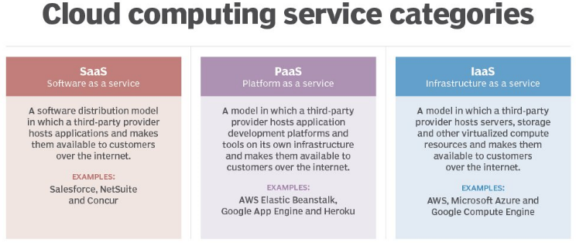

IaaS. In an IaaS service model, a cloud provider hosts the infrastructure components that are traditionally present in an on-premises data center. This includes servers, storage and networking hardware, as well as the virtualization or hypervisor layer.Amazon Web Services (AWS) Iaas model, supplies a virtual server instance and storage, as well as application programming interfaces (APIs) that let users migrate workloads to a virtual machine (VM). Users have an allocated storage capacity and can start, stop, access and configure the VM and storage as desired. IaaS providers offer small, medium, large, extra-large, and memory- or compute-optimized instances, in addition to enabling customization of instances, for various workload needs. The IaaS cloud model is closest to a remote data center for business users. Not only that, These services are increasingly policy-driven, enabling IaaS users to implement greater levels of automation and orchestration for important infrastructure tasks. For example, a user can implement policies to drive load balancing to maintain application availability and performance.

PaaS. Platform as a service (PaaS) is a cloud computing model where a third-party provider delivers hardware and software tools to users over the internet. Usually, these tools are needed for application development. A PaaS provider hosts the hardware and software on its own infrastructure. As a result, PaaS frees developers from having to install in-house hardware and software to develop or run a new application.

Amazon Web Services (AWS) PaaS model, Amazon Web Services (AWS) cloud providers host development tools on their infrastructures. Users access these tools over the internet using APIs, web portals or gateway software. PaaS is used for general software development, and many PaaS providers host the software after it's developed. Common PaaS products include Salesforce's Lightning Platform, AWS Elastic Beanstalk and Google App Engine. It offers compute and storage infrastructures, as well as text editing, version management, compiling and testing services that help developers create new software quickly and efficiently. A PaaS product can also enable development teams to collaborate and work together, regardless of their physical location.

SaaS. Amazon Web Services (AWS) SaaS model is a distribution model that delivers software applications over the internet; these applications are often called web services. Users can access SaaS applications and services from any location using a computer or mobile device that has internet access. In the SaaS model, users gain access to application software and databases. One common example of a SaaS application is Microsoft 365 for productivity and email services.

Subsystems
MediHealth Sdn Bhd. have big network consists of 3 major subsystems:
MediHealth Ordering System (MOS), responsible for handling massive order of medical devices and medicine

MediHealth Delivery System (MDS), responsible for handling massive delivery order of medical devices and medicine

Information for Pharmaceutical System (IPS), responsible for handling massive information related to medical devices, medicine and customers.

Costings
We see compelling reasons that favor utility computing over traditional on-premises hosting. An opening case is when demand for services varies over time. For example, provisioning a data center for the peak load it must sustain a few days per month leads to underutilization at other times.
Moving to the cloud gives you greater control, including greater cost control. Because you’re moving from capital expenditure to operational expense, you can adjust based on business demand and cost management initiatives. Although paying for what you use is a powerful value proposition, AWS helps you take this one step further by integrating cloud cost optimization as a pillar in its well architected framework. With the help of AWS tools like the free AWS cost explorer, you can quickly get an understanding of your cloud spend and how to optimize it.

Pay-Per-Use Model
Public cloud environment is maintained by an outsourced AWS cloud provider and is reachable to many businesses through the internet on a Pay-Per-Use model.

Pay only for the services used, and no more. Rather than paying a 100 percent for infrastructure that are only used 20 percent of the time, one only pays for the exact number of resources used. The ideal cloud providers charge usage in terms that everyday people, not just IT architect understand. A pay-per-use model involves different payment mechanisms, such as subscription-based payment, reservation-based payment, consumption based and so on. In subscription-based payment, user has monthly or yearly fees to access the service.

A pay-per-reservation method is when the user pays for the duration of the service. How much of the infrastructure used from the moment the service started is not necessary, the user will be charged according to the time. In consumption based, the user’s consumption is measured and charged according to the amount of memory, CPU cycles, disk space, and network traffic. These examples show that there are different approaches to the pay-per-use model, but they are all based on the number of resources used or the period the service was available.

Advantages of AWS
There are several benefits with Amazon Web Services that companies can use to reduce costs while providing a high level of service to customers. This section will show how AWS can benefit MediHealth Sdn Bhd.

Reduced Costs
With the introduction of AWS, companies can test a new application or develop a new application without first investing in software, hardware, and networking, and if they like it, they will go ahead and purchase it. A need might arise to increase storage or buy new software for various departments, but there is not enough money to buy all those services at once. AWS service vendors might rent storage on a per-gigabyte basis.
Companies are often confronted with the need to improve the infrastructure of IT while reducing costs. By adopting AWS pay-as-you-go model, where one only pays for the amount of resources they use or respectively for the time service is accessible, companies are able to avoid a large initial investment and instead pay the functionality as an operating cost.

Elasticity and Scalability
Computing resources are dynamically assigned, released, and reassigned according to consumer demand. Elasticity means that the platform can handle sudden, unexpected, and large loads. This could be due to an event happening those results in a vast but short influx of users on the system. Scalability is a planned level of capacity that is able to scale up or down in a quick and easy manner when more or less resources are needed. In cloud computing resources allocation can get bigger or smaller depending on demand.

Caching
Caching is a technique you can use to achieve a scalable strategy. It takes advantage of a content delivery network (CDN) like Amazon CloudFront, which caches requests, so when a similar request comes in, it can be resolved without touching a server. This makes caching very efficient and highly scalable, improving the customer experience. In addition, caching can be used between an application and a database, decreasing the number of requests to the database, making for a much more efficient, scalable solution because you can serve more users from any database size.

Highly availability
AWS services are built with fault tolerance in mind to ensure the ongoing availability of critical services. Amazon Simple Storage Service (S3) and Elastic Load Balancing that help distribute application traffic, routing users to healthy instances to ensure availability.

Agility and flexibility
By shifting to AWS, organizations can provision new servers in minutes, which means greater agility and flexibility. When coupled with AWS Serverless Application Model, it becomes even easier to deploy infrastructure and applications in AWS. This allows you to treat servers as replaceable components that create space for rapid experimentation and greater innovation.

Security
To help you avoid missteps that can lead to security risk, unscalable systems and inefficiencies that slow cloud migration, AWS landing zones help you achieve automation that reduce human errors and ensure consistent, secure account creation and operation while providing security best practices built into a foundational architecture that speeds the deployment of high value applications.

The proposed solution
The use case, MediHealth Sdn Bhd. comprises of around 400 employees in major office and three branches contain each of those around 100 employees. The use case of the migration is comprised of the migration of on-premise system in organization to cloud computing. Below is an anonymized case description. Organization built its entire infrastructure on premises and installed internal Enterprise Management System (EMS). Branches assets are dependent upon major company’s production facilities, which is why, the server and database located on major company and all branches access the application EMS using remote desktop client over the internet. The major office support department has been responsible for the maintenance of the system and solving any problem which has emerged.
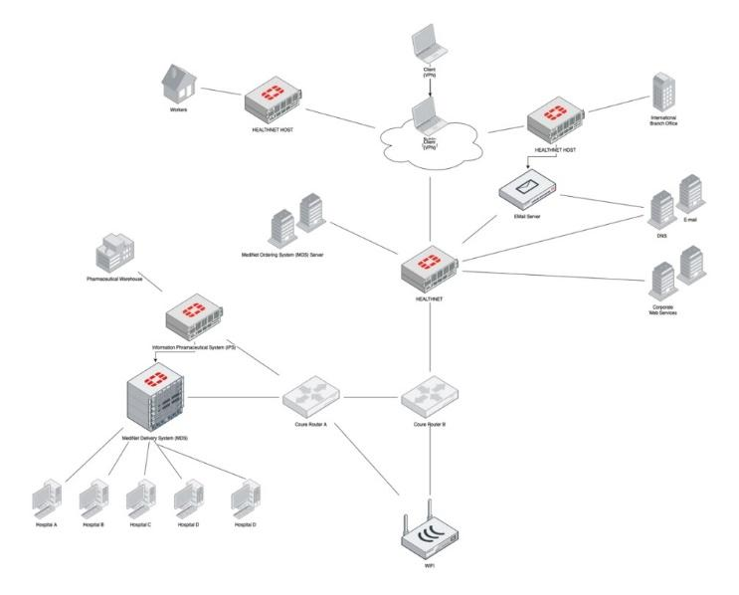
Figure 1. MediHealth Sdn Bhd on premise network
Organization management hypothesizes that movement to cloud and gives the company a competitive advantage as well as reduces expenses for managing and maintaining the system and updates features EMS tools have today. This use case study investigated the possibility of the same system that could be deployed into cloud. In the case of the proper leveraging, the cloud computing is capable of bringing exceptional agility and considerably reducing the expenses while connecting its organization to the global collections of services, therefore you must fully understand the pros and cons of AWS.
Cloud migration should be a gradual process, Henceforth, the basis applications should be migrated first these will facilitate good testing, comfort level and even training for the more difficult applications to upcoming to migrate in future.
If aim is replacing an existing system, for the old application altogether may eliminate most task. If we are upgrading existing applications, the upgrade process can be taken ahead. All together concentrating on following factor may be more helpful.
- Software licensing is a critical issue when it comes to cloud migration. To avoid big surprises when application goes live, thorough review of each software license for the better cost implications is essential.
- The architecture of some applications is simply not conducive to a cloud environment, particularly when it comes to performance. Review this issue for every application planned to migrate.
- A stand alone application that wont have many interfaces to other programs generally gets proved better for migration.
- If we have already virtualized an application on a local server, it will be much easier to migrate to a cloud based server. Some service providers have tools specifically developed to facilitate this.
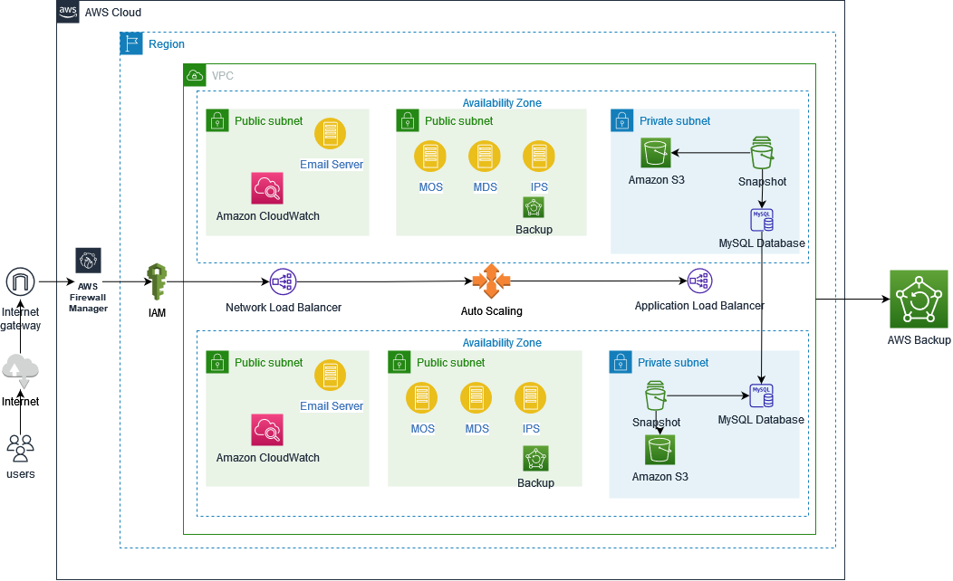
Figure 2. Proposed AWS network diagram

Result and Discussion
MediHealth Sdn Bhd new cloud based HEALTHNET, is a customer facing web application that serves as a medical devices and medicine management system. Consumers, partners and employees use the web application to work together with each other using rich web interface that can be viewed in any standard internet browser. The new cloud based HealthNet is online it can happen that the traffic can increase, resulting in periodic spikes. When the traffic is normal HealthNet will experiences a fairly steady and practicable traffic load.
It is important to understand how different they operate. Consider these key comparisons:
- Deployment: With configuration and foresight, deploying software into AWS or on premises is relatively the same, but it’s drastically different for hardware based resources. When IT teams need an additional server in their data center, they order, rack, network and provision it. To spin up a server in AWS, they simply press a button or run a few commands.
- Management: AWS handle so many of the management tasks that help users not do much more than monitor and make adjustments through a management dashboard or software tools. An on premises environment requires hands on hardware maintenance, eg. replacing drives, managing configurations, maintaining the network, handling power and even upkeep of the building that house it all.
- Security: AWS take on most security requirements at the infrastructure level in a shared responsibility model, but it’s up to users to properly configure and secure apps and data. With an on premises environment, IT teams are solely responsible for software patches, OS upgrades and security configurations for applications and networks.
- Infrastructure: AWS invest massive sums for infrastructure to support higher uptimes, faster responses times and what feels like infinite resources. In an on premises environment, IT teams are limited to the infrastructure in place and what they can acquire. They own and control that infrastructure outright, in contrast to AWS, which controls user access to thei infrastructure.
- Budgeting: AWS instances are generally cheaper because users can pay for a fraction of a server and the shut it down when they are done. However, companies must carefully configure and monitor their cloud usage to avoid consuming more services than tehy planned and a shocking monthly bill. On premises pricing is fixed, but underutilized resources are financially wasteful, and investment in additional hardware to scale up capacity may take years to become cost effective.

Conclusion
Cloud computing is an emerging technology, migrating is very important and essential concept of this trend and technology behind it is maturing. This case study gives the intrinsic knowledge about the basic of migration concept, focusing upon the initial needed factors to migrate which include type of cloud and application migration paradigms helping beginners to try and figure what are the essential steps and factors for migration to cloud.
This case study has proposed the on premise migration to AWS cloud. large enterprises are often in mature levels when it comes to the discussion and implementations of cloud computing to migrate their data into the cloud. This case study addressed the key opportunities and challenges involved in the process of building trust in AWS for moving on premise data to the cloud. Every cloud provider uses different approaches and strategies to gain the confidence of customers that are based on the on premises computing environment of client. The AWS specific tactics highlighted in the case study will help design cloud applications using these services.

References
[1]. The sentence punctuation follows the bracket [2]. Refer simply to the reference number, as in [3]—do not use “Ref. [3]” or “reference [3]” except at the beginning of a sentence: “Reference [3] was the first ...”
- Mell, P. and Grance, T., The NIST Definition of Cloud Computing, Tech Report National Institute of Standards and Technology, USA, 2009.
- Netflix Case Study By Amazon Web Service. https://aws.amazon.com/solutions/case-studies/netflix-case-study/ (2016)
- Chainstack Case Study By Amazon Web Services. https://aws.amazon.com/solutions/case-studies/chainstack-case-study/?did=cr_card&trk=cr_card (2022)
- Nissan Case Study By Amazon Web Services https://aws.amazon.com/solutions/case-studies/nissan-europe-case-study/?did=cr_card&trk=cr_card (2022)
- Amazon Case Study. https://aws.amazon.com/solutions/case-studies/amazon/(2014)
- Server and Cloud Platform,http://www.microsoft.com/en-us/server-cloud/default.aspx (2013)
- Skilton, M., Gordon, P.: Cloud Buyers’ Decision Tree. The Open Group (2010)
- RightScale: PlanForCloud. http://www.planforcloud.com/ (2012)
- Halvey, J.K., Melby, B.M.: Business Process Outsourcing: Processes, Strategies, and Contracts. John Wiley & Sons, Inc., Hoboken, New Jersey (2007)

