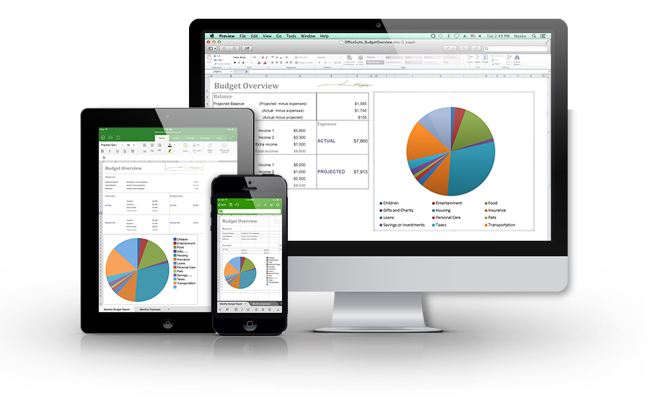

## The leading productivity app is now available for Apple iPhone and iPad!

The latest version of OfficeSuite brings the power and capability of a desktop app to the iPhone and iPad like never before! This is the perfect tool for effortlessly viewing, editing, creating and sharing Documents, Spreadsheets and Presentations and converting them to/from PDFs.

## What our users say about OfficeSuite:

*“I’ve tried perhaps 15 different word processing apps and this is by far the best…”*

*“…So now it’s really easy to create Word-like docs, easy to name them and even email them (keeping the formatting – YAY)!...”*

Create, view and edit Documents, Spreadsheets and Presentations files and attachments and view PDF files on your iPhone and iPad with a single complete feature-rich mobile office solution. The software accesses the most commonly used desktop document formats and also includes a File Browser and integration with iCloud, Google Drive, Dropbox, Box, OneDrive, and WebDAV to help you manage your local and remote files. OfficeSuite is essential productivity application offering greater office efficiency anywhere, anytime.

# What makes OfficeSuite better?

* Extremely fast and easy to use
* Familiar desktop-inspired user interface
* Track Changes with multiple author support
* Full editor for Documents, Spreadsheets and Presentations
* Edit, annotate and save PDF documents
* View and edit RTF and CSV file formats
* Supports all Microsoft Office file formats
* Printing support
* Auto-correct while you type

# Feature-rich support for all file formats

* Documents– Microsoft Office 97 to 2010 text documents –  
  **DOC, DOCX, DOCM, RTF, TXT, LOG, and ODT**
* Spreadsheets – Microsoft Office 97 to 2010 spreadsheets –  
  **XLS, XLSX, XLSM, CSV, and ODS**
* Presentations– Microsoft Office 97 to 2010 presentations –  
  **PPT, PPTX, PPTM, PPS, PPSX, PPSM, and ODP**
* Other formats **– PDF, ZIP**

# OfficeSuite Pro and OfficeSuite Premium

Get even more from OfficeSuite with OfficeSuite Premium (available as an in-app purchase from OfficeSuite Free), and OfficeSuite Pro:

|  |  |  |  |
| --- | --- | --- | --- |
|  | **OfficeSuite Free** | **OfficeSuite Pro** | **OfficeSuite Premium** |
| **Documents editing and creation** |  | C:\Documents and Settings\az\Desktop\blue-check-mark-png-small.png | C:\Documents and Settings\az\Desktop\blue-check-mark-png-small.png |
| **Spreadsheets editing and creation** | C:\Documents and Settings\az\Desktop\blue-check-mark-png-small.png | C:\Documents and Settings\az\Desktop\blue-check-mark-png-small.png | C:\Documents and Settings\az\Desktop\blue-check-mark-png-small.png |
| **Presentations editing and creation** | C:\Documents and Settings\az\Desktop\blue-check-mark-png-small.png | C:\Documents and Settings\az\Desktop\blue-check-mark-png-small.png | C:\Documents and Settings\az\Desktop\blue-check-mark-png-small.png |
| **View PDF Files** | C:\Documents and Settings\az\Desktop\blue-check-mark-png-small.png | C:\Documents and Settings\az\Desktop\blue-check-mark-png-small.png | C:\Documents and Settings\az\Desktop\blue-check-mark-png-small.png |
| **Complete cloud support – iCloud, Dropbox, OneDrive, Google Drive, Box, or WebDAV** | C:\Documents and Settings\az\Desktop\blue-check-mark-png-small.png | C:\Documents and Settings\az\Desktop\blue-check-mark-png-small.png | C:\Documents and Settings\az\Desktop\blue-check-mark-png-small.png |
| **Support for password protected files** | C:\Documents and Settings\az\Desktop\blue-check-mark-png-small.png | C:\Documents and Settings\az\Desktop\blue-check-mark-png-small.png | C:\Documents and Settings\az\Desktop\blue-check-mark-png-small.png |
| **Print** | C:\Documents and Settings\az\Desktop\blue-check-mark-png-small.png | C:\Documents and Settings\az\Desktop\blue-check-mark-png-small.png | C:\Documents and Settings\az\Desktop\blue-check-mark-png-small.png |
| **Spell check** | C:\Documents and Settings\az\Desktop\blue-check-mark-png-small.png | C:\Documents and Settings\az\Desktop\blue-check-mark-png-small.png | C:\Documents and Settings\az\Desktop\blue-check-mark-png-small.png |
| **Documents, Spreadsheets and Presentations file templates** | C:\Documents and Settings\az\Desktop\blue-check-mark-png-small.png | C:\Documents and Settings\az\Desktop\blue-check-mark-png-small.png | C:\Documents and Settings\az\Desktop\blue-check-mark-png-small.png |
| **Track Changes with multiple author support** |  |  |  |
| **OpenDocument Format support: .ODS, .ODT, .ODP** |  | C:\Documents and Settings\az\Desktop\blue-check-mark-png-small.png | C:\Documents and Settings\az\Desktop\blue-check-mark-png-small.png |
| **Save as PDF** |  | C:\Documents and Settings\az\Desktop\blue-check-mark-png-small.png | C:\Documents and Settings\az\Desktop\blue-check-mark-png-small.png |
| **Save as legacy Microsoft formats: .DOC, .XLS, .PPT** |  | C:\Documents and Settings\az\Desktop\blue-check-mark-png-small.png | C:\Documents and Settings\az\Desktop\blue-check-mark-png-small.png |
| **Save as .CSV** |  | C:\Documents and Settings\az\Desktop\blue-check-mark-png-small.png | C:\Documents and Settings\az\Desktop\blue-check-mark-png-small.png |
| **Add camera photo** |  | C:\Documents and Settings\az\Desktop\blue-check-mark-png-small.png | C:\Documents and Settings\az\Desktop\blue-check-mark-png-small.png |
| **PDF annotations and fillable forms** |  | C:\Documents and Settings\az\Desktop\blue-check-mark-png-small.png | C:\Documents and Settings\az\Desktop\blue-check-mark-png-small.png |
| **Advanced formatting and review functions for spreadsheet editing** |  | C:\Documents and Settings\az\Desktop\blue-check-mark-png-small.png | C:\Documents and Settings\az\Desktop\blue-check-mark-png-small.png |
| **Set app passcode** |  | C:\Documents and Settings\az\Desktop\blue-check-mark-png-small.png | C:\Documents and Settings\az\Desktop\blue-check-mark-png-small.png |
| **Advanced PDF security – set user passwords** |  |  | C:\Documents and Settings\az\Desktop\blue-check-mark-png-small.png |
| **Convert PDF to Documents, Spreadsheets and** **ePub** |  |  |  |
| **Quick Sign for PDF documents** |  |  | C:\Documents and Settings\az\Desktop\blue-check-mark-png-small.png |
| **Font Pack with 70+ fonts** |  |  | C:\Documents and Settings\az\Desktop\blue-check-mark-png-small.png |