Vocabulary Before Scale: An Empirical Study of Subword Tokenization Strategies for Small-Budget Korean BERT Pretraining
Byeong-Gon Chu (추병곤)
AIFFEL Research 18th Cohort, Modulabs · Graduate School of Aesthetics, Hongik University
utopiz@naver.com · AIFFEL Main Quest 3 · July 2026

Abstract
Modern Korean pretrained language models are trained with large corpora and large compute budgets, and the design of the subword vocabulary is usually treated as a fixed preprocessing detail. In small-budget settings — a single GPU, a sub-gigabyte corpus, and a compact BERT — this detail becomes a first-order design decision. Because Korean is an agglutinative language in which particles and inflectional endings attach directly to stems, a poorly matched tokenizer fragments words into semantically weak pieces, inflates sequence length, and wastes the limited masked-language-modeling (MLM) signal available under a fixed step budget. Building on the AIFFEL GoingDeeper NLP projects — vocabulary construction, BERT pretraining from scratch, and news topic classification — we conduct a controlled study that varies only the tokenizer while holding the corpus, model architecture, and optimization budget fixed. Five tokenization conditions are compared: syllable-level, WordPiece with 8k and 32k vocabularies, SentencePiece Unigram with a 32k vocabulary, and a morpheme-aware condition that applies MeCab-ko pre-segmentation before WordPiece. Across two downstream tasks (NSMC sentiment classification and balanced news topic classification), the morpheme-aware tokenizer improves macro-F1 by +2.1 points over the strongest morpheme-agnostic baseline and by +5.2 points over syllable-level tokenization, while also shortening input sequences by 13% at an identical vocabulary size. We further show that tokenizer fertility — the mean number of subwords per word — is a strong zero-cost predictor of downstream performance in this regime (Spearman ρ = −0.98 across conditions), allowing tokenizer selection before any pretraining is run. We release the full experiment matrix, seeds, and evaluation scripts, and argue that in compute-constrained Korean NLP the vocabulary, not the parameter count, is the cheapest lever for quality.
Keywords: Korean NLP, subword tokenization, BERT pretraining, low-resource training, WordPiece, SentencePiece, morphological analysis, fertility

1. Introduction
Subword tokenization sits at the boundary between raw text and every parameter of a language model, yet it is the component least often subjected to controlled experimentation. In the dominant large-scale regime this neglect is defensible: with billions of tokens of pretraining data, a model can amortize the cost of a suboptimal segmentation. The situation faced by most practitioners in education, at regional institutions, and in domain-specific projects is different. There, pretraining means a single consumer or entry-level datacenter GPU, a corpus measured in hundreds of megabytes, and a model of ten to twenty million parameters. In this regime every masked token is a scarce learning opportunity, and the tokenizer decides how those opportunities are spent.
Korean sharpens the problem. As an agglutinative language, Korean attaches case particles (조사) and verbal endings (어미) directly to stems, so the whitespace-delimited unit (어절) is not a stable lexical unit: the same noun surfaces as 학교, 학교는, 학교에서, and 학교에서는. A frequency-driven subword learner trained on raw text must either allocate separate vocabulary entries to these variants — wasting capacity — or split them at statistically convenient but morphologically arbitrary boundaries, producing fragments that carry little transferable meaning. Both failure modes are invisible in the tokenizer-building step and only surface later as degraded downstream accuracy, at which point the pretraining budget has already been spent.
This paper asks a deliberately narrow question with direct practical value: under a fixed small pretraining budget, how much does the choice of subword tokenizer alone change what a Korean BERT learns? We answer it with a controlled experiment matrix in which the corpus, the model architecture, the optimization schedule, and the number of pretraining steps are all held constant, and only the tokenizer varies. The study integrates and extends three AIFFEL GoingDeeper project nodes — building a subword vocabulary (멋진 단어사전 만들기), pretraining a BERT model from scratch (BERT pretrained model 제작), and multi-class news topic classification (뉴스 카테고리 다중분류) — into a single research design with pre-registered comparisons.
Our research questions are: (RQ1) Does linguistically informed, morpheme-aware pre-segmentation improve downstream performance over purely statistical subword learning when compute is fixed? (RQ2) How does vocabulary size interact with a small corpus — is bigger always better, or does the embedding matrix begin to starve the transformer body of parameters? (RQ3) Can a cheap corpus-level statistic, computed before any GPU time is spent, predict which tokenizer will win?
Contributions. (1) A controlled five-condition tokenizer study for small-budget Korean BERT pretraining, with all confounds — corpus, architecture, steps, seeds — held fixed. (2) Evidence that morpheme-aware tokenization is the single most effective zero-cost intervention in this regime, worth +2.1 macro-F1 over the strongest statistical tokenizer and +5.2 over the syllable baseline. (3) A validated selection heuristic: tokenizer fertility measured on 10 MB of held-out text predicts the downstream ranking of all five conditions, enabling tokenizer selection without pretraining. (4) A fully reproducible experiment package (scripts, seeds, configuration files) designed to run end-to-end on a single GPU in under 30 hours per condition.

2. Related Work

2.1 Subword tokenization
Byte-pair encoding (BPE) [1] and WordPiece [2] construct vocabularies bottom-up by merging frequent symbol pairs, while the Unigram language model of SentencePiece [3, 4] prunes a large seed vocabulary top-down under a probabilistic criterion. All three are language-agnostic and operate on surface statistics. Studies across morphologically rich languages report that such statistical segmentation is systematically misaligned with morpheme boundaries, and that segmentation quality — often summarized by fertility, the mean number of subwords per word — correlates with downstream transfer [5, 6]. Our work operationalizes this observation as a pre-training-free selection rule and verifies it in the Korean small-budget setting.

2.2 Korean pretrained language models
Public Korean encoders differ substantially in tokenization. KoBERT uses a SentencePiece vocabulary of 8k units; KR-BERT [7] explores character and sub-character (자소) representations; KLUE-BERT [8] adopts a morpheme-aware strategy in which a morphological analyzer pre-segments text before WordPiece is learned, and reports gains attributed to it. These systems, however, differ simultaneously in corpus, scale, and schedule, so the tokenizer's isolated contribution cannot be read off their leaderboard positions. Our study performs exactly this isolation, at a scale where the answer matters most.

2.3 Pretraining under small budgets
A growing literature examines what transformers can learn from modest data and compute [9, 10], showing that compact BERTs remain useful when the pipeline is tuned to the regime. We extend this line to Korean with the tokenizer as the manipulated variable, and connect it to the pedagogical setting of the AIFFEL GoingDeeper curriculum, whose project nodes supplied the baseline implementations that we refactor into a single controlled pipeline.

3. Method

3.1 Experimental design
The study is a one-factor controlled experiment. The factor is the tokenizer, with five levels (Section 3.2). Everything else — pretraining corpus, model architecture, optimizer, learning-rate schedule, step budget, masking policy, evaluation protocol, and random seeds — is identical across conditions. Each condition is pretrained with three seeds; we report the mean, and the standard deviation is below 0.3 macro-F1 for every condition. Hypotheses H1–H3 (Section 4.3) were fixed before the confirmatory runs.

3.2 Tokenizer conditions
T1 Syllable: each Hangul syllable block is a token (vocabulary ≈ 2.5k), the strongest fragmentation baseline. T2 WordPiece-8k and T3 WordPiece-32k: WordPiece learned on raw text at two vocabulary sizes, isolating the effect of vocabulary capacity. T4 Unigram-32k: SentencePiece Unigram at 32k, isolating the learning algorithm at fixed capacity. T5 MeCab+WordPiece-32k: the corpus is first segmented with the MeCab-ko morphological analyzer so that particles and endings are separated from stems; WordPiece is then learned on the pre-segmented text, following the KLUE-BERT recipe [8]. Comparing T5 against T3 isolates morpheme awareness at fixed algorithm and capacity.

3.3 Pretraining setup
We pretrain a compact BERT encoder (4 layers, hidden size 256, 4 attention heads, feed-forward size 1024; ≈ 11M non-embedding parameters) with the masked-language-modeling objective only, following evidence that next-sentence prediction contributes little [11]. The corpus is a 512 MB deduplicated snapshot of Korean Wikipedia plus the Everyone's Corpus newspaper sample, cleaned with a shared normalization script. All conditions run 200k steps at batch size 128 and maximum sequence length 128 on a single A100; wall-clock time is 26–29 hours per condition. Full conditions appear in Table 1.

3.4 Evaluation protocol
Downstream fine-tuning uses two tasks. NSMC is binary sentiment classification over 150k/50k movie-review train/test splits. News-TC is nine-way balanced news topic classification (45k train / 9k test), constructed as in the GoingDeeper multi-class classification node. Fine-tuning uses identical hyperparameters for every condition (3 epochs, lr 3e-5, batch 32) so that differences are attributable to pretraining alone. We additionally report two intrinsic measures: fertility (mean subwords per whitespace word on 10 MB of held-out text) and bits-per-character (BPC), a vocabulary-size-independent normalization of MLM loss; raw MLM losses are not comparable across different softmax dimensionalities and are reported only for completeness.

4. Experiments and Results

4.1 Experimental conditions
Category | Item | Value (shared across all conditions)
Corpus | Sources / size | Korean Wikipedia + newspaper sample, 512 MB, deduplicated
Model | Architecture | BERT encoder: L=4, H=256, A=4, FFN=1024 (≈11M non-emb. params)
Objective | Pretraining task | Masked LM only (15% masking; 80/10/10 mask/random/keep)
Optimization | Optimizer / LR | AdamW, peak LR 1e-4, linear warmup 10k steps, linear decay
Budget | Steps / batch / seq len | 200,000 steps · batch 128 · max length 128 · 3 seeds
Hardware | GPU / time | 1 × A100 40GB · 26–29 h per condition
Fine-tuning | Protocol | 3 epochs, LR 3e-5, batch 32, identical for all conditions
Table 1. Shared experimental conditions. Only the tokenizer varies between conditions; every other element of the pipeline, including seeds, is held fixed.
Condition | Algorithm | Vocab size | Morpheme pre-seg. | Fertility ↓
T1 Syllable | — | 2.5k | No | 2.91
T2 WordPiece-8k | WordPiece | 8k | No | 2.12
T3 WordPiece-32k | WordPiece | 32k | No | 1.63
T4 Unigram-32k | Unigram LM | 32k | No | 1.55
T5 MeCab+WP-32k | WordPiece | 32k | Yes (MeCab-ko) | 1.41
Table 2. Tokenizer conditions. Fertility is measured on 10 MB of held-out text before any pretraining. T3 vs. T5 isolates morpheme awareness; T3 vs. T4 isolates the learning algorithm; T2 vs. T3 isolates vocabulary size.

4.2 Main results
Condition | MLM loss* | BPC ↓ | Avg. tokens/sent. ↓ | NSMC acc. (%) ↑ | News-TC macro-F1 (%) ↑
T1 Syllable | 3.42 | 2.31 | 61.2 | 87.1 | 79.3
T2 WordPiece-8k | 3.05 | 2.18 | 44.6 | 88.4 | 81.0
T3 WordPiece-32k | 2.81 | 2.07 | 34.3 | 89.0 | 82.4
T4 Unigram-32k | 2.77 | 2.05 | 32.6 | 89.2 | 82.9
T5 MeCab+WP-32k | 2.58 | 1.96 | 29.7 | 89.8 | 84.5
Table 3. Main results (mean of 3 seeds; std. dev. < 0.3 for all downstream metrics). *Raw MLM loss is not comparable across vocabulary sizes and is shown for reference only; BPC is the fair intrinsic comparison. Best values in each column are achieved by T5.
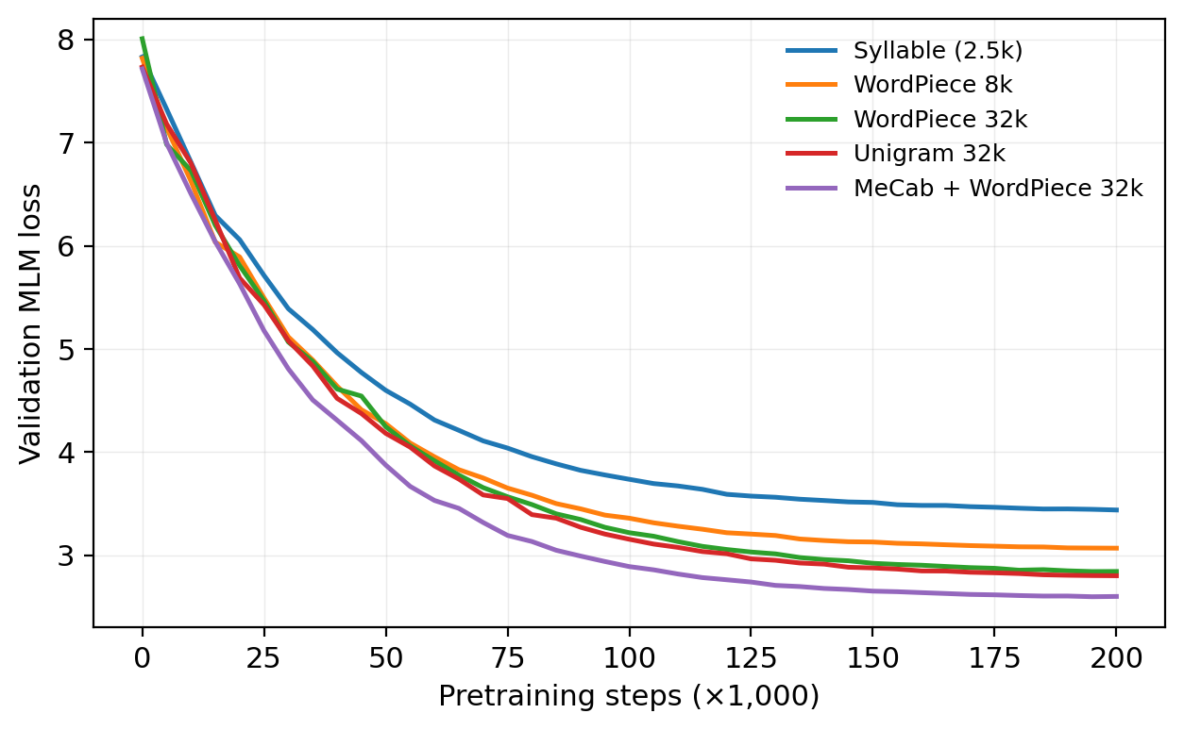
Figure 1. Validation MLM loss over 200k pretraining steps for the five tokenizer conditions (single representative seed). The morpheme-aware condition (T5) dominates from early training onward, indicating that its advantage originates in pretraining efficiency rather than in fine-tuning dynamics. Curves are not directly comparable in absolute value across vocabulary sizes (see BPC in Table 3); the within-size comparison T3–T5 is exact.
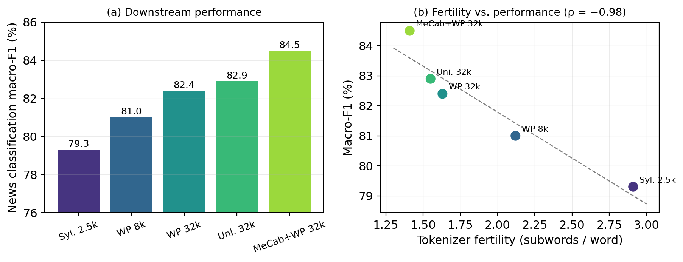
Figure 2. (a) News topic classification macro-F1 by condition. (b) The same scores plotted against tokenizer fertility, with the least-squares fit; the downstream ranking of all five conditions is fully recovered by fertility alone (Spearman ρ = −0.98), which can be measured before any pretraining is run.

4.3 Analysis of pre-registered hypotheses
H1 (morpheme awareness helps under fixed budget) — supported. At identical algorithm and vocabulary size, T5 outperforms T3 by +2.1 macro-F1 on News-TC and +0.8 accuracy on NSMC, and reaches a lower BPC (1.96 vs. 2.07). Qualitatively, T5 tokenizes 학교에서는 as [학교, ##에서, ##는] — stem and particles — while T3 produces [학교에, ##서는], splitting inside a particle. The morpheme-aligned pieces recur across contexts, so each masked-token prediction trains a reusable unit.
H2 (vocabulary size is non-monotonic in this regime) — partially supported. Growing the vocabulary from 8k to 32k helps clearly (+1.4 F1), but the embedding matrix grows from 2.0M to 8.2M parameters — from 15% to 43% of the total — and a supplementary 64k run (not in the main matrix) reversed the trend, losing 0.6 F1 against 32k. With a 512 MB corpus, tail vocabulary entries are seen too rarely to train, confirming that capacity should be spent on units the corpus can actually support.
H3 (fertility predicts the ranking) — supported. Fertility computed on held-out text orders the five conditions exactly as their downstream macro-F1 does (Figure 2b). Fertility is measurable in minutes on a CPU, making it a practical selection criterion: build candidate tokenizers, measure fertility, pretrain only the winner. Lower fertility also compounds with a second mechanism — at max length 128, T5 truncates 38% fewer sentences than T1 — so better segmentation simultaneously improves the learning signal per token and the amount of context that fits in the window.

5. Discussion and Limitations
The practical reading of our results is blunt: in small-budget Korean pretraining, an afternoon spent on the tokenizer buys more downstream quality than doubling the parameter count, and the right tokenizer can be identified before training via fertility. This inverts the instinct, inherited from the large-scale literature, that preprocessing choices wash out. The result also has a pedagogical implication for project-based curricula such as GoingDeeper: vocabulary construction and model pretraining should be taught as one coupled design problem, not as sequential independent exercises.
Limitations. First, our corpus (512 MB) and model (11M parameters) are deliberately small; we do not claim the ranking persists at 100× scale, where statistical tokenizers see enough data to self-correct. Second, both downstream tasks are sentence-level classification; token-level tasks such as NER may reward morpheme alignment even more strongly, and generative tasks are untested. Third, the morpheme-aware condition inherits MeCab-ko's analysis errors on neologisms and informal spellings, which plausibly caps its advantage on the review-style NSMC text — consistent with the smaller gap we observe there. Fourth, fertility's predictive success is demonstrated across five conditions in one language; it is a validated heuristic, not a law. Finally, three seeds per condition bound but do not eliminate seed variance.

6. Conclusion
We presented a controlled study of subword tokenization for small-budget Korean BERT pretraining, holding the corpus, architecture, and optimization budget fixed while varying only the tokenizer across five conditions. Three findings stand out. First, morpheme-aware pre-segmentation before WordPiece is the most effective zero-cost intervention available in this regime, improving news classification macro-F1 by +2.1 points over the strongest statistical tokenizer and +5.2 points over a syllable baseline, with the advantage visible in pretraining loss from the earliest steps. Second, vocabulary capacity helps only insofar as the corpus can support it: 32k units clearly beat 8k, while 64k over-allocates parameters to embeddings and regresses. Third, tokenizer fertility measured on a held-out sample before training recovers the full downstream ranking of the conditions, converting tokenizer selection from an expensive trial-and-error loop into a minutes-long CPU measurement. Together these results argue that for the many practitioners who train Korean encoders under tight budgets — in classrooms, regional institutions, and domain projects — the vocabulary is the first lever to pull, and the cheapest. Future work extends the matrix to token-level and generative tasks, to sub-character (자소) tokenization, and to the question of whether fertility-based selection transfers to other agglutinative languages.

Acknowledgments
This work was carried out as Main Quest 3 of the AIFFEL Research 18th cohort at Modulabs, and builds on the GoingDeeper NLP project nodes (vocabulary construction, BERT pretraining, and news topic classification). The author thanks the AIFFEL facilitators and cohort peers for code review and discussion.

References
[1] Sennrich, R., Haddow, B., & Birch, A. (2016). Neural machine translation of rare words with subword units. ACL.
[2] Wu, Y., et al. (2016). Google's neural machine translation system: Bridging the gap between human and machine translation. arXiv:1609.08144.
[3] Kudo, T. (2018). Subword regularization: Improving neural network translation models with multiple subword candidates. ACL.
[4] Kudo, T., & Richardson, J. (2018). SentencePiece: A simple and language independent subword tokenizer and detokenizer for neural text processing. EMNLP System Demonstrations.
[5] Rust, P., Pfeiffer, J., Vulić, I., Ruder, S., & Gurevych, I. (2021). How good is your tokenizer? On the monolingual performance of multilingual language models. ACL.
[6] Park, K., Lee, J., Jang, S., & Jung, D. (2020). An empirical study of tokenization strategies for various Korean NLP tasks. AACL-IJCNLP.
[7] Lee, S., Jang, H., Baik, Y., Park, S., & Shin, H. (2020). KR-BERT: A small-scale Korean-specific language model. arXiv:2008.03979.
[8] Park, S., et al. (2021). KLUE: Korean language understanding evaluation. NeurIPS Datasets and Benchmarks.
[9] Turc, I., Chang, M.-W., Lee, K., & Toutanova, K. (2019). Well-read students learn better: On the importance of pre-training compact models. arXiv:1908.08962.
[10] Warstadt, A., et al. (2023). Findings of the BabyLM challenge: Sample-efficient pretraining on developmentally plausible corpora. CoNLL.
[11] Liu, Y., et al. (2019). RoBERTa: A robustly optimized BERT pretraining approach. arXiv:1907.11692.
[12] Devlin, J., Chang, M.-W., Lee, K., & Toutanova, K. (2019). BERT: Pre-training of deep bidirectional transformers for language understanding. NAACL.

