# Web Developer’s Guide for TAH Support Webpage Template

The purpose of this guide is to assist a web developer or content administrator with editing the TAH Support Webpage Template.

*This template is built using* [*Boostrap*](http://getbootstrap.com/)*, the popular HTML, CSS, and JavaScript template developed by Twitter. Refer to the* [*Boostrap documentation*](http://getbootstrap.com/css/) *for a complete list of markup, styles, and JavaScript that is available with Bootstrap.*

**Replace the highlighted areas of the template with the details for your school:**

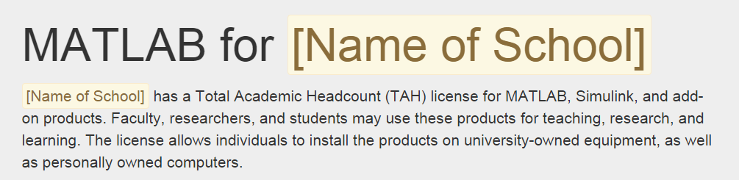

In the index.html file, replace: <span class="alert alert-warning">[Name of School]</span> with the name of your school.

**In the Products Section, add or remove products that are included with your license:**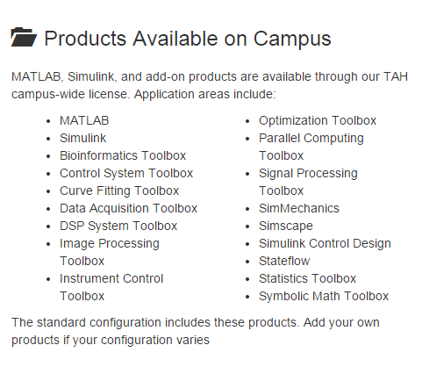

**In the Get Access section, add a link to the service that Students or Faculty can use to request the activation key:**



**In the Need Assistance section, add information for getting additional help with your TAH license:**

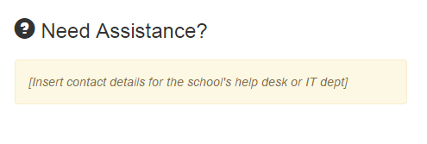

When all sections requesting custom information have been filled out, upload the following files/directories to a web-accessible section of your website:

/tah-support/

* Index.html
* /images/MLSL_RGB_stacked.png

The URL for your TAH Support website will be:

<http://your-internal-or-external-domain.edu/path/to/tah-support/>