Supplementary table 1. Functional annotation of targets sorted by size
(annotations in brown are uncertain)

With advancements in AI structure prediction tools like AlphaFold and ESMFold, millions of structures can be compared for homology inference. Our study employs a dual approach, combining sequence-based function annotation via hidden Markov model comparisons (still among state of the art tools for homology detection) and structural comparisons using ESMFold- and AlphaFold2-predicted models. Longer targets generally yielded more reliable functional predictions and structural models.

In assessing homology, various factors are considered, including probability, E-values, and the relationship among top hits. Homologous hits within the same SCOP superfamily for instance strengthen the likelihood of true homology. Hits that are the target's own experimental structure, or that of a close ortholog, are marked as such and were not used for functional transfer. Our analysis, based on a database of 28 targets, confidently predicted the function of 15 targets with high HHsearch probability (>90%) and Z-scores exceeding 8. Nine targets were predicted with less confidence, while four had no homologous hits. Among the predicted functions were enzymes, proteases, ion transporters, DNA-binding proteins, a transcriptional regulator, a periplasmic solute-binding protein, a peptidoglycan-binding protein, a phage terminase subunit and lipoproteins. Notably, targets of viral origin were also identified.

Protein target | Annotated in EcoCyc | Annotated by structure  DALI | Annotated by sequence  HHsearch | Functional Annotation  Structural model
b0955  sp|P75867|LONH_ECOLI  Structure 07 | gene: ycbZ  polypeptide: putative ATP-dependent protease YcbZ | Hit with: 3k1j  z-score: 25.1  rmsd: 3.2  Aligned residues: 497 | Hit with: 3k1j  Probability: 99.97  Aligned columns: 478  E-Value: 9.7e-28 | Several domains: ATP-dependent protease Lon; ATP-binding; Nucleotide binding  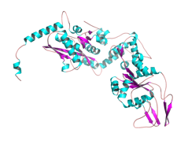
b1754  sp|P76223|YNJB_ECOLI  Structure 023 | gene: ynjB  polypeptide: putative ABC transporter periplasmic binding protein YnjB | Hit with: 6dtq  z-score: 27.7  rmsd: 2.9  Aligned residues: 326 | Hit with: 8c8f  Probability: 100  Aligned columns: 355  E-Value: 2.1e-33 | Periplasmic solute-binding protein of an ABC transporter (MalE-like fold, Pfam SBP_bac_8); ligand unknown  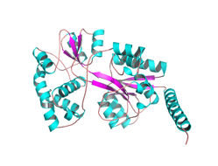
b1422  Structure 028  sp|P77171|YDCI_ECOLI | gene ydcI  polypeptide: DNA-binding transcriptional dual regulator YdcI | Hit with: 3fxq  z-score: 20.1  rmsd: 3.2  Aligned residues: 227  Values are for the whole 307-residue model. Figure 7e reports the aligned core (residues 88–306) against the same template: Z-score 20.0, rmsd 3.0 Å over 204 Cα. | Hit with: 3fxq  Probability: 100  Aligned columns: 296  E-Value: 3.5e-52 | LysR-type transcriptional regulator (TsaR-like)  Characterized: transcription factor for pH homeostasis and acetate metabolism (PMID 30137486; 32419108)  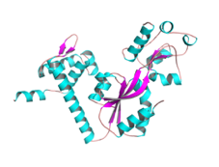
b0658  sp|P0AE78|CORC_ECOLI  Structure 018 | gene: ybeX  polypeptide: CorC-HlyC family protein YbeX | Hit with: 3nqr  z-score: 22.7  rmsd: 1.3  Aligned residues: 123 | Hit with: 4hg0  Probability: 100  Aligned columns: 291  E-Value: 7.6e-58 | magnesium and cobalt efflux (CorC family)  2024: implicated in ribosome assembly / rRNA degradation under Mg limitation (PMID 38494741)  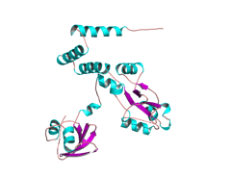
b3644  sp|P23839|YICC_ECOLI  Structure 013 | gene: yicC  polypeptide: putative RNase adaptor protein YicC | Hit with: 8ax9  z-score: 5.4  rmsd: 2.2  Aligned residues: 73 | Hit with: 8ax9  Probability: 90.59  Aligned columns: 154  E-Value: 37 | Endoribonuclease YicC, characterized: endonucleolytic ssRNA cleavage and degradation of the sRNA RyhB (PMID 34210798; 34815358). The 8ax9 match (human apolipoprotein E4 N-terminal domain) is a fold coincidence and is not used  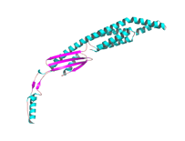
b1725  sp|P77739|KT3K_ECOLI  Structure 012 | gene: yniA  polypeptide: putative kinase YniA | Hit with: 3jr1  z-score: 38.4  rmsd: 1.5  Aligned residues: 285 | Hit with: 3jr1  Probability: 100  Aligned columns: 285  E-Value: 9.5e-30 | Fructosamine kinase  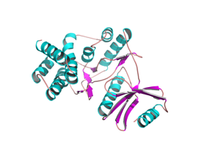
b2229  sp|P76466|YFAT_ECOLI  Structure 02 | gene: yfaT  polypeptide: DUF1175 domain-containing protein YfaT | Hit with: 7bk8  z-score: 29.3  rmsd: 1.7  Aligned residues: 192  (73% identity) | Hit with: 7bk8  Probability: 99.85  Aligned columns: 186  E-Value: 3.7e-19 | MagC-like NlpC/P60-family protein, peptidoglycan-binding (Pfam PF06672)  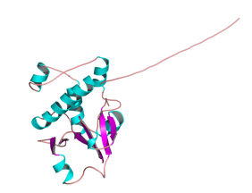
b1758  sp|P76226|YNJF_ECOLI  Structure 026 | gene: ynjF  polypeptide: CDP-alcohol phosphatidyltransferase domain-containing protein YnjF | Hit with: 5d92  z-score: 20.6  rmsd: 2.1  Aligned residues: 188 | Hit with: 6h59  Probability: 99.89  Aligned columns: 196  E-Value: 4.4e-20 | CDP-alcohol phosphatidyltransferase (phosphatidylinositol-phosphate-synthase-like fold); product unknown  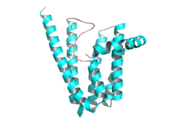
b0190  sp|P0AA97|YAEQ_ECOLI  Structure 024 | gene: yaeQ  polypeptide: uncharacterized protein YaeQ | Hit with: 3c0u  z-score: 30.8  rmsd: 1.6  Aligned residues: 177  Structure Available (3c0u is YaeQ itself; self-hit) | Hit with: 3C0U  Probability: 100  Aligned columns: 181  E-Value: 2.5e-54  Structure Available (self-hit) | YaeQ family; function unknown (the closest other structures, 2g3w, 2ot9 and 7tcb, are YaeQ-family proteins of unknown function)  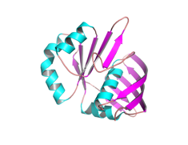
b2948  sp|P0A8W5|YQGE_ECOLI  Structure 015 | gene: yqgE  polypeptide: DUF179 domain-containing protein YqgE | Hit with: 2haf  z-score: 26.8  rmsd: 1.4  Aligned residues: 185 | Hit with: 2haf  Probability: 100  Aligned columns: 183  E-Value: 5.1e-4 | UPF0301 / AlgH-like family protein (2haf is V. cholerae VC_0467, whose PDB title is "putative translation repressor"); function unknown  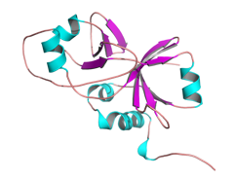
b1361  sp|P76066|YDAW_ECOLI  Structure 019 | gene: ydaW  polypeptide: Rac prophage; putative uncharacterized protein YdaW | Hit with: 4lb5  z-score: 9.0  rmsd: 1.0  Aligned residues: 52  DNA bound in target | 2x Hit with: 7bzh  Probability: 98.29  Aligned columns: 51  E-Value: 1.3e-5 | Putative winged-helix DNA-binding domain (about 50 residues matching the Zα domain of PKZ, 4lb5, and a Sulfolobus DNA-binding protein, 7bzh)  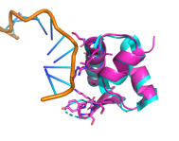
b2123  sp|P33354|YEHR_ECOLI  Structure 022 | gene: yehR  polypeptide: DUF1307 domain-containing lipoprotein YehR | Hit with: 2joe  z-score: 16.5  rmsd: 1.8  Aligned residues: 126  (2joe is YehR itself; self-hit) | Hit with: 2joe  Probability: 99.94  Aligned columns: 131  E-Value: 6.6e-24  (self-hit) | Lipoprotein (DUF1307); own NMR structure 2joe, so no functional transfer  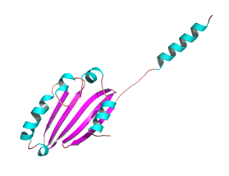
b2446  sp|P76546|YFFO_ECOLI  Structure 08 | gene: yffO  polypeptide: CPZ-55 prophage; uncharacterized protein YffO | Hit with: 4dyq  z-score: 11.3  rmsd: 3.4  Aligned residues: 100 | Hit with: 4dyq  Probability: 99.54  Aligned columns: 111  E-Value: 1.7e-12 | Phage terminase small-subunit-like protein (Sf6 gp1-like; Pfam PF20901); DNA-binding for genome packaging  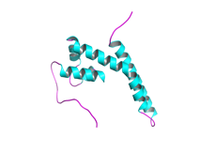
b3611  sp|P0AG27|YIBN_ECOLI  Structure 016 | gene: yibN  polypeptide: putative sulfurtransferase YibN | Hit with: 1gmx  z-score: 17.1  rmsd: 2.3  Aligned residues: 107 | Hit with: 1yt8  Probability: 99.38  Aligned columns: 103  E-Value: 2.8e-11 | Rhodanese-like domain (GlpE-like); putative sulfurtransferase  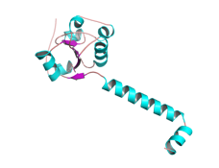
b0468  sp|P0AAR5|YBAN_ECOLI  Structure 020 | gene: ybaN  polypeptide: DUF454 domain-containing inner membrane protein YbaN | Hit with: 6rfl  z-score: 6.8  rmsd: 2.8  Aligned residues: 57 | Hit with: 7awa  Probability: 88.32  Aligned columns: 34  E-Value: 1.4 | No confident homolog (DUF454 inner-membrane protein; the hits are short helical fragments of 6rfl and 7awa)  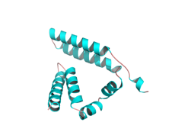
b1104  sp|P75946|YCFL_ECOLI  Structure 010 | gene: ycfL  polypeptide: DUF1425 domain-containing protein YcfL | Hit with: 4gio  z-score: 12.3  rmsd: 1.5  Aligned residues: 96 | Hit with: 4gio  Probability: 99.92  Aligned columns: 101  E-Value: 2e-23 | Lipoprotein (DUF1425; Cj0090-like)  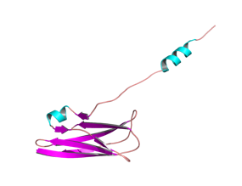
Structure 01  b1085  sp|P62066|YCEQ_ECOLI | gene: yceQ  polypeptide: DUF2655 domain-containing protein YceQ | No hits | No hits | =====  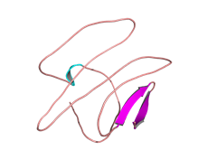
b0232  sp|Q47156|YAFN_ECOLI  Structure 017 | gene: yafN  polypeptide: antitoxin YafN | Hit with: 2a6q  z-score: 5.1  rmsd: 2.4  Aligned residues: 51 | Hit: 2A6Q  Probability: 98.47  Aligned columns: 68  E-Value: 2.3e-6 | Antitoxin YafN of the YafN-YafO toxin-antitoxin system (characterized, PMID 19617347; 19943910)  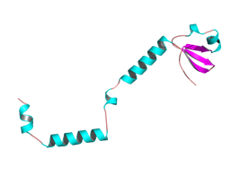
b1848  sp|P0ACY9|YEBG_ECOLI  Structure 014 | DNA damage-inducible protein YebG | Hit with: 4njc  z-score: 4.8  rmsd: 5.9  Aligned residues: 60 | Hit with: PF07130.16  Probability: 100  Aligned columns: 74  E-Value: 1.3e-33 | DNA damage-inducible (LexA/SOS regulon); no structural homolog of known function  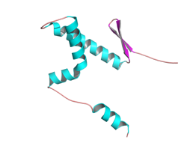
b0549  sp|P68661|YBCO_ECOLI  Structure 027 | gene: ybcO  polypeptide: DLP12 prophage; putative nuclease YbcO | Hit: 3g27  z-score: 16.7  rmsd: 0.7  Aligned residues: 81  (3g27 is YbcO itself; self-hit) | Hit: 3g27  Probability: 99.96  Aligned columns: 96  E-Value: 1.9e-28  (self-hit) | Putative nuclease (fold and conserved His, PMID 27562564); own crystal structure 3g27  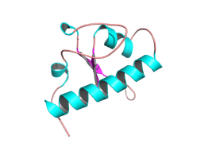
b1777  sp|P76231|YEAC_ECOLI  Structure 05 | gene: yeaC  polypeptide: DUF1315 domain-containing protein YeaC | Hit: 6yt0  z-score: 4.9  rmsd: 3.3  Aligned residues: 53 | Hit: 2hs5  Probability: 91.39  Aligned columns: 32  E-Value: 0.37 | Possible helix-turn-helix domain (32-column match to a GntR-family regulator, 2hs5); low confidence  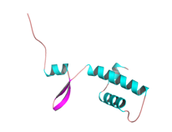
b1332  sp|P64445|YNAJ_ECOLI  Structure 025 | gene: ynaJ  polypeptide: DUF2534 domain-containing protein YnaJ | Hit: 5uz7  z-score: 6.6  rmsd: 3.1  Aligned residues: 69 | Hit: PF10749.13  Protein of unknown function (DUF2534)  Probability: 100  Aligned cols: 80  E-value: 3.4e-34 | No confident homolog (DUF2534; the 5uz7 match is a helical fragment of a GPCR-G-protein complex)  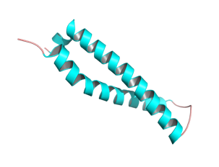
b1648  sp|P64474|YDHL_ECOLI  Structure 09 | gene: ydhL  polypeptide: DUF1289 domain-containing protein YdhL | No hits | No hits | =====  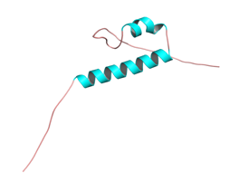
b2377  sp|P76521|YFDY_ECOLI  Structure 06 | gene: yfdY  polypeptide: DUF2545 domain-containing protein YfdY | Hit: 2m6u  z-score: 7.2  rmsd: 3.4  Aligned residues: 74 | Hit: COG2059  Probability: 61.82  Aligned columns: 67  E-Value: 100 | No confident homolog (DUF2545; the 2m6u match is the helical N-terminal domain of CbpA, not its choline-binding module)  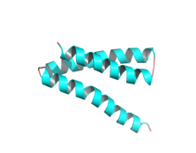
b4406  sp|P0A8K5|YAEP_ECOLI  Structure 04 | gene: yaeP  polypeptide: PF06786 family protein YaeP | Hit: 6kmb  z-score: 7.6  rmsd: 2.8  Aligned residues: 65 | Hit: 5h1n  Probability: 100  Aligned columns: 66  E-Value: 4.2e-44  Structure Available (5h1n is the Shigella ortholog) | UPF0253 family; function unknown (the 6kmb bromodomain match is a fold coincidence)  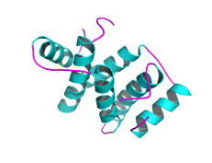
b4176  sp|P0AF73|YJET_ECOLI  Structure 021 | gene: yjeT  polypeptide: DUF2065 domain-containing protein YjeT | Hit: 4xk4-D  z-score: 5.4  rmsd: 4.4  Aligned residues: 61 | Hit: 3jc8  Probability: 60.72  Aligned columns: 34  E-Value: 69 | Possible helical DNA-binding fold (weak match to the TetR-family regulator RutR, 4xk4); very low confidence  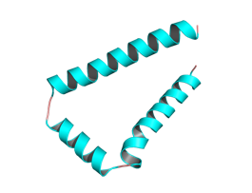
b1824  sp|P64508|YOBF_ECOLI  Structure 03 | gene: yobF  polypeptide: DUF2527 domain-containing protein YobF | Bad model | No hits | =====  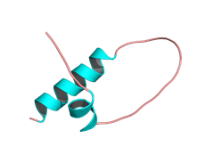
b4402  sp|P0ADD9|YJJY_ECOLI  Structure 011 | gene: yjjY  polypeptide: uncharacterized protein YjjY | Bad model | No hits | =====  

