STANDARD OPERATING PROCEDURE (SOP)

Display “Hello World” on 16x2 LCD using Arduino

1. Objective
To display the text “Hello World” on a 16x2 LCD using an Arduino Uno.

2. Components Required
- Arduino Uno
- 16x2 LCD Display (HD44780 compatible)
- 10kΩ Potentiometer
- Breadboard
- Jumper wires
- USB cable

3. Circuit Diagram
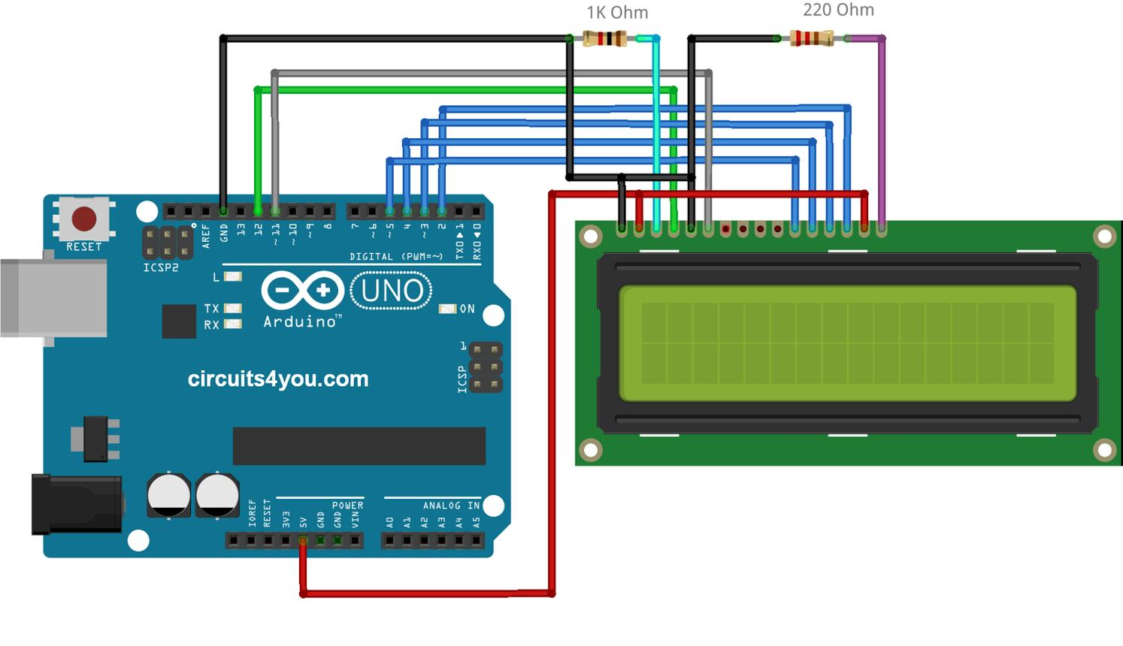
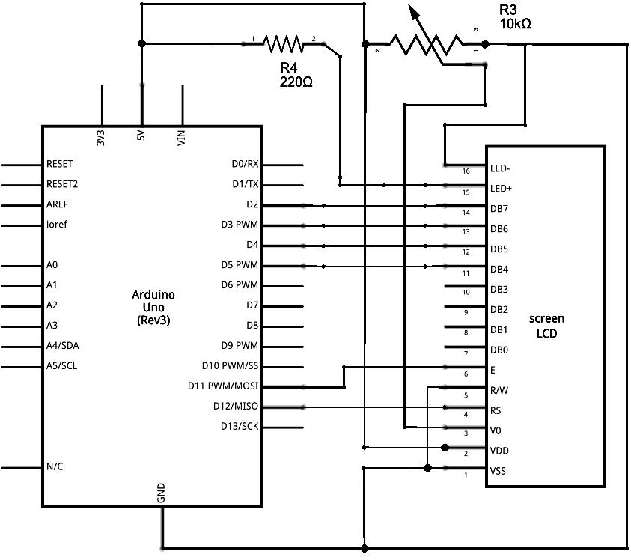
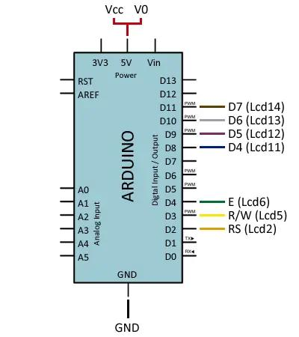
6

4. Circuit Connections
LCD Pin Configuration:
1 (VSS) → GND
2 (VDD) → 5V
3 (V0) → Middle pin of potentiometer (contrast control)
4 (RS) → Arduino pin 12
5 (RW) → GND
6 (E) → Arduino pin 11
11 (D4) → Arduino pin 5
12 (D5) → Arduino pin 4
13 (D6) → Arduino pin 3
14 (D7) → Arduino pin 2
15 (A) → 5V (via resistor, optional)
16 (K) → GND
Potentiometer:
- One side → 5V
- Other side → GND
- Middle → V0 (Pin 3 of LCD)

5. Arduino Program
#include <LiquidCrystal.h>
// RS, E, D4, D5, D6, D7
LiquidCrystal lcd(12, 11, 5, 4, 3, 2);
void setup(){
lcd.begin(16, 2);
}
void loop(){
lcd.setCursor(0,0);
lcd.print("Hello World");
}

6. Working Principle
- The Arduino initializes the LCD using lcd.begin(16, 2).
- The cursor is set to the first row and first column using lcd.setCursor(0,0).
- The text “Hello World” is displayed using lcd.print().
- The LCD works in 4-bit mode, using pins D4–D7 for data transfer.

7. Output
The LCD will display:
Hello World

8. Precautions
- Ensure all wiring connections are correct.
- Adjust the potentiometer for proper contrast.
- Connect RW pin to GND.
- Use a stable 5V power supply.

9. Troubleshooting
Problem: No display
Solution: Adjust contrast or check wiring
Problem: Only black boxes visible
Solution: LCD initialized but data not sent properly
Problem: Flickering
Solution: Avoid using lcd.clear() repeatedly
Problem: Backlight not glowing
Solution: Check pins 15 (A) and 16 (K)

