STANDARD OPERATING PROCEDURE (SOP)

Motion Detection using PIR Sensor and Arduino

1. Objective
To detect motion using a PIR sensor and control an LED using Arduino Uno, while displaying status on the Serial Monitor.

2. Components Required
- Arduino Uno
- PIR Motion Sensor (HC-SR501 or similar)
- LED
- 220Ω Resistor
- Breadboard
- Jumper wires
- USB cable

3. Circuit Diagram
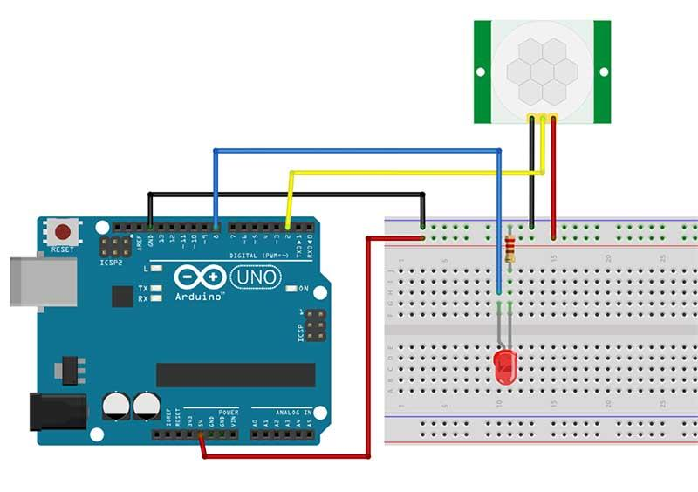
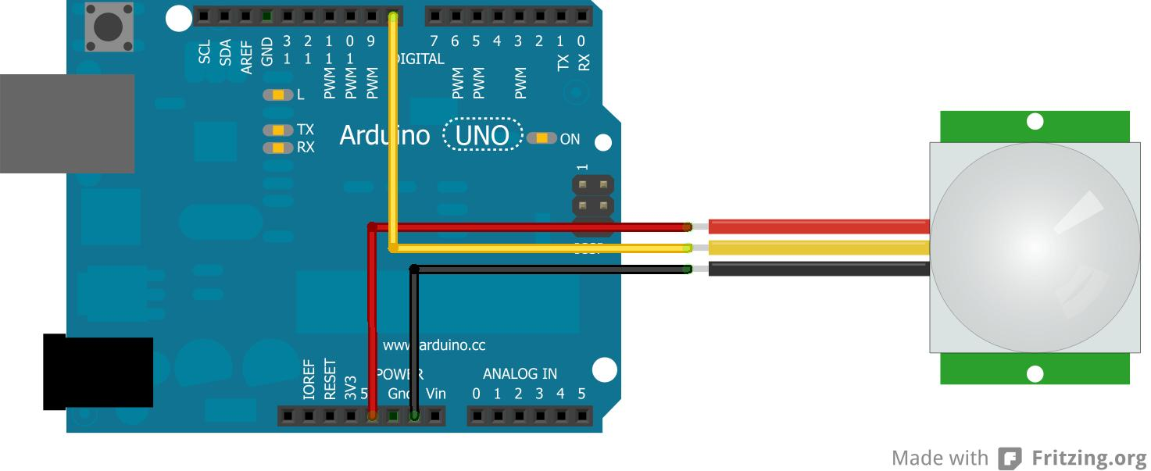
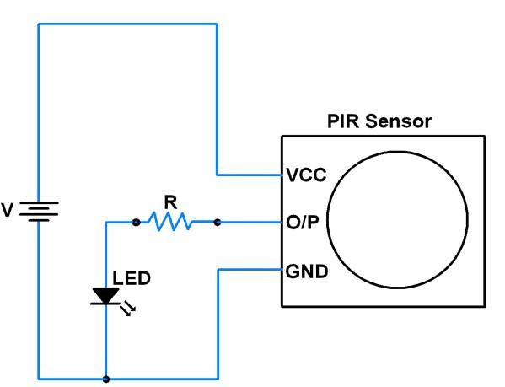
6

4. Circuit Connections

PIR Sensor:
- VCC → 5V
- GND → GND
- OUT → Arduino pin 2

LED:
- Anode (+) → Arduino pin 3
- Cathode (–) → GND through 220Ω resistor

5. Arduino Program
int pir_output = 2;
int led_pin = 3;
void setup(){
pinMode(pir_output, INPUT);
pinMode(led_pin, OUTPUT);
Serial.begin(9600);
}
void loop(){
int res = digitalRead(pir_output);
if(res == 1){
Serial.println("Motion detected");
digitalWrite(led_pin, HIGH);
}
else{
Serial.println("No Motion detected");
digitalWrite(led_pin, LOW);
}
delay(1000);
}

6. Working Principle
- The PIR sensor detects infrared radiation changes caused by human movement.
- When motion is detected, the sensor outputs HIGH (1).
- Arduino reads this signal using digitalRead().
- If motion is detected:
  - LED turns ON
  - Message “Motion detected” is displayed on Serial Monitor
- If no motion:
  - LED turns OFF
  - Message “No Motion detected” is displayed

7. Output
- Motion detected → LED ON + Serial Monitor shows “Motion detected”
- No motion → LED OFF + Serial Monitor shows “No Motion detected”

8. Precautions
- Ensure correct PIR pin connections (VCC, GND, OUT).
- Wait 30–60 seconds after powering the sensor (initial stabilization).
- Use resistor with LED to prevent damage.
- Avoid placing sensor near heat sources.

9. Troubleshooting
Problem: Sensor not detecting motion
Solution: Wait for stabilization and adjust sensitivity
Problem: LED always ON
Solution: Adjust sensitivity/delay knobs on PIR
Problem: No Serial output
Solution: Check baud rate (9600) and COM port
Problem: False triggering
Solution: Reduce sensitivity or change position

🔥 Extra Tips
- PIR sensor has 2 knobs:
  - Sensitivity adjustment
  - Delay time adjustment
- You can remove delay(1000) for faster detection

