STANDARD OPERATING PROCEDURE (SOP)

RGB LED Color Control using Arduino (PWM)

1. Objective
To generate different colors using an RGB LED by controlling intensity of Red, Green, and Blue channels using PWM in Arduino.

2. Components Required
- Arduino Uno
- RGB LED (Common Cathode recommended)
- 3 × 220Ω Resistors
- Breadboard
- Jumper wires
- USB cable

3. Circuit Diagram
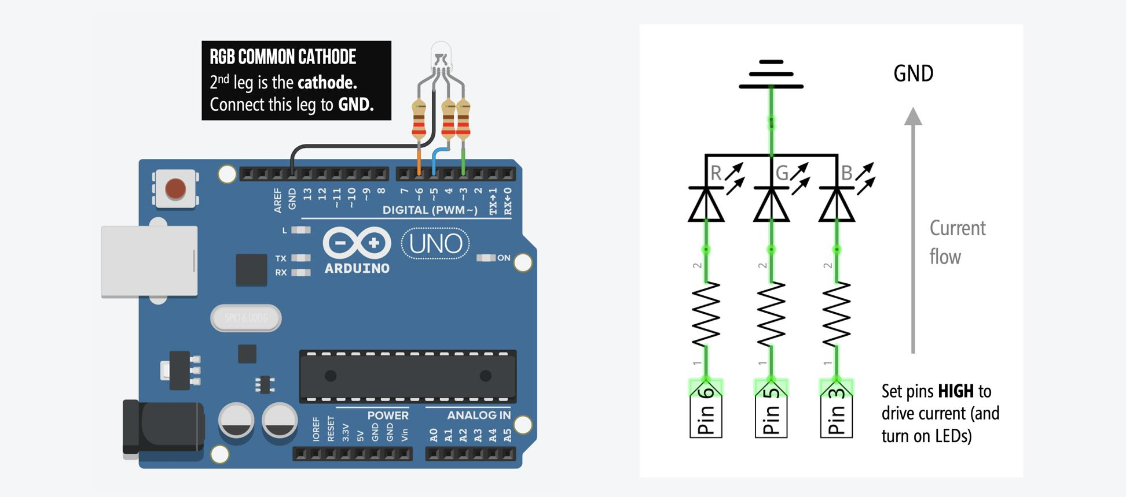
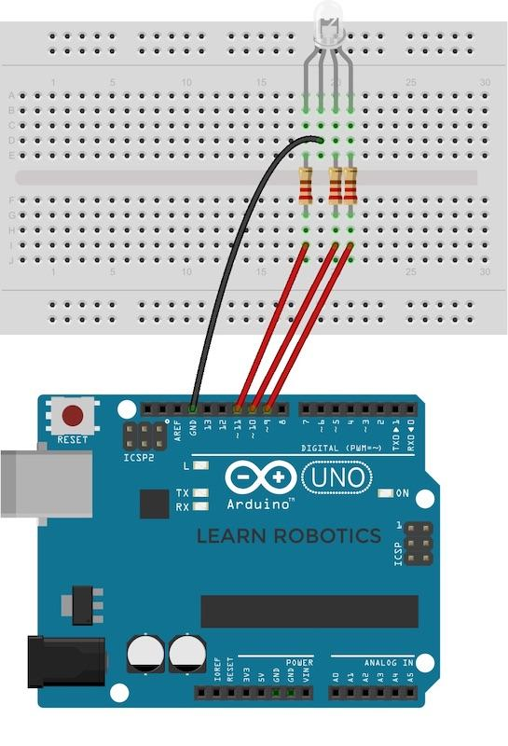
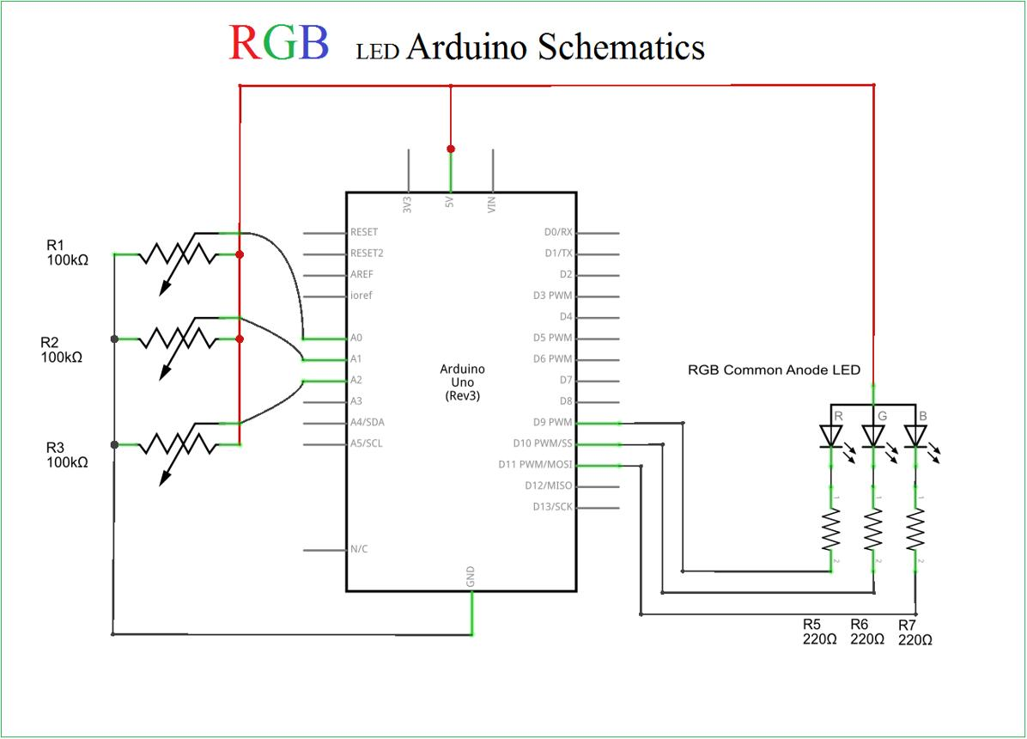
6

4. Circuit Connections

RGB LED (Common Cathode):
- Red pin → Arduino pin 6 (via 220Ω resistor)
- Green pin → Arduino pin 5 (via 220Ω resistor)
- Blue pin → Arduino pin 3 (via 220Ω resistor)
- Common Cathode (longest pin) → GND

5. Arduino Program
int red_pin = 6;
int green_pin = 5;
int blue_pin = 3;
void setup(){
pinMode(red_pin, OUTPUT);
pinMode(green_pin, OUTPUT);
pinMode(blue_pin, OUTPUT);
Serial.begin(9600);
}
void loop(){
// Red Light
analogWrite(red_pin, 0);
analogWrite(green_pin, 255);
analogWrite(blue_pin, 255);
delay(1000);
// Green Light
analogWrite(red_pin, 255);
analogWrite(green_pin, 0);
analogWrite(blue_pin, 255);
delay(1000);
// Blue Light
analogWrite(red_pin, 255);
analogWrite(green_pin, 255);
analogWrite(blue_pin, 0);
delay(1000);
// Yellow Light
analogWrite(red_pin, 0);
analogWrite(green_pin, 0);
analogWrite(blue_pin, 255);
delay(1000);
// Purple Light
analogWrite(red_pin, 0);
analogWrite(green_pin, 255);
analogWrite(blue_pin, 0);
delay(1000);
// White Light
analogWrite(red_pin, 0);
analogWrite(green_pin, 0);
analogWrite(blue_pin, 0);
delay(1000);
}

⚠️ Important Note
This code assumes a Common Cathode RGB LED where:
- 0 → ON
- 255 → OFF
👉 If using Common Anode, logic will be reversed.

6. Working Principle
- RGB LED produces colors by mixing Red, Green, and Blue light.
- Arduino uses PWM (Pulse Width Modulation) via analogWrite() to control brightness.
- Values range from 0 to 255:
  - 0 → Full brightness
  - 255 → OFF (for common cathode in your wiring logic)
- By combining different intensities, multiple colors are generated.

7. Output
The RGB LED will glow in sequence:
- Red
- Green
- Blue
- Yellow
- Purple
- White
Each color appears for 1 second.

8. Precautions
- Always use resistors with RGB LED pins.
- Ensure correct identification of RGB pins.
- Use PWM pins (3, 5, 6 are correct).
- Check whether LED is common cathode or anode.

9. Troubleshooting
Problem: Wrong colors displayed
Solution: Check pin connections or LED type
Problem: LED not glowing
Solution: Verify wiring and resistor connections
Problem: Colors too dim
Solution: Adjust PWM values
Problem: Only one color works
Solution: Check individual LED pins

🔥 Improvement Ideas
- Smooth color fading (rainbow effect 🌈)
- Control color using Serial input
- Add potentiometer to control brightness
- Sync with music or sensors 🎵

