STANDARD OPERATING PROCEDURE (SOP)

RGB LED Color Control using Arduino

1. Objective
To generate different colors using an RGB LED by controlling Red, Green, and Blue channels with Arduino using PWM.

2. Components Required
- Arduino Uno
- RGB LED (Common Cathode)
- 3 × 220Ω Resistors
- Breadboard
- Jumper wires
- USB cable

3. Circuit Diagram
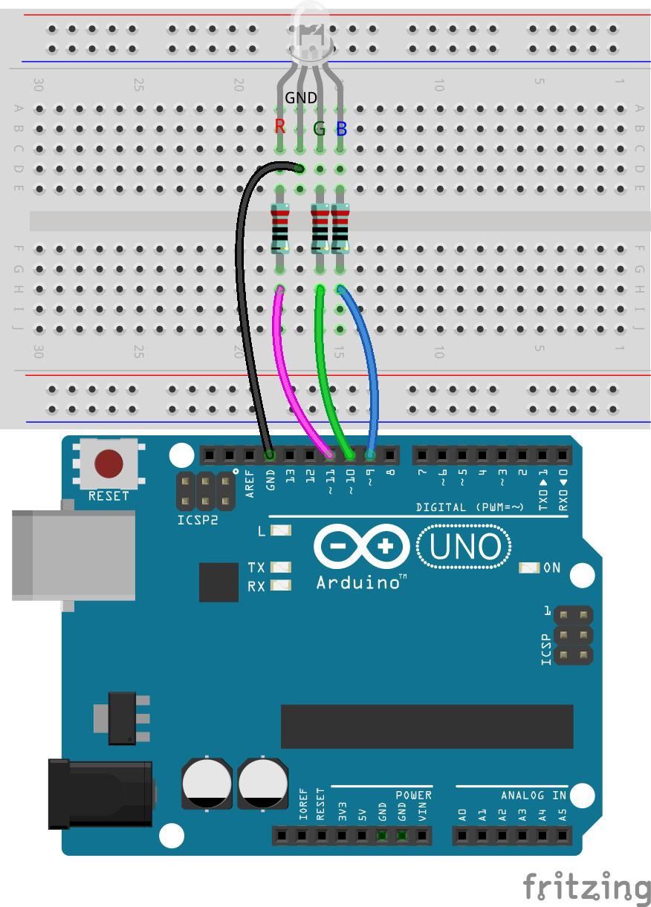
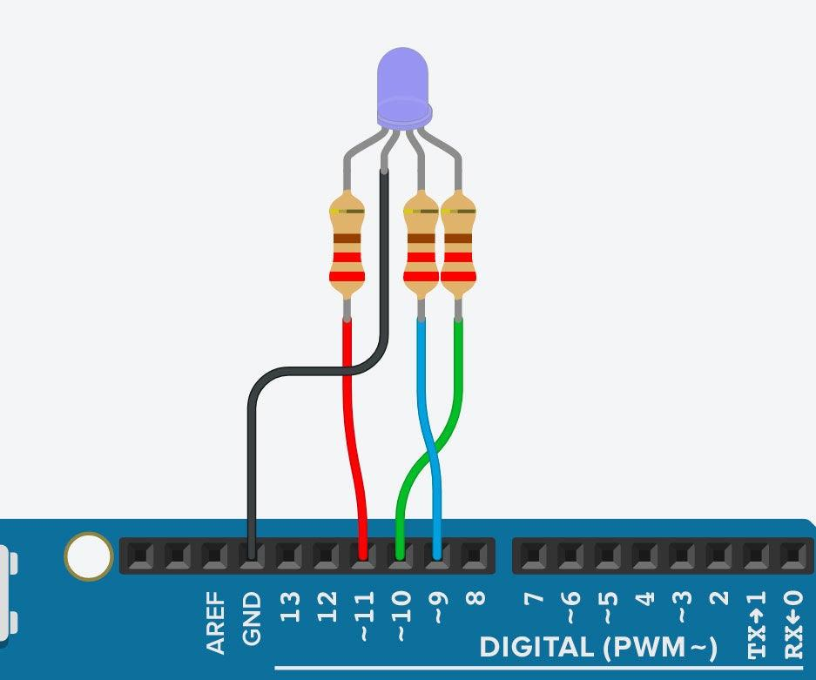
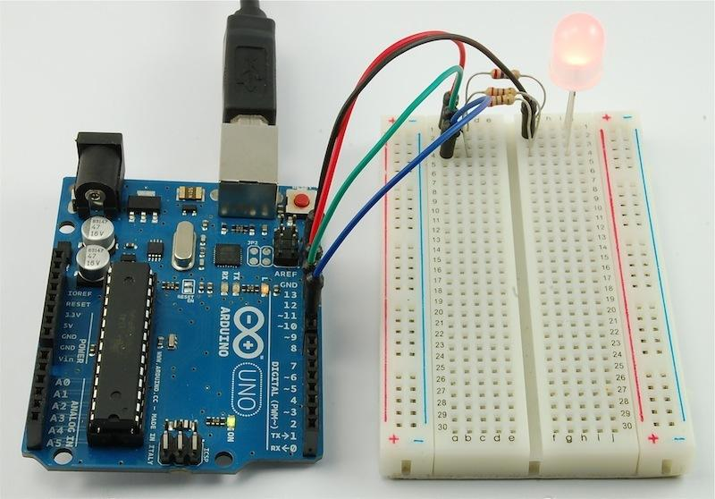
6

4. Circuit Connections
- Red pin → Arduino pin 6 (via 220Ω resistor)
- Green pin → Arduino pin 5 (via 220Ω resistor)
- Blue pin → Arduino pin 3 (via 220Ω resistor)
- Common cathode → GND

5. Arduino Program
int red_pin = 6;
int green_pin = 5;
int blue_pin = 3;
void setup(){
pinMode(red_pin, OUTPUT);
pinMode(green_pin, OUTPUT);
pinMode(blue_pin, OUTPUT);
Serial.begin(9600);
}
void loop(){
// Red Light
analogWrite(red_pin, 0);
analogWrite(green_pin, 255);
analogWrite(blue_pin, 255);
STANDARD OPERATING PROCEDURE (SOP)
RGB LED Color Control using Arduino
1. Objective

To generate different colors using an RGB LED by controlling Red, Green, and Blue channels with Arduino using PWM.

2. Components Required
Arduino Uno
RGB LED (Common Cathode)
3 × 220Ω Resistors
Breadboard
Jumper wires
USB cable
3. Circuit Diagram
6
4. Circuit Connections
Red pin → Arduino pin 6 (via 220Ω resistor)
Green pin → Arduino pin 5 (via 220Ω resistor)
Blue pin → Arduino pin 3 (via 220Ω resistor)
Common cathode → GND
5. Arduino Program
int red_pin = 6;
int green_pin = 5;
int blue_pin = 3;

void setup(){
pinMode(red_pin, OUTPUT);
pinMode(green_pin, OUTPUT);
pinMode(blue_pin, OUTPUT);
Serial.begin(9600);
}

void loop(){
// Red Light
analogWrite(red_pin, 0);
analogWrite(green_pin, 255);
analogWrite(blue_pin, 255);
delay(1000);

// Green Light
analogWrite(red_pin, 255);
analogWrite(green_pin, 0);
analogWrite(blue_pin, 255);
delay(1000);

// Blue Light
analogWrite(red_pin, 255);
analogWrite(green_pin, 255);
analogWrite(blue_pin, 0);
delay(1000);

// Yellow Light
analogWrite(red_pin, 0);
analogWrite(green_pin, 0);
analogWrite(blue_pin, 255);
delay(1000);

// Purple Light
analogWrite(red_pin, 0);
analogWrite(green_pin, 255);
analogWrite(blue_pin, 0);
delay(1000);

// White Light
analogWrite(red_pin, 0);
analogWrite(green_pin, 0);
analogWrite(blue_pin, 0);
delay(1000);
}
6. Working Principle
RGB LED combines Red, Green, and Blue light to produce different colors.
Arduino uses PWM (analogWrite) to control brightness of each color.
PWM values range from 0 to 255:
0 → Full brightness
255 → OFF (in this configuration)
By mixing different values, multiple colors are generated.
7. Output

The RGB LED will glow in sequence:

Red
Green
Blue
Yellow
Purple
White

Each color appears for 1 second and repeats continuously.

8. Precautions
Use resistors to prevent LED damage.
Ensure correct identification of RGB pins.
Use PWM pins (3, 5, 6).
Confirm LED type (common cathode).
9. Troubleshooting

Problem: Wrong colors
Solution: Check wiring or LED type

Problem: LED not glowing
Solution: Verify connections and power

Problem: Dim light
Solution: Adjust PWM values

Problem: Only one color working
Solution: Check individual pins

10. Improvement Ideas
Smooth color fading (rainbow effect)
Control colors using Serial Monitor
Add potentiometer for brightness control
Bluetooth control via mobil delay(1000);
// Green Light
analogWrite(red_pin, 255);
analogWrite(green_pin, 0);
analogWrite(blue_pin, 255);
delay(1000);
// Blue Light
analogWrite(red_pin, 255);
analogWrite(green_pin, 255);
analogWrite(blue_pin, 0);
delay(1000);
// Yellow Light
analogWrite(red_pin, 0);
analogWrite(green_pin, 0);
analogWrite(blue_pin, 255);
delay(1000);
// Purple Light
analogWrite(red_pin, 0);
analogWrite(green_pin, 255);
analogWrite(blue_pin, 0);
delay(1000);
// White Light
analogWrite(red_pin, 0);
analogWrite(green_pin, 0);
analogWrite(blue_pin, 0);
delay(1000);
}

6. Working Principle
- RGB LED combines Red, Green, and Blue light to produce different colors.
- Arduino uses PWM (analogWrite) to control brightness of each color.
- PWM values range from 0 to 255:
  - 0 → Full brightness
  - 255 → OFF (in this configuration)
- By mixing different values, multiple colors are generated.

7. Output
The RGB LED will glow in sequence:
- Red
- Green
- Blue
- Yellow
- Purple
- White
Each color appears for 1 second and repeats continuously.

8. Precautions
- Use resistors to prevent LED damage.
- Ensure correct identification of RGB pins.
- Use PWM pins (3, 5, 6).
- Confirm LED type (common cathode).

9. Troubleshooting
Problem: Wrong colors
Solution: Check wiring or LED type
Problem: LED not glowing
Solution: Verify connections and power
Problem: Dim light
Solution: Adjust PWM values
Problem: Only one color working
Solution: Check individual pins

10. Improvement Ideas
- Smooth color fading (rainbow effect)
- Control colors using Serial Monitor
- Add potentiometer for brightness control
- Bluetooth control via mobil

