
TRIBHUVAN UNIVERSITY
FACULTY OF HUMANITIES AND SOCIAL SCIENCE

A Project Report
On
"Interconnected: A Social Media Platform"
Submitted to
Department of Computer Application
Prime College

In partial fulfillement of the requriments for Bachelor Degree in Computer Application

Submitted By:
Utsab Dangol
Under the Supervision of

Table of Contents
CHAPTER 1 INTRODUCTION 1
1.1 Introduction 1
1.2 Problem statement 2
1.3 Objectives 3
1.4 scope and limitation 3
1.4.1 Scope 3
1.4.2 Limitations 3
1.5 Development Methodology 4
1.6 Report Organization 7
CHAPTER 2 BACKGROUND STUDY AND LITERATURE REVIEW 8
2.1 Background Study 8
2.2 Literature Review 9
CHAPTER 3 SYSTEM ANALYSIS AND DESIGN 10
3.1 System Analysis 10
3.1.1 Requirement Analysis 10
3.1.2 Feasibility Study 13
3.1.3 Data Modeling 15
3.1.4 Process Modeling 16
3.2 System Design 18
3.2.1 System Architecture 18
3.2.2 Database Schema Design 19
References 19
4.1 Requirement Identification 20
4.1.1 Study of Existing Systems 20
4.1.2 Requirement Collection 21
Non-Functional Requirements: 21
4.2 Feasibility Study 22
4.2.1 Technical Feasibility 22
4.2.2 Operational Feasibility 22
4.2.3 Economic Feasibility 22
4.3 High Level Design 23
4.3.1 System Architecture 23
4.3.2 User Flow Design 23
5. Project Gannt chart 23
6. Expected Outcome 24
7. References 25

CHAPTER 1 INTRODUCTION

1.1 Introduction
Social media has transformed how people communicate, but most platforms now optimize for endless engagement rather than genuine connection. The heavy use of algorithmic feeds and addictive design often overwhelms users with constant noise, leading to shallow interactions and fragmented attention.
Interconnected aims to counter this trend by creating a community-first social platform where people can focus on meaningful conversations with others who share their interests. Instead of pushing algorithm-driven feeds, the system uses a single-community viewing model that highlights depth over distraction. Users can join many communities, but only one is shown at a time, encouraging intentional, focused engagement.
This design is built on a simple idea: people communicate better when they aren’t bombarded with unrelated content. By reducing information overload and emphasizing topic-specific spaces, Interconnected supports clearer thinking, richer discussion, and a healthier online experience.
Interconnected serves multiple user groups including community creators who want to build focused discussion spaces around specific topics, community members seeking meaningful interactions with others who share their interests, and moderators who maintain the quality and relevance of community discussions. The platform provides comprehensive tools for community management, content creation and curation, user interaction, and administrative oversight.
Interconnected brings together three kinds of people: creators who build focused discussion spaces, members who want meaningful conversations, and moderators who keep communities healthy. The platform gives each group the tools they need for managing communities, creating content, and maintaining quality.
It’s built with React.js for a fast, dynamic interface, PHP for the core application logic, and MySQL for stable data management. The system uses a clean three-tier architecture separating the UI, backend logic, and database to keep everything scalable, secure, and easy to maintain.
Interconnected shows that social platforms don’t have to rely on addictive design or algorithmic manipulation. By centering communities and giving users control over their interactions, it creates a space for focused, productive, and truly meaningful online engagement.

1.2 Problem statement
Social media has become a big part of modern communication and community building. However, current platforms often prioritize engagement-driven algorithms that can lead to distraction and superficial interactions. While platforms like Facebook offer community features, they are often overshadowed by algorithmic feeds that promote irrelevant content. Apps like Pinterest excel at idea sharing but lack meaningful community interaction, and Discord focuses on group communication but doesn't emphasize productive, interest-based connections.
Current social media platforms face several critical issues that affect user experience and community building:
- Algorithm-Driven Distraction: Most platforms use engagement algorithms that prioritize controversial or trending content over relevant, productive material, leading to user distraction and reduced focus on meaningful topics.
- Fragmented Community Experience: While communities exist on platforms like Facebook, they are not the primary focus and are often difficult to access or navigate effectively.
- Lack of Productive Focus: Existing platforms rarely balance entertainment with productivity, often leaning heavily toward one side or the other.
- Surface-Level Interactions: Many platforms encourage quick reactions and brief comments rather than thoughtful, substantive discussions that build genuine connections.
- Content Overwhelm: Users are bombarded with information from multiple sources simultaneously, making it difficult to maintain focus on specific interests or communities.
These issues create a need for a platform that facilitates meaningful connections between users with shared interests while promoting productive engagement and reducing digital distraction.

1.3 Objectives
The primary objectives of developing Interconnected are:
- To create a community-driven social media platform that prioritizes meaningful connections and productive interactions among users with shared interests.
- To enable users to connect with like-minded individuals through topic-specific communities
- To provide a platform for sharing and showcasing ideas in a focused environment
- To balance social interaction with productivity by reducing algorithmic distractions
- To form moderated groups and communities that maintain topic relevance and constructive discourse
- To implement a user interface that promotes focus by displaying one community at a time
- To create a safe, moderated environment free from harmful or negative content

1.4 scope and limitation

1.4.1 Scope
The Interconnected platform is designed to support community-oriented social networking. Users will be able to register securely, create and manage personal profiles, and participate in communities aligned with their interests. Each community will function as a dedicated space for topic-focused discussions, enabling users to create, edit, and engage with posts and threaded comments. Community creators and moderators will have the necessary tools to manage members, oversee content, and enforce community guidelines.
The platform includes administrative controls that allow system administrators to supervise user activity, review reported content, and manage communities through a centralized dashboard. The technical implementation employs React.js for the frontend interface, PHP for backend processing, and MySQL for structured data storage. The system architecture is developed with scalability in mind, ensuring stable performance as user activity and content volume increase.

1.4.2 Limitations
The initial version of the platform prioritizes core community and discussion features. Advanced functionalities—such as real-time messaging, video sharing, live streaming, and extensive multimedia support—are not included. Access is limited to web browsers, with no native mobile applications or offline capabilities.
File uploads are restricted in both size and supported formats, emphasizing text-based content with limited image support. Scalability constraints may arise due to the absence of advanced infrastructure components such as content delivery networks, distributed caching, and load balancing.
Moderation depends primarily on human review, with no integrated artificial intelligence or automated content-analysis systems. The platform supports only English in its first release, lacking multilingual interfaces or localization features. Additionally, advanced analytics, detailed behavioral insights, and integration with external services—such as social logins or cross-platform content sharing—are beyond the scope of the current implementation.

1.5 Development Methodology
A development methodology is a structured framework used in software engineering to guide the planning, design, implementation, testing, and delivery of a software system. It provides an organized set of processes, tasks, and defined roles that support the systematic execution of a project throughout its lifecycle. Various models are used within the Software Development Life Cycle (SDLC), such as the Waterfall Model, Prototyping Model, and Spiral Model, each selected based on the nature and objectives of the project.
For the Interconnected platform, the Waterfall Model was adopted. This approach is appropriate because the project requirements were largely identified and finalized prior to development. The model’s linear and sequential structure allows each phase to be completed thoroughly before progressing to the next, ensuring clarity, reducing ambiguity, and minimizing the risk of missing key functional or design elements. This systematic progression supports a disciplined development process aligned with the defined goals and scope of the platform.
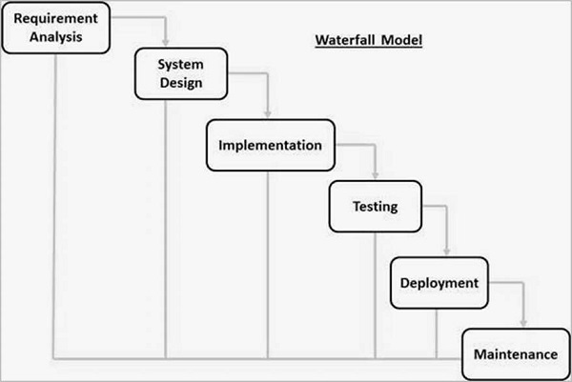
Figure 1.1: Waterfall Model of SDLC
Requirement Analysis Phase
The Requirement Analysis Phase involves systematic identification and documentation of all system requirements. This includes gathering information from different user groups—community members, creators, moderators, and administrators—to determine their specific needs and expectations. Research on existing platforms such as Discord, Facebook Groups, Reddit, and Pinterest was conducted to analyze their strengths and limitations. Issues such as algorithmic distraction, information overload, and lack of focused community engagement informed the platform’s objectives.
The outcome of this phase is a comprehensive set of functional requirements (user management, content posting, moderation tools, administrative controls) and non-functional requirements (performance, security, usability, scalability) that guide subsequent development.

System Design Phase
The System Design Phase translates the documented requirements into a complete architectural blueprint for the platform. A three-tier architecture—presentation, application, and data layers—was designed to support scalability, maintainability, and system security.
Database design includes an Entity Relationship Diagram (ERD) and a fully defined schema for entities such as users, communities, posts, and comments. Detailed interface wireframes and mockups outline user interactions, emphasizing clarity, usability, and the single community viewing approach. Data Flow Diagrams (DFDs) illustrate system processes and the movement of information across components.
This phase establishes the structural foundation necessary for accurate and efficient implementation.

Implementation Phase
The Implementation Phase involves translating the system design into a fully functioning application. The frontend is developed using React.js, supported by HTML5, CSS3, and JavaScript to create a responsive and interactive user experience. Interfaces are implemented for authentication, community browsing, posting, commenting, and administrative actions. The backend is developed in PHP to handle business logic, session management, request processing, and database interactions. A structured MySQL database is created based on the defined schema. Modular development practices ensure that components are built, tested, and refined individually before integration. Version control is used to track all changes and maintain development consistency.

Testing Phase
The Testing Phase verifies that the implemented system meets all functional and non-functional requirements. Unit testing is performed on individual components to ensure each function operates correctly. Integration testing validates the interactions between frontend, backend, and database components, ensuring proper communication and data flow.
System testing evaluates the entire platform against the defined requirements, ensuring correct operation of user workflows, content management, moderation functions, and administrative tools. User acceptance testing (UAT) gathers feedback from target users to ensure the system is intuitive and meets usability expectations prior to deployment.

Deployment Phase
The Deployment Phase prepares the platform for real-world use. This involves configuring the production environment, migrating the database, setting up the web server, and performing final security checks.
A staging environment may be used for final validation before releasing the system to end users. Deployment documentation is produced to support future maintenance, troubleshooting, and updates.

Maintenance Phase
The Maintenance Phase begins once the system is live. It includes monitoring platform performance, addressing bugs or user-reported issues, updating security measures, and making minor improvements. Regular activities include database backups, system optimization, and release of patches to resolve any issues discovered post-deployment. User feedback plays an essential role in identifying enhancements for future iterations of the platform.
The Waterfall Model’s sequential structure provides clear deliverables and measurable progress at each stage. Although modern agile methods allow more flexibility, the Waterfall approach is well-suited to this academic project due to the stability of requirements and the need for a clearly documented, systematic development process.

1.6 Report Organization
This report is structured into five chapters, each describing a specific aspect of the design, development, and evaluation of the Interconnected platform.
Chapter 1: Introduction presents an overview of the Interconnected platform and the motivation for developing a community-focused social media system. It defines the problem statement, project objectives, scopes, and limitations. The chapter also explains the development methodology adopted for the project, including a detailed justification for using the Waterfall Model.
Chapter 2: Background Study and Literature Review discuss the background of social networking systems and highlights the need for a focused community-based platform. It includes a review of existing systems and related research, analyzing their strengths, limitations, and relevance to the proposed platform.
Chapter 3: System Analysis and Design describes the system analysis and design processes undertaken during development. It covers requirement analysis, feasibility study, system architecture, database schema design, and interface design. This chapter also includes various structural and process models such as Use Case Diagrams, Entity Relationship Diagrams (ERD), Data Flow Diagrams (Level 0 and Level 1), Gantt Chart, and Physical Data Flow Diagrams.
Chapter 4: Implementation and Testing details the implementation and testing phases of the Interconnected platform. It outlines the tools and technologies used for frontend and backend development, explains the implementation of major system modules, and describes the testing strategies employed, including unit testing, integration testing, system testing, and user acceptance testing.
Chapter 5: Conclusion and Future Recommendations summarizes the outcomes and achievements of the project. It reflects on the objectives, scopes, and limitations, discusses lessons learned during development, and provides recommendations for future enhancements and improvements to the platform.
The report concludes with a references section listing all sources consulted during the study and an appendix containing supplementary materials such as detailed diagrams, configurations, and supporting documentation.

CHAPTER 2 BACKGROUND STUDY AND LITERATURE REVIEW

2.1 Background Study
The evolution of social media has significantly transformed human interaction since the early days of the internet. Initial platforms such as bulletin board systems and chat rooms offered simple, user-controlled spaces for discussion. Early social networking sites, including Friendster and MySpace, emphasized personal connections and chronological content display, allowing users direct control over the information they consumed.
The emergence of large-scale platforms such as Facebook and Twitter marked a shift toward algorithmic content curation. Chronological feeds were replaced by engagement-driven algorithms designed to maximize likes, comments, and shares. While these systems increased user activity, they also introduced challenges including information overload, fragmented attention, and declining discourse quality.
Research shows that engagement-optimizing algorithms tend to amplify emotionally charged or divisive content due to higher interaction rates, creating feedback loops that prioritize visibility over accuracy. Excessive social media use has also been linked to negative mental health outcomes such as anxiety, depression, and reduced self-esteem, particularly among younger users.
The phenomenon of “doomscrolling” further illustrates the ethical concerns of algorithmic feeds, as platforms exploit negativity bias to encourage compulsive consumption despite negative emotional effects. In response, the digital wellness movement has promoted mindful technology use and influenced features such as screen-time tracking and notification controls, though these measures often fail to address the underlying engagement-driven design.
Community-based platforms such as Discord and Reddit present alternative models by organizing interaction around shared interests. However, Discord’s focus on real-time communication limits reflective discussion, while Reddit’s anonymity and voting mechanisms can reinforce echo chambers and suppress minority viewpoints.
Emerging “slow social” or “intentional social” design approaches advocate for meaningful engagement through chronological content, reduced interaction frequency, and quality-focused contributions. Studies on online communities consistently emphasize the importance of clear guidelines, effective moderation, focused group size, and structured discussions. Research on attention and cognitive load further indicates that reduced context-switching improves comprehension and depth of engagement.
The Interconnected platform is developed in response to these findings. By eliminating algorithmic content curation, adopting single-community viewing, and emphasizing moderated, topic-focused interaction, the platform seeks to promote meaningful engagement aligned with principles of digital wellness and intentional technology use.

2.2 Literature Review
The development of the Interconnected platform is informed by key research in social media design, online community management, user experience, and the psychological impact of digital platforms. This literature review focuses on influential and widely cited studies that highlight the limitations of engagement-driven social networks and propose principles for healthier, community-oriented online environments.
Zuboff examined how large technology platforms use data-driven algorithms to shape user behavior and maximize engagement. Her work highlights how algorithmic content curation prioritizes attention capture over meaningful interaction, raising concerns about user autonomy and ethical platform design. These findings support Interconnected’s decision to avoid algorithmic feeds in favor of chronological, user-controlled content organization. [1]
Tufekci analyzed recommendation algorithms on platforms such as YouTube and demonstrated how engagement optimization can lead users toward increasingly extreme or sensational content. The study emphasizes the unintended social consequences of algorithmic amplification and reinforces the need for alternative content delivery models. [2]
Research on online communities by Kraut and Resnick identified critical success factors for sustainable digital communities, including clear goals, effective moderation, and mechanisms that encourage constructive participation. These principles directly influenced Interconnected’s emphasis on topic-focused communities with active moderation. [3]

Ren, Kraut, and Kiesler explored the role of persistent user identity in online interactions and found that accountability through consistent identities leads to higher-quality discussions and reduced antisocial behavior. This research supports Interconnected’s requirement for registered user accounts while maintaining privacy protections. [4]
Attention and cognitive focus in digital environments have been widely studied. Newport demonstrated that constant context-switching significantly reduces cognitive performance and deep thinking, while Carr highlighted how rapid, fragmented content consumption weakens sustained attention. These findings justify Interconnected’s single community viewing approach, which aims to reduce information overload and promote focused engagement. [5][6]
Content moderation is a critical component of healthy online platforms. Gillespie examined platform governance and the challenges of balancing free expression, scalability, and community values. His work informed Interconnected’s moderation structure, which combines community-level moderation with platform-wide oversight. [7]
User experience design principles established by Norman emphasize usability, feedback, and intuitive interaction. These principles guided Interconnected’s interface design, focusing on clarity, simplicity, and reduced cognitive load. [8]
Overall, the reviewed literature provides a strong theoretical foundation for the Interconnected platform. By drawing on influential research across technology, psychology, and social science, the platform adopts evidence-based design choices aimed at fostering meaningful interaction, focused communities, and improved digital wellbeing.

CHAPTER 3 SYSTEM ANALYSIS AND DESIGN

3.1 System Analysis
System analysis is a critical phase in the software development lifecycle that focuses on examining, understanding, and clearly defining the requirements and specifications of the proposed system. It involves a systematic study of the needs of intended users and other stakeholders to ensure that the developed system effectively fulfills its intended purpose. The primary objective of system analysis is to ensure that the software system meets defined goals while addressing identified problems in an efficient and feasible manner.
For the Interconnected platform, system analysis provides a structured understanding of functional expectations, operational constraints, and user interactions. This phase ensures that the system design and implementation are aligned with the project objectives and that the final product effectively supports community-focused social interaction. The outcomes of system analysis form the foundation for system design, development, testing, and deployment.

3.1.1 Requirement Analysis
Requirement analysis involves identifying, analyzing, and documenting the functional and non-functional requirements of the Interconnected platform. This process focuses on understanding the needs of different user roles, including general users, community moderators, and system administrators. Input was gathered through the study of existing social media platforms, analysis of user behavior, and evaluation of common challenges associated with engagement-driven social networks.
The requirement analysis phase aims to define clear system expectations, ensuring that all required features and constraints are documented before development begins. Proper documentation of requirements helps minimize ambiguity, reduces development risks, and provides a reference point for subsequent phases such as system design, coding, testing, and maintenance. A thorough requirement analysis is essential for achieving a reliable, user-centered, and scalable platform.
i. Functional Requirements
The Interconnected platform is a web-based application designed to facilitate structured interaction among users within topic-focused communities. The system provides functionality that allows users to create accounts, authenticate securely, join or request access to communities, and participate in discussions through posts and comments. Users can view content within a single community at a time to reduce information overload and encourage focused engagement.
Community moderators are provided with tools to manage membership requests, enforce community guidelines, moderate content, and handle reports submitted by users. Administrative users have access to platform-wide management features, including user management, community oversight, and moderation support. The system also supports content reporting, notification mechanisms, and role-based access control to ensure a secure and well-regulated environment.

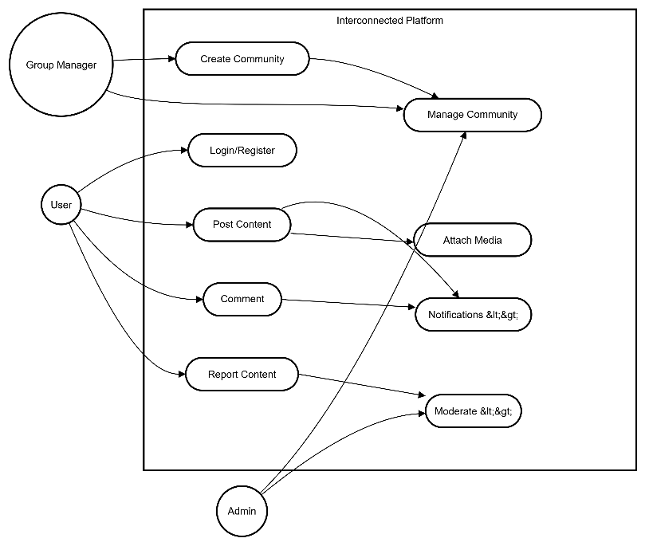
Figure 3.1: Use Case Diagram of Interconnected
Admin:
The administrator must be authenticated before accessing the system. Once logged in, the admin can access the administrative dashboard to manage users, oversee communities, review reported content, and enforce platform-wide policies.
Group Manager (Community Moderator):
The group manager must be authenticated to access community management features. Their primary responsibility is to approve or reject membership requests for private communities they manage. Group managers do not have permission to moderate posts or comments.
User:
Registered users can access the platform after logging in. Users are able to create posts, attach media, comment on community content, receive notifications, and report inappropriate content. They can participate in communities of interest but cannot perform moderation or administrative actions without the appropriate privileges.
ii Non-Functional Requirements
Performance and Responsiveness
- The website should load quickly and respond promptly to user actions.
- It should handle many users at the same time without slowing down.
Accessibility
- Users should be able to access the system from anywhere with a stable internet connection.

Usability
- The website should be simple and easy to use.
- The interface should be intuitive and work on desktop, tablet, and mobile devices.
Security
- User data, including passwords and payment information, must be protected.
- Communication should be secure (HTTPS), and user inputs must be validated.

Reliability and Availability
- The system should be available 24/7 with minimal downtime.
- Errors should be handled properly, and data should be backed up regularly.

Maintainability
- The system should be easy to update and maintain.
- Code should be organized and documented for future improvements.

3.1.2 Feasibility Study
A feasibility study evaluates whether the proposed system can be successfully developed and operated, considering available resources, technology, time, and operational factors. For Interconnected, the study examines technical, operational, economic, and schedule feasibility to determine practicality and identify any risks.
a. Economic Feasibility
The system uses free and open-source technologies such as React with TypeScript, PHP, MySQL, and XAMPP, so there are no software licensing costs. Development can be done on existing computers, and internet and electricity costs are minimal. Overall, the project is financially feasible for a college setting, with no significant expenses.
b. Technical Feasibility
The required technologies are mature, well-documented, and suitable for building the platform:
Frontend Technologies: The interface will be built using React with TypeScript, HTML, and CSS. TypeScript ensures fewer errors due to its strong typing, and React supports dynamic, responsive interfaces. Features such as user profiles, posts, comments, and single-community viewing are fully achievable with this stack.
Backend Technologies: PHP handles server-side operations including authentication, session management, and database interactions. PHP is widely used and well-documented.
Database Technology: MySQL is a reliable relational database suitable for storing users, communities, posts, and relationships. It provides indexing, transactions, and data integrity. Administration tools are available for easy management.
Development Environment: XAMPP provides a complete local environment including Apache, MySQL, and PHP, allowing full development and testing on a local machine.
The technical feasibility confirms that all required resources are available and there are no significant technical barriers to completing the project.

c. Operational Feasibility
The system is designed to be intuitive and easy to use for both students and administrators:
User Perspective: Users will find the platform accessible and user-friendly. It follows familiar social media patterns (profiles, posts, comments) with enhancements like single-community viewing. Minimal learning is required for students already familiar with online communities.

Administrator Perspective: The admin dashboard and moderation tools provide full control over communities. The interface is simple and does not require extensive training.
Maintenance Perspective: The modular design allows easy updates and maintenance. Documentation created during development supports future maintenance.
Overall, the system is practical, usable, and maintainable in a college project setting.
d. Schedule Feasibility
The project can be completed within the available timeframe using a Waterfall development model, which organizes tasks sequentially. Each phase (analysis, design, implementation, testing, deployment) follows a clear order, reducing confusion and ensuring systematic progress.

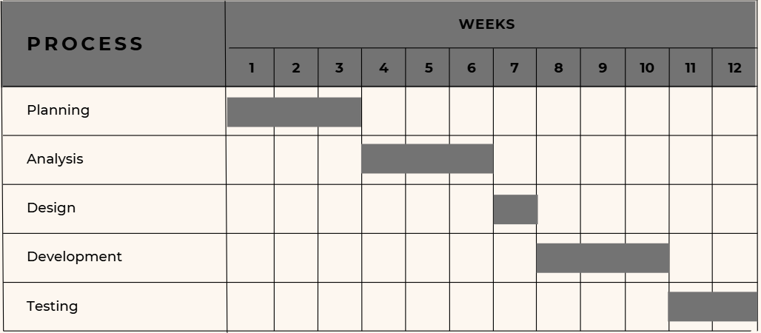
Figure 3. 1 Gantt Chart of interconnected

task | Start date | Duration | End date
documentation | 10/10/2025 | 2 | 10/10/2025
Requirement | 10/10/2025 | 22 | 10/10/2025
Design | 10/10/2025 | 22 | 10/10/2025
Implementation | 10/10/2025 | 2 | 10/10/2025
Testing | 10/10/2025 | 2 | 10/10/2025
maintenance | 10/10/2025 | 2 | 10/10/2025

Figure 3.2 Gantt Table of interconnected

3.1.3 Data Modeling
Data modeling is the process of creating a conceptual representation of the data structures, entities, relationships, and constraints that will be stored in a system's database. For Interconnected, data modeling uses Entity Relationship Diagrams (ERD) to visualize the database schema and illustrate the relationships between different data entities. ERDs provide a clear structure for developers and stakeholders to understand how data is organized, maintained, and interconnected.
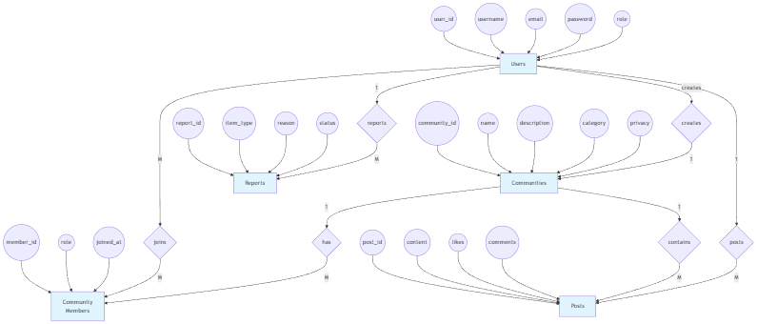
Figure 3.3: Entity Relationship Diagram of Interconnected
Figure 3.3: The Entity Relationship Diagram for Interconnected provides a visual representation of the relationships and interactions between the primary entities such as User, Community, Post, Comment, Membership, and Report. It shows how users can register, log in, join communities, create posts, and comment on content, highlighting the connections between these entities and their attributes. The diagram also illustrates the roles and functionalities available to administrators and moderators, including managing communities, monitoring content, and handling reports. By visually mapping the database schema and the relationships between these components, the ER diagram serves as a clear tool for understanding the underlying structure, data flow, and functionality of the Interconnected platform’s database.

3.1.4 Process Modeling
Process modeling involves graphically representing the processes that capture, manipulate, store, and distribute data between a system and its environment. For Interconnected, Data Flow Diagrams (DFDs) are used to illustrate how data moves through the system, showing processes, data stores, external entities, and the flow of information. Multiple levels of DFDs provide different views of the system, from a high-level overview to more detailed process specifications.
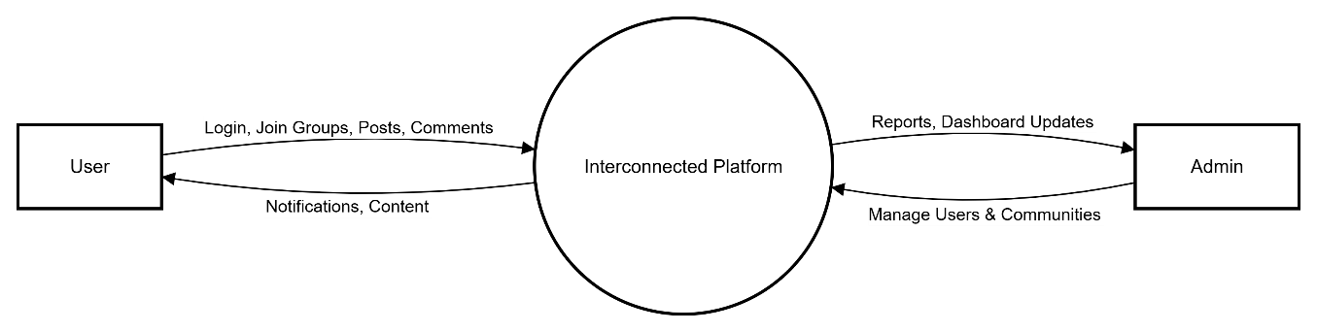
Figure 3.4: Context Level Diagram of Interconnected

The Context Level Diagram provides the highest-level view of the Interconnected system, showing it as a single process interacting with external entities:
- User: Registered users who can log in, browse communities, view posts, create content, and perform other platform actions.
- Administrator: Platform administrators responsible for managing users, communities, and reported content.
This diagram establishes the system boundary, highlighting interactions between external entities and the Interconnected platform.

Level 1 DFD – User Processes:

<!-- [INSERT: Figure 3.5 - Level 1 DFD showing detailed user processes and data flows] -->

Figure 3.5: User Level 1 Data Flow Diagram of Interconnected

The Level 1 DFD for users decomposes the system into major functional processes:
- User Authentication: Users log in and receive authentication responses.
- Profile Management: Users can view and update their profiles.
- Community Discovery & Joining: Users can browse communities, search by category, and join communities.
- Community Creation & Management: Users can create new communities. Upon creation, they are assigned the role of community manager, granting them moderation privileges within their community.
- Content Viewing & Creation: Users can view posts and comments or create new posts/comments within communities they are members of.
- Content Interaction: Users can report inappropriate content.
The diagram shows how data flows between users and the system’s core functions while interacting with relevant data stores, including User, Community, Membership, Post, and Comment data stores.
Level 1 DFD – Administrator Processes:
<!-- [INSERT: Figure 3.6 - Level 1 DFD showing detailed administrator processes and data flows] -->
Figure 3.6: Admin Level 1 Data Flow Diagram of Interconnected
The Level 1 DFD for administrators shows the main management and moderation processes:
- Admin Authentication: Administrators log in and receive authentication responses.
- User Management: Administrators view, suspend, or ban users.
- Community Management: Administrators manage communities and assign moderators.
- Content Moderation: Administrators review reported posts and comments.
- Analytics & Monitoring: Administrators generate reports and monitor platform activity.
- System Configuration: Administrators update platform settings and policies.
This diagram illustrates how administrators interact with the system independently of regular users while accessing the same underlying data stores.

3.2 System Design
System design is the process of defining a system's components, including modules, architecture, interfaces, and data, based on the requirements identified during analysis. Design serves as the bridge between system analysis and implementation. In the design phase of Interconnected, several design artifacts were created, including system architecture, database schema design, UI interface and structure diagrams, and physical DFDs.

3.2.1 System Architecture
The system architecture of Interconnected is divided into three main layers: presentation layer, application layer, and database layer.
Presentation Layer:
The presentation layer handles all interactions with users, receiving their requests and providing responses. Users access the platform via web browsers, where the interface displays content and functionalities. The frontend is built using React.js for dynamic, responsive, and interactive interfaces, alongside HTML5 for structure and CSS3 for styling. These technologies ensure smooth user experience for activities such as registering, logging in, browsing communities, creating posts, and managing content.
Application Layer:
The application layer, also called the logic layer, processes requests from the presentation layer. It implements the business logic of the platform, handling authentication, community management, content creation, reporting, and moderation workflows. PHP is used for server-side development, providing secure processing of user requests, session management, and interaction with the database. This layer ensures that user actions are validated, processed, and returned with the appropriate responses.
Database Layer:
The database layer stores all persistent data of the Interconnected platform. It manages users, communities, posts, comments, memberships, and reports. MySQL is used as the relational database management system, ensuring data integrity, support for transactions, indexing for performance, and structured storage. This layer allows the application to retrieve and update data efficiently, supporting platform functionalities such as community discovery, content viewing, user management, and reporting.
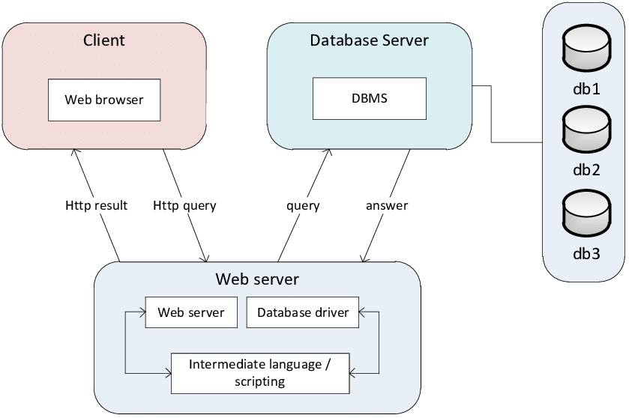
Figure 3.7: System Architecture of Interconnected

3.2.2 Database Schema Design
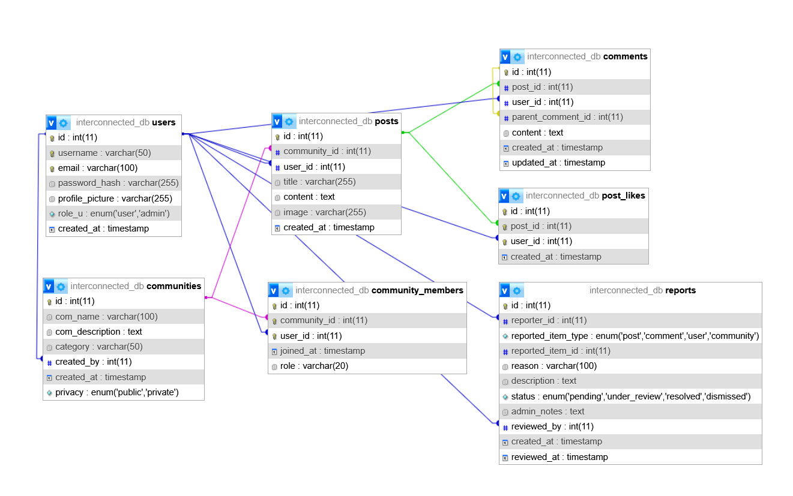
Figure 3.8: Database Schema Design of Interconnected
The database schema for Interconnected provides a structured representation of the platform’s data and the relationships between different entities. The relational database design organizes information across several interconnected tables, including Users, Communities, Community Members, Posts, Post Likes, Comments, and Reports.
- Users Table: Stores information about registered users, including username, email, password hash, profile picture, role, and account creation timestamp. Indexes on email and username optimize search and authentication queries.
- Communities Table: Manages information about communities, including name, description, category, creator, creation date, and privacy level. Each community references a creator from the Users table.
- Community Members Table: Represents the many-to-many relationship between users and communities, tracking membership, roles (member, moderator), and join date. Unique constraints ensure a user cannot join the same community twice.
- Posts Table: Contains posts created within communities, including title, content, optional images, creation timestamp, and references to the author and community.

- Post Likes Table: Tracks likes on posts, ensuring each user can like a post only once, with foreign key relationships to posts and users.
- Comments Table: Stores comments and replies on posts, supporting hierarchical relationships through a parent comment reference. Includes timestamps for creation and updates.
- Reports Table: Captures user-reported content requiring moderation. It stores the reporter, type of reported item (post, comment, user, or community), reason, description, status, assigned moderator, and timestamps.
Foreign keys enforce referential integrity between tables, ensuring consistent relationships between users, communities, posts, comments, and reports. Indexes on frequently queried fields enhance performance, enabling efficient data retrieval for platform functionalities such as user management, community interaction, content moderation, and reporting.
Overall, this schema supports the core functionalities of Interconnected, facilitating scalable, secure, and organized storage of all platform data.

3.2.3 Interface Design (UI Interface/ Interface Structure Diagrams)

References
[1] Zuboff, S. (2019). The Age of Surveillance Capitalism: The Fight for a Human Future at the New Frontier of Power. New York: PublicAffairs.
[2] Tufekci, Z. (2018). YouTube, the great radicalizer. The New York Times.
[3] Kraut, R. E., & Resnick, P. (2011). Building Successful Online Communities: Evidence-Based Social Design. MIT Press.
[4] Ren, Y., Kraut, R., & Kiesler, S. (2007). Applying common identity and bond theory to design of online communities. Organization Studies, 28(3), 377–408.
[5] Newport, C. (2016). Deep Work: Rules for Focused Success in a Distracted World. Grand Central Publishing.
[6] Carr, N. (2010). The Shallows: What the Internet Is Doing to Our Brains. W. W. Norton & Company.
[7] Gillespie, T. (2018). Custodians of the Internet: Platforms, Content Moderation, and the Hidden Decisions That Shape Social Media. Yale University Press.
[8] Norman, D. A. (2013). The Design of Everyday Things (Revised and Expanded Edition). Basic Books.

4.1 Requirement Identification

4.1.1 Study of Existing Systems
Discord:
Strengths: Excellent group chat functionality, real-time communication, server-based organization
Limitations: Less focused on community productivity, primarily gaming-oriented, can be overwhelming for new users

Facebook Groups:
Strengths: Large user base, established community features, diverse topic coverage
Limitations: Algorithm prioritizes engagement over relevance, communities buried under news feed, privacy concerns

Pinterest:
Strengths: Excellent idea sharing and discovery, visual-focused content, inspiration-driven
Limitations: Limited community interaction, no real-time discussion features, lacks depth in conversations

Reddit:
Strengths: Topic-focused subreddits, community moderation, diverse content
Limitations: Can be intimidating for new users, voting system can create bias, limited personal connection features

4.1.2 Requirement Collection
Functional Requirements:
User Management:
- User registration and authentication system
- Profile creation and management
- Privacy settings and preferences
Community Features:
- Create and join interest-based communities
- Community moderation tools
- Topic categorization system
Content Management:
- Create, edit, and delete posts within communities
- Comment and reply to functionality
- Content sharing and bookmarking

Administrative Functions:
- Admin dashboard for platform oversight
- Community and user management
- Content moderation and reporting system

Non-Functional Requirements:
Performance: Support many users, fast & responsive, scalable
Security: Encrypted data, secure login, spam/malware protection
Usability: Simple UI, works on all devices, focus mode (one community at a time)

4.2 Feasibility Study

4.2.1 Technical Feasibility
The system will be developed using proven web technologies:
Frontend: React.js for dynamic user interfaces, HTML5, CSS3 for styling
Backend: PHP for server-side logic
Database: MySQL for data storage and management
Development Environment: XAMPP for local development and testing
These technologies are well-documented, widely supported, and suitable for the project requirements.

4.2.2 Operational Feasibility
The platform is designed with user experience in mind:
- Simple registration and onboarding process (CRUD operations)
- Intuitive community navigation
- Clear content organization
- Minimal learning curve for users familiar with social media

4.2.3 Economic Feasibility
The project is economically viable:
Uses open-source technologies (React, PHP, MySQL)
Low initial development costs
Minimal hosting requirements for initial deployment
Scalable architecture allows for gradual growth
Potential for monetization through premium features or partnerships

4.3 High Level Design

4.3.1 System Architecture

Figure: Context Level Diagram

4.3.2 User Flow Design

5. Project Gannt chart

Figure: Gantt Chart

6. Expected Outcome
The Interconnected platform is expected to deliver:
Core Features:
- A fully functional community-oriented social media platform
- User registration and authentication system
- Community creation and management tools
- Focused content sharing and discussion features
- Administrative control panel

User Experience:
- Intuitive interface that promotes focus and productivity
- Meaningful connections between users with shared interests
- Reduced information overload through single-community viewing
- Safe, moderated environment for constructive discussions
Technical Deliverables:
- Complete CRUD operation
- Responsive web applications compatible with desktop and mobile devices
- Secure, scalable backend system
- Comprehensive documentation
- Admin tools for platform management

7. References
[1] Discord Inc. "Discord." [Online]. Available: https://discord.com/. [Accessed: Dec. 2024]
[2] Meta Platforms Inc. "Facebook." [Online]. Available: https://www.facebook.com/. [Accessed: Dec. 2024]
[3] Pinterest Inc. "Pinterest." [Online]. Available: https://www.pinterest.com/. [Accessed: Dec. 2024]
[4] Reddit Inc. "Reddit." [Online]. Available: https://www.reddit.com/. [Accessed: Dec. 2024]
[5] React Documentation. "React – A JavaScript library for building user interfaces." [Online]. Available: https://reactjs.org/. [Accessed: Dec. 2024]
[6] PHP Group. "PHP: Hypertext Preprocessor." [Online]. Available: https://www.php.net/. [Accessed: Dec. 2024]
[7] Oracle Corporation. "MySQL." [Online]. Available: https://www.mysql.com/. [Accessed: Dec. 2024]

