Before creating snapshot:

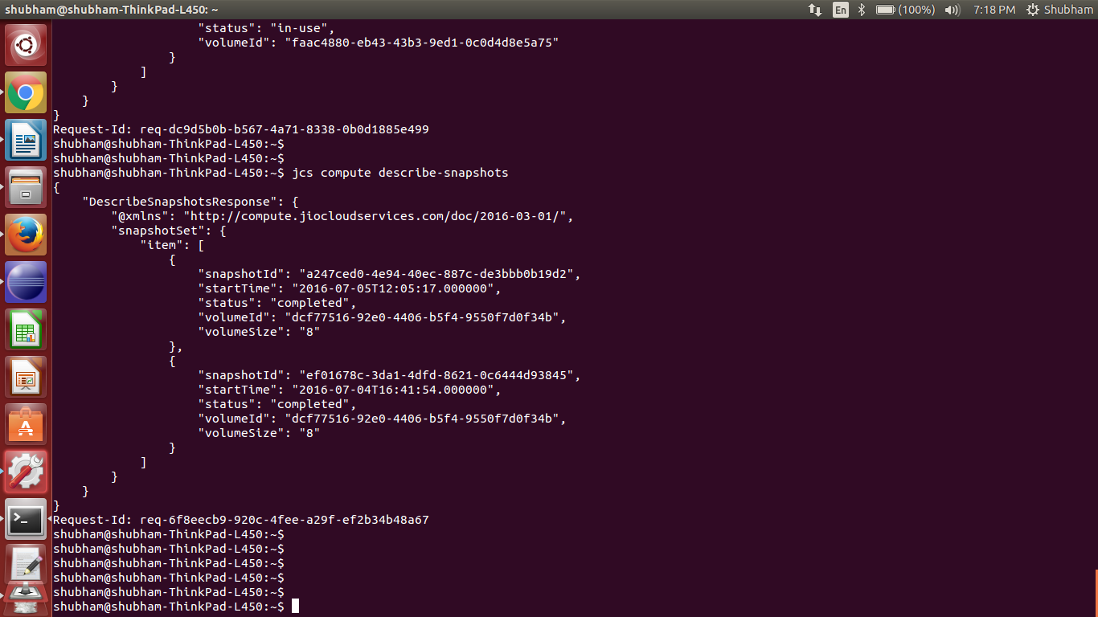

creating snapshot using java sdk:

public class JCStry {

static JCSCompute jcs;

private static void init() throws Exception {

JCSCredentials credentials = new JCSCredentials() {

@Override
public String getJCSAccessKey() {
// TODO Auto-generated method stub
return "856207ec61a64f3a8b59a5a33b6186a7";

}

@Override
public String getJCSSecretKey() {
// TODO Auto-generated method stub
return "567c59052b374d1ea308b938020dc0e3";
}

};

jcs = new JCSComputeClient(credentials);

}

public static void main(String[] args) throws Exception {

init();

try {

CreateSnapshotRequest createSnapshotRequest = new CreateSnapshotRequest() .withVolumeId("dcf77516-92e0-4406-b5f4-9550f7d0f34b");

CreateSnapshotResult createSnapshotResult = jcs.createSnapshot(createSnapshotRequest);

System.out.println(createSnapshotResult.toString());

} catch (Exception e) {
e.printStackTrace();

}
}
}

OUTPUT:

HTTP/1.1 200 OK
<CreateSnapshotResponse xmlns="http://compute.jiocloudservices.com/doc/2016-03-01/">
<requestId>req-3e499bb7-c274-4f3f-8531-78a9ddc62e04</requestId>
<status>pending</status>
<snapshotId>4ad40d1f-5cb6-4588-b527-7e43bcbe54d3</snapshotId>
<volumeSize>8</volumeSize>
<volumeId>dcf77516-92e0-4406-b5f4-9550f7d0f34b</volumeId>
<startTime>2016-07-05T19:20:22.000000</startTime>
</CreateSnapshotResponse>

Describe-snapshots after creating snapshot:

