Before deleting snapshot:

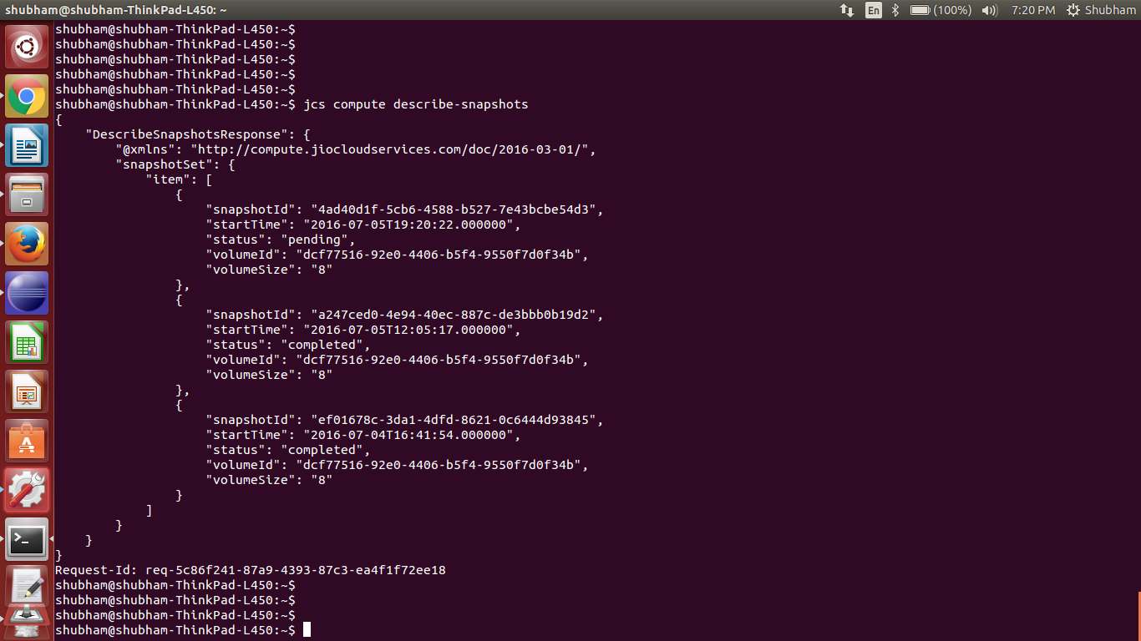

deleting snapshot using java sdk:

public class JCStry {

static JCSCompute jcs;

private static void init() throws Exception {

JCSCredentials credentials = new JCSCredentials() {

@Override
public String getJCSAccessKey() {
// TODO Auto-generated method stub
return "856207ec61a64f3a8b59a5a33b6186a7";

}

@Override
public String getJCSSecretKey() {
// TODO Auto-generated method stub
return "567c59052b374d1ea308b938020dc0e3";
}

};

jcs = new JCSComputeClient(credentials);

}

public static void main(String[] args) throws Exception {

init();

try {

DeleteSnapshotRequest deleteSnapshotRequest = new DeleteSnapshotRequest().withSnapshotId("4ad40d1f-5cb6-4588-b527-7e43bcbe54d3");

DeleteSnapshotResult deleteSnapshotResult = jcs.deleteSnapshot(deleteSnapshotRequest);

System.out.println(deleteSnapshotResult.toString());

} catch (Exception e) {
e.printStackTrace();

}
}
}

OUTPUT:

HTTP/1.1 200 OK
<DeleteSnapshotResponse xmlns="http://compute.jiocloudservices.com/doc/2016-03-01/">
<requestId>req-68a1ce71-aadd-416c-b809-aa5609414cc4</requestId>
<return>true</return>
</DeleteSnapshotResponse>

Describe-snapshots after deleting snapshot with ID: 4ad40d1f-5cb6-4588-b527-7e43bcbe54d3

