Before creating volume:

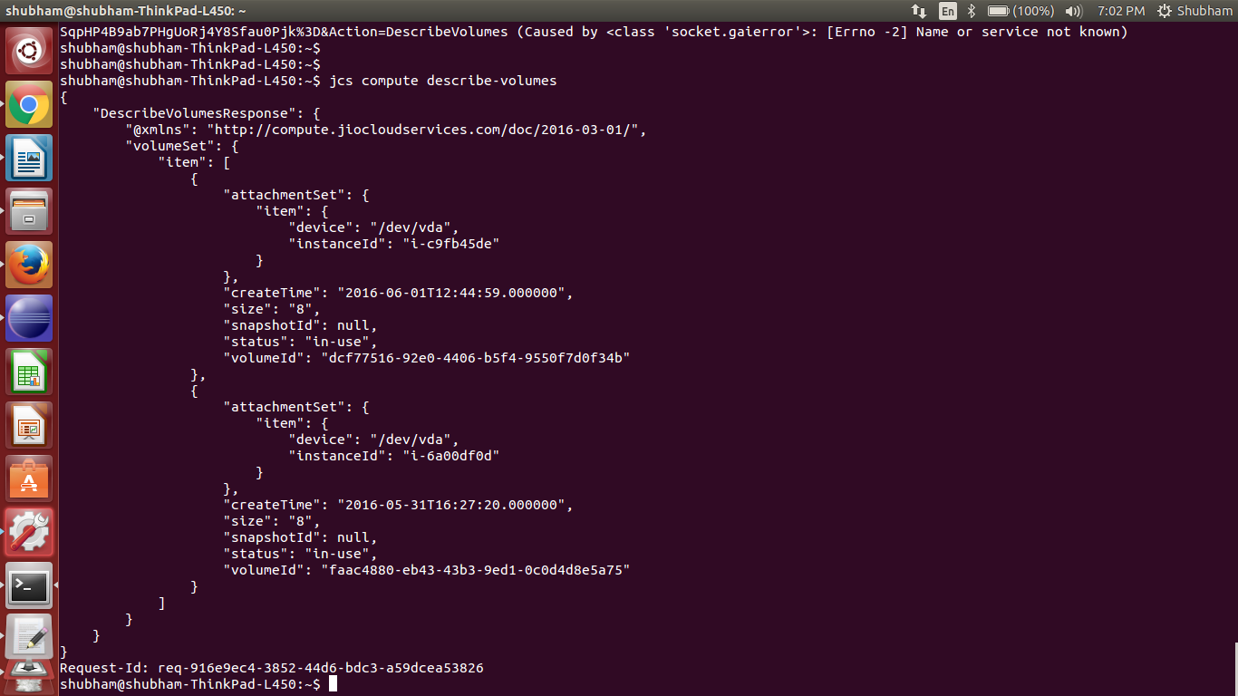

creating volume using java sdk:

public class JCStry {

static JCSCompute jcs;

private static void init() throws Exception {

JCSCredentials credentials = new JCSCredentials() {

@Override
public String getJCSAccessKey() {
// TODO Auto-generated method stub
return "856207ec61a64f3a8b59a5a33b6186a7";

}

@Override
public String getJCSSecretKey() {
// TODO Auto-generated method stub
return "567c59052b374d1ea308b938020dc0e3";
}

};

jcs = new JCSComputeClient(credentials);

}

public static void main(String[] args) throws Exception {

init();

try {

CreateVolumeRequest createVolumeRequest = new CreateVolumeRequest();

createVolumeRequest.setSize(5);

CreateVolumeResult createVolumeResult = jcs.createVolume(createVolumeRequest);

System.out.println(createVolumeResult.toString());

} catch (Exception e) {
e.printStackTrace();

}
}
}

OUTPUT:

HTTP/1.1 200 OK
<CreateVolumeResponse xmlns="http://compute.jiocloudservices.com/doc/2016-03-01/">
<requestId>req-884c48a6-e5c0-4e39-a223-1e6bd5b548c1</requestId>
<status>creating</status>
<volumeId>91d804df-3e31-416d-9a64-8a2488ca7b0f</volumeId>
<attachmentSet/>
<snapshotId/>
<createTime>2016-07-05T19:04:01.574503</createTime>
<size>5</size>
</CreateVolumeResponse>

Describe-volumes after creating volume:

