Before deleting volume:

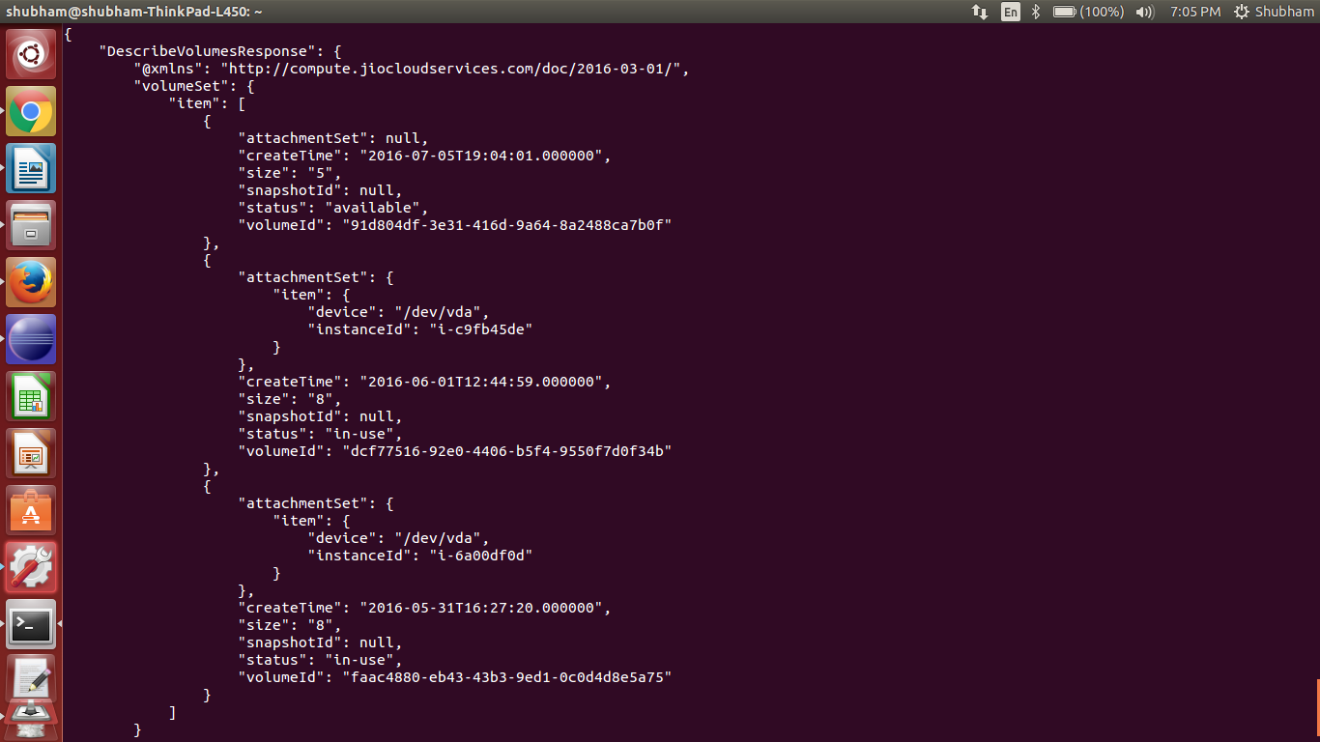

deleting volume using java sdk:

public class JCStry {

static JCSCompute jcs;

private static void init() throws Exception {

JCSCredentials credentials = new JCSCredentials() {

@Override
public String getJCSAccessKey() {
// TODO Auto-generated method stub
return "856207ec61a64f3a8b59a5a33b6186a7";

}

@Override
public String getJCSSecretKey() {
// TODO Auto-generated method stub
return "567c59052b374d1ea308b938020dc0e3";
}

};

jcs = new JCSComputeClient(credentials);

}

public static void main(String[] args) throws Exception {

init();

try {

DeleteVolumeRequest deleteVolumeRequest = new DeleteVolumeRequest().withVolumeId("91d804df-3e31-416d-9a64-8a2488ca7b0f");

DeleteVolumeResult deleteVolumeResult = jcs.deleteVolume(deleteVolumeRequest);

System.out.println(deleteVolumeResult.toString());

} catch (Exception e) {
e.printStackTrace();

}
}
}

OUTPUT:

HTTP/1.1 200 OK
<DeleteVolumeResponse xmlns="http://compute.jiocloudservices.com/doc/2016-03-01/">
<requestId>req-921bd46d-ac74-4d55-850a-5b97ceee3515</requestId>
<return>true</return>
</DeleteVolumeResponse>

Describe-volumes after deleting volume:

