PS16 Design Document – Group G160
Institute: BITS Pilani, WILP
Program: M.Tech AI & ML
Course: AIMLCZG557 / AECLZG557
Semester: S2 2025–2026
Assignment: PS16 – Genetic Algorithm
Group Id: G160

1. Introduction
This assignment implements a Genetic Algorithm (GA) to maximize the function f(x) = x^2 over the domain 0 ≤ x ≤ 31. The variable x is encoded as a 5-bit binary chromosome and evolved using selection, crossover, mutation, and elitism.
The goal is to build a complete GA workflow that initializes a population, evaluates fitness, selects parents using roulette wheel selection, applies single-point crossover and bit-flip mutation, preserves the best solution via elitism, and stops after a fixed number of generations. The behavior is analyzed using numerical outputs and plots of best and average fitness versus generation.

2. Problem Formulation and GA Design

2.1 Objective and encoding
Objective function: f(x) = x^2, with 0 ≤ x ≤ 31. Each solution is represented as a 5-bit binary chromosome b4 b3 b2 b1 b0, interpreted as an unsigned integer. For example, 11111 represents x = 31 with fitness 961.

2.2 GA parameters
The Genetic Algorithm uses: population size 10, chromosome length 5 bits, fitness f(x) = x^2, roulette wheel selection, single-point crossover with Pc = 0.8, bit-flip mutation with Pm = 0.01, elitism, and termination after 50 generations. These values provide a reasonable balance between exploration and exploitation for a small discrete search space.

2.3 GA workflow overview
For each generation, the GA: (1) decodes chromosomes to x, (2) evaluates fitness, (3) selects parents using roulette wheel selection, (4) applies single-point crossover with probability Pc, (5) applies bit-flip mutation with probability Pm, (6) applies elitism by preserving the best chromosome, and (7) records best and average fitness. This loop is repeated for 50 generations.

3. Workflow Details

3.1 Population initialization
The initial population consists of 10 randomly chosen 5-bit chromosomes or, for the sample run, the 10 chromosomes provided in inputPS16.txt. Each chromosome is a string of bits such as 10101 or 11111.

3.2 Fitness evaluation
For each chromosome c, the algorithm decodes c to integer x and computes fitness as f(x) = x^2. In Generation 0 of the sample run, fitness values range from 9 (x = 3) to 961 (x = 31), and the average fitness is 352.40. The best chromosome is 11111 with fitness 961.

3.3 Roulette wheel selection
Roulette wheel selection chooses parents with probability proportional to their fitness. The algorithm computes total fitness, samples a random value, and walks through the population accumulating fitness until the cumulative sum exceeds the sample. High-fitness chromosomes are selected more often, but lower-fitness chromosomes still have a chance, which maintains diversity.

3.4 Single-point crossover
Parents from the mating pool are paired and undergo single-point crossover with probability Pc = 0.8. A random crossover point between positions 1 and 4 is chosen, and the parents exchange tails to produce two offspring. If crossover is not applied, parents are copied unchanged. This recombines useful bit patterns from different individuals.

3.5 Bit-flip mutation
After crossover, each bit in each chromosome is flipped independently with probability Pm = 0.01. A 0 becomes 1, and a 1 becomes 0 if mutation occurs. Because the rate is low, most bits stay the same, but occasional flips introduce new genetic material and help prevent premature convergence.

3.6 Elitism and termination
Elitism is implemented by copying the best chromosome from the previous generation into the new population, replacing the worst chromosome. This guarantees that the best fitness does not decrease. The GA stops after 50 generations, and the histories of best and average fitness are used to plot convergence curves.

4. Role of Crossover and Mutation

4.1 Crossover
Single-point crossover is the main exploration operator. By recombining genes from two parents, it constructs offspring that may inherit high-fitness bit patterns from both. With Pc = 0.8, crossover is applied frequently, which accelerates the spread of good schemata through the population.

4.2 Mutation
Bit-flip mutation provides a steady background of randomness. It restores alleles that may have been lost and offers a mechanism to escape local optima. With Pm = 0.01, mutation makes small changes that complement selection and crossover without destroying high-quality chromosomes.

4.3 Interaction with selection and elitism
Roulette wheel selection and elitism focus the search around high-fitness regions, while crossover and mutation explore new combinations. Selection and elitism exploit current best solutions such as 11111, crossover recombines useful building blocks, and mutation maintains diversity. Together, these operators guide the population toward the global optimum x = 31.

5. Results and Observations

5.1 Generation 0 and diversity
The initial population in the sample run is: 10101, 00111, 11100, 01010, 10011, 01101, 11001, 00011, 11111, 00101. The best chromosome is 11111 with fitness 961, and the average fitness is 352.40. The remaining chromosomes cover a range of values, providing good initial diversity.

5.2 Convergence and final population
After 50 generations, the GA reports best chromosome 11111, decoded value x = 31, and maximum fitness 961. The final population consists entirely of 11111, which shows complete convergence to the global optimum. Elitism preserves this solution once it appears, and roulette wheel selection ensures it quickly dominates the population.

5.3 Fitness curves
The best fitness curve rises rapidly to 961 and remains flat at that value, reflecting the effect of elitism. The average fitness curve starts at 352.40 and steadily increases as more individuals become identical to 11111. Both curves confirm that the GA is effective at finding and maintaining the optimal solution.
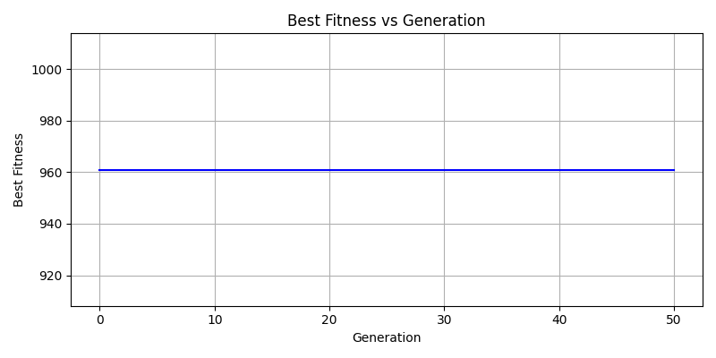
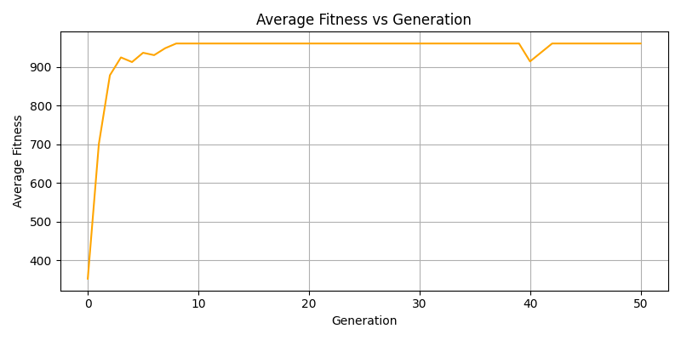

5.4 Key observations
The GA converges reliably to x = 31. Roulette wheel selection strongly favors high-fitness chromosomes, mutation introduces limited but useful diversity, and elitism prevents loss of the best individual. For this small search space and parameter setup, the GA behaves predictably and reaches the global maximum.

6. Alternative Modelling

6.1 Tournament selection
An alternative to roulette wheel selection is tournament selection. A small group of individuals is sampled, and the best individual in the group is chosen as a parent. Tournament selection is simple to implement, and selection pressure can be tuned by changing the tournament size. However, if the tournament is too large, the population may lose diversity more quickly than with roulette wheel selection.
For this small one-dimensional problem, tournament selection with a moderate tournament size would likely still converge to the optimal solution x = 31. Roulette wheel selection is used in our implementation because it matches the assignment specification and provides a smooth probability distribution based on fitness.

7. Conclusion
We implemented a complete binary Genetic Algorithm to maximize f(x) = x^2 on 0 ≤ x ≤ 31 using 5-bit chromosomes, roulette wheel selection, single-point crossover, bit-flip mutation, and elitism. The algorithm converges to the global optimum x = 31 with fitness 961 and produces best and average fitness plots that clearly illustrate convergence behavior.
The results show that even with a small population and simple operators, a GA can efficiently solve this discrete optimization task when parameters and representation are chosen appropriately

