DATASETS FOR BUILDING CORPUS
follow this link to get the corpus set of parrot library
https://huggingface.co/datasets/Pavithra/sampled-code-parrot-ds-valid
instructions
For transformer
https://github.com/huggingface/transformers/blob/main/src/transformers/data/datasets/language_modeling.py

COMPARITIVE SCORES(THE SCORES FOR OUR SECOND PARAPHRASER)
In a final evaluation to measure the syntactic correctness of the paraphrases ,we used a
novel technique based on Charniak's parser
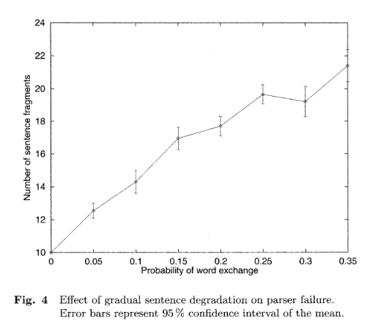
Our results support the findings of turian test,showing that
adding more references to the references set improvesthe MT evaluation performance,except in the case of NIST where more than 4.referencesdegrades the evaluation performance, for NIST,16 references offers a comparable level of performance to just a single
reference.For NIST,16 references offers a comparable level of performance to just a single
reference.
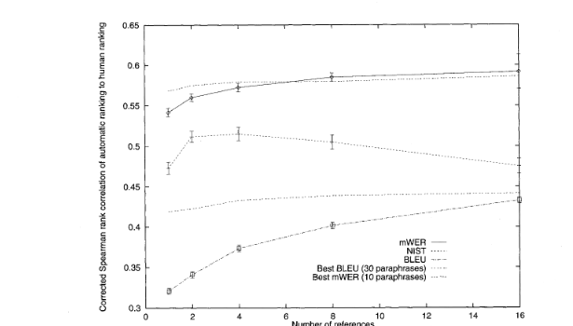

REFERENCES

https://aclanthology.org/J83-1001.pdf
https://aclanthology.org/C12-1177.pdf
https://aclanthology.org/C88-2088.pdf
https://www.jstage.jst.go.jp/article/jnlp1994/11/5/11_5_87/_pdf

