PRECOG RECRUITMENT TASK

Pandas and numpy libraries were mainly used along with slight usage of, matplotlib and collections.

We first went on analysing the data, on a single state for avoiding clarity purpose on state code = 2(andhra pradesh).

We first checked the the number and percentages of male and female judges in the judges_clean.csv and got
67540 male , 27202 female and 0 unclear judges, which brings down to 28.71%, which was significantly low.
We further went on analysing andhra pradesh, 998 female and 1925 males which brings the percentage to34.13.
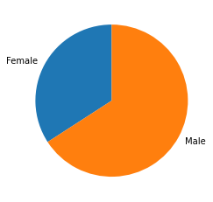

Next we went on analysing the different kinds of judge positions
We notice that chief judicial magistrate': 14373, 'civil judge junior division': 9918, 'civil judge senior division': 13632, 'district and sessions court': 20286, 'judicial magistrate court': 3578, have the maximum number cases summing to around 2/3rds of total cases and others are of total : 37000
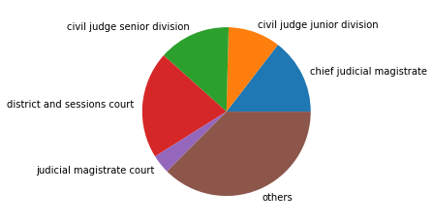

After this we went on finding the number of days a case lasts irrespective of the judge and type of case, and got to a conclusion that average case took 355.57 days.(The mean number of days it takes for a case to reach from filing to decision date ranges from 149 days in Gyalshing district in Sikkim, to 5 years in Chandauli district in Uttar Pradesh!)
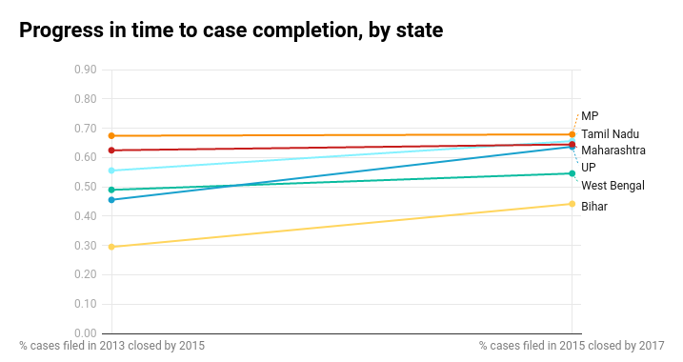
Now we went on a deeper analysis and found that the female average came out to be 346 days and male around 359 days.

Which directs us to conclusion, that female though take a considerably less time in closing the cases, yet are low in number in the courts.

Next we went to year – by – year analysis, again on the state code 2.

Firstly we analysed the purpose of the cases and found almost 50% of the case comprised of 4126.0 3545.0 4762.0 1455.0 2461.0 case codes.
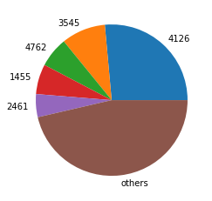

Next we went on analysing the type of cases for further understanding
and found about 82% of the cases comprised of types 820 4274 2219 4080 4222

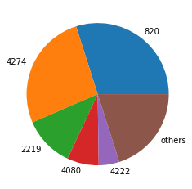

On further detailed analysis:
To our astonishment, we discovered almost no evidence of in-group bias among judges on either gender or religion across six million criminal cases. When male defendants were assigned to male judges, their outcomes did not improve; similarly, female judges did not favour women.

