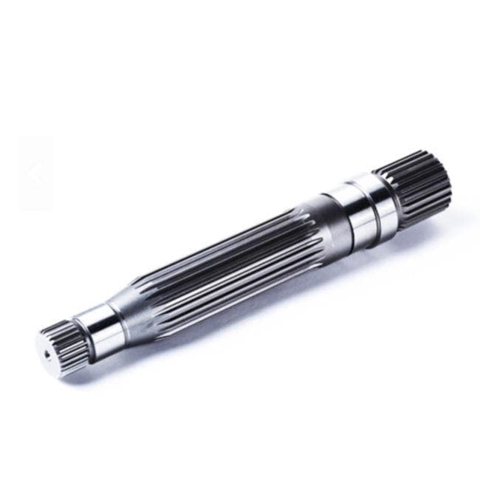Hydraulic Fitting

forged shaft
A forged shaft is a cylindrical mechanical component shaped by heating metal billets and applying extreme compressive forces using hammers or presses. This process refines the internal grain structure, creating high-strength, durable parts capable of withstanding heavy impact and high torque.
View details
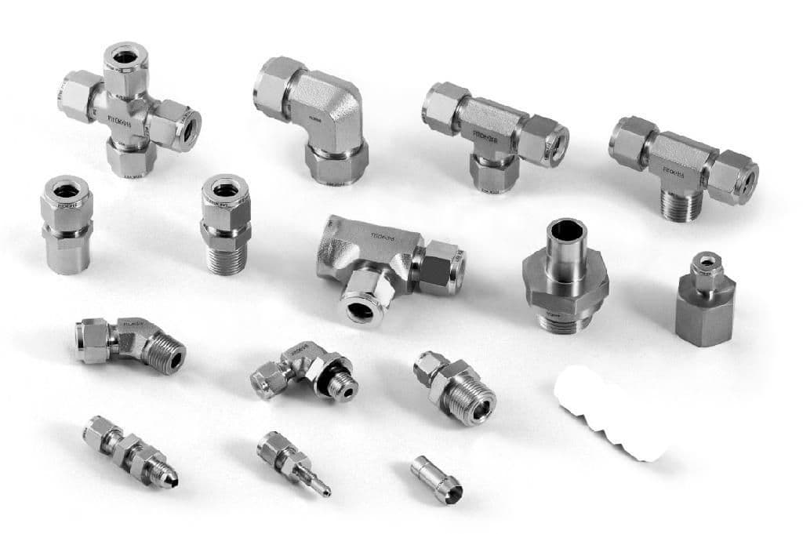Automotive

automotive
Our industrial-grade valve actuator, model V215, is designed to effectively and reliably control the flow of fluids or gases in critical applications where precise and repeatable control is essential. Constructed from premium stainless steel, it offers superior rust and corrosion resistance, making it well-suited for harsh environments requiring long-lasting durability in even the most aggressive media environments. With a wide range of available torques from 25 Nm to 280 Nm, it provides precise and smooth linear motion and is compatible with various valve types, including globe, ball, and butterfly valves. Its robust construction boasts a load-sensing spring return feature, enabling quick reset times and repeatablepositioning accuracy. The V215 excels in applications such as chemical, pharmaceutical, and food and beverage processing, featuring a linear output between the limit switches and programmable soft starting/stopping in a compact, user-selectable design. Its versatile electronics work with a range of signal types, including MODBUS, analog, SIMATIC, and STO, and its intrinsically safe options meet the requirements of hazardous area classifications such as Zone 2/ Div 1. Backed by our industry-leading warranty, this actuator ensures optimal performance and reliability.
View details
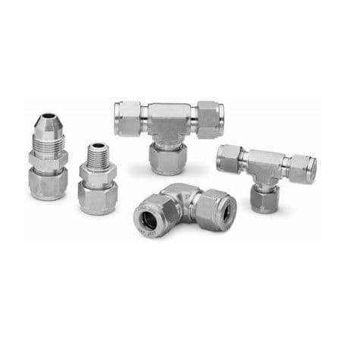Automotive

automotive
Introducing our heavy-duty cast iron flange seal, carefully crafted to deliver reliable performance in harsh industrial environments. This high-grade component is engineered to provide superior sealing and withstand even the most demanding use cases. Consisting of high-strength, corrosion-resistant iron alloy, it features a precise machining for a flush mount installation and precision ground surface for a snug fit. With a pressure rating up to 500 psi, this flange seal is ideal for applications in the chemical, mineral processing, and food and beverage industries, where high-purity and consistent flow are crucial. The integrated metering flange allows secure attachment to a variety of piping systems, providing a leak-free seal that guarantees excellent flow control. Its smooth finish and accessible taper thread make installation and maintenance effortless, ensuring maximum efficiency and hygiene compliance. Trust in this durable product to deliver unparalleled sealing performance that endures harsh chemicals and temperatures ranging from -200°F to 1000°F (-129°C to 377°C). With a long service life, you can rely on its ability to maintain an airtightness, preserving chemical purity without risk of corrosion or deformation. Trust our cast iron flange seal as a dependable upgrade for any challenging industrial application.
View details
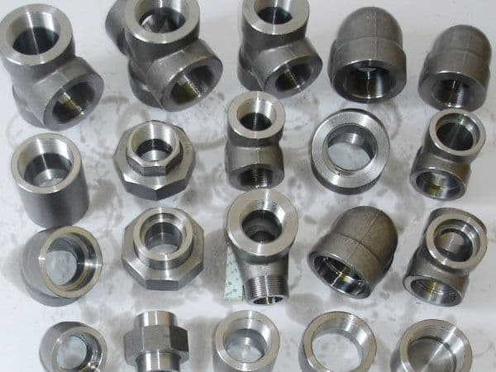Automotive

automotive
The presented product is a high-performance adhesive tape, specifically formulated for use in demanding manufacturing environments where durability is crucial. Made of a durable acrylic-based adhesive, this tape provides excellent bonding strength and shear resistance, making it ideal for securing various components and materials during assembly processes. It offers superior chemical and moisture resistance, ensuring long-lasting performance in harsh industrial applications, withstands temperature variations and provides excellent initial tack for fast and precise placement of parts. Featuring a high initial bondline strength, it provides reliable performance in automated environments and exhibits excellent process reliability. Measuring 19mm wide and 76m in length, this tape offers high flexibility and minimal shrinkage during prolonged storage, leading to minimized residue and waste production during removal. Its versatility allows for usage in a wide range of substrates such as plastics, metals, and glass, making it a versatile option for various factory floor requirements. Its double-coated scrim provides reinforced strength, ensuring a sturdy hold even under tension. This tape also features a tamper-evident security label to ensure traceability throughout the installation process, enhancing supply chain security and compliance with industry standards.
View details
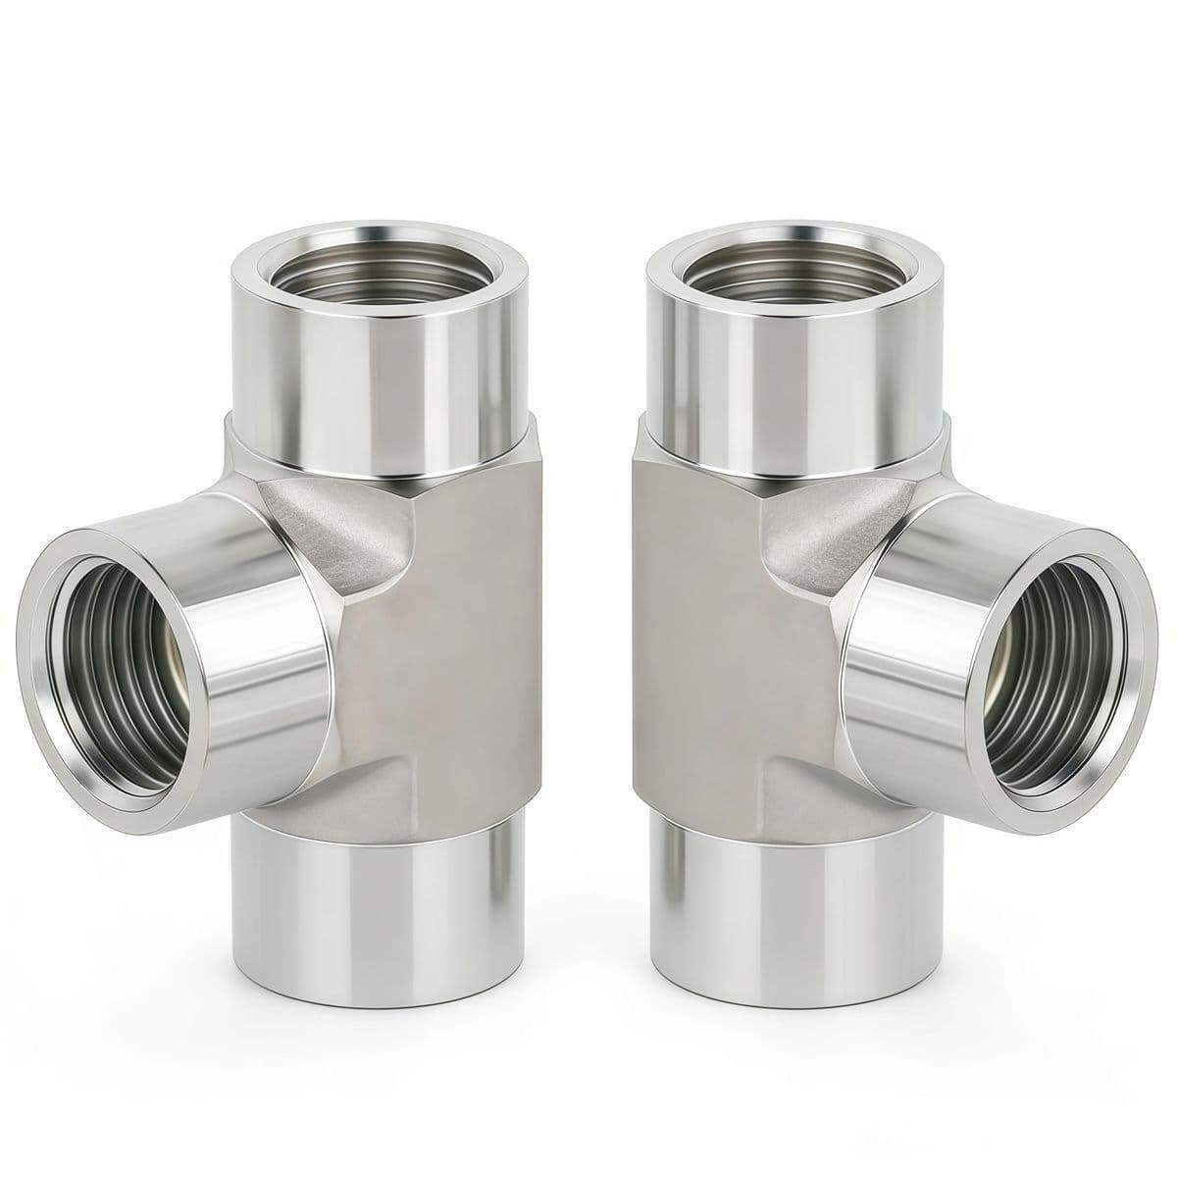Automotive

automotive
Introducing our top-of-the-line industrial cable tie, specifically designed to secure and organize cables, wires, and hoses in harsh environments. Manufactured using high-strength, UV-resistant nylon material, it withstands temperatures ranging from -76 to 212°F (-60 to 100°C) and has a tensile strength of 225 lbs. Its innovative locking mechanism provides secure fastening without the need for a tool, ensuring effortless installation and maximizing uptime for machine performance. Coated with friction-enhancing polypropylene for anti-slip properties, the tie accommodates a wide range of diameters from 0.118 to 0.787 inches (3 to 20mm) and boasts a vibrant orange color for optimal visibility in confined areas. This reliable cable management solution withstands UV light, chemical exposure, and can withstand immersion in water for up to six months, making it an impervious choice for damp conditions. Ensure optimal safety and efficiency with our durable cable tie.
View details
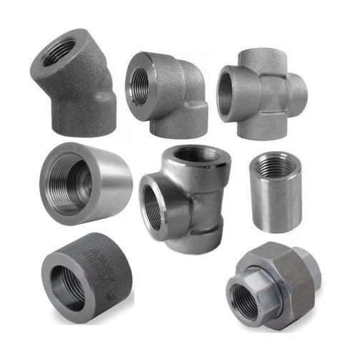Automotive

automotive
Introducing our heavy-duty steel cable chain, engineered to withstand the rigors of industrial environments with a tensile strength of up to X tons and a working load limit of Y kilograms. Featuring link pitches of Z millimeters, this chain is crafted from high-grade carbon steel with a chrome-molybdenum coating for superior rust and corrosion resistance. The roller bearings facilitate smooth movement and minimal maintenance, while the precision-forged connections ensure durability and precise operation. Its hot-dip galvanized zinc coating ensures long-lasting durability in harsh conditions, making it ideal for material handling, assembly line transport, and lifting applications. Specifically designed to handle heavy-duty tasks of up to 140 kilograms per link, it conforms to international standards for safety and reliability. Trust our cable chain to deliver maximum efficiency and longevity for your industrial needs.
View details
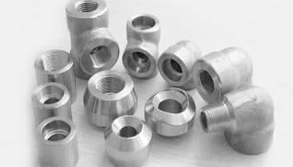Automotive

automotive
Our innovative polyamide slip resistance stair tread insert provides superior traction on metal, concrete, and ceramic surfaces in wet or dry environments. Manufactured using cutting-edge technology, this high-performance insert is renowned for its durability and corrosion resistance, making it a preferred choice in industrial settings where safety is paramount. With a puncture-resistant design and a textured surface that inhibits slips and falls, our product offers exceptional slip resistance while maintaining a sleek, minimalistic profile to seamlessly integrate into any stairway renovation. Made from top-quality, high-impact-resistant polyamide material with excellent mechanical properties and ideal for use in harsh industrial environments, it's not only reliable but also provides long-lasting wear resistance for optimal functionality. With a simple yet efficient installation process, it's the perfect solution for enhancing stairway safety in commercial and industrial settings. Trust us to improve safety and eliminate hazardous accidents with our durable stair tread insert, the ultimate choice for industrial applications.
View details
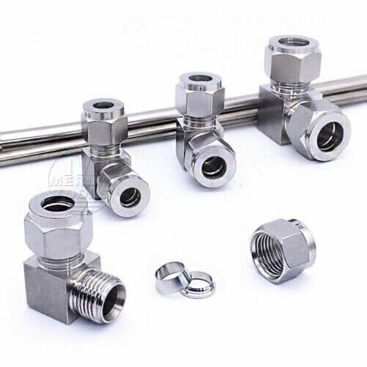Automotive

automotive
Our high-performance loop sensor, model LSH-150, is a versatile and precise proximity switch designed for demanding industrial environments. Crafted from durable stainless steel materials, it provides reliable and accurate position sensing in harsh applications with a LipDrive™ lip-warning feature that alerts users when the proximity of the respective object is within 0.5-1.5mm of the device. This DIN rail mountable sensor operates up to 13.2kV AC/DC and 1A contacts, making it suitable for various control panel applications with a rated insulation resistance of 1000MΩ and contact resistance of 50mΩ maximum. The sensor features single pole changeover relay output with 3.3VDC coil voltage and a versatile adjustable switching point and adjustable hysteresis for optimal customization in line with specified applications. With a maximum operating temperature of 150°C andip67 rating, it is ideally used in industrial machines, material handling equipment, and automated systems requiring reliable and resilient touchless sensing technology. The loop sensor's bipolar magnet provides a contact distance of up to 8mm for metallic, magnetic or non-conductive materials and long service life in high-cycle applications.
View details
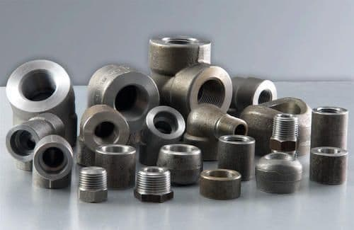Automotive

automotive
This 1/2 inch diameter stainless steel adjustable cable lug with stainless steel body and crocodile-style spring ferrule boasts a durable design suitable for motion control, process control, and other demanding industrial applications. The superior quality of materials used ensures reliable electrical and mechanical connections for cables up to 600 volts in harsh environments. Its corrosion-resistant stainless steel construction ensures longevity in corrosive environments, while the adjustable mechanical cone allows for secure and easy installation of cables up to 6 AWG. This cable lug features a smooth, finished appearance and is compatible with rigid and stranded conductors in sizes ranging from 24 AWG to 6 AWG, with a maximum tensile strength rating of 200 pounds. The flat seal ensures conformal coating compatibility, making it ideal for use in electronic and electrical equipment exposed to harsh environments. Overall, this cable lug delivers reliable performance and enhanced safety under demanding industrial conditions.
View details
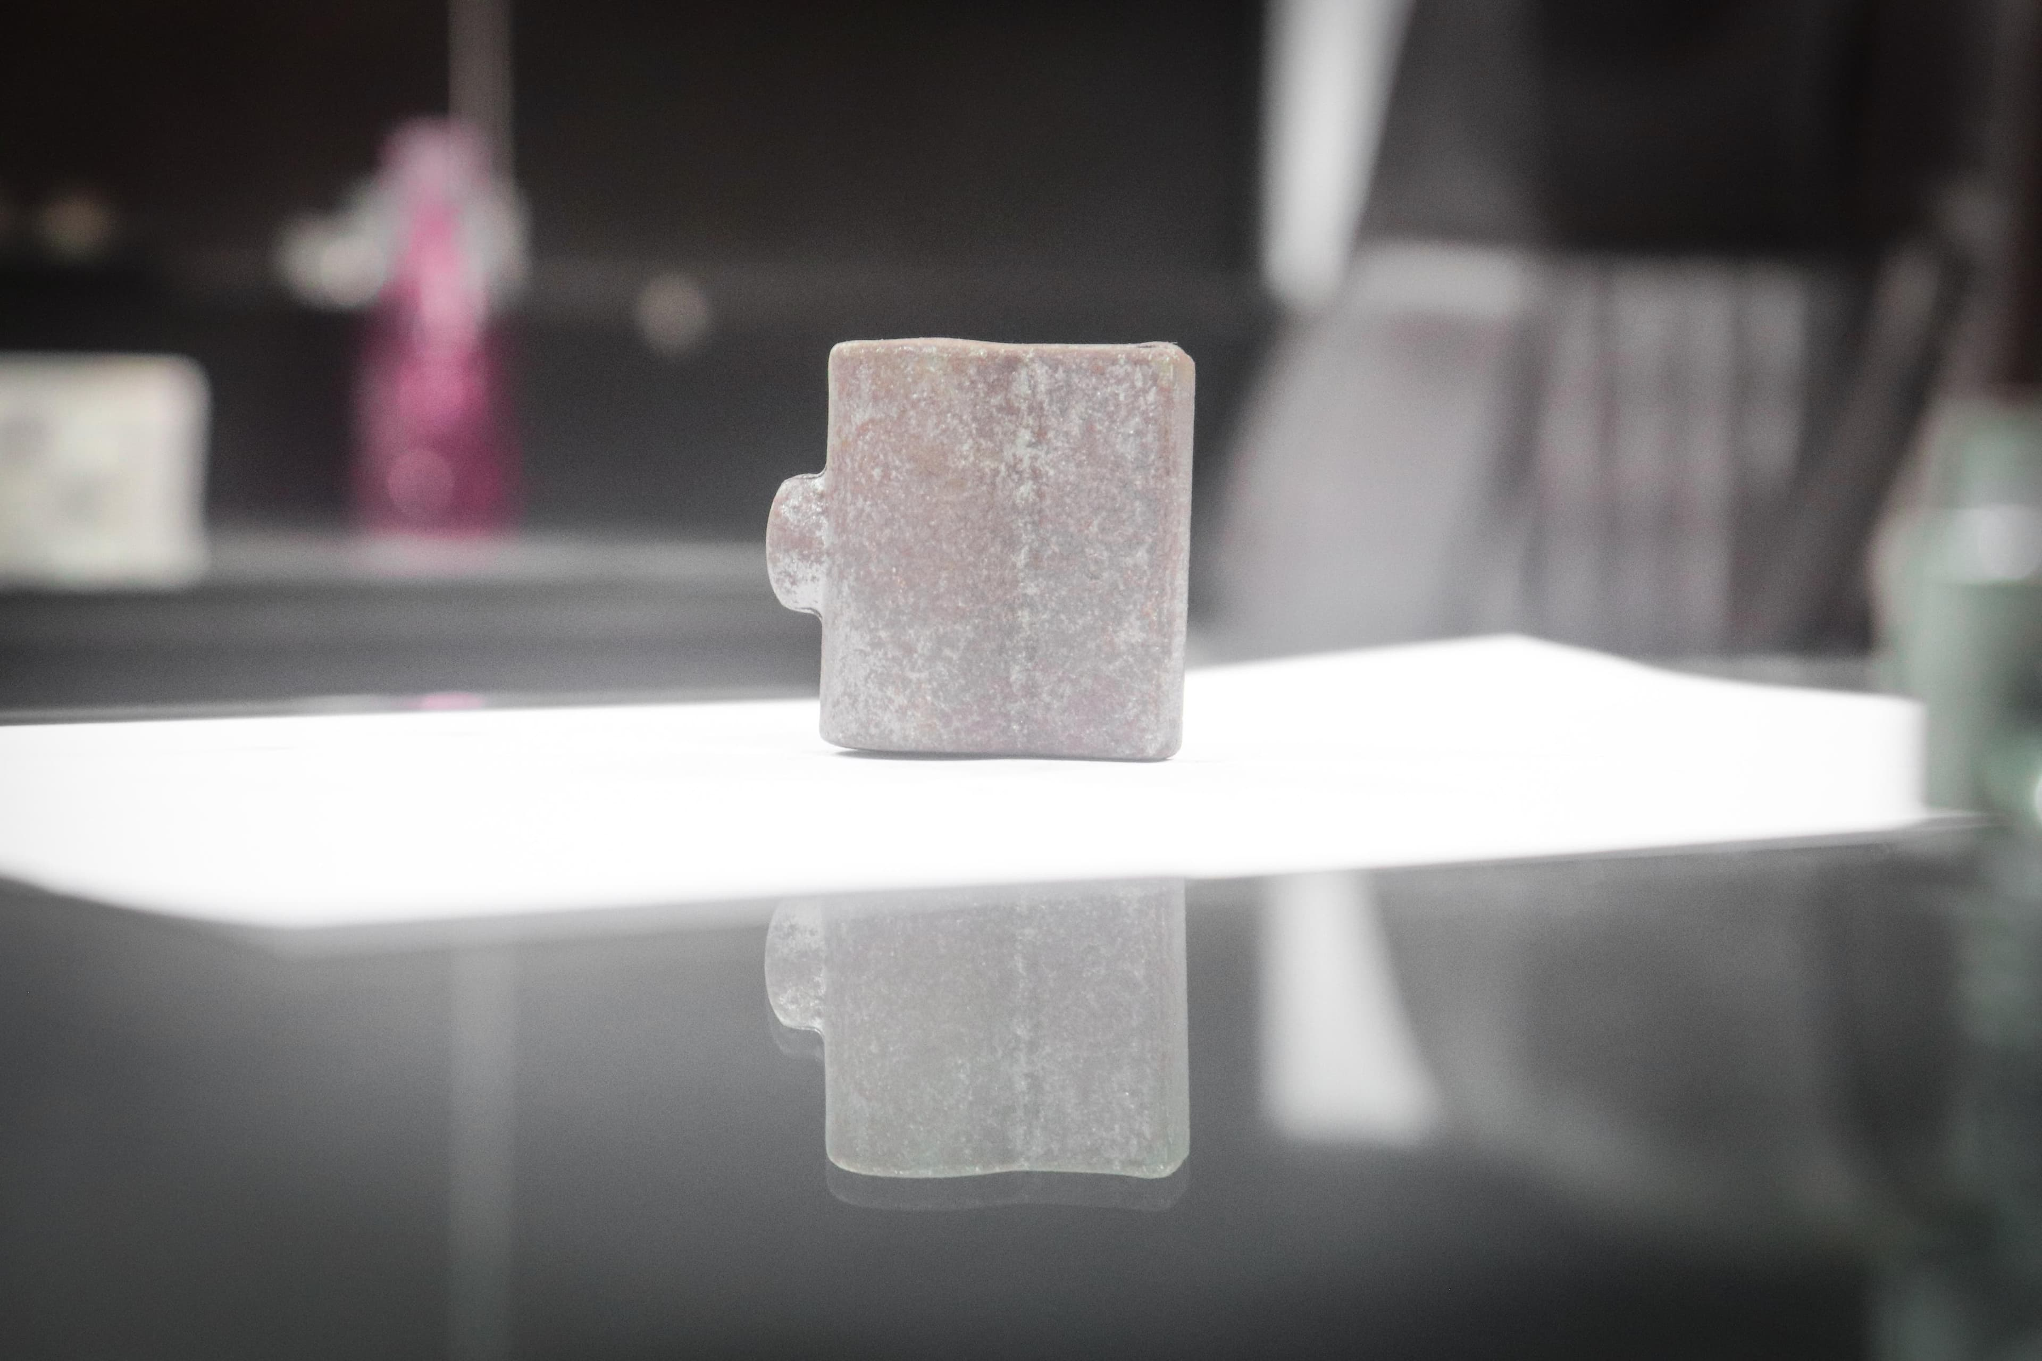Industrial

Forging
Our industrial-grade, polyvinyl chloride (PVC) conduit pipe is designed to offer superior durability and functionality for a variety of applications in harsh environments. With a diameter of 1 inch, a wall thickness of 3/8 inch, and a smooth interior surface, the pipe provides optimal flow resistance and chemical resistance. Its rigid construction ensures excellent impact and abrasion resistance, making it suitable for use in industrial settings where reliable performance is crucial. With a flexible, coilable design and easy installation options, this PVC conduit pipe offers a practical and cost-effective solution for moving electrical wires, cables, and piping systems in demanding industrial environments.
View details
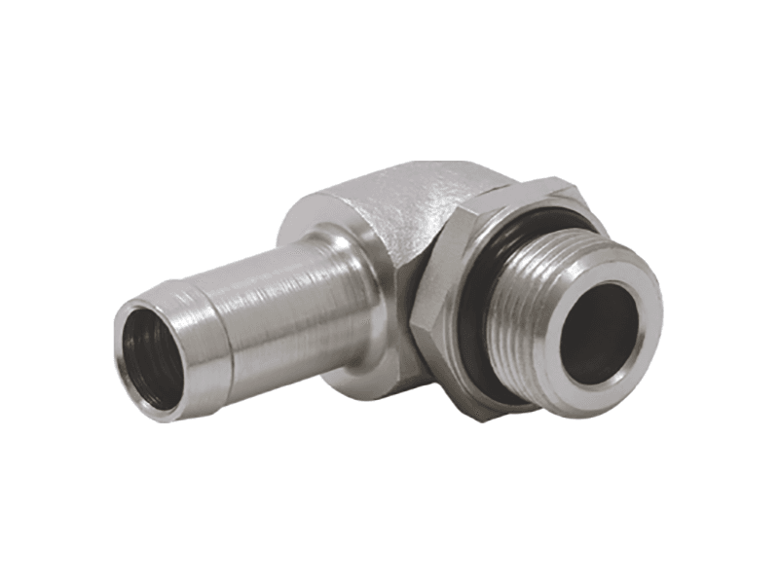Industrial

Elbow
Our industrial-grade thermoplastic conveyor pulley (Model: T-PC-500) is designed to meet the demands of harsh material handling environments. Manufactured using high-impact, UV stabilized, and chemically resistant polycarbonate material, this pulley delivers exceptional durability and resistance to wear and tear caused by corrosive substances and abrasive materials. Its precise machining and internal steel ball bearings offer smooth start-up and running operation, reducing friction and noise levels. The 500mm outside diameter with a bore of 100mm makes it suitable for conveyor belt systems operating at a capacity of up to 750kg. With its rugged construction and versatile dimensions, this conveyor pulley is an excellent choice for industrial applications requiring high performance and durability in demanding environments.
View details
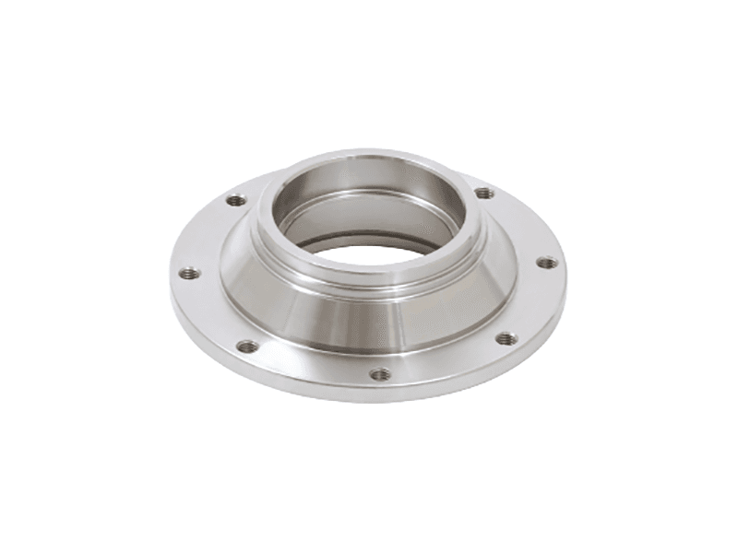Industrial

Flange
The undefined product is a high-performance sealing solution designed for use in demanding industrial applications. Manufactured from premium grade materials, including advanced polymers and high-carbon steel, this sealing system offers exceptional durability and resilience in harsh environments. Boasting a unique design that is both low-friction and leakage-free, this sealing solution delivers reliable and consistent performance, making it the ideal choice for a wide range of industrial applications. With its superior sealing capability, resistance to chemicals, and high temperature tolerance, this product offers unmatched dependability in demanding industrial settings.
View details
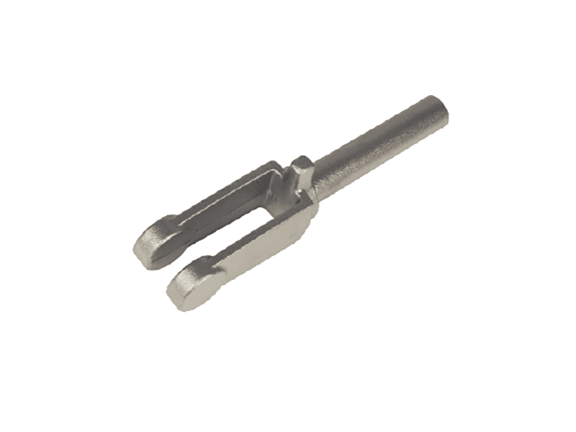Industrial

Fork
Introducing our industrial-grade high-performance sealing gasket, meticulously designed to deliver exceptional durability and functionality in demanding applications. Crafted from premium-grade elastomeric material, this gasket offers outstanding resistance to chemicals, oils, and temperature extremes, making it the ideal solution for harsh industrial environments. With precise dimensions and excellent sealing properties, our gasket minimizes leakage, extends equipment life, and ensures optimal system performance. Trust in our commitment to superior craftsmanship and reliability in all our products.
View details
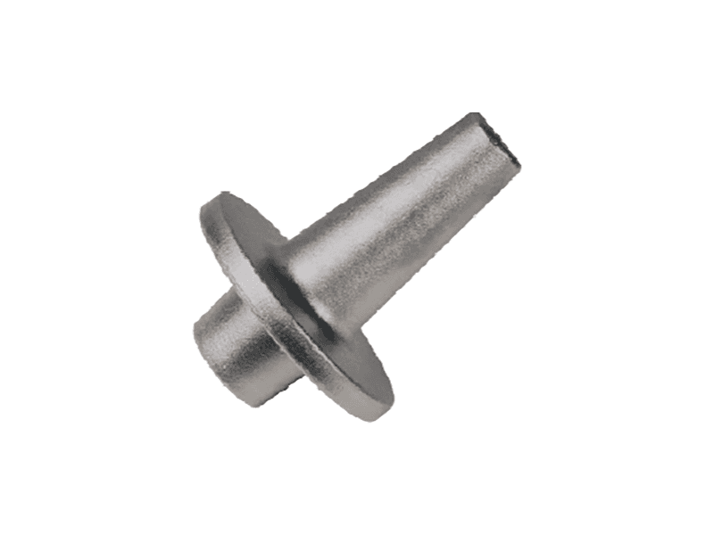Industrial

Shaft-1
Our Galvanized Steel Angle Stock is a versatile industrial product designed for structural support and reinforcement applications. Made from high-strength steel that undergoes a galvanizing process for added durability, this angle stock offers superior corrosion resistance in harsh environments. Its 90-degree configuration provides robust structural support, while its quick and easy assembly eliminates the need for welding in many scenarios. With a range of thicknesses and lengths available, this Galvanized Steel Angle Stock is an ideal choice for construction, manufacturing, and infrastructure projects where strength, durability, and functionality are critical.
View details
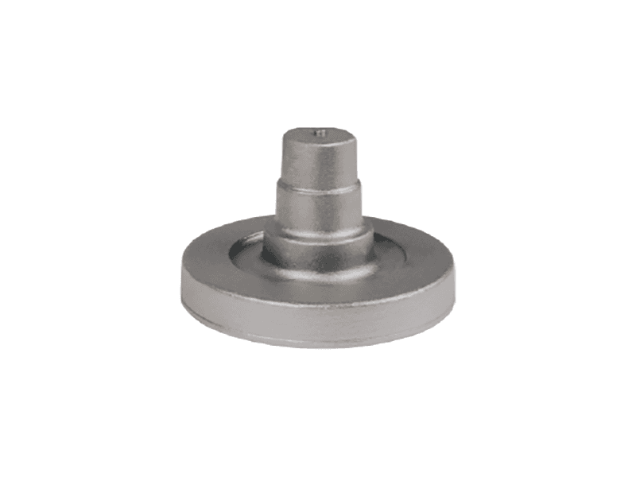Industrial

Shaft
Our industrial-grade rotary pump features a rugged cast iron construction for exceptional durability and reliability in demanding applications. This pump is specifically designed for transferring a wide range of industrial fluids, including water, oils, and chemicals, with maximum efficiency and reliability. Its advanced seal design provides superior leak prevention, while its optimized flow rate ensures reliable performance under varying operational conditions. Additionally, this pump is easy to operate and maintain, with simple maintenance requirements and a user-friendly control panel for enhanced functionality and operability.
View details
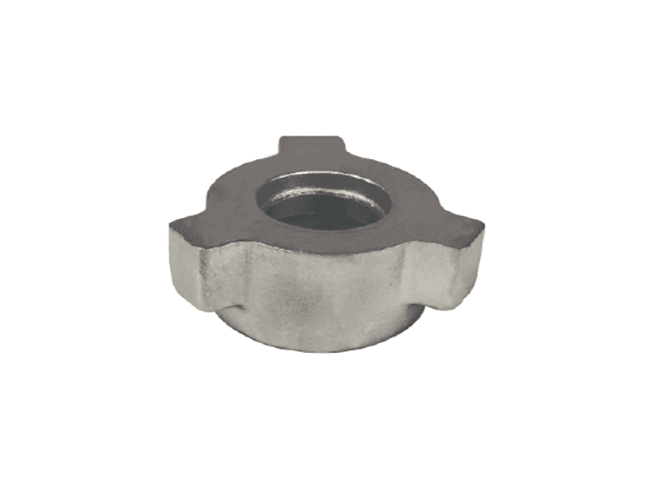Industrial

Wing Nut
This industrial-grade roller chain is designed to withstand the most demanding applications in harsh environments, providing exceptional durability and reliability. Manufactured from the highest quality materials, including zinc-coated carbon steel for superior corrosion resistance, this chain features a precise tooth profile and hardened bushings to ensure smooth and efficient movement. The rollers are made from high-strength, wear-resistant alloy steel for maximum longevity and minimal maintenance, making this chain an ideal choice for heavy-duty conveyor or hoisting systems.
View details
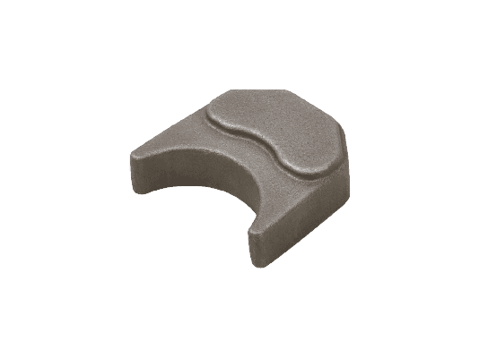Mining

Mounting Block 1
This industrial-grade metal bracket is engineered for precise load bearing applications, featuring a robust yet lightweight design manufactured from high-strength 304 stainless steel. Its sleek and streamlined form ensures optimal functionality in confined spaces, making it an ideal choice for a wide range of industrial applications, including but not limited to machinery equipment, conveyor systems, and structural support. Its superior durability and corrosion resistance provide optimal longevity and reliability in harsh industrial environments, making it an essential component for any demanding industrial setup.
View details
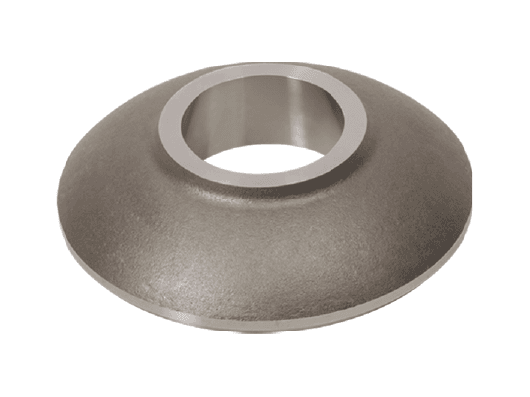Mining

Flange
Intended for use in high-stress industrial environments, our S11 Steel Coupling is designed to provide unparalleled durability and functionality. Crafted from low-carbon steel with superior strength-to-weight ratios, this coupling features fluid-tight inner and outer sleeves to prevent leaks and contamination between pipes. Its innovative 2-lobe design enables smooth and reliable rotational coupling in straight or angular orientations, making it suitable for a wide range of industrial applications where reliability and durability are of utmost importance.
View details
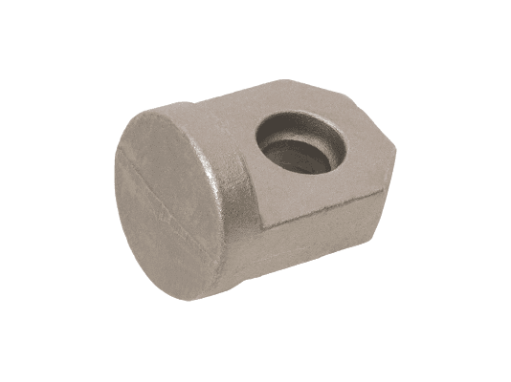Mining

Cap End Cover
Our high-performance, reinforced nylon transmission cable (Part Number XYZ) is specifically designed for heavy-duty industrial applications requiring superior durability and reliability. The cable is constructed with a robust nylon sheath, featuring a high-strength synthetic fiber reinforcement to ensure maximum tensile strength and exceptional resistance to bending and twisting. Its slick nylon inner core offers smooth and precise motion, minimizing wear and tear on machinery and components. This cable is suitable for use in a wide range of industrial applications, including automation, conveying, and material handling equipment, where reliability and durability are critical factors in ensuring optimal performance and output.
View details
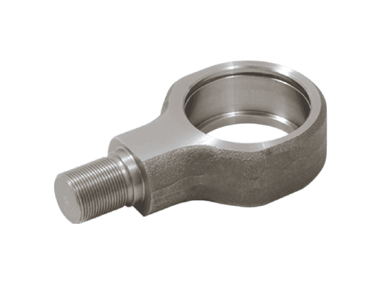Mining

Rod Eye
Our electronically commutated (EC) brushless DC fan motor, model MBX50-14, is specifically designed for heavy-duty industrial applications requiring high reliability and durability. Made of rust-resistant, black, epoxy-coated aluminum, the motor features a maximum speed of 14,000 RPM and an efficiency rating of up to 85%, enabling efficient cooling under high airflow conditions. With its low internal resistance, high starting torque, and overload protection, this motor ensures reliable operation and longevity in even the most challenging industrial environments.
View details
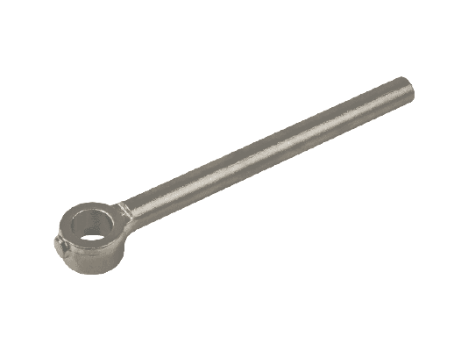Mining

Piston Rod
Our high-performance extruded aluminum profile is designed for Industrial applications where durability and functionality are essential. Manufactured from superior grade aluminum alloy, this profile features interlocking sections, smooth extruded edges, and undercut grooves for enhanced aesthetic and structural integrity. Its anodized surface ensures effective protection against corrosion and wear, making it ideal for demanding industrial environments. With customizable length options and flexibility in color choices, this profile offers a versatile and reliable solution for various industrial applications.
View details
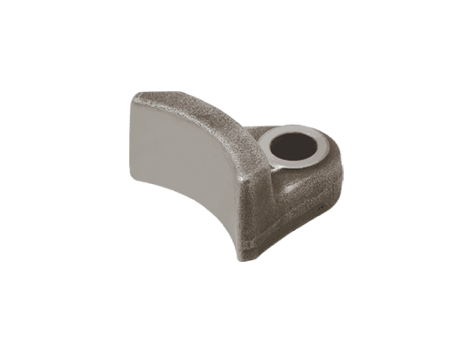Mining

Mounting Block
Our heavy-duty steel cable with galvanized corrosion resistance is specifically designed for industrial applications requiring high strength and durability. With a minimum breaking strength of 14,500 pounds, this cable is ideal for use in lifting, pulling, and hoisting equipment in harsh environments. Its four-strand vertical-lay construction provides excellent flexibility, while the galvanized coating prevents rust and wear from corrosive materials. With a maximum cable length of 3,045 feet and a round core diameter of 3/8 inches, this cable offers superior functionality and reliability for a wide range of industrial applications.
View details
Tractor & Farm Equipment

Mounting Block
Our heavy-duty steel cable with galvanized corrosion resistance is specifically designed for industrial applications requiring high strength and durability. With a minimum breaking strength of 14,500 pounds, this cable is ideal for use in lifting, pulling, and hoisting equipment in harsh environments. Its four-strand vertical-lay construction provides excellent flexibility, while the galvanized coating prevents rust and wear from corrosive materials. With a maximum cable length of 3,045 feet and a round core diameter of 3/8 inches, this cable offers superior functionality and reliability for a wide range of industrial applications.
View details
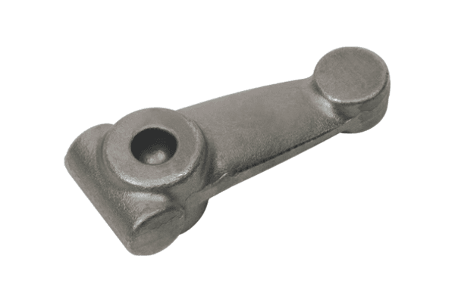Tractor & Farm Equipment

Steering Arm
Our undefinable product is a versatile industrial component designed for high-performance applications requiring exceptional durability and functionality. Crafted from premium-grade, corrosion-resistant materials, this product is versatile in use across various industrial settings, including high-temperature, chemically-exposed, and water-intense environments. Its sleek, streamlined design maximizes efficiency while minimizing maintenance, making it an optimal choice for demanding industrial operations. Additionally, its robust performance capabilities ensure reliable and consistent results, making it an indispensable asset in any industrial application.
View details
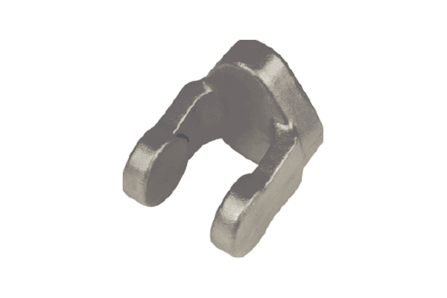Tractor & Farm Equipment

Yoke
Introducing our heavy-duty industrial casters, engineered with premium-grade polyurethane wheels and stainless steel ball bearings for effortless movement across various surfaces. The deform-resistant nylon hubs offer optimal durability and low maintenance, making them ideal for handling heavy loads in commercial, manufacturing, and warehouse settings. These casters boast a load capacity of up to 4000lbs and are versatile in their application, able to acquire weighty trolleys and machinery in both dolly and furniture configurations. Our casters are supplemented by a rust-resistant finish, ensuring they remain functional and reliable under rigorous industrial circumstances.
View details
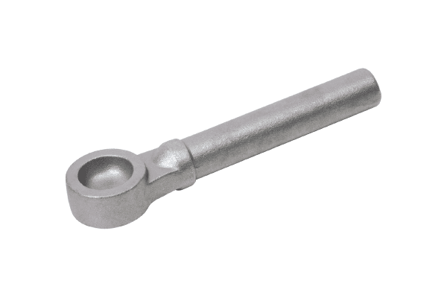Tractor & Farm Equipment

Piston Rod
Our Polytetrafluoroethylene (PTFE) coated stainless steel valve ball is specifically designed for use in harsh industrial environments to provide exceptional durability and corrosion resistance. The PTFE coating offers a low coefficient of friction, ensuring smooth operation and minimizing wear on the ball's mating surface. The stainless steel ball offers exceptional strength and resistance to high temperatures and harsh chemicals, making it ideal for use in a wide range of industrial applications where quality and reliability are critical. Overall, our PTFE coated stainless steel valve ball delivers superior functionality and longevity in demanding industrial settings.
View details
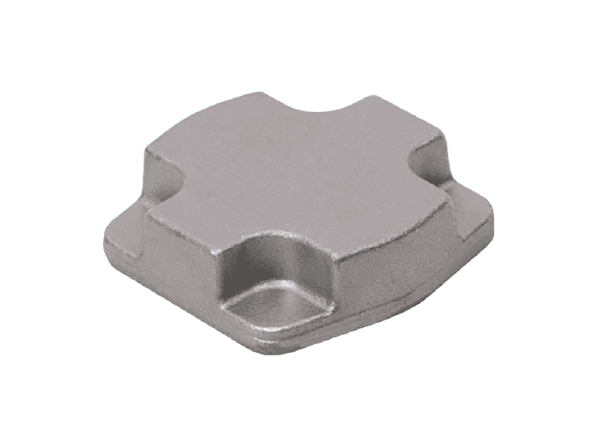Tractor & Farm Equipment

Oil Seal Cup
Our ultra-durable industrial high-pressure hose reel (ID 123456) is constructed from high-quality imported leather and heavy-duty steel for exceptional reliability and longevity. Boasting a maximum pressure rating of 300 Bar, this hose reel is designed for use in a range of industrial environments, including manufacturing, mining, and oil and gas. Its durable construction and versatile functionality make it the ideal choice for safe and efficient hose management when working with high-pressure fluids. Its wide drum diameter allows for ample space for storing up to 75 meters of 32mm hose, reducing setup time and increasing efficiency. With easy push-on or push-off coupling, this hose reel ensures effortless and rapid connection and disconnection, minimizing downtime and maximizing productivity.
View details
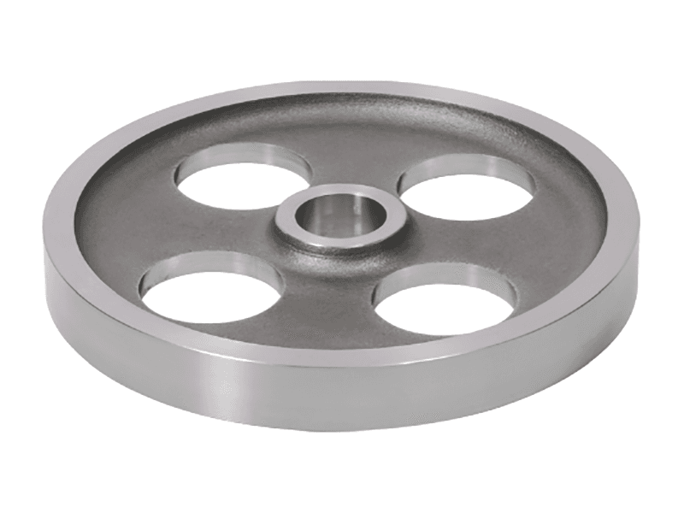Tractor & Farm Equipment

gear and flanges
Our high-performance, low-friction linear guide system is specifically designed for enhanced industrial applications, featuring a robust construction and exceptional durability. Crafted from advanced materials including high-strength stainless steel, precision-ground ball components, and high-quality plastics, this linear guide system guarantees superior functionality, making it an ideal choice for a variety of industrial settings. Architected for minimal friction and optimal smoothness, this guide system delivers exceptional service life and performance, making it a reliable solution for any demanding industrial application.
View details
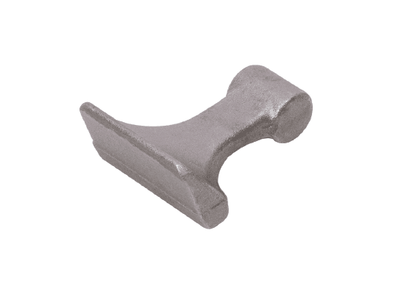Tractor & Farm Equipment

Flade
The XYZ Series ball valve is a versatile industrial component, designed to meet the highest demands for durability and functionality in demanding applications. Made from premium stainless steel, this valve features a corrosion-resistant, flush-mounted lever handle that provides easy operation, even in hard-to-reach and hazardous environments. Its robust, triple-offset design ensures minimal internal leakage, providing superior flow characteristics and award-winning sealing capabilities. Designed for pressures up to 300 PSI and temperatures up to 600°F, this valve is the perfect choice for a wide range of industrial applications where reliability and performance are paramount.
View details
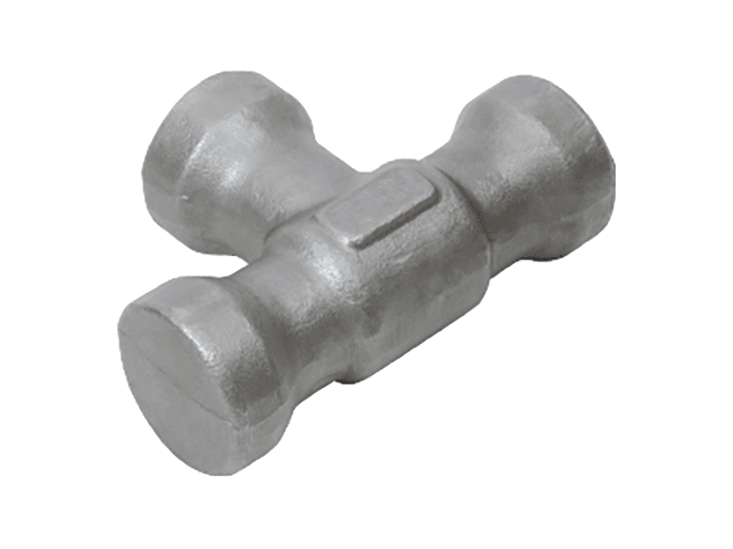Oil & Gas Industry

2 Tee
Our undefinable product is an ergonomically designed assembly aid featuring a machined 6061 aluminum construction for exceptional durability in harsh industrial environments. With a non-slip rubber insert, this tool securely grips and positions components during assembly, facilitating increased efficiency and reduced errors. The smooth anodized finish ensures easy component fitting while minimizing friction and wear, making it an indispensable tool for assembly line productivity and safety.
View details
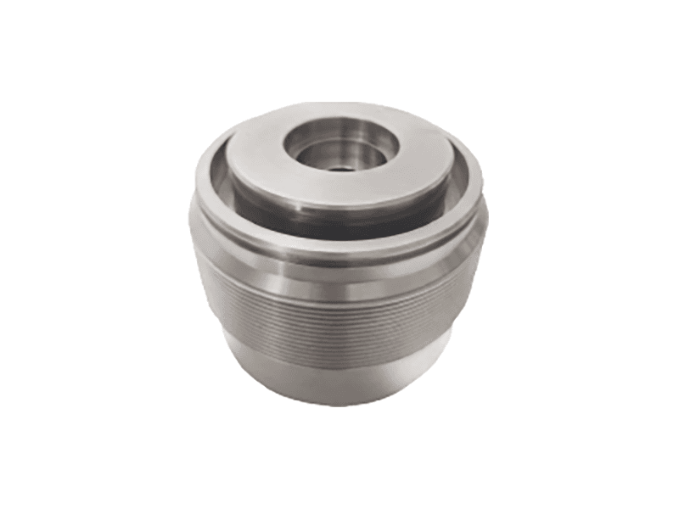Oil & Gas Industry

Adjustable Nut
Introducing our industrial-grade pollution control system designed to effectively mitigate airborne contaminants and emissions in manufacturing facilities, factories, and other high-pollution environments. Constructed from high-strength materials, including galvanized steel and premium-grade filters, this system boasts exceptional durability and longevity, making it a reliable and cost-effective solution for managing air quality. With advanced functionality such as programmable controls, real-time monitoring, and easy integration with existing systems, our pollution control system provides industry-leading performance and unparalleled precision in protecting people and the environment from hazardous airborne pollutants.
View details
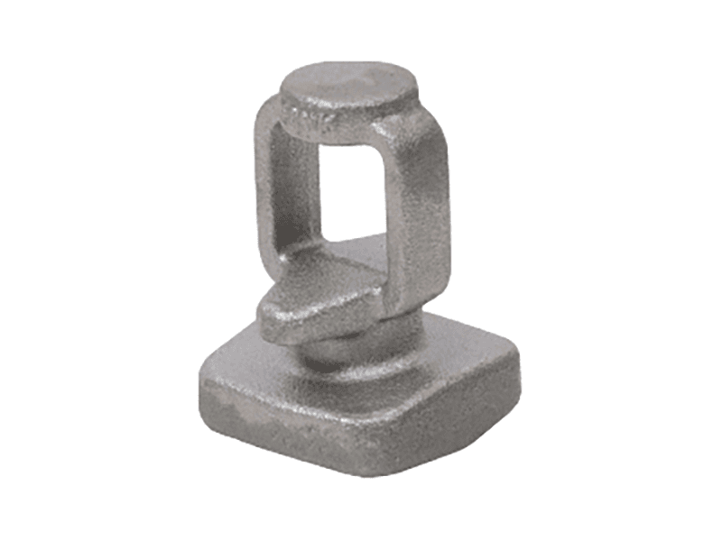Oil & Gas Industry

Bonnet
Introducing our heavy-duty, Type 304 stainless steel cable drum rated at a maximum capacity of 15,000 pounds with a 5-to-1 safety factor, specifically designed for industrial applications. This drum's seamless, rust-free construction withstands harsh environments, making it ideal for use in manufacturing, transportation, and other industrial settings. Its easy-roll design promotes smooth cable winding with minimal stress, while the drum's innovative tapered base and smooth bottom facilitate straightforward cable insertion and enhanced durability. With its high functionality and exceptional build quality, this drum represents an essential tool in any thoroughgoing industrial operation.
View details
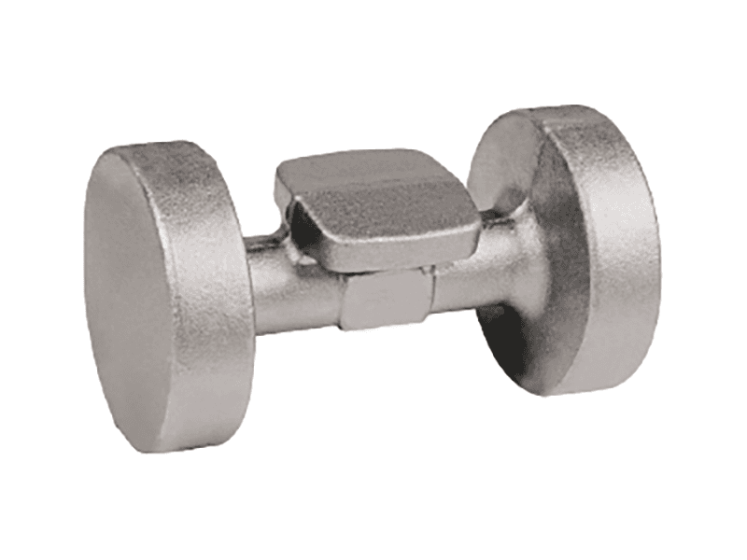Oil & Gas Industry

Internal Value Body
Our high-performance, composite transmission pulley is engineered for heavy-duty industrial applications requiring maximum durability and reliability. Crafted from advanced ceramic and carbon fiber materials, this pulley offers superior strength-to-weight ratio and exceptional resistance to wear, corrosion, and chemicals. Its precision machined design ensures optimal load transfer and enhanced functionality, making it the ideal choice for demanding industrial environments seeking exceptional performance and longevity.
View details
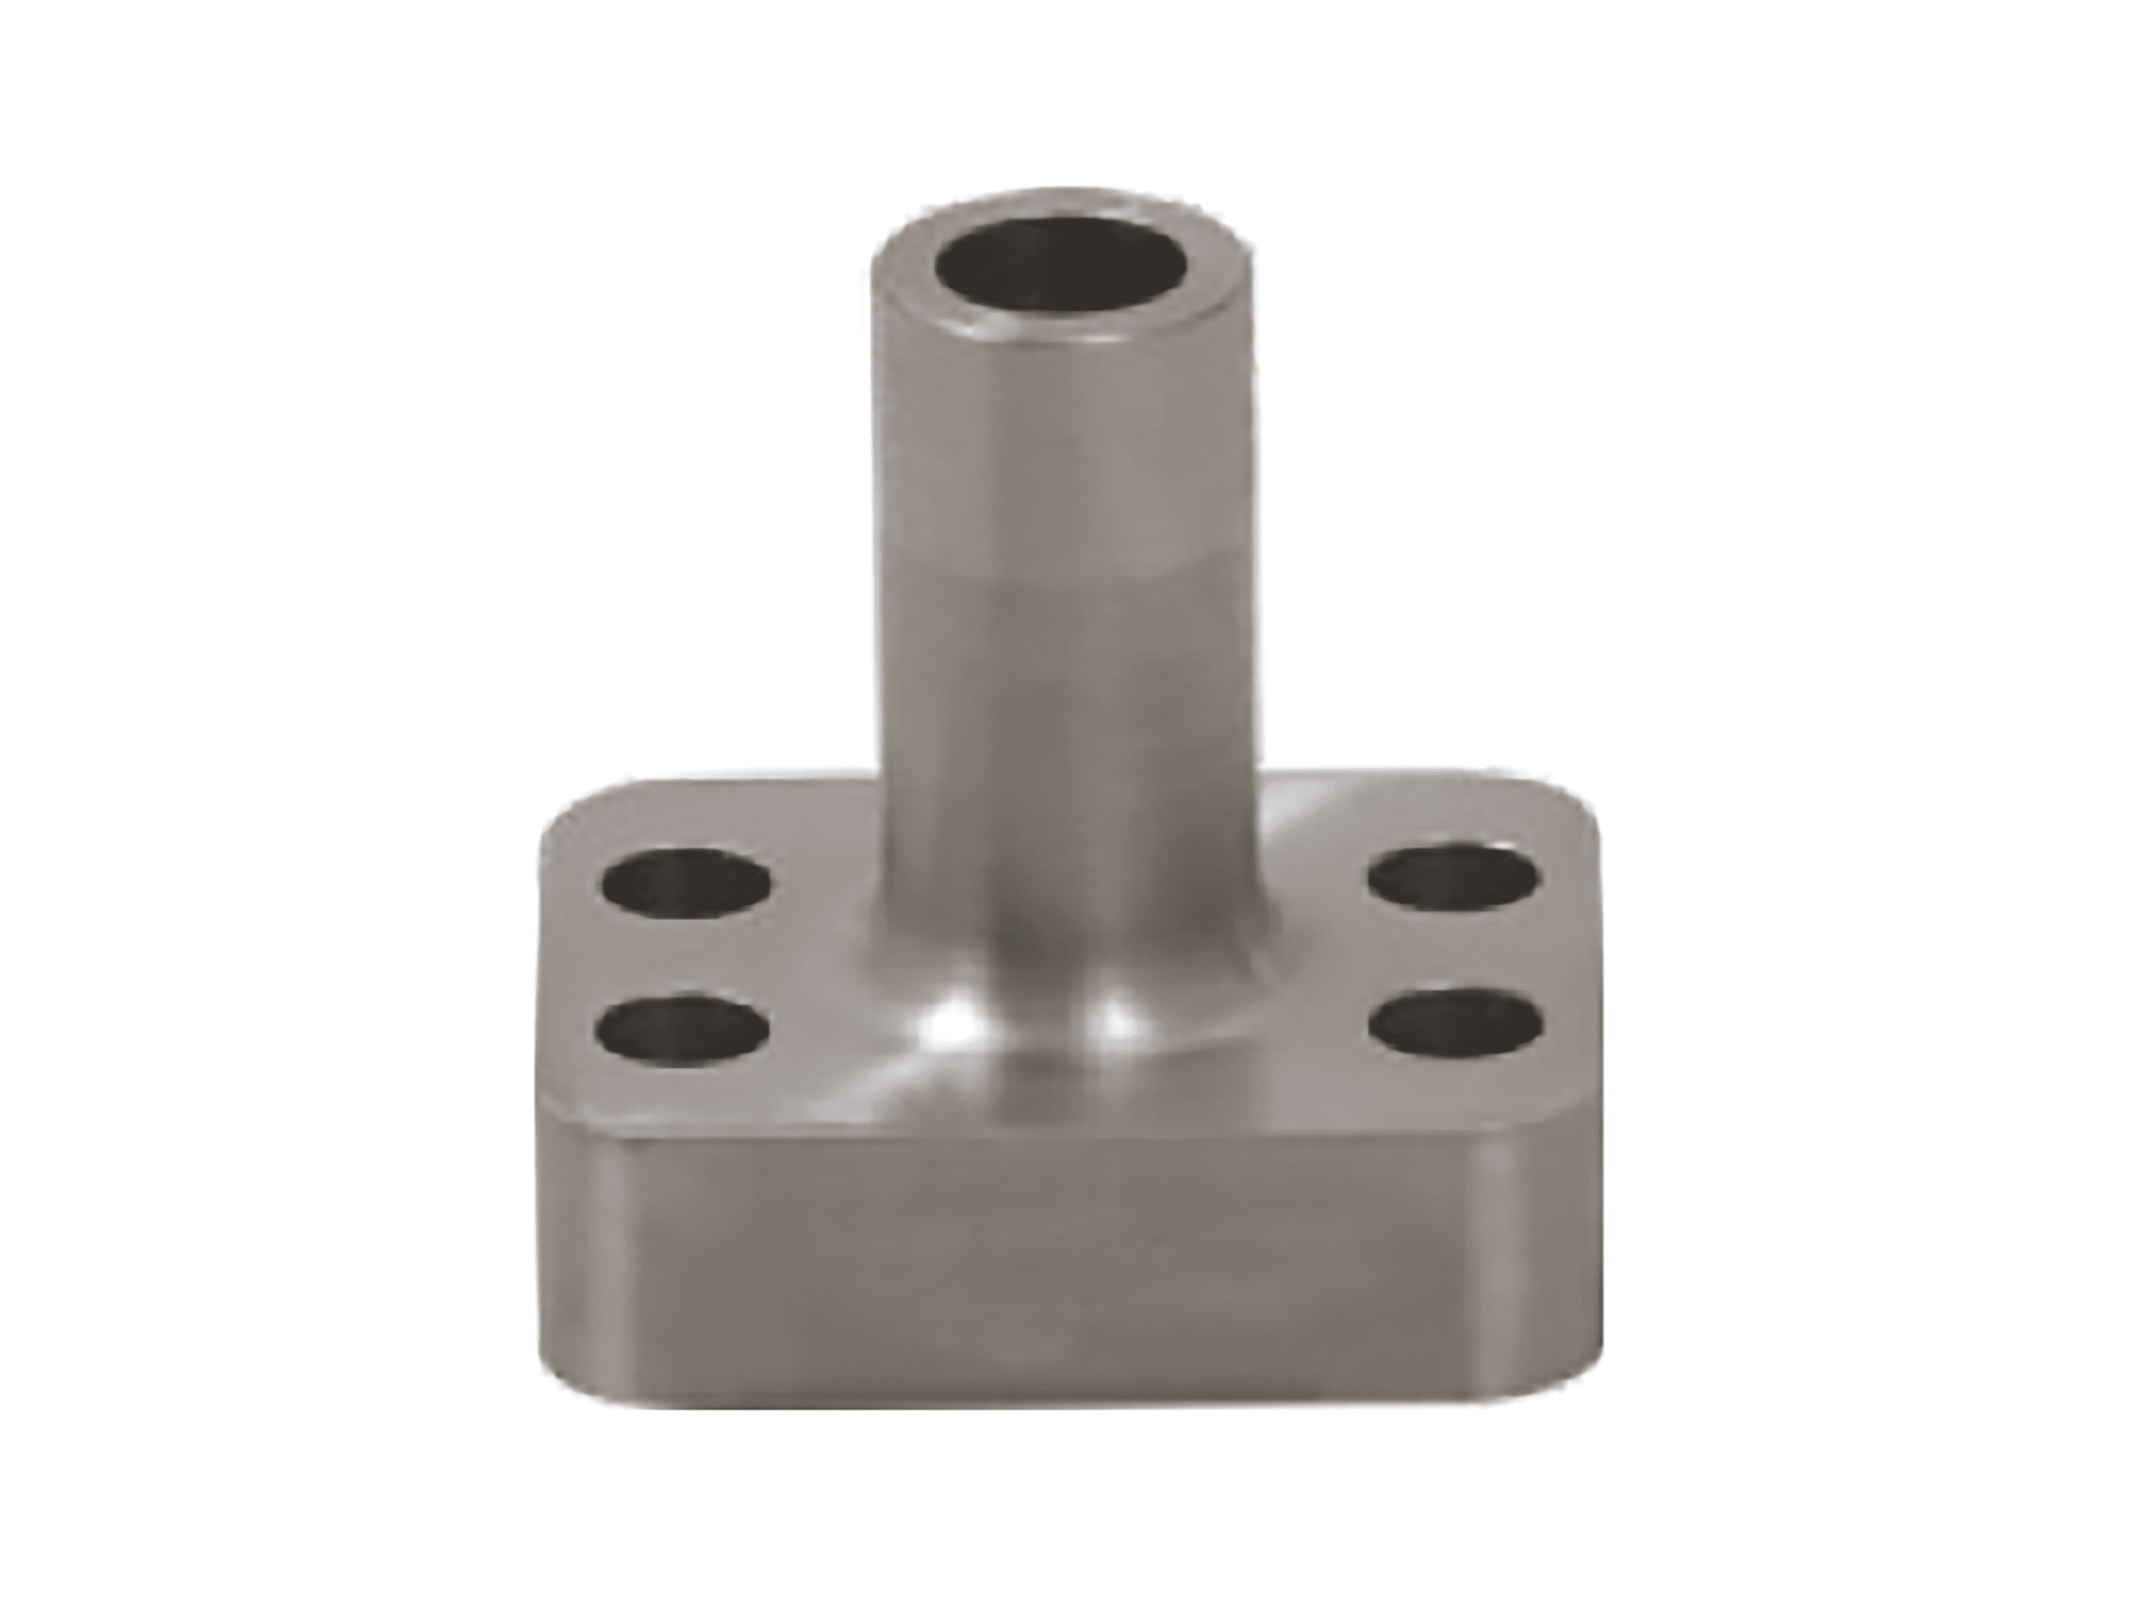Oil & Gas Industry

Port
The undefined series industrial ball bearings offer exceptional performance and durability for a wide range of demanding applications. Manufactured from high-quality materials, these precision bearings feature a robust design and advanced lubrication technology to ensure smooth and reliable operation in harsh industrial environments. They are well-suited for use in heavy-duty machinery, conveyor systems, and superior manufacturing equipment requiring high load capacities and minimal maintenance requirements. With their exceptional functionality, these ball bearings provide outstanding reliability, longevity, and overall cost-effectiveness in industrial applications.
View details
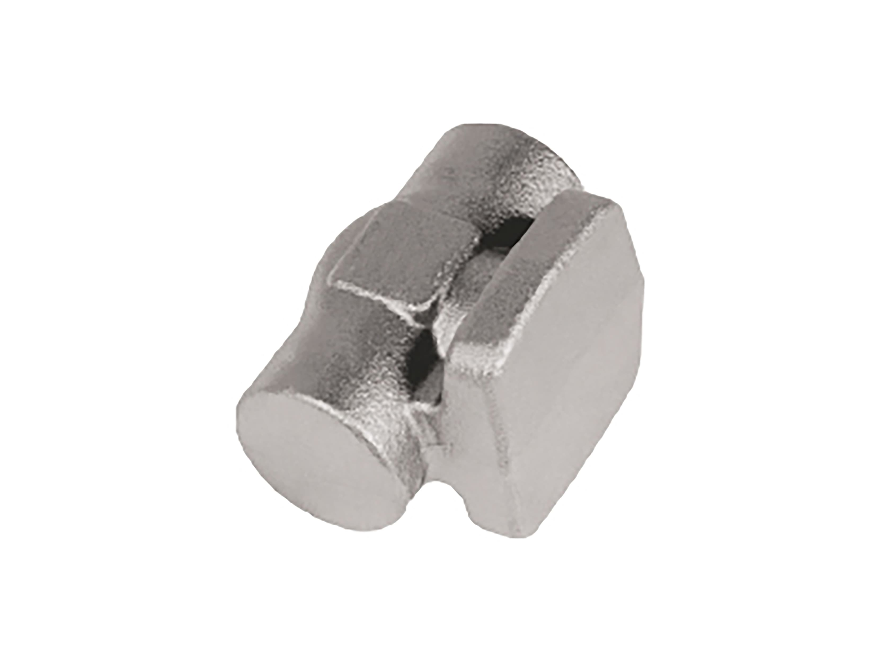Oil & Gas Industry

Valve body
Our industrial-grade cable chain, fabricated from high-strength carbon steel and coated with corrosion-resistant epoxy, offers superior durability and reliability in demanding environments. Ideal for material handling and heavy-duty conveyance applications, its adjustable design enables flexible installation in confined spaces while ensuring smooth cable travel and minimal wear over time.
View details
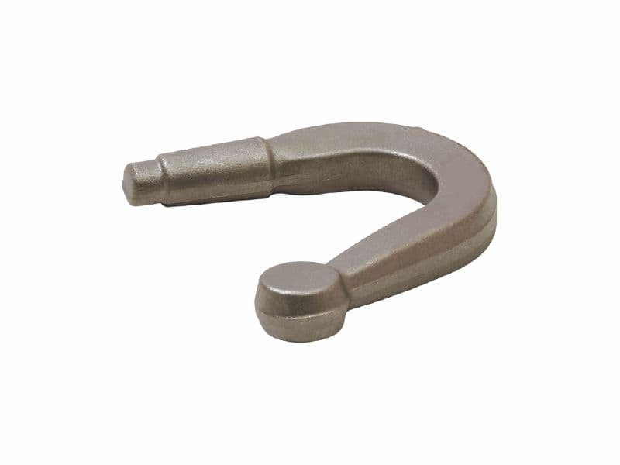Automotive

Arm Knuckle
Introducing our industrial-grade baffle plate, designed with a high level of durability and functionality to ensure optimal performance in your critical applications. Crafted from premium-grade 304L stainless steel, this product boasts exceptional corrosion resistance and longevity, making it an ideal solution for harsh industrial environments. With its unique baffle design, this plate provides unparalleled fluid distribution and flow control, ensuring consistent and efficient performance. Ideal for use in various industrial processes such as chemical separations, heat exchangers, and bioreactors, our baffle plate excels in high-pressure and high-temperature applications, delivering exceptional performance and reliability.
View details
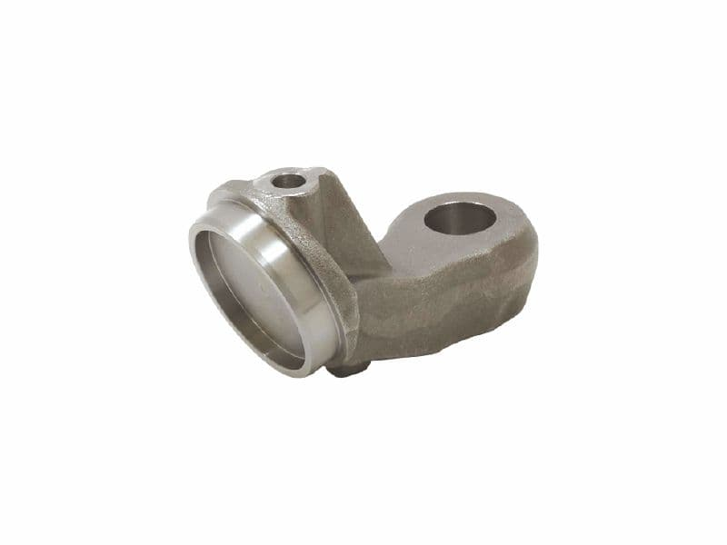Automotive

Ball Joint
Our industrial-grade undefined is designed to deliver exceptional performance for high-demand applications. Made from premium-strength, corrosion-resistant stainless steel, this product boasts superior durability and resistance to harsh environmental conditions. It features a streamlined and ergonomic design, enhancing functionality and ease of use, alongside exceptional compatibility with standard fittings and connectors, making it a reliable choice for a wide range of industrial and commercial applications.
View details
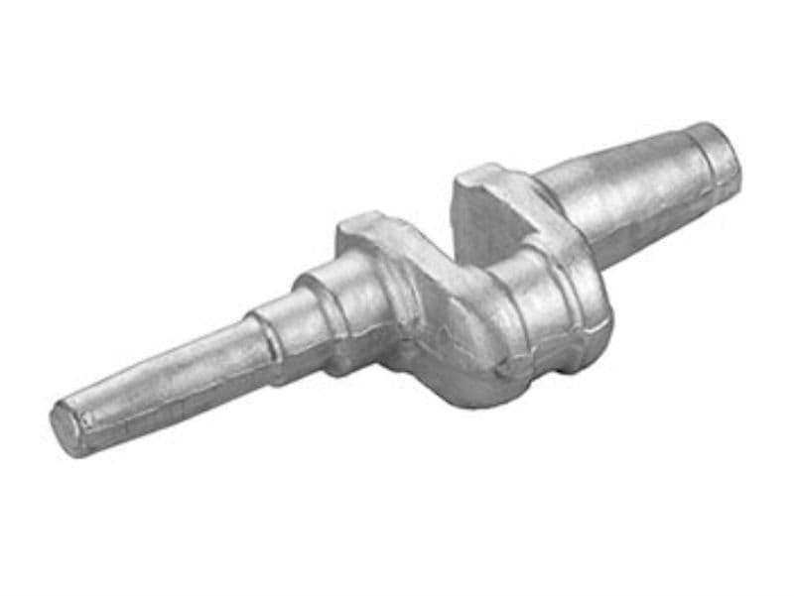Automotive

Crancksharft
Our high-performance Tungsten Carbide Ball Bearings are designed for rugged industrial applications requiring exceptional durability and reliability. Made from premium-grade Tungsten Carbide, these bearings offer unparalleled wear resistance and can withstand extreme operating temperatures, making them ideal for use in harsh environments such as mining, metal production, and food processing. With a high load-carrying capacity and precise ball and race dimensions, our Tungsten Carbide Ball Bearings deliver superior performance, minimizing friction, and ensuring consistent operation over extended periods. Whether you need bearings for high-pressure oil drilling, chemical processing, or other heavy-duty industrial applications, our Tungsten Carbide Ball Bearings are the optimal choice for long-lasting, high-performance operation.
View details
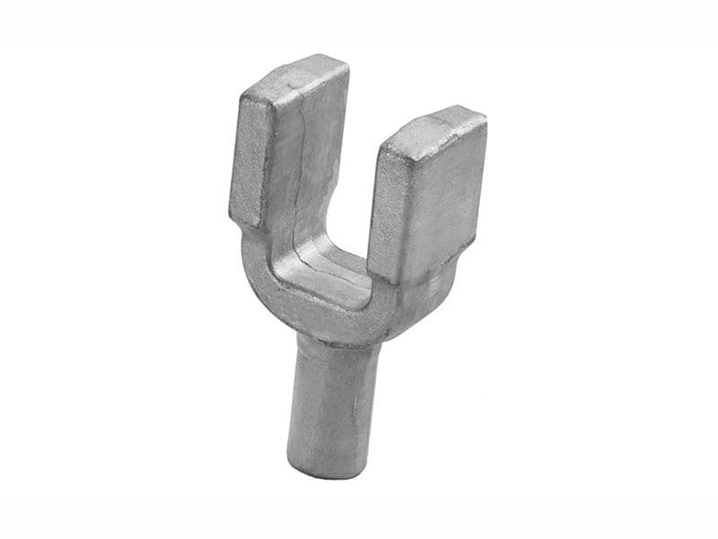Automotive

small yoke
Introducing our heavy-duty, industrial-grade strip curtains designed for optimal efficiency and durability in high-traffic commercial and manufacturing environments. Made from high-quality PVC material, these curtains offer superior resistance against harsh chemicals, dust, and moisture while maintaining excellent aesthetic appeal. With their easy-to-install stainless steel guide rails and flexible strip design, these curtains effectively regulate temperature, airflow, and noise levels, resulting in substantial cost savings and quick ROI for your industrial application. Enhance your industrial space's safety, functionality, and style with our premium strip curtains.
View details
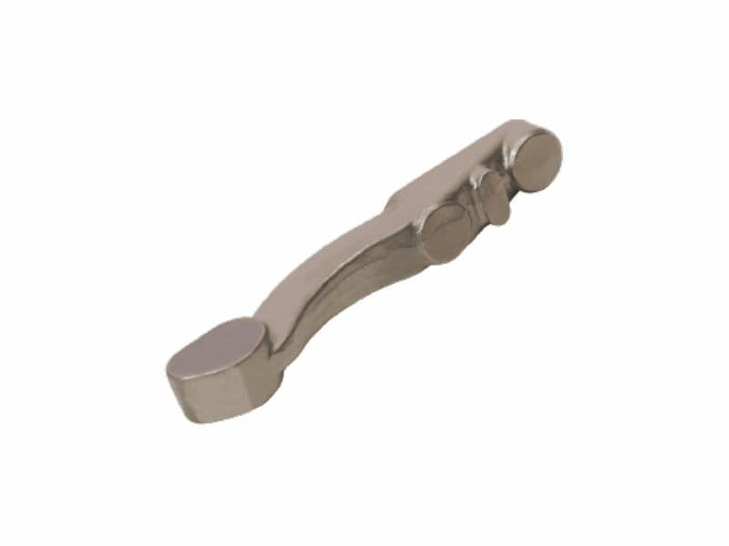Automotive

Track Arm
Our versatile aluminum junction box (Model XYZ) is designed for use in industrial settings where reliable circuitry and durability are essential. Engineered with high-quality 6061-T6 aluminum, this junction box provides a sturdy and corrosion-resistant solution for integrating electrical components in harsh environments. Unmatched in functionality, this box offers a removable access cover, built-in gasket, and knockouts for wiring flexibility. The rugged design ensures optimal circuit management, reducing the risk of electrical hazards and equipment failure. The industrial-grade junction box is the ideal solution for a variety of applications, from communication towers to manufacturing facilities, where reliability and performance are paramount.
View details
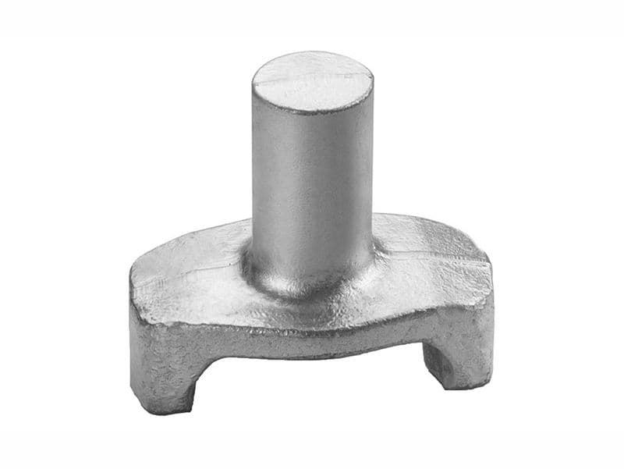Automotive

Yoke
Introducing our innovative industrial product, the definitive solution for professionals who demand both outstanding performance and unparalleled durability. Crafted from high-grade polymers, this product features superior resilience, achieving outstanding mechanical properties that allow for reliable use in the most demanding industrial environments. Its functional design is optimized for efficient operation, offering unparalleled precision and control. Whether in manufacturing, assembly, or maintenance applications, this product is the go-to choice for those who require exceptional quality and reliability.
View details

