Using FTP, uploading file in local machine

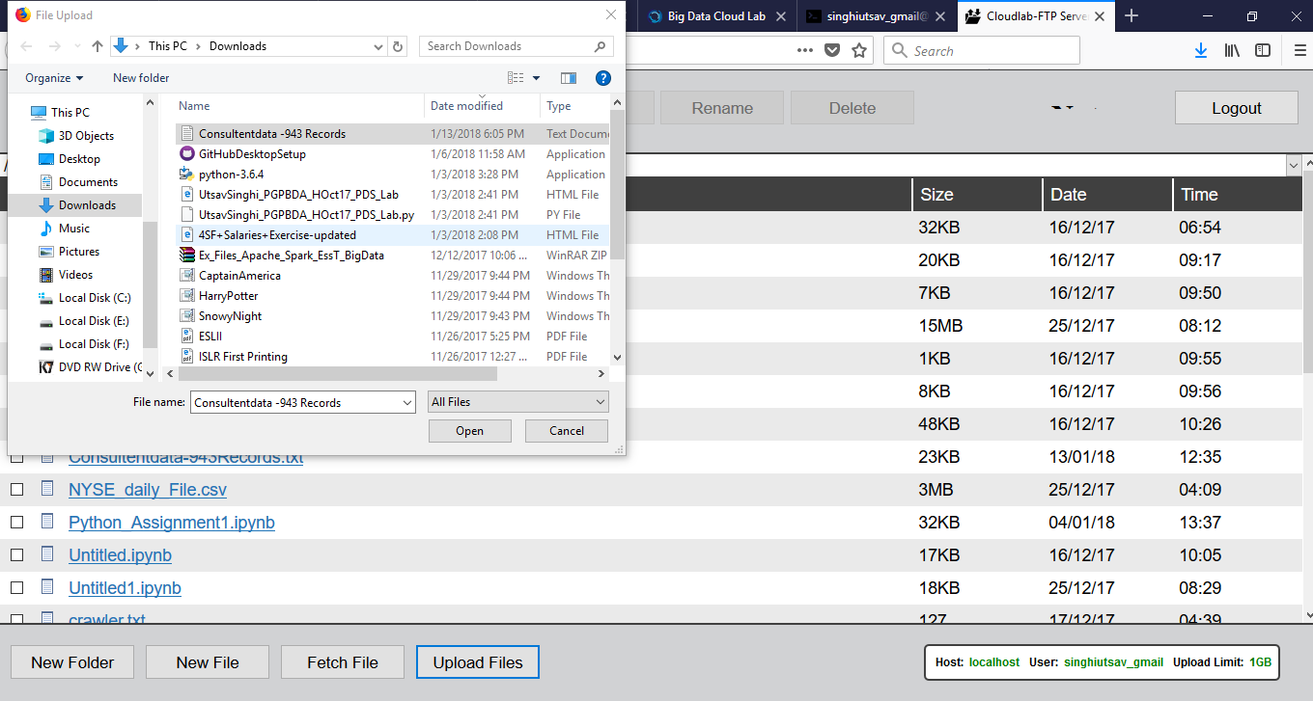

File Uploaded in local machine

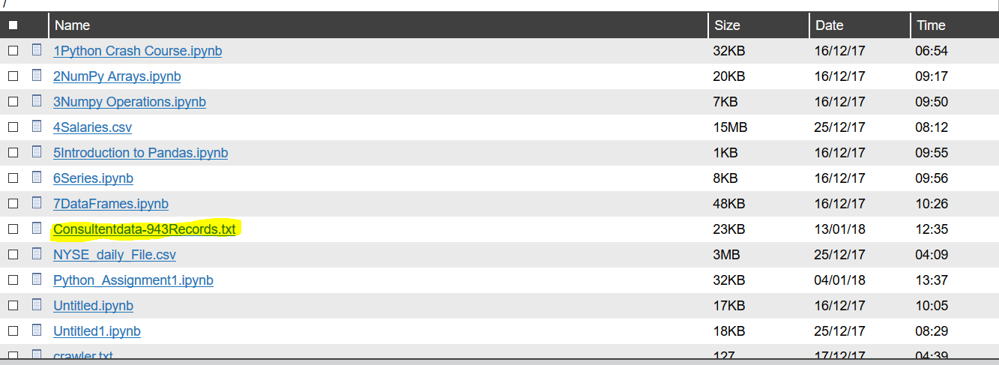

Login to Webconsole and creating new directory using mkdir



Now putting file in HDFS



Entering Hive

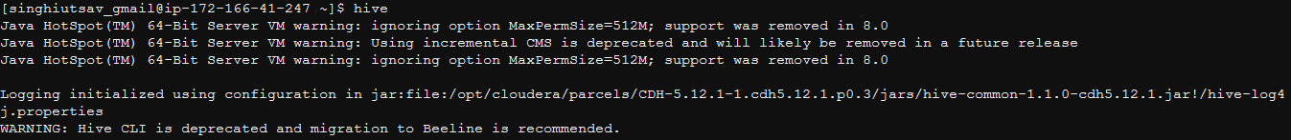

As per requirement, Creating External Table as “employees_table” having 5 fields.

* CREATE EXTERNAL TABLE IF NOT EXISTS EMPLOYEES_TABLE( Id smallint, age smallint, gender string, role string, salary bigint) ROW FORMAT DELIMITER FIELDS TERMINATED BY ‘|’ STORED AS TEXTFILE LOCATION ‘/user/singhiutsav_gmail/bigdataassignment2/’;

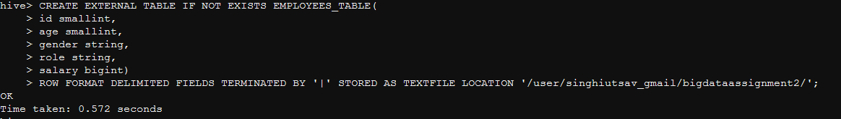

Checking Correct Data been Inserted

* Select * from employees_table limit 5;

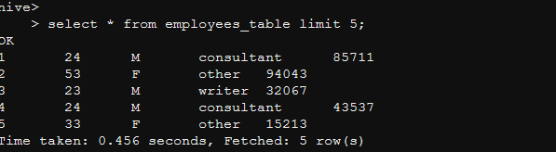

As per requirement, we will be Creating 4 buckets

* CREATE TABLE Consultant_Table_Bucket( id smallint, age smallint, gender string, role string, salary bigint) CLUSTERED BY(salary) into 4 buckets row format delimited fields terminated by ‘,’ stored as orc tblproperties(“transactional”=”true”);

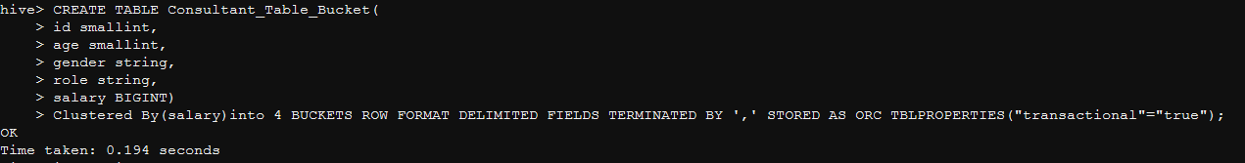

Inserting Data in Consultant_Table_Bucket

* Insert into consultant_table_bucket Select * from employee_table where salary > 5000

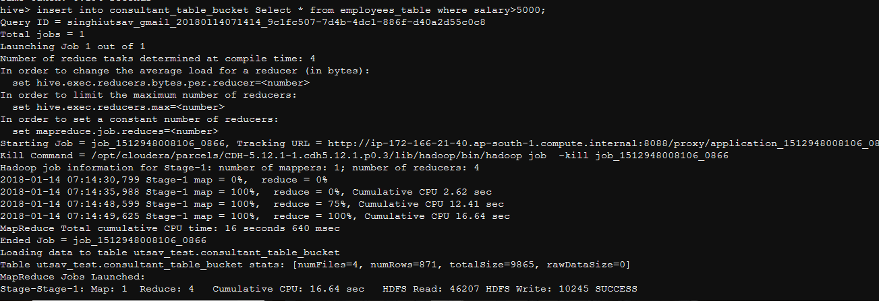

Updating table Consultant_table_bucket table role =’ consultant’ will be updated role=’BigData Consultant’

* Updating Consultant_Table_Bucket set role =’BigData Consultant’ where role= ‘Consultant’



Selecting maximum and minimum salary from table Consultant_Table_Bucket



