**[Creating a new repository from the web UI](https://docs.github.com/en/repositories/creating-and-managing-repositories/creating-a-new-repository" \l "creating-a-new-repository-from-the-web-ui)**

1. In the upper-right corner of any page, select , then click **New repository**.

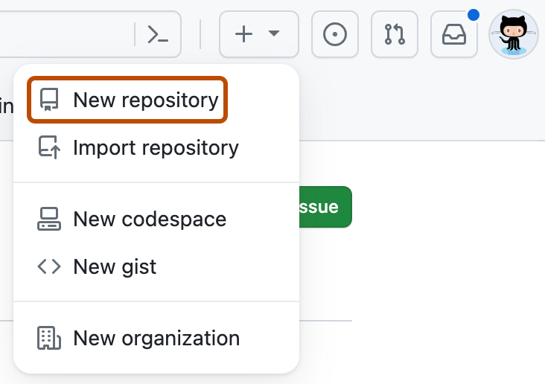

1. Optionally, to create a repository with the directory structure and files of an existing repository, select the **Choose a template** dropdown menu and click a template repository. You'll see template repositories that are owned by you and organizations you're a member of or that you've used before. For more information, see "[Creating a repository from a template](https://docs.github.com/en/repositories/creating-and-managing-repositories/creating-a-repository-from-a-template)."
2. Optionally, if you chose to use a template, to include the directory structure and files from all branches in the template, and not just the default branch, select **Include all branches**.
3. Use the **Owner** dropdown menu to select the account you want to own the repository.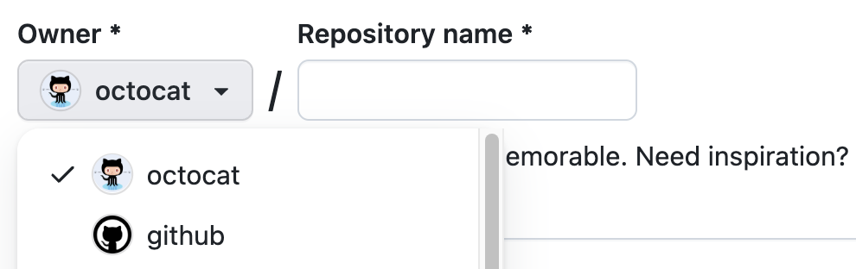
4. Type a name for your repository, and an optional description.

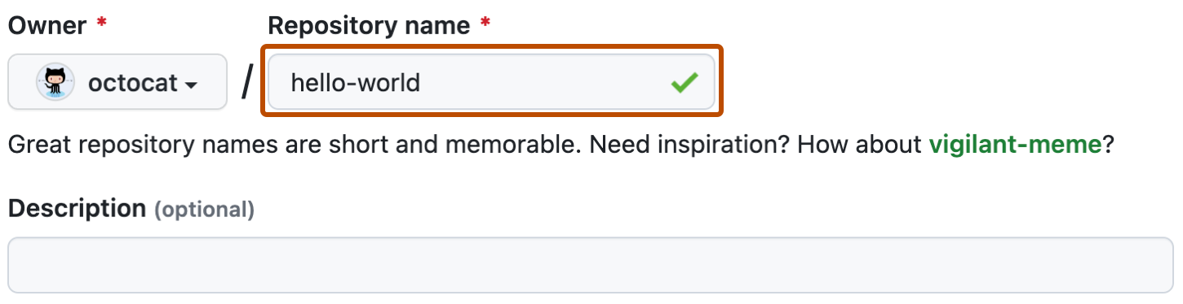

1. Choose a repository visibility. For more information, see "[About repositories](https://docs.github.com/en/repositories/creating-and-managing-repositories/about-repositories#about-repository-visibility)."
2. If you're not using a template, there are a number of optional items you can pre-populate your repository with. If you're importing an existing repository to GitHub, don't choose any of these options, as you may introduce a merge conflict. You can add or create new files using the user interface or choose to add new files using the command line later. For more information, see "[Importing an external Git repository using the command line](https://docs.github.com/en/migrations/importing-source-code/using-the-command-line-to-import-source-code/importing-an-external-git-repository-using-the-command-line)," "[Adding a file to a repository](https://docs.github.com/en/repositories/working-with-files/managing-files/adding-a-file-to-a-repository#adding-a-file-to-a-repository-using-the-command-line)," and "[Addressing merge conflicts](https://docs.github.com/en/pull-requests/collaborating-with-pull-requests/addressing-merge-conflicts)."
   * You can create a README, which is a document describing your project. For more information, see "[About READMEs](https://docs.github.com/en/repositories/managing-your-repositorys-settings-and-features/customizing-your-repository/about-readmes)."
   * You can create a *.gitignore* file, which is a set of ignore rules. For more information, see "[Ignoring files](https://docs.github.com/en/get-started/getting-started-with-git/ignoring-files)."
   * You can choose to add a software license for your project. For more information, see "[Licensing a repository](https://docs.github.com/en/repositories/managing-your-repositorys-settings-and-features/customizing-your-repository/licensing-a-repository)."
3. Optionally, if the personal account or organization in which you're creating uses any GitHub Apps from GitHub Marketplace, select any apps you'd like to use in the repository.
4. Click **Create repository**.
5. At the bottom of the resulting Quick Setup page, under "Import code from an old repository", you can choose to import a project to your new repository. To do so, click **Import code**.