**JAYGOGA PTY LTD**

STAFF HYGIENE RULES - PICKING & PACKING

WEAR CLEAN CLOTHES, NO JEWELLERY (EXCEPT PLAIN WEDDING BAND - NO STUDS OR GROOVES),

NO FOOD OR PERSONAL ITEMS, NO SMOKING IN GROWING AREAS - THESE ARE TO BE KEPT IN DESIGNATED

STAFF FACILITIES

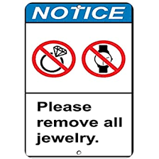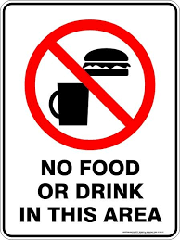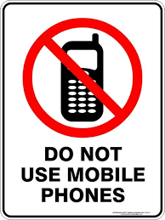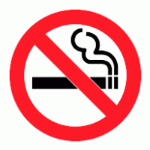

IF YOU ARE SICK, REPORT TO SUPERVISOR – BLUE BANDAID FOR CUTS/SORES



WASH AND DRY HANDS (BEFORE HANDLING PRODUCE, AFTER TOILET, EATING FOOD, BLOWING NOSE, SMOKING, HANDLING RUBBISH, ETC)

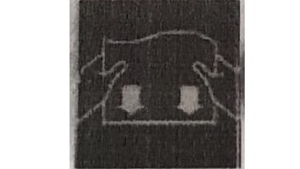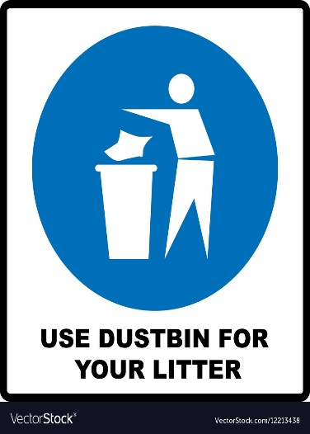

USE TOILETS PROVIDED

