Module 1 – Core Java

- Introduction to Java
- History of Java :-
- Java was developed by Sun Microsystems (which is now the subsidiary of Oracle) in the year 1995.
- James Gosling is known as the father of Java.
- Before Java, its name was Oak. Since Oak was already a registered company, so James Gosling and his team changed the name from Oak to Java.

- Features of Java:

  - Simple
  - Object-Oriented
  - Portable
  - Platform independent
  - Secured
  - Robust
  - Architecture neutral
  - Interpreted
  - High Performance
  - Multithreaded
  - Distributed
  - Dynamic

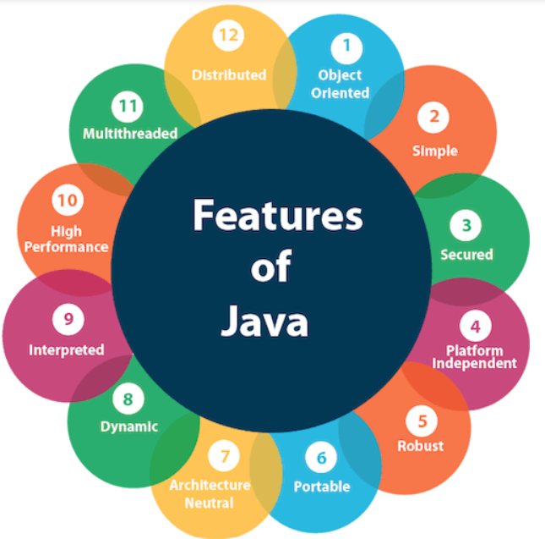

- Understanding JVM, JRE, and JDK :

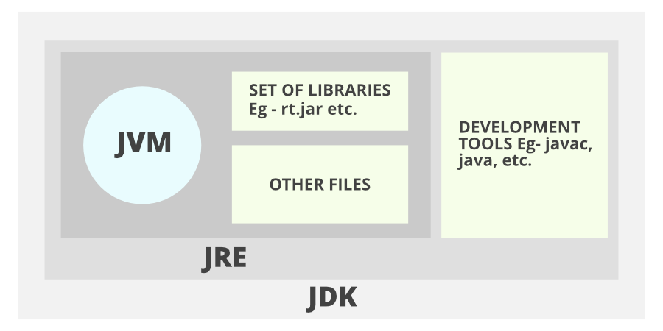

- JVM
JVM (Java Virtual Machine) is an abstract machine. It is called a virtual machine because it doesn't physically exist.
It is a specification that provides a runtime environment in which Java bytecode can be executed.
It can also run those programs which are written in other languages and compiled to Java bytecode.
The JVM performs the following main tasks:
- Loads code
- Verifies code
- Executes code
- Provides runtime environment

JRE
- JRE is an acronym for Java Runtime Environment.
- It is also written as Java RTE.
- Java Runtime Environment is a set of software tools which are used for developing Java applications.
- It is used to provide the runtime environment.
- It is the implementation of JVM. It physically exists.
- It contains a set of libraries + other files that JVM uses at runtime.
- JDK
JDK is an acronym for Java Development Kit. The Java Development Kit (JDK) is a software development environment which is used to develop Java applications and applets. It physically exists. It contains JRE + development tools.
JDK is an implementation of any one of the below given Java Platforms released by Oracle Corporation:
- Standard Edition Java Platform
- Enterprise Edition Java Platform
- Micro Edition Java Platform
The JDK contains a private Java Virtual Machine (JVM) and a few other resources such as an interpreter/loader (java), a compiler (javac), an archiver (jar), a documentation generator (Javadoc), etc. to complete the development of a Java Application.

- Setting up the Java environment and IDE (e.g., Eclipse, IntelliJ)
To set up a Java development environment, you need to install the necessary software: the Java Development Kit (JDK) and an Integrated Development Environment (IDE) like Eclipse or IntelliJ IDEA. Below are the steps to guide you through this process.

1. Install the Java Development Kit (JDK)
The Java Development Kit (JDK) is required to compile and run Java applications.

Step-by-Step JDK Installation:
- Download the JDK:
  - Go to the official Oracle JDK website: JDK Downloads (or search for the version you need, like Java 23).
  - Choose the version you need (e.g., JDK 23) and download the appropriate version for your operating system (Windows, macOS, or Linux).
  - Install the JDK:
  - Windows: Run the downloaded .exe file and follow the installation instructions.
• Verify Installation: After installing the JDK, open a terminal or command prompt and type:
java -version
This should display the installed version of Java, confirming that the JDK is installed.
- Java Program Structure (Packages, Classes, Methods).

Java Program Structure
A Java program follows a specific structure to define its components and functionality. The structure of a typical Java program consists of the following key elements:
- Package Declaration
- Import Statements
- Class Definition
- Main Method
- Statements and Expressions

1. Package Declaration
- A package is a namespace that organizes a set of related classes and interfaces.
- This is the first line in a Java file (optional, but recommended).
- Packages help to avoid name conflicts and manage large software projects more efficiently.
- If no package is declared, the program belongs to the default package.
Syntax: package com.example.myapp;

2. Class Definition
- Classes are the blueprints from which objects are created. Every Java program must have at least one class.
- The class defines the properties (fields) and behaviors (methods) of the objects.
Syntax: public class MyClass {
// Fields, Constructors, and Methods go here
}

3. Main Method
- The main method is the entry point of any Java application. It is where the program begins execution.
- It must be declared as: public static void main(String[] args) ;

- Data Types, Variables, and Operators

  - Primitive Data Types in Java :
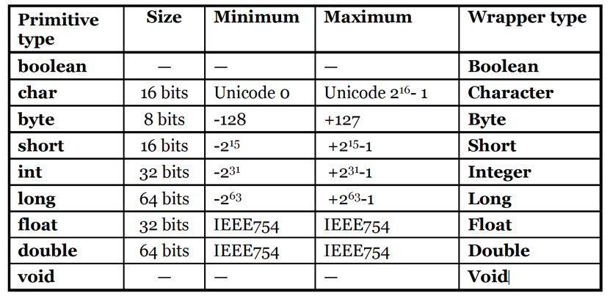
  - Variable Declaration and Initialization.

Variable Declaration
To declare a variable, you must specify:
- Data Type: The type of data the variable will hold (e.g., int, double, String, etc.).
- Variable Name: A unique name that identifies the variable (must follow Java naming conventions).
Variable Initialization
- After declaring a variable, you can assign an initial value to it. This is called initialization.
Example :
public class Person {
// Instance variables
String name; // Declared but not initialized
int age = 30; // Declared and initialized

// Method with local variables
public void displayInfo() {
int salary = 50000; // Local variable initialized
System.out.println("Name: " + name); // Prints default value (null)
System.out.println("Age: " + age); // Prints 30
System.out.println("Salary: " + salary); // Prints 50000
}
public static void main(String[] args) {
Person person = new Person();
person.name = "John"; // Initializing instance variable 'name'
person.displayInfo();
}
}

  - Operators: Arithmetic, Relational, Logical, Assignment, Unary, and Bitwise :

Key Points:
- Arithmetic operators: perform basic calculations. (+, -, *, /, % )
- Relational operators: compare values and return a boolean result. ( ==, !=, >, <, >=, <= )
- Logical operators: combine multiple boolean expressions. ( &&, ` )
- Assignment operators: assign values to variables. ( =, +=, -=, *=, /=, %= )
- Unary operators: perform operations on a single operand (e.g.,incrementing or negating values). ( ++, --, +, -, ! )
- Bitwise operators:Work on the binary representations of integers and are often used for low-level data manipulation.(&,` )
  - Summary of Type Conversion and Type Casting
- Type Conversion:
  - Implicit (Widening): Automatically done by the compiler from a smaller type to a larger type.
  - Explicit (Narrowing): Manually done by the programmer, often resulting in data loss.
- Type Casting: The process of converting one data type to another.
  - Widening (Implicit Casting): Done automatically by the compiler (e.g., int to long, float to double).
  - Narrowing (Explicit Casting): Requires the programmer to manually cast the value (e.g., double to int).
- Object Casting: Can be done between classes in an inheritance hierarchy, where upcasting is implicit and downcasting is explicit but requires caution to avoid ClassCastException.
Example 1: Widening Type Casting
byte b = 50;
int i = b; // Implicit casting from byte to int
System.out.println(i); // Output: 50

Example 2: Narrowing Type Casting
float f = 3.14f;
int i = (int) f; // Explicit casting from float to int
System.out.println(i); // Output: 3 (fraction part is discarded)

3 Control Flow Statements

- If-Else Statements : - it is used to statements either if statement or else statements for a single condition.
Syntax : if(condition){
}
else{
}

2 . Switch Case Statements :- Switch is a multiple choice decision making selection statements ,it is used when we want to select only one case out of multiple cases.
Syntax : Switch (exp){
Case 1: statement 1;
Break;
Case 2: statement 2;
Break;
Default: statement;
Break;
}
3.Loops (For, While, Do-While) :-
- For loop :- it is used when we want to perform initialization , condition and incr/decr operation is single line.
Syntax:- for(initialization,condition,incr/decr){
}
- While loop:- it is used when we don’t know the number of itration in advance .

Syntax:- while(condition){
}
- Do while loop:- it used when we want to execute loop doby atleast once even condition is false.

Syntax:- do{
}
While(condition)

4.Break and Continue Keywords :-
- Break statement : -This statement terminates the smallest enclosing loop (i.e., while, do-while, for loop, or switch statement). Below is the program to illustrate the same.
- Continue statement :- This statement skips the rest of the loop statement and starts the next iteration of the loop to take place. Below is the program to illustrate the same:

4 Classes and Objects

- Defining a Class and Object in Java: -
- Class :- Class is a collection of objects and it does not take any space on memory , class is also as blueprint/logical entity.
- Types of Class:-
1. pre-defined:- Scanner , Console , System , String.
2. user-defined:- A class which is created by java programmer is called user-defined class.
Syntax:- class class_name{
-----------//data
-----------//methods
}
- Object:- object is an instance of class that executes the class .once the object is created , it takes us space like other variable in memory.
Syntax:- class_name obj_name=new
class_name()

2.Constructors and Overloading:-
Constructor:- A constructor is a special type of method whose name is same as class name.
Syntax:- class class_name{
Class_name(){
}
}

- Types of constructor :

1.Default constructor :- A constructor which does not have any parameter is called default constructor.
Syntax:- class A{
A(){
}
}
2.perametrise constructor:- A constructor through which we can pass one or more parameters is called parametrise constructor.
Syntax:- class A{
A(int x, string y){
}
}
3.copy constructor:-Whenever we pass object refrence to the constructor then it is called copy constructor.
Syntax:- class_name{
class_name(obj ref){
}
}
Overloading:- Whenever a class contain more than one method with same name and different types of parameters is called method overloading.
Syntax:- return_type method_name(param 1);
Return_type method_name(param,param2);

4. This Keyword:-
- this keyword refers to the current object inside a method or constructor .
Eg: class A{
}
- It is also used when we want to call the default constructor of its own class.
Eg: classA{
A(){
}
A(int a){
This();
}
}
- It is also called parametrised constructor of its own class.
Eg: class A{
A(){
}
A(int a){
}

  - Methods in Java

1.Defining Methods: - In Java, methods are blocks of code that perform a specific task and can be reused throughout your program. Here's a breakdown of how to define methods in Java, including their syntax.

Syntax:-
accessModifier returnType methodName(parameterType parameterName) {
// method body
// return statement (if returnType is not void)
}

2.Method Parameters and Return Types:-
Method Parameters:-
Parameters are variables listed in a method's definition that allow the method to accept input values when called.
Types of Parameters:-
- Required Parameters: Must be provided when calling the method.
- Optional Parameters: Can be given default values (Java doesn't support optional parameters directly, but you can use method overloading to achieve similar functionality).
- Variable Arguments (Varargs): Allows you to pass a variable number of arguments to a method.
Syntax:- public void methodName(type1 param1, type2 param2) {
// Method body }
3.Method Overloading:- Method overloading in Java allows you to define multiple methods with the same name but different parameter lists within the same class.

Rules for Method Overloading:-
- Different Parameter List: The methods must have different parameter lists.
- Same Method Name: The method name must remain the same.
- Return Type: The return type can be the same or different, but it alone cannot be used to differentiate overloaded methods.
Syntax:- returnType methodName(parameterType1 parameterName1, parameterType2 parameterName2, ...) { // method body // return statement (if applicable) }

4.Static Methods and Variables:- A static method belongs to the class rather than any particular object. It can be called without creating an instance of the class. Static methods can only access static variables and other static methods directly.
Syntax:- class ClassName {
static returnType methodName(parameters) {
// method body
}
}

6. Object-Oriented Programming (OOPs) Concepts

1.Basics of OOP: Encapsulation, Inheritance, Polymorphism, Abstraction :-
- Encapsulation:- The data member and member method of class in a single unit called encapsulation.
- Declare the class variable as a private
- Declare the class methods as a public.
- Two Types..1. Setter 2. Getter

- Inheritance:- It is to access properties to one class to another class.

- Three types:-
1. SingleLevel Inheritance:-One sub class & one Super class.
2. MultiLevel Inheritance:- One sub class & Multiple Super class.
3. Hirachical Inheritance:-One sub class & Two Super class.

- Polymorphism:- polymorphism is the Greek word whose meaning is same object having different behaviour.
- Two types :-
1.Method Overloading:- Same function name having different parameters.
2.Method Overriding:- Same name as class name in inheritance class.

- Abstraction:- Data hiding.. internal details showing assensial information to user is called. in abstract class there put be abstract default and static function are their.
2.Inheritance: Single, Multilevel, Hierarchical :-
- Three types:-
1. SingleLevel Inheritance:-One sub class & one Super class.
2. MultiLevel Inheritance:- One sub class & Multiple Super class.
3. Hirachical Inheritance:-One sub class & Two Super class.

3.Method Overriding and Dynamic Method Dispatch:-
Method Overriding:-
Method overriding occurs when a subclass provides a specific implementation of a method that is already defined in its superclass. This allows the subclass to modify or extend the behavior of the superclass method.
Dynamic Method Dispatch:-
Dynamic method dispatch is the mechanism by which a call to an overridden method is resolved at runtime rather than compile time. This means that the Java Virtual Machine (JVM) determines which method to invoke based on the actual object type, not the reference type.

7. Constructors and Destructors

- Constructor Types (Default, Parameterized):-
- Default:- A constructor which does not have any parameter is called default constructor.
Syntax:- class A{
{
A(){
}
}
- Parameterized:-A constructor through which we can pass one or more parameters is called parametrized constructor.
Syntax:- class A{
A(int x, string y);
{
}
}
2.Copy Constructor (Emulated in Java):- Whenever we pass obj refrence to the constructor the is is called copy constructor.
Syntax:- class class_name{
Class_name(obj ref){
{
}
}

3.Constructor Overloading:- Constructor overloading in Java allows a class to have more than one constructor, each with different parameters.

4. Object Life Cycle and Garbage Collection:-
- Object Life Cycle :- In Java, the object life cycle refers to the various stages an object goes through from creation to destruction.
- Garbage Collection :- Garbage collection is the process of automatically reclaiming memory by removing objects that are no longer in use.

8. Arrays and Strings

1 . One-Dimensional and Multidimensional Arrays: -
One-Dimensional Arrays:- A one-dimensional array in Java is a simple list of elements of the same type.
Declaration and Initialization.
Eg:- // Declaration
int[] array = new int[5]; // Array of integers with size 5
// Initialization
int[] numbers = {1, 2, 3, 4, 5}; //
Multidimensional Arrays:-
A multidimensional array in Java is essentially an array of arrays. The most common type is a two-dimensional array.
Eg:- // Declaration
int[][] matrix = new int[3][3]; // 3x3 matrix
// Initialization
int[][] grid = {
{1, 2, 3},
{4, 5, 6},
{7, 8, 9}
};
2. String Handling in Java: String Class, StringBuffer, StringBuilder :-
- String handling in Java involves several classes, each designed to work with strings in different ways.

- String Class:- Instances of the String class are immutable, meaning once created, their values cannot be changed. Any modification creates a new String object.
Eg:- String str1 = "Hello"; String str2 = new String("World");
- StringBuffer :- StringBuffer is mutable, meaning you can modify the contents without creating a new object. It is synchronized, making it safe for use in multithreaded environments.
Eg:- StringBuffer sb = new StringBuffer("Hello");
- StringBuilder :- Like StringBuffer, StringBuilder is also mutable. It is not synchronized, making it faster than StringBuffer for single-threaded scenarios.
Eg:- StringBuilder sb = new StringBuilder("Hello");

3.Array of Objects:- An array of objects is a collection of instances of a class stored in a single array structure. Each element of the array is a reference to an object of that class, allowing you to manage multiple objects conveniently.
Eg:- ClassName[] arrayName = new ClassName[size];
4. String Methods (length, charAt, substring, etc.):-
- length():- Returns the number of characters in the string.
Eg:- String str = "Hello";
int length = str.length(); // length = 5
- 2. charAt(int index):- Returns the character at the specified index. Indexing starts at 0.
Eg:- String str = "Hello";
char ch = str.charAt(1); // ch = 'e'
- 3. substring(int beginIndex):- Returns a new string that is a substring starting from the specified index to the end of the string.
Eg:- String str = "Hello, World!";
String sub = str.substring(7); // sub = "World!"
- 4. substring(int beginIndex, int endIndex):- Returns a substring from the specified beginIndex (inclusive) to endIndex (exclusive).
Eg:- String str = "Hello, World!";
String sub = str.substring(0, 5); // sub = "Hello"
- 5. toUpperCase():-Converts all characters in the string to uppercase.
Eg:- String str = "Hello";
String upper = str.toUpperCase(); // upper = "HELLO"
- 6. toLowerCase():- Converts all characters in the string to lowercase.
Eg:- String str = "Hello";
String lower = str.toLowerCase(); // lower = "hello"
- 7. trim():- Removes leading and trailing whitespace from the string.
Eg:- String str = " Hello ";
String trimmed = str.trim(); // trimmed = "Hello"
- 8. concat(String str):- Concatenates the specified string to the end of this string.
Eg:- String str1 = "Hello";
String str2 = " World!";
String result = str1.concat(str2); // result = "Hello World!"
- 9. equals(Object obj):- Compares this string to the specified object for equality.
Eg:- String str1 = "Hello";
String str2 = "Hello";
boolean isEqual = str1.equals(str2); // isEqual = true
- 10. equalsIgnoreCase(String anotherString):- Compares this string to another string, ignoring case considerations.
Eg:- String str1 = "hello";
String str2 = "HELLO";
boolean isEqual = str1.equalsIgnoreCase(str2); // isEqual = true
- 11. indexOf(String str):- Returns the index of the first occurrence of the specified substring or -1 if it does not occur.
Eg:- String str = "Hello, World!";
int index = str.indexOf("World"); // index = 7
- 12. replace(char oldChar, char newChar):- Returns a new string with all occurrences of oldChar replaced by newChar.
Eg:- String str = "Hello, World!";
String replaced = str.replace('o', 'a'); // replaced = "Hella, Warld!"
- 13. split(String regex):- Splits the string around matches of the given regular expression and returns an array of strings.
Eg:- String str = "apple,banana,cherry";
String[] fruits = str.split(","); // fruits = ["apple", "banana", "cherry"]

9. Inheritance and Polymorphism

1 . Inheritance Types and Benefits:-
- Types of Inheritance in Java
- Single Inheritance
  - A class inherits from only one superclass.
- Multilevel Inheritance
  - A class inherits from a superclass, which is itself a subclass of another superclass.
- Hierarchical Inheritance
  - Multiple classes inherit from the same superclass.
- Multiple Inheritance (through Interfaces)
  - Java does not support multiple inheritance with classes to avoid ambiguity (the "diamond problem"). However, it can be achieved using interfaces.
2.Method Overriding:- is same name as class name same as inheritance. Method overriding is a core concept in Java that allows a subclass to provide a specific implementation of a method that is already defined in its superclass. This mechanism enables polymorphism, allowing you to call overridden methods based on the object's runtime type rather than its reference type.
Syntax:- class Superclass { // Method in the superclass returnType methodName(parameters) { // method body } } class Subclass extends Superclass { @Override // Overriding method returnType methodName(parameters) { // new method body } }
3.Dynamic Binding (Run-Time Polymorphism):Method overriding is one of the ways in which Java supports Runtime Polymorphism. Dynamic method dispatch is the mechanism by which a call to an overridden method is resolved at run time, rather than compile time. At run-time, it depends on the type of the object being referred to (not the type of the reference variable) that determines which version of an overridden method will be executed
4.Super Keyword and Method Hiding:-
Super Keyword:- The super keyword in Java is a reference variable that refers to the immediate parent class object.
- When a method in a subclass overrides a method in the superclass, you can use super to call the superclass method.
Method Hiding :- Method hiding occurs when a subclass defines a static method with the same name and parameters as a static method in its superclass. In this case, the method in the subclass "hides" the method in the superclass.

10. Interfaces and Abstract Classes

- . Abstract Classes and Methods:-
- Abstract Classes:- An abstract class is a class that cannot be instantiated directly. It is declared with the abstract keyword.
- Abstract Methods:- An abstract method is a method that is declared without an implementation. It is also marked with the abstract keyword.
2.Interfaces: Multiple Inheritance in Java:- An interface is declared using the interface keyword. All methods in an interface are implicitly public and abstract (unless they are default or static). A class can implement multiple interfaces, allowing for a form of multiple inheritance. Interfaces can have default methods that provide a default implementation.
Syntax:- interface InterfaceName {
// Abstract method
returnType methodName(parameters);
// Default method
default returnType defaultMethodName(parameters) {
// Default implementation }
// Static method static
returnType staticMethodName(parameters) {
// Static implementation
}
}
3.Implementing Multiple Interfaces:- Interfaces are declared using the interface keyword and can contain abstract methods, default methods, and static methods. A class can implement multiple interfaces by using a comma-separated list in the implements clause. When a class implements multiple interfaces, it must provide implementations for all abstract methods defined in those interfaces.
Syntax:- interface InterfaceName1 {
// Abstract method
returnType methodName(parameters);
}
interface InterfaceName2 {
// Abstract method
returnType methodName(parameters);
}

11. Packages and Access Modifiers

- . Java Packages: Built-in and User-Defined Packages:-
- Built-in Packages:- Java provides several built-in packages that contain a wide variety of classes and interfaces.

User-Defined Packages:- User-defined packages are created by developers to organize their own classes and interfaces. This helps maintain code structure and prevents naming conflicts between classes in different packages.

2. Access Modifiers: Private, Default, Protected, Public.
- Private:- Members (variables and methods) declared as private are accessible only within the same class.
- Default:- If no access modifier is specified, the member is accessible only within classes in the same package. This is often referred to as "default" access or "package-private".
- Protected:- Members declared as protected are accessible within the same package and also by subclasses, even if they are in different packages.
- Public:- Members declared as public are accessible from any other class in any package.

3.Importing Packages and Classpath

Importing Packages:- When you want to use classes or interfaces from a package, you need to import them into your Java file. This is done using the import statement.

Syntax:- import packageName.ClassName; // Import a specific class
import packageName.*; // Import all classes from a package
- Classpath:- The classpath is a parameter in the Java environment that tells the Java Virtual Machine (JVM) and Java compiler where to look for classes and packages.
Eg:- java -cp path/to/classes Main

12. Exception Handling

- Types of Exceptions Checked and Unchecked:-
- Checked exceptions:- Checked exceptions are exceptions that are checked at compile time. The Java compiler ensures that these exceptions are either handled with a try-catch block or declared in the method signature using the throws keyword.
- Unchecked Exceptions:- Unchecked exceptions are exceptions that are not checked at compile timwwe. These exceptions occur during runtime, and the Java compiler does not require them to be handled or declared.
2.try, catch, finally, throw, throws.
- 1.try:- The try block is used to enclose the code that might throw an exception. If an exception occurs within the try block, control is transferred to the corresponding catch block.
- 2. catch:- The catch block is used to handle exceptions that are thrown in the try block. You can have multiple catch blocks to handle different types of exceptions.
- 3. finally:- The finally block is used to execute code that must run regardless of whether an exception was thrown or caught. This is useful for releasing resources, such as closing files or network connections.
- 4. throw:- The throw keyword is used to explicitly throw an exception. You can throw a built-in exception or create your own custom exception class.
- 5. throws:- The throws keyword is used in a method signature to declare that a method can throw one or more exceptions. This informs callers of the method that they should handle those exceptions.
3.Custom Exception Classes:- efinition of Custom Exception Classes:- in Java are user-defined exceptions that extend the existing exception hierarchy, allowing developers to create specific error types tailored to their application's needs. They enable more granular error handling by providing meaningful and contextual information about exceptional conditions that may occur during program execution.

13. Multithreading

1.Introduction to Threads:- Thread is a smallest unique of process at a time only single thread can be execute . • A Java application can have multiple threads running concurrently.

2.Creating Threads by Extending Thread Class or Implementing Runnable Interface:-
- by Extending Thread :- When you extend the Thread class, you create a new class that inherits from Thread. You need to override the run() method to define the code that will execute in the thread. is a simple and direct, suitable for small tasks where the thread's functionality is the primary concern.
Syntax:- Class A extends thread{
@override
Public void run()
{
//code
}
- Implementing Runnable Interface:-Implementing the Runnable interface is a more flexible approach. You create a class that implements Runnable and define the run() method. You then pass an instance of your class to a Thread object. is recommended for more complex scenarios, especially when you need to share the same task among multiple threads or when your class needs to extend another class.
Syntax:- Class A implements Runable{
Public void main(){
//code;
}
}
Class B{
Public static void main(){
A r=newA()
Thread t=new thread();
Thread(r);
t.start();
}
3.Thread Life Cycle:-
New
|
| start()
v
Runnable <-------------------+
| |
| (scheduler) |
| (synchronized lock) |
v |
Running <----------------- Blocked
| |
| (waits for CPU) |
| (wait, join, sleep) |
v |
Terminated <----------------+

4.Synchronization and Inter-thread Communication
- Synchronization:- object to binary stream converting process is called Synchronization.

- Inter-thread communication:- in Java is a mechanism that allows threads to communicate and synchronize their actions, ensuring they can coordinate access to shared resources effectively.

14. File Handling

- Introduction to File I/O in Java (java.io package):- File I/O (Input/Output) in Java allows you to read from and write to files on the filesystem. The java.io package provides the classes and interfaces necessary for handling file operations.
Key Classes in java.io
- File
- FileInputStream
- FileOutputStream
- FileReader:
- FileWriter
- BufferedReader
- BufferedWriter
- PrintWriter
2.FileReader and FileWriter Classes:-
- FileReader Class:- The FileReader class is used to read the contents of a file as a stream of characters. It reads bytes and decodes them into characters using a specified charset.
- FileWriter Class:- The FileWriter class is used to write characters to a file. It can create a new file or overwrite an existing file.
3.BufferedReader and BufferedWriter:-
- BufferedReader:- BufferedReader is used to read text from a character input stream. It buffers characters to provide efficient reading of characters, arrays, and lines.

- BufferedWriter:- BufferedWriter is used to write text to a character output stream. It buffers the output to provide efficient writing of characters, arrays, and strings.

4. Serialization and Deserialization:-
- Serialization:- To serialize an object in Java, the class of the object must implement the Serializable interface. This interface is a marker interface (it has no methods).

- Deserialization:- To deserialize an object, use the ObjectInputStream class to read the byte stream and reconstruct the object.

15. Collections Framework

- Introduction to Collections Framework:- The Collections Framework in Java is a unified architecture designed to store, manipulate, and retrieve groups of objects efficiently. It provides various data structures and algorithms that simplify programming by offering a standard way to manage collections of objects.
2.List, Set, Map, and Queue Interfaces:-
List:- Represents an ordered collection (also known as a sequence) that allows duplicate elements. The order of elements is determined by their insertion order.
Map:- Represents a collection that does not allow duplicate elements. The order of elements is not guaranteed (except in specific implementations).
Map:-Represents a collection of key-value pairs, where each key is unique. A map does not allow duplicate keys but allows duplicate values.
Interfaces :-Represents a collection designed for holding elements prior to processing. Typically follows the First-In-First-Out (FIFO) principle, though other ordering methods exist.

3.ArrayList, LinkedList, HashSet, TreeSet, HashMap, TreeMap.
- ArrayList:- A resizable array implementation of the List interface that allows dynamic resizing, fast random access, and maintaining the order of elements. It allows duplicate elements.
- LinkedList:- A doubly-linked list implementation of the List and Deque interfaces, allowing for efficient insertions and deletions from both ends. It maintains the order of elements and allows duplicate elements.
- HashSet:- A set implementation that uses a hash table for storage, which does not allow duplicate elements and does not guarantee any specific order of elements.
- TreeSet:- A set implementation that uses a red-black tree, storing elements in a sorted order. It does not allow duplicate elements.
- HashMap:- A hash table-based implementation of the Map interface that stores key-value pairs. It allows for fast retrieval of values based on their unique keys and does not maintain any order.
- TreeMap:- A Map implementation that uses a red-black tree to store key-value pairs in sorted order based on the keys. It does not allow duplicate keys.

4.Iterators and ListIterators:-
- Iterator:- Iterator is a standard interface for iterating over a collection. It provides methods to traverse the collection in a sequential manner.
- ListIterator:- ListIterator is a more specialized interface that extends the Iterator interface and is specifically designed for List collections. It allows bidirectional traversal and provides additional functionality.

16. Java Input/Output (I/O)

1.Streams in Java (InputStream, OutputStream)
- InputStream:- InputStream is an abstract class that represents an input stream of bytes. It provides methods for reading data from various sources.
- OutputStream:- OutputStream is an abstract class that represents an output stream of bytes. It provides methods for writing data to various destinations.

2.Reading and Writing Data Using Streams:-
1. Byte Streams:- Byte streams handle raw binary data. They are suitable for all types of I/O, including images, audio files, and more.
2. Character Streams:- Character streams are designed for handling text data. They read and write data in characters, making them more suitable for text files.
3. Buffered Streams:- Buffered streams enhance performance by reducing the number of I/O operations. They use a buffer to temporarily store data, allowing for more efficient reading and writing.
3.Handling File I/O Operations in java:- Handling file I/O operations in Java involves using classes from the java.io package to read from and write to files. Below is a comprehensive guide on how to perform common file I/O operations, including creating, reading, writing, and deleting files.

