Project Start Time : 10:16

Output :

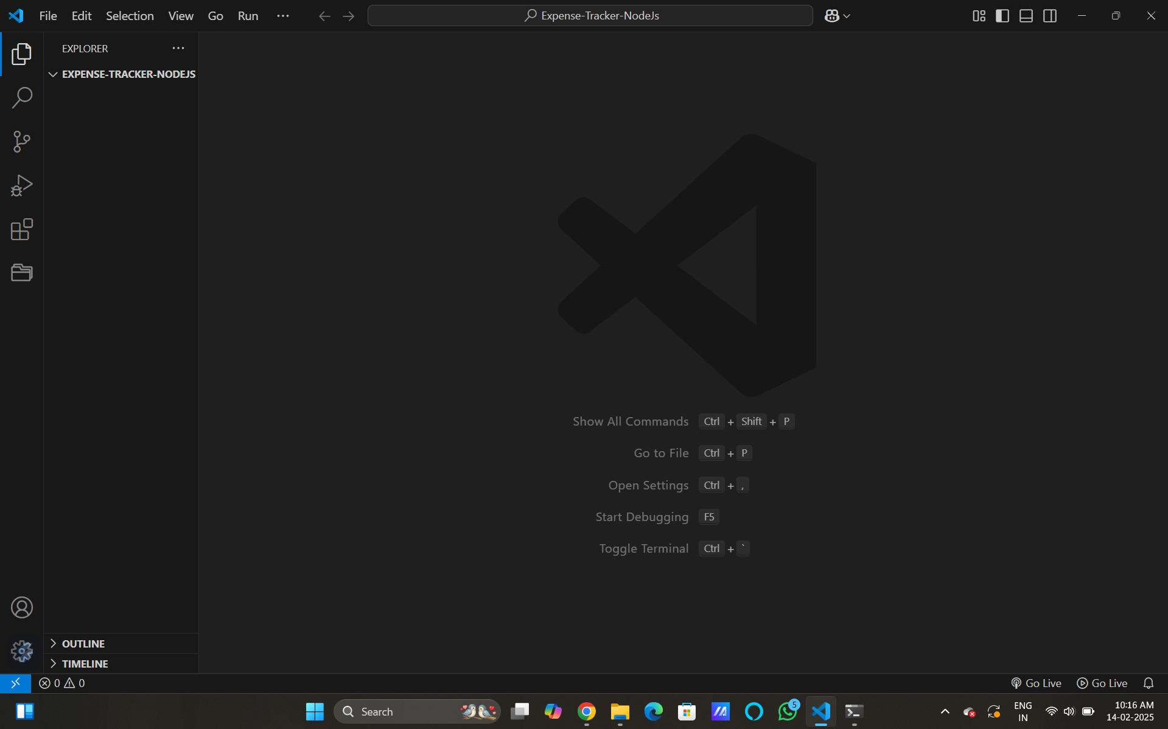

Project End Time :- 08:07

Output :-

