Project Start Time :- 11:13 AM

Output :-

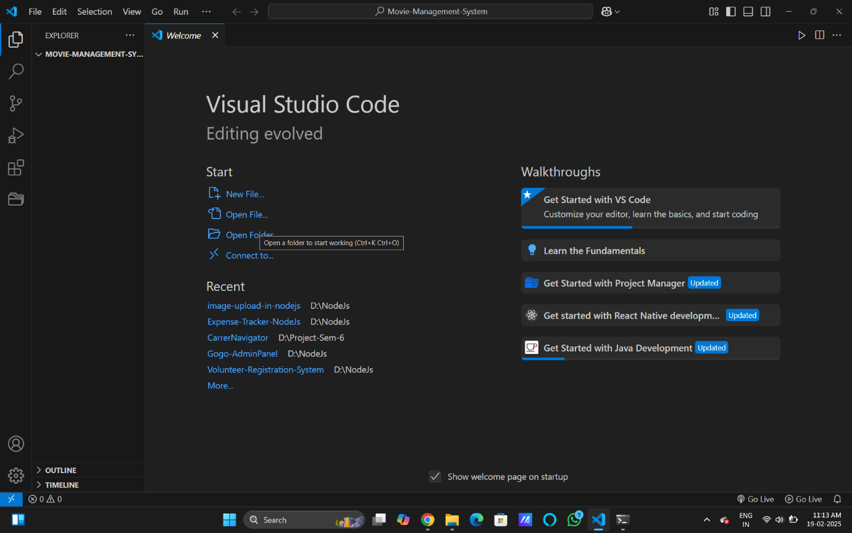

Project End Time :- 11:12 PM

Output :-

