Merge Seven-Style Hex Merge Game
Complete Product, UX/UI, Visual Design, Kotlin Architecture, Gameplay Logic, QA and Release Plan
Reference basis: the two supplied gameplay screenshots, translated into an original implementation plan rather than a pixel-for-pixel clone.
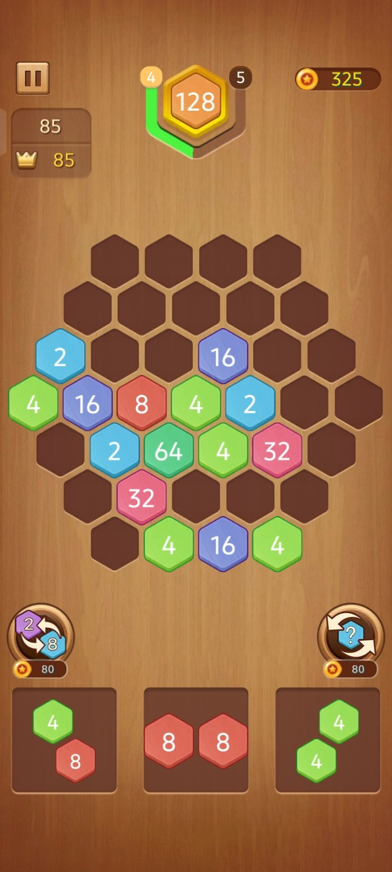
Recommended target: Android, Kotlin, Jetpack Compose, Canvas-based game board, MVVM, testable game engine.
Document goal: give the product owner and developer a single source of truth for what to build, why it exists, how each screen behaves, the rules for every scenario, and the acceptance criteria for every phase.

Document Map
Section | What it answers
1. Product definition | What the game is, who it is for, and what “done” means.
2. Design reference | How the supplied screenshots translate into an original design system.
3. UX + screen plan | Every major screen, state, action, empty/error/loading scenario.
4. Gameplay specification | Board, pieces, merge rules, chain reactions, scoring, levels, game-over.
5. Technical architecture | Kotlin package plan, state model, rendering, algorithms, persistence.
6. Phase-by-phase delivery | Concrete tasks, decisions, dependencies and exit criteria.
7. QA strategy | Unit tests, interaction tests, visual checks, devices and release gates.
8. Monetization + live operations | Ads, boosters, economy, analytics and remote tuning.
9. Asset + design checklist | Images, icons, effects, audio, copy and file naming.
10. Final acceptance checklist | Release-ready definition of done.

Executive Summary
The game is a portrait mobile puzzle built around a fixed or level-defined honeycomb board. The player chooses a small multi-tile piece from the bottom tray, previews where it can fit, places it on empty hex cells, and triggers merges when three or more connected tiles share the same value. A successful merge converts the group into one tile of the next value and can start a chain reaction. Progress, score, coins and level targets are shown in the top area; boosters and upcoming pieces live below the board.
The implementation should be original in branding and artwork. The reference screenshots should guide layout hierarchy, tactile feel and information density, but the final product should use its own tile rendering, icons, textures, sound, effects and visual language.
The highest engineering priority is deterministic game logic. The board and merge engine must be testable without Android UI. The highest UX priority is making every move feel predictable: show legal placement, clearly animate the merge, explain the score change, and never punish the player for a tap that does not create a valid state.

1. Product Definition

1.1 Product vision
Create a polished, calming, high-retention hex merge puzzle that feels easy to learn in under one minute and deep enough to replay for long sessions. The first release should favor clarity and game feel over an oversized feature set.

1.2 Core pillars
Pillar | Requirement | Measurement
Readable | Tile value, legal cells and current piece are instantly clear. | Usability test: player places first piece without instruction.
Tactile | Placement, merge and score feedback feel physical and rewarding. | No critical interaction without visible/haptic/audio feedback.
Strategic | Players can plan one or more moves ahead. | Preview shows next pieces and legal placement.
Fair | Randomness creates pressure, not obvious cheating. | Seeded QA and distribution monitoring.
Fast | A normal move takes only a few seconds. | Target: tap/drag-to-result under 1.2 s excluding merge chain.

1.3 MVP versus post-MVP
MVP | Post-MVP
One core game mode | Daily challenge
Hex board + multi-tile pieces | Level map with special boards
3+ matching-neighbor merge | Special challenge rules
Score + best score + coins | Cloud sync / account
2 boosters | Booster shop and booster inventory
Pause / restart / game over | Events / seasons
Save and resume current game | Leaderboards
Rewarded ad continuation | Subscription / VIP

1.4 Non-goals for first production build
- Do not build a multiplayer mode in MVP.
- Do not add a complex account system just to save a local puzzle.
- Do not over-animate every UI component; game-board feedback gets priority.
- Do not clone proprietary logos, typography, artwork, sound effects or exact UI assets from the reference game.

2. Design Reference and Visual Direction

2.1 Supplied screenshot references

Reference screenshot A: board, HUD, boosters and bottom pieces.
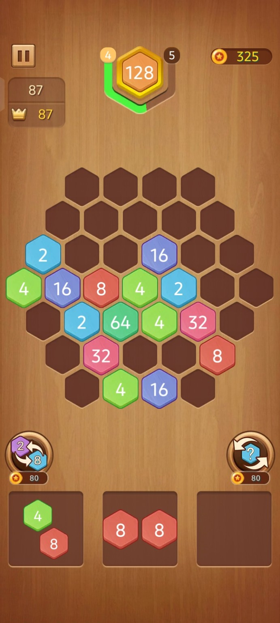
Reference screenshot B: same board family in a later state; useful for state-difference analysis.
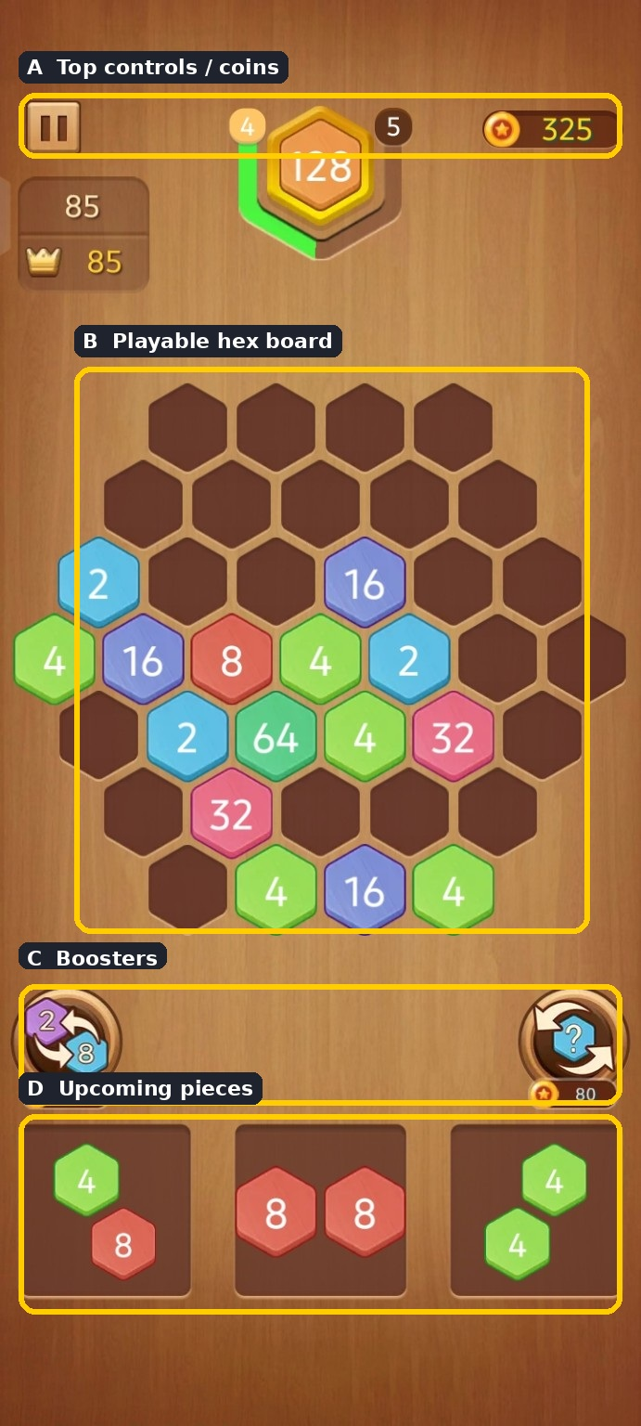
Annotated reference: A top controls, B playable board, C boosters, D upcoming pieces.

2.2 Design translation rules
Reference element | Original design decision | Implementation rule
Wood background | Use a distinct warm wood texture with subtle vignette. | Bitmap or procedural texture; no gameplay logic tied to image size.
Hex tiles | Use custom vector-like hex drawing with layered shadow/highlight. | Render in Canvas for resolution independence.
Top HUD | Keep score/level/coins visually grouped. | Use Compose overlays above Canvas.
Bottom trays | Retain three-slot visual rhythm. | Each slot is an interactive preview container.
Boosters | Make cost and action explicit. | Icon + action label + coin cost; show disabled state.
Progress badge | Use an original badge/ring treatment. | Render progress from normalized value 0..1.

2.3 Visual design system
Token | Recommended value
Primary wood | Warm mid-brown with subtle radial vignette
Panel brown | Dark chocolate/brown for tray and HUD cards
Text | Warm white for gameplay; dark charcoal for menus
Tile 2 | Cool blue
Tile 4 | Fresh green
Tile 8 | Warm red
Tile 16 | Purple
Tile 32 | Pink
Tile 64 | Teal/green
Tile 128+ | Gold/amber or level-specific special style
Corner radius | 12-20 dp for UI cards; tile itself is geometric
Shadow | Soft 2-6 dp equivalent; stronger on draggable piece
Typography | One clean sans family; large numeric glyphs; tabular-feel numbers if available

2.4 Tile rendering stack
- Shadow polygon: offset downward 2-5 dp with low opacity.
- Outer border: slightly darker/lighter than the fill.
- Main fill: tile value color.
- Top-left sheen: small gradient or translucent polygon.
- Value label: centered, bold, high contrast.
- Optional merge glow: short-lived radial effect.
- Optional rarity effect for 128+ if the design uses it.

3. UX and Screen Plan

3.1 Screen inventory
ID | Screen | Purpose | Primary actions
S01 | Splash | Fast brand entry. | Wait for bootstrap / continue.
S02 | Home | Main navigation and re-entry. | Play, Levels, Daily, Shop, Settings.
S03 | Game | Primary puzzle. | Select/drag, place, rotate, booster, pause.
S04 | Pause | Safe interruption. | Resume, restart, home, audio settings.
S05 | Game Over | Explain loss and recovery. | Retry, continue by reward, home.
S06 | Level Complete | Celebrate target achievement. | Next level, replay, home.
S07 | Levels | Progressive campaign. | Select unlocked level.
S08 | Daily Challenge | Repeatable challenge. | Start, review result.
S09 | Shop | Coins and boosters. | Buy, restore, close.
S10 | Settings | Controls and legal. | Sound, music, vibration, language, policy.
S11 | How to Play | Teach core mechanics. | Step through tutorial.
S12 | Rewarded Ad overlay | Optional ad exchange. | Watch, close, cancel.

3.2 Home screen
Layout priority: game logo at top, primary Play button in the middle, then secondary modes (Levels, Daily), then Shop and Settings. Show best score and current coin balance without competing with Play.

Home scenarios
Scenario | Expected behavior
First launch | Show short tutorial entry or guided first game; no login required.
Returning user | Show Continue if a saved game exists; otherwise Play.
Saved game exists | Play resumes exactly where user left off, including queue and board.
Offline | Core game remains playable; online-only monetization may be unavailable.
Corrupt save | Discard only the invalid save, keep coins/settings, start a fresh game; log diagnostic event.

3.3 Game screen states
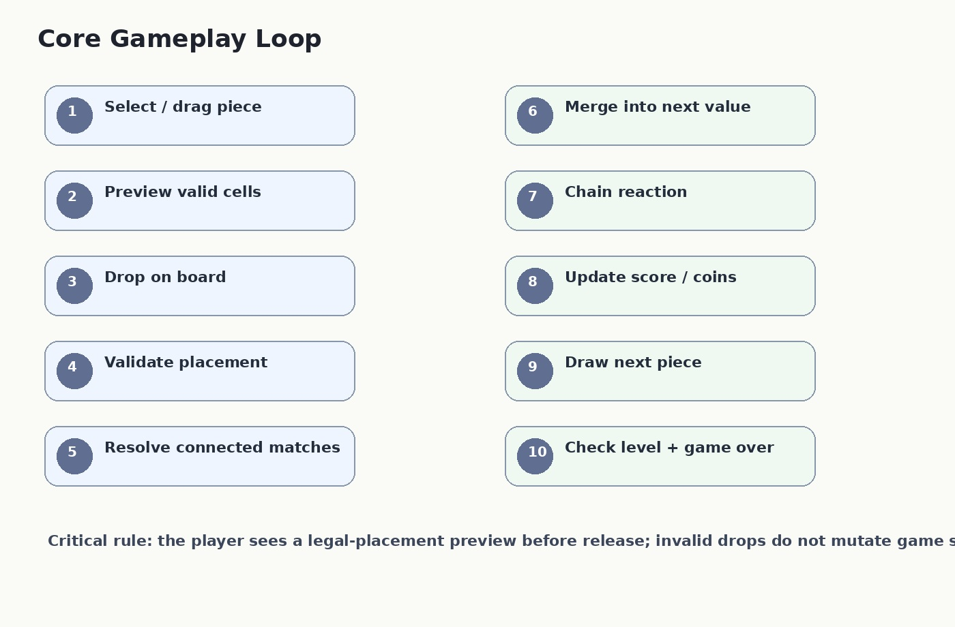
Core gameplay interaction flow.

Game screen zones
Zone | Content | Behavior
Top-left | Pause / score card | Always visible during play; pause must not lose state.
Top-center | Level + target/progress | Updates after score/merge; animate only the numeric delta and progress.
Top-right | Coins | Updates after rewards/spending; never changes without a visible reason.
Center | Hex board | Main touch/drag surface; highlights legal placement.
Lower center | Boosters | Shows current balance/cost; locked or empty state is explicit.
Bottom | Piece tray | Shows current piece and upcoming pieces; selection state is obvious.

3.4 Detailed user scenarios
Scenario | Behavior specification
SC-01 First game onboarding | User launches for the first time. Show 3-step tutorial: pick piece -> place on highlighted cell -> merge 3 matches. After tutorial, create a playable board with generous legal moves.
SC-02 Tap placement | User taps a piece, then taps a legal cell. Preview confirms the target, piece snaps to cells, merge resolves, score updates, and the queue advances.
SC-03 Drag placement | User drags current piece. During movement, show ghost hex cells and legal/illegal status. On release, snap to the nearest valid position or return the piece if invalid.
SC-04 Rotate before drop | User taps rotate or performs the supported rotation gesture. Piece orientation changes through 60-degree increments; impossible orientations are still allowed in preview but reject if cells collide/outside board.
SC-05 Merge | A placement creates 3+ connected equal-value tiles. All matching cells pulse, move toward the merge center, disappear, and become one next-value tile.
SC-06 Chain merge | New tile creates another 3+ connected match. Continue automatically until no merge remains; score increments for each merge separately.
SC-07 No merge | A legal placement creates no merge. Only placement feedback and score/move count update; no false celebration.
SC-08 Invalid placement | User releases outside legal cells. No board state changes; use short error motion or snap-back.
SC-09 Booster: undo | User presses Undo after a move. Restore board, score, queue, coins and progress to the exact prior state. Do not restore a spend that occurred before the move unless the product explicitly defines that behavior.
SC-10 Booster: swap/change | User activates booster, selects valid target, sees a confirmation highlight, then the tile/piece changes according to the defined booster rule.
SC-11 Game over | No valid placement exists for the current queue. Pause input, settle animations, show Game Over result and optional rewarded continuation.
SC-12 Continue by rewarded ad | User chooses continue, watches successful reward, game resumes with a defined recovery action (for example, remove selected low-value tiles or grant a recovery piece). One continuation per run unless design explicitly allows more.
SC-13 Level completion | Target is reached. Complete animation, reward coins, save progress, unlock next level and show the next action.
SC-14 App backgrounded | Save current game on lifecycle pause/stop. When returning, resume only after restoring all state; never duplicate score or consume a piece twice.
SC-15 Low battery / process kill | Persist frequently enough that a process kill loses at most one atomic move. Use transactional state write after move resolution.
SC-16 Offline play | Core mechanics work offline. Ads and cloud features gracefully disable without blocking the puzzle.
SC-17 Purchase restore | If monetization exists, restore previous entitlements without altering game board state. Show a clear result.
SC-18 Accessibility | Support larger system text where it does not overlap; do not rely on color alone for critical feedback; provide labels for buttons and boosters.

4. Gameplay Specification

4.1 Board model
Use axial hex coordinates q,r. Each cell has a stable logical ID and an optional tile. The logical board must not know about pixels. Rendering converts logical coordinates to screen coordinates.
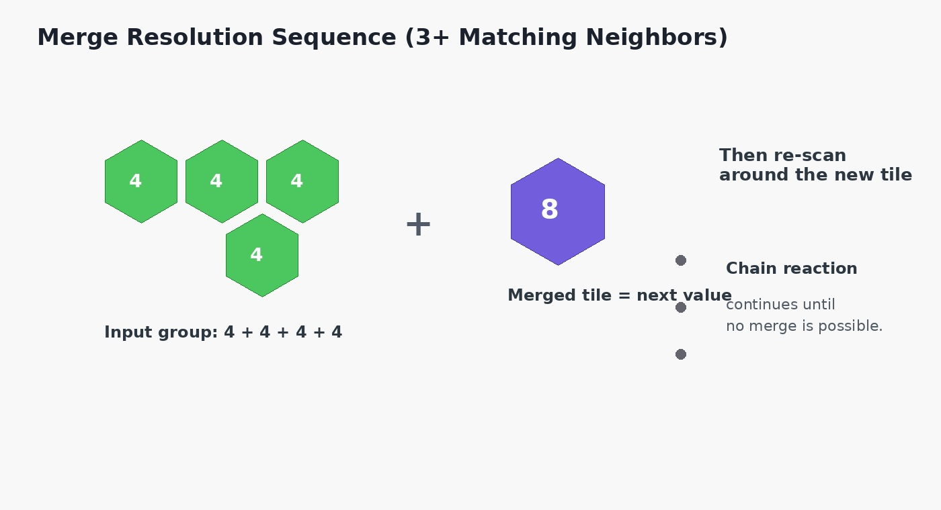
Example merge resolution sequence. Exact artwork, values and effects are implementation-controlled.

4.2 Neighbor model
Each hex has six neighbors. The canonical axial neighbor offsets are: (+1,0), (+1,-1), (0,-1), (-1,0), (-1,+1), (0,+1).

4.3 Piece model
A piece is a connected set of one or more tiles described relative to an anchor cell. For example, a two-cell piece may be [(0,0),(0,1)]. Store tile values separately so a piece can support mixed values such as [4,8].
Object | Required fields
HexCoord | q, r
BoardCell | id, coordinate, tileId?, playable
Tile | id, value, cellId
TilePiece | pieceId, relativeCells, values, rotation
GameState | board, currentPiece, nextPieces, score, bestScore, coins, level, target, moveCount, flags
BoosterState | type, inventory count, cost, enabled
LevelConfig | level, target, boardLayoutId, spawnWeights, minMergeCount, maxValueRule

4.4 Merge rule
Default product rule: when the placed tile belongs to a connected group of three or more tiles with the same value, merge the whole qualifying group into one tile of value x2. The merge center must be deterministic so replays and tests are repeatable. If the new tile creates another qualifying group, resolve the chain until stable.

4.5 Group-selection decision
Recommended policy: merge every tile in the connected equal-value component that includes the placed tile, not an arbitrary subset. This is easiest to explain, deterministic, and strategically consistent. If a future mode requires subset selection, treat it as a separate rule set and test it separately.

4.6 Oversized groups
Group size | Default behavior | Reason
0-2 | No merge | Does not meet threshold.
3 | Merge all 3 | Base rule.
4+ | Merge all connected equal tiles | Avoid arbitrary choice and accidental exploit states.
Chain | Repeat after merge | Creates satisfying combo play.

4.7 Placement validity
- All relative cells must be inside the active board layout.
- All target cells must be empty before placement.
- Target cannot overwrite an existing tile.
- Piece must use one consistent rotation state for the whole placement.
- Invalid drop does not consume a piece or a move.
- The preview must show exactly the same validity result used by the actual drop validator.

4.8 Spawn system
Use weighted probabilities, not uniform random, and keep the distribution configurable per level. The initial prototype can bias heavily toward 2 and 4, then gradually introduce larger values. For QA, expose a deterministic seed so the same sequence can be reproduced.

4.9 Score system
Recommended baseline: score += mergedValue * groupSize before or after the merge according to one consistent formula. Example: merging four 4 tiles into an 8 earns 8 x 4 = 32 points. Add combo bonuses only after base scoring is stable.
Scoring event | Formula example | Design note
Placement | 0 | Do not reward empty placements unless desired.
3-tile merge | nextValue x 3 | Easy to reason about.
4+ merge | nextValue x groupSize | Rewards building larger clusters.
Chain step | base score x combo multiplier | Multiplier should be capped and visible.
Level complete | fixed reward + score-based bonus | Avoid economy inflation.

4.10 Game-over detection
Game over occurs only when there is no legal placement for the current piece (and any other simultaneously playable next-piece rule, if applicable). Brute-force all candidate anchor cells and orientations for the current piece because the board is small; correctness is more important than theoretical optimization.

5. UI Screen-by-Screen Design Specification
Screen | Visual design | Functional details
S01 Splash | 2.0-2.5 sec max visual hold; logo center; no fake loading progress. | If bootstrap completes earlier, navigate immediately.
S02 Home | Logo, Play, Levels, Daily, Shop, Settings, best score, coins. | Primary action visually dominant.
S03 Game | HUD + board + boosters + queue. | No persistent ads over board.
S04 Pause | Blur/dim board, centered card. | Underlying game frozen.
S05 Game Over | Score, best, rewards, retry, continue, home. | Rewarded ad is optional.
S06 Level Complete | Confetti/sparkles, target, score, coins, next. | Do not trap user in animation.
S07 Levels | Scrollable map or grid. | Locked levels clearly explain unlock condition.
S08 Daily | Daily badge, challenge target, reward. | If offline, show cached challenge or disable with explanation.
S09 Shop | Coins, bundles, boosters. | Purchase feedback and restore handling.
S10 Settings | Sound, music, vibration, language, policy. | Immediate toggle response.
S11 How to Play | Three to five swipe/tap panels. | Skip button available.
S12 Rewarded overlay | Benefit, ad status, cancel. | Never imply reward before completion.

5.1 Interaction animation timings
Animation | Recommended duration | Notes
Piece press scale | 90-120 ms | Small scale-up only.
Drag ghost | continuous | Follow finger with low-latency.
Snap placement | 120-160 ms | Use ease-out.
Merge attract | 100-180 ms | Tiles move to center.
Merge pop | 120-180 ms | Scale 0.8 -> 1.1 -> 1.0.
Score float | 500-800 ms | Fade and rise.
Level complete | 700-1200 ms | Can be skipped by tap.
Invalid drop | 120-200 ms | Short shake/snap-back.

5.2 Sound and haptic plan
Event | Sound | Haptic
Select | Soft click | Light tap
Place | Wooden/soft click | Light tick
Merge | Pitch by value | Medium impact
Big merge | Higher layered sound | Heavy impact
Level complete | Short melody | Success pattern
Invalid | Muted thud | Error tick
Game over | Short resolve cue | Medium impact

6. Kotlin Engineering Architecture
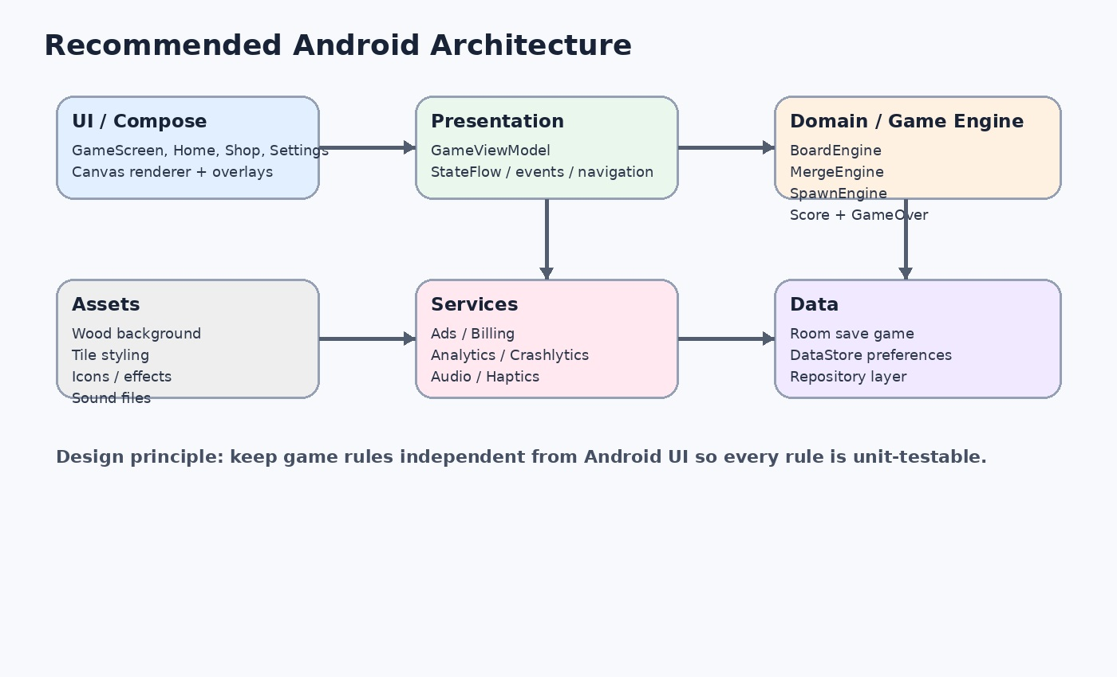
Recommended architecture: UI, presentation, game engine, data and services remain separated.

6.1 Package structure
Suggested package structure:
com.yourcompany.mergeseven
core/
game/engine/
game/model/
game/repository/
ui/home/
ui/game/
ui/levels/
ui/shop/
ui/settings/
data/database/
data/datastore/
ads/
billing/
analytics/
audio/

6.2 State and event model
Use immutable GameState and one-way event flow. UI sends GameIntent; ViewModel passes the intent to GameEngine; engine returns a new state plus a list of side effects (sound, haptic, analytics, animation event).
Layer | Owns | Must not own
Compose UI | Rendering, input capture, accessibility semantics | Merge rules, score formulas
ViewModel | State exposure, orchestration, lifecycle | Pixel calculations, direct database SQL
Game Engine | Rules, board mutation, scoring, legality | Android Context, Compose state
Repository | Save/load, settings boundary | Gameplay rules
Services | Ads, billing, analytics, sound | Board state mutation

6.3 Core classes
Class | Responsibility | Key methods
GameEngine | Single entry point for gameplay commands | placePiece(), rotatePiece(), undo(), useBooster(), restart()
BoardEngine | Board queries and placement | canPlace(), place(), remove(), getNeighbors()
MergeEngine | Connected components and merge resolution | findGroup(), resolveMerges()
SpawnEngine | Piece generation | nextPiece(), nextQueue(), randomValue()
ScoreEngine | Scoring and progression | scoreForMerge(), updateLevel()
GameOverEngine | Legal move search | hasMove(), isGameOver()
SaveGameRepository | Persistence boundary | save(), load(), clear()

6.4 Rendering architecture
Use one main Canvas for the board and overlays for controls. Convert every HexCoord to pixel coordinates through a pure geometry helper. Avoid using a separate Android view for each tile. Draw only what is needed and keep animation state local to the renderer while authoritative board state stays in GameState.

7. Phase-by-Phase Delivery Plan
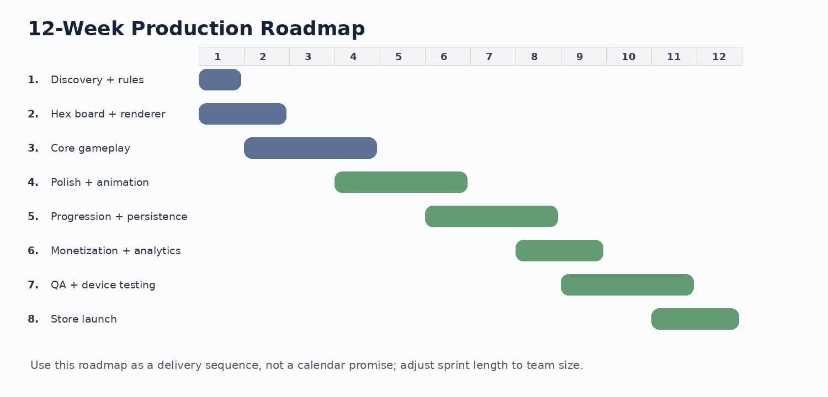
Illustrative 12-week sequence for one small team; resize to actual capacity.
Phase | Name | Effort guide | Tasks | Exit criteria
Phase 0 | Product decisions + setup | 1-2 days | Lock rules, package, art direction and analytics naming before coding. | Signed-off game rules, screen map, repository, branch strategy.
Phase 1 | Project foundation | 2-3 days | Create Android project, modules, theme, navigation, test framework. | App launches; CI/build passes.
Phase 2 | Hex geometry + board | 4-6 days | Axial coords, board layout, Canvas renderer, hit testing. | Stable board on supported devices.
Phase 3 | Core gameplay engine | 5-8 days | Pieces, placement, merge groups, chain reactions, score, game-over. | Playable without polished art.
Phase 4 | Game UI + visual polish | 5-8 days | HUD, piece tray, boosters UI, effects, audio, haptics. | Visual match to approved design spec.
Phase 5 | Progression + persistence | 3-5 days | Levels, targets, coins, save/resume, undo. | State survives relaunch safely.
Phase 6 | Ads + analytics + shop | 3-5 days | Rewarded continuation, coin economy, events, purchase shell. | Monetization can be tested end-to-end.
Phase 7 | QA + optimization | 5-7 days | Automated tests, device matrix, crash fixes, performance and accessibility. | Release candidate passes gates.
Phase 8 | Store launch | 2-4 days | AAB, screenshots, privacy, listing, internal/closed/prod rollout. | Production release or controlled rollout.

Phase 0 - Task Checklist
- Write one-page rule sheet and explicit examples for merge sizes 3, 4, 5+.
- Decide whether 4+ connected equal tiles merge all at once (recommended).
- Confirm piece rotation behavior and whether all pieces are fixed-shape or generated.
- Decide fixed board versus level-defined board layouts (recommended: level-defined templates).
- Decide exact booster semantics before UI artwork.
- Define score, coins, level target and continuation reward rules.
- Define privacy / analytics event naming convention.
- Create original brand name, icon and visual tokens.

Phase 1 - Task Checklist
- Create Kotlin Android project with Compose.
- Set up version control and branch strategy.
- Create core modules/packages.
- Add unit-test dependencies.
- Create base theme, typography and spacing tokens.
- Add navigation skeleton for Home/Game/Settings.
- Create a fake GameState preview screen for UI work.

Phase 2 - Task Checklist
- Implement HexCoord and neighbor math.
- Define board templates.
- Implement coordinate-to-screen and screen-to-coordinate conversion.
- Draw board cells and tile placeholders.
- Implement cell hit testing.
- Add density/screen-size support.
- Add debug overlay showing q/r coordinates.
- Verify geometry on at least 4 aspect ratios.

Phase 3 - Task Checklist
- Implement Tile and TilePiece models.
- Implement piece generation.
- Implement legal placement.
- Implement connected-component search.
- Implement merge-to-next-value.
- Implement chain reactions.
- Implement score update.
- Implement queue advancement.
- Implement deterministic random seed for tests.
- Implement game-over scan.
- Add unit tests for every edge case.

Phase 4 - Task Checklist
- Implement wood background and panels.
- Draw polished hex tiles.
- Add HUD and progress badge.
- Add current/next piece tray.
- Add drag preview.
- Add legal/illegal highlights.
- Implement merge animation timeline.
- Add score popup, particles, glow.
- Add sound and haptic hooks.
- Add pause and result overlays.

Phase 5 - Task Checklist
- Implement Room save entity or equivalent serialized state.
- Persist after atomic move resolution.
- Restore state on launch.
- Add coins and best score.
- Implement levels and unlocks.
- Implement undo history.
- Add data validation/migration strategy.
- Test process death and background/foreground.

Phase 6 - Task Checklist
- Implement rewarded ad continuation.
- Implement ad frequency caps in product config.
- Create coin reward sinks and sources.
- Add shop UI.
- Add billing abstraction.
- Add analytics events.
- Add crash reporting.
- Add remote/tunable values only where useful; keep core rules local.

Phase 7 - Task Checklist
- Run unit and instrumentation suites.
- Run visual comparison against approved design reference.
- Test touch at edges and notches.
- Test low-end Android device.
- Test 60 fps during merge animation target.
- Test background/restore during active animation.
- Test ad cancellation/failure.
- Test purchase failure/retry if enabled.
- Run accessibility pass.
- Fix crash/ANR/performance issues.
- Prepare release candidate.

Phase 8 - Task Checklist
- Create signed AAB.
- Complete store listing and screenshots.
- Finalize privacy/data safety declarations based on actual implementation.
- Internal test.
- Closed test.
- Production rollout with monitoring.
- Review analytics and crash data after launch.
- Create hotfix rollback plan.

8. Product Decisions to Lock Before Coding
Decision | Recommended choice | Why | Owner
Merge threshold | 3 tiles | Simple and familiar for the target mechanic. | Product
Group policy | Merge entire connected equal component | Deterministic and easy to test. | Product/Engineering
Piece input | Tap + drag, rotation optional | Tap is accessible; drag improves game feel. | UX
Board shape | Level-defined hex templates | Supports progression without rewriting engine. | Design/Engineering
Rendering | Canvas for board, Compose for UI | Performance and geometry control. | Engineering
Persistence | Local only for MVP | Fast, offline-friendly, low operational cost. | Engineering
Continue | Rewarded ad, one controlled use | Clear value exchange. | Monetization
Booster economy | Coin sinks + limited inventory | Preserves strategic resource use. | Product
Randomness | Weighted + seedable | Fairness + deterministic testing. | Engineering
Art style | Original warm wood + jewel-like tiles | Preserves reference mood while creating a distinct product. | Design

8.1 Decision log template
ID | Question | Decision | Date | Impact
DEC-001 | What merges? | 3+ connected equal-value tiles. | TBD | Core engine
DEC-002 | How are 4+ groups handled? | Entire component merges. | TBD | Core engine
DEC-003 | Can pieces rotate? | Yes, 60-degree steps if enabled in MVP. | TBD | Input/rendering
DEC-004 | What is the continue reward? | Define one recovery action; do not improvise in code. | TBD | Monetization
DEC-005 | How is score calculated? | Value x group size + optional combo bonus. | TBD | Progression

9. QA, Test Cases and Acceptance Criteria

9.1 Unit test matrix
Test ID | Given | When | Then
UT-001 | Three connected 4 tiles | Place final 4 | One 8 is created; three 4s disappear.
UT-002 | Two connected 4 tiles | Place final 8 | No merge occurs.
UT-003 | Three 4 tiles not connected | Place final 4 | No merge unless all become one connected component.
UT-004 | Five connected 4s | Resolve group | One 8 replaces entire group; no leftover 4s.
UT-005 | Merge creates second 8 | Resolve first merge | Second merge resolves automatically.
UT-006 | Piece overlaps occupied cell | Drop | Placement rejected and state unchanged.
UT-007 | Piece extends outside board | Drop | Placement rejected.
UT-008 | No legal move exists | Check game-over | Game over = true.
UT-009 | One legal move exists | Check game-over | Game over = false.
UT-010 | Undo after merge | Undo | Exact prior board, score, queue, coins and progress restored.
UT-011 | Save after move | Reload | Exact state restored.
UT-012 | Deterministic seed | Generate queue twice | Queues are identical.

9.2 Manual scenario matrix
Area | Test scenarios
Touch | Single tap, drag, slow drag, fast drag, edge drop, multi-touch accidental input.
Display | Small phone, large phone, 19.5:9, 16:9, display cutout, font scale increase.
Lifecycle | Home -> game -> background -> restore; process death; rotation if orientation is not locked.
Ads | Load success, load failure, cancel, no fill, reward callback, duplicate callback protection.
Billing | Purchase success, decline, cancellation, restore, duplicate notification.
Audio | Muted device, Bluetooth, focus loss, rapid merge events.
Persistence | Interrupted save, corrupted JSON, migration, storage full.
Performance | Long chain reaction, many tiles, repeated boosters, low memory.
Accessibility | Screen reader labels, large text, color contrast, non-color status cues.

9.3 Definition of Done
- All P0 bugs closed; P1 bugs either fixed or explicitly accepted.
- Core game rules have automated unit coverage for normal and edge states.
- No board mutation can happen from an invalid drop.
- A saved move cannot be duplicated after app restart.
- Animation never blocks input longer than the approved interaction window.
- Release candidate is tested on a high-end, mid-range and low-end Android device.
- Analytics events contain no accidental personal information.
- Original game assets and branding are licensed or created by the project team.

10. Economy, Boosters and Monetization

10.1 Economy rules
Source | Reward | Cap/guardrail
Daily login | Small coin reward | No unlimited stacking.
Level completion | Fixed reward by level | Tune through config.
Large merge | Bonus coins | Avoid runaway economy.
Rewarded ad | Fixed coin amount or continue | Rate-limited per session.
Purchase | Coin/booster bundle | Server/store truth if used.

10.2 Booster specifications
Booster | Player action | Suggested effect | Cost model
Undo | Tap booster, confirm | Revert last resolved move. | Coins or earned inventory.
Swap | Select target | Swap current/selected piece or defined tile pair. | Coins.
Reroll | Tap before placement | Replace current piece with another valid piece. | Coins.
Hammer | Select one tile | Remove one selected tile with defined penalty. | Coins.
Continue | Game Over -> watch ad | Return game to a recoverable state. | Rewarded ad.

Do not let boosters silently change the board. Every booster should show: selected state, preview of the outcome, confirmation/commit, result, cost and cooldown/availability if applicable.

11. Analytics and Observability
Event | When | Parameters
game_start | New or resumed game | source, level
piece_place | Successful placement | level, pieceSize, orientation
merge | Each merge | level, fromValue, toValue, groupSize, comboIndex
game_over | No legal move | level, score, moves
continue_offer | Game over dialog visible | level
continue_complete | Rewarded continuation granted | level, rewardType
level_complete | Target reached | level, score, moves
booster_use | Booster applied | boosterType, level
daily_start | Daily challenge begins | dateKey
purchase | Store purchase acknowledged | productId
crash_context | Nonfatal gameplay error | stateHash, level

11.1 Product dashboards
- Retention: first-session completion, day-1/day-7 retention, games per user.
- Difficulty: average moves to first game over, top merge value by level, restart rate.
- Economy: coins earned/spent per session, booster use rate, rewarded ad opt-in rate.
- Quality: crash-free sessions, ANR rate, failed load/save events, invalid-state diagnostics.

12. Asset and Design Production Checklist
Asset group | Required assets | Preferred format | Notes
Brand | Logo, app icon, wordmark | PNG/WebP/SVG where supported | Original identity.
Background | Wood texture, vignette, dark variant | WebP/PNG | Use tiling or high-res source.
Tiles | Hex style layers or vector recipe | Vector/Canvas preferred | Avoid 40+ exported bitmap variants.
HUD | Pause, coin, crown, progress frame | SVG/PNG | Provide active/disabled states.
Boosters | Undo, swap, reroll/other | SVG/PNG | 24/32/48 dp variants.
Effects | Glow, spark, confetti, dust | PNG/WebP | Keep particles lightweight.
Audio | Tap, place, merge, big merge, success, game-over | WAV/OGG | Provide normalized volume.
Store | Screenshots, feature graphic, icon | PNG/JPG as platform requires | Create from final build, not mockups.

12.1 Recommended file naming
bg_wood_main.webp
tile_style_base.svg
icon_pause.svg
icon_coin.svg
icon_booster_undo.svg
sfx_tile_place.ogg
sfx_merge_small.ogg
sfx_merge_big.ogg
ui_button_primary.svg

13. Performance, Reliability and Security

13.1 Performance targets
Metric | Target
Board rendering | Smooth 60 fps on target mid-range device during normal play.
Merge chain | No visible frame drop during typical chain; cap particle count.
Memory | No unbounded allocation per move; reuse geometry/paint objects.
Save | Atomic state write after move resolution.
Launch | Avoid loading all audio/art assets synchronously on first frame.
Input latency | Tap/drag response should feel immediate; preview update within the same frame budget.

13.2 Security and trust
- Do not store payment secrets or service credentials in the app.
- Validate purchase state through the supported billing flow.
- Treat local coins as non-authoritative only if there is a server-backed economy later.
- Keep analytics payloads limited to gameplay metadata; do not log raw user content.
- Do not ship debug overlays or forced RNG controls in production builds.

14. Release Plan

14.1 Build flavors
Flavor | Purpose | Differences
dev | Fast local development | Debug logs, deterministic test controls.
qa | Test team | QA menu, test ads, extra diagnostics.
prod | Store | Production ads/billing, no debug tools.

14.2 Release gates
- Core rules signed off by product owner.
- UI design signed off by design owner.
- All P0/P1 bugs resolved or explicitly waived.
- Ad/billing test flows passed.
- Save/resume tested after process death.
- Accessibility and performance sanity checks passed.
- Store metadata and privacy statements match actual behavior.
- Production rollout plan and rollback/hotfix process prepared.

15. Developer Task Board (Ready to Assign)
ID | Task | Priority | Dependency | Output
ENG-001 | Create project + theme | P0 | None | Buildable app shell
ENG-002 | Implement axial hex coordinates | P0 | ENG-001 | HexCoord utilities
ENG-003 | Implement board templates | P0 | ENG-002 | BoardLayout repository
ENG-004 | Canvas renderer | P0 | ENG-003 | Visible board
ENG-005 | Hit testing | P0 | ENG-004 | Cell selection
ENG-006 | Piece model + queue | P0 | ENG-003 | Playable piece preview
ENG-007 | Placement validator | P0 | ENG-005,006 | Safe placement
ENG-008 | Connected group search | P0 | ENG-002 | Merge candidate finder
ENG-009 | Merge resolver | P0 | ENG-008 | Core mechanic
ENG-010 | Chain resolution | P0 | ENG-009 | Stable state
ENG-011 | Score/level | P0 | ENG-010 | Progression
ENG-012 | Game over | P0 | ENG-007 | End condition
ENG-013 | Drag/rotate UI | P1 | ENG-007 | Polished input
ENG-014 | Merge animation | P1 | ENG-010 | Game feel
ENG-015 | Persistence | P1 | ENG-011 | Resume
ENG-016 | Boosters | P1 | ENG-011 | Economy hooks
ENG-017 | Ads/analytics | P1 | ENG-016 | Monetization instrumentation
ENG-018 | QA suite | P0 | ENG-009 | Regression safety
ENG-019 | Release build | P0 | All | AAB + store release

16. Final Product Checklist

Gameplay
Board works; piece can be selected; placement validates correctly; 3+ merge works; 4+ group rule is deterministic; chain reactions work; score updates; level target updates; game over only when no legal move; restart works.

UX
Tutorial explains the mechanic; legal cells preview; invalid drops return cleanly; pause is safe; result screens explain score and rewards; every action has clear feedback.

Visual
Wood background; original tile styles; readable numbers; progress badge; coin HUD; boosters; bottom queue; consistent spacing; no stretched assets; no overlaps on supported devices.

Audio
Tap, place, merge, big merge, level complete and game over sound hooks; mute settings work; no audio spam.

Persistence
Resume, save, restore, undo, coins and level progress survive app restart; corrupt save is handled.

Monetization
Rewarded ad flow handles no-fill and cancellation; purchases restore; no accidental reward duplication.

QA
Unit tests; manual scenarios; low-end device; lifecycle; accessibility; performance; crash checks.

Launch
Signed AAB; icon; screenshots; listing; privacy/data declarations; versioning; monitoring plan.

17. Recommended First Sprint
The first sprint should not attempt the entire game. The fastest path to a trustworthy prototype is to complete the game engine and a gray-box board before polishing art.
- Create the Kotlin/Compose project and base theme.
- Implement HexCoord + six-neighbor math.
- Create the first board template matching the reference silhouette.
- Render empty hex cells in Canvas.
- Implement piece model and one hard-coded test piece.
- Implement tap-to-place on a valid empty cell.
- Implement 3+ connected equal-value group detection.
- Implement merge + score + next-piece queue.
- Add deterministic debug controls and unit tests.
- Finish one complete 60-second playable loop before adding monetization or detailed art.
Sprint acceptance: a tester can launch the build, place pieces, trigger at least one merge, see the value increase, receive the next piece, intentionally lose by blocking the board, and restart the run. No visual polish is required until this behavior is stable.

Appendix A - Reference Interpretation Notes
The supplied images show a portrait puzzle interface with a warm wooden environment, top-level progress/score information, a honeycomb/hex board, multi-tile pieces in bottom trays, and two coin-priced utility controls. The second screenshot also demonstrates a board-state transition and a changing bottom tray, which is useful for specifying state persistence and queue advancement. The design in this document intentionally turns these observations into implementation-neutral requirements instead of copying the original visual identity.

Appendix B - Suggested naming for your own game
Use your own game name, logo, tile artwork and store assets. “Merge Seven” can be used here as a working description of the mechanic, not as a recommendation to ship under someone else’s trademark.
END OF BLUEPRINT

