1. **Ping Sweep**

nmap -sP 192.168.0.*

Ping sweep is a technique used to discover live hosts within a network or range.

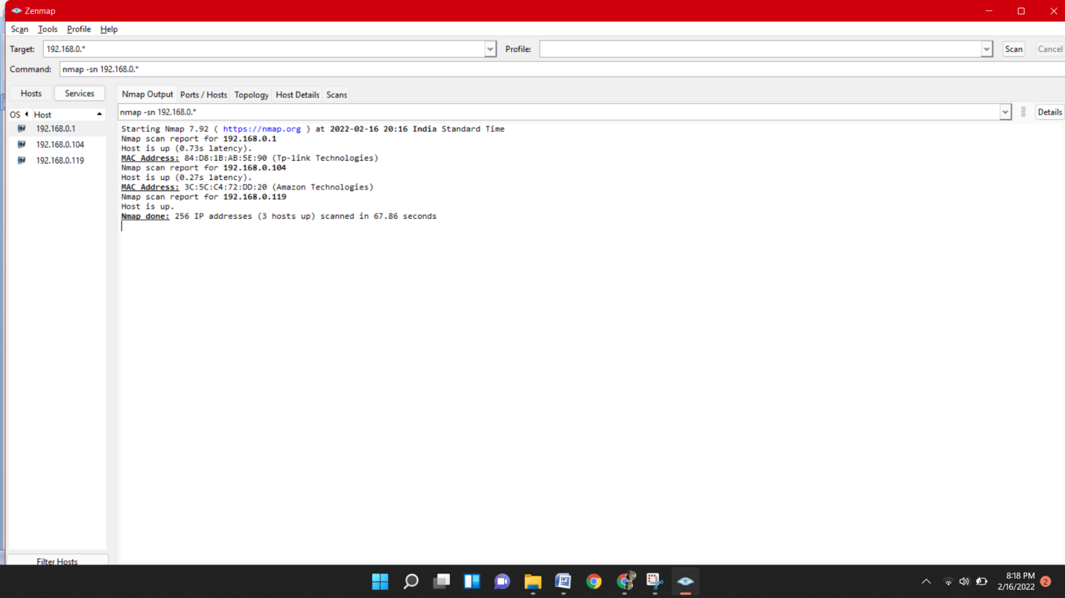

## Defining Ports with Nmap Using the -p Flag

Defining a port to scan with Nmap is pretty easy, just add the flag **-p** followed by the port, or ports separated by commas as shown in the screenshot below.

nmap -p 80,22,139,21,23 192.168.0.*

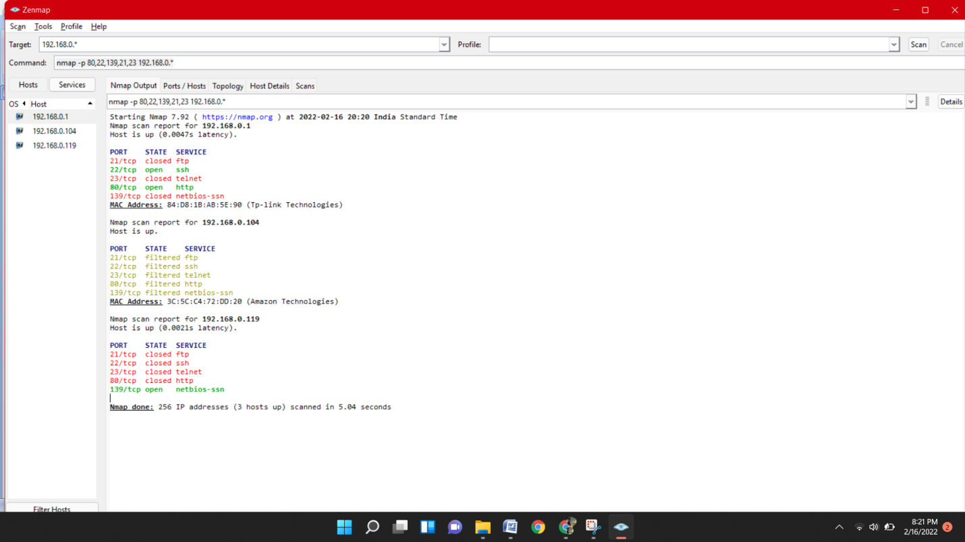

1. In the following example the port range is defined with a hyphen to scan Linux Hint port range from 22 to 80:

nmap -p 22-80 linuxhint.com

