1. nmap -T4 -A -v 172.21.208.1

The -T4 is for the speed template, these templates are what tells nmap how quickly to perform the scan. The speed template ranges from 0 for slow and stealthy to 5 for fast and obvious.

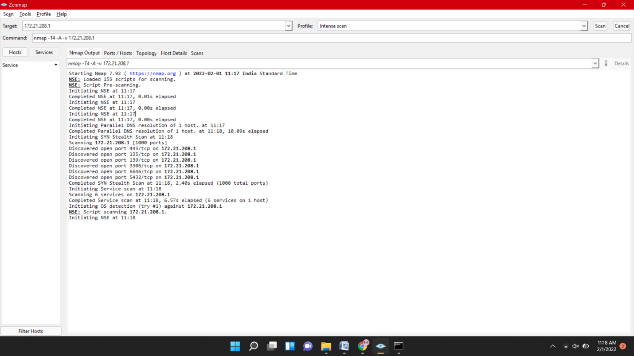

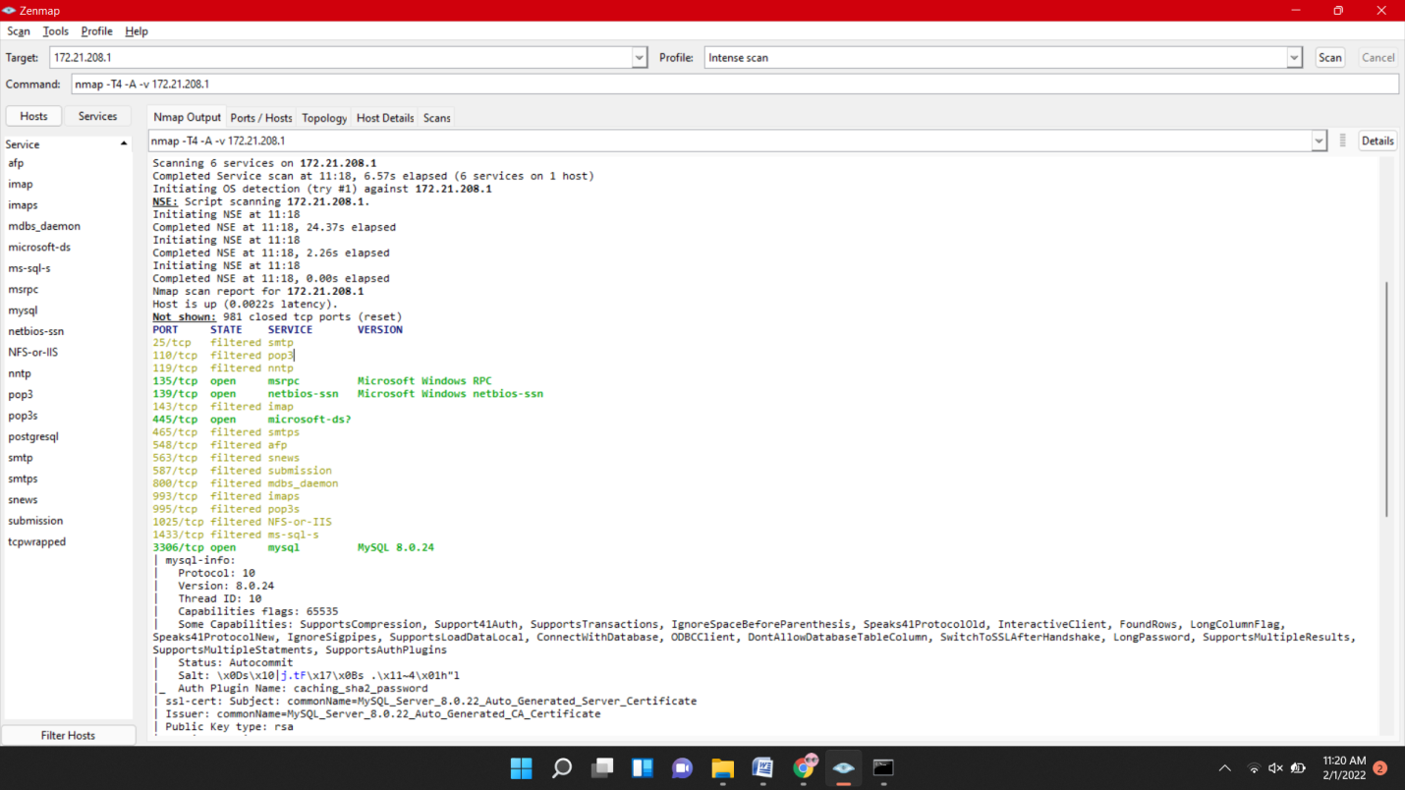

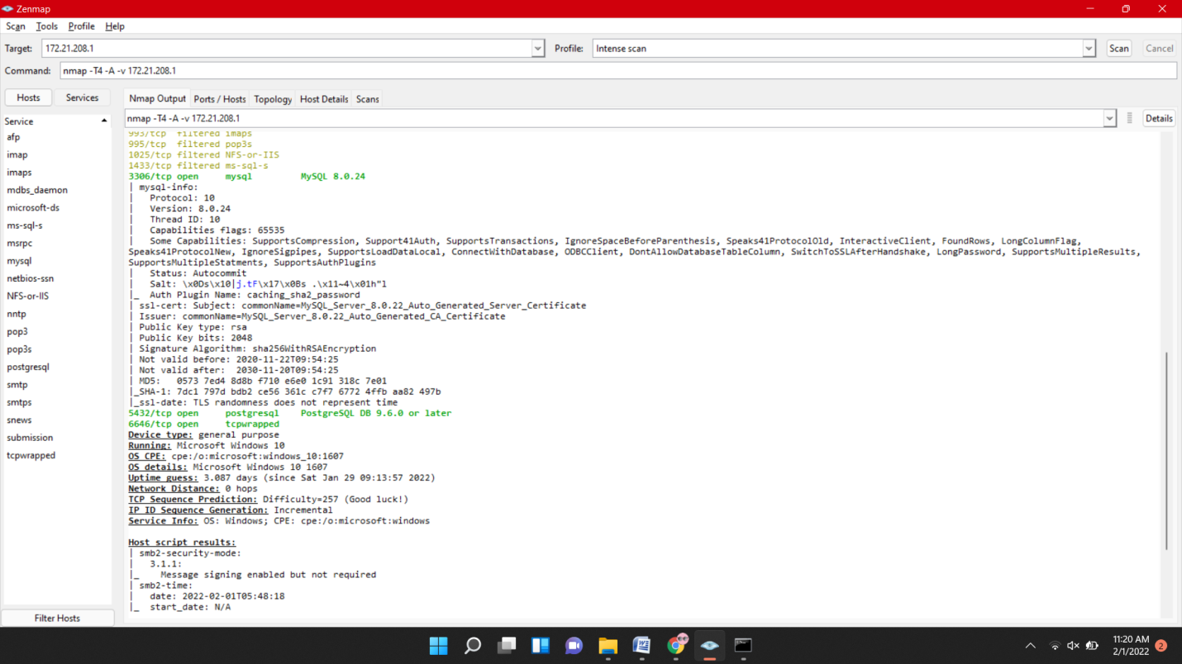

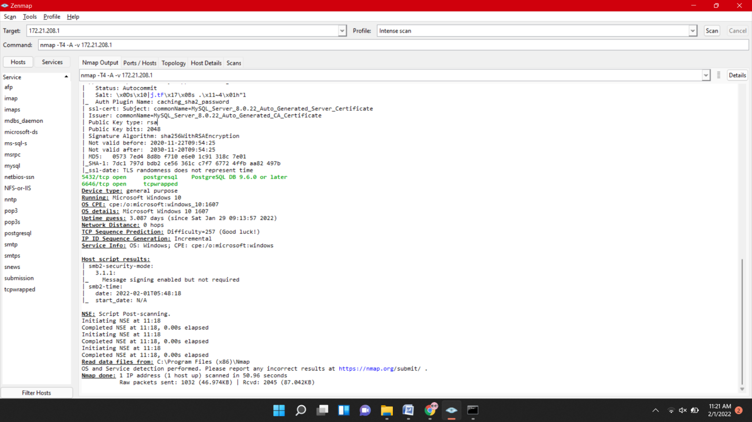

1. Ping scan  This identifies all of the IP addresses that are currently online without sending any packers to these hosts.

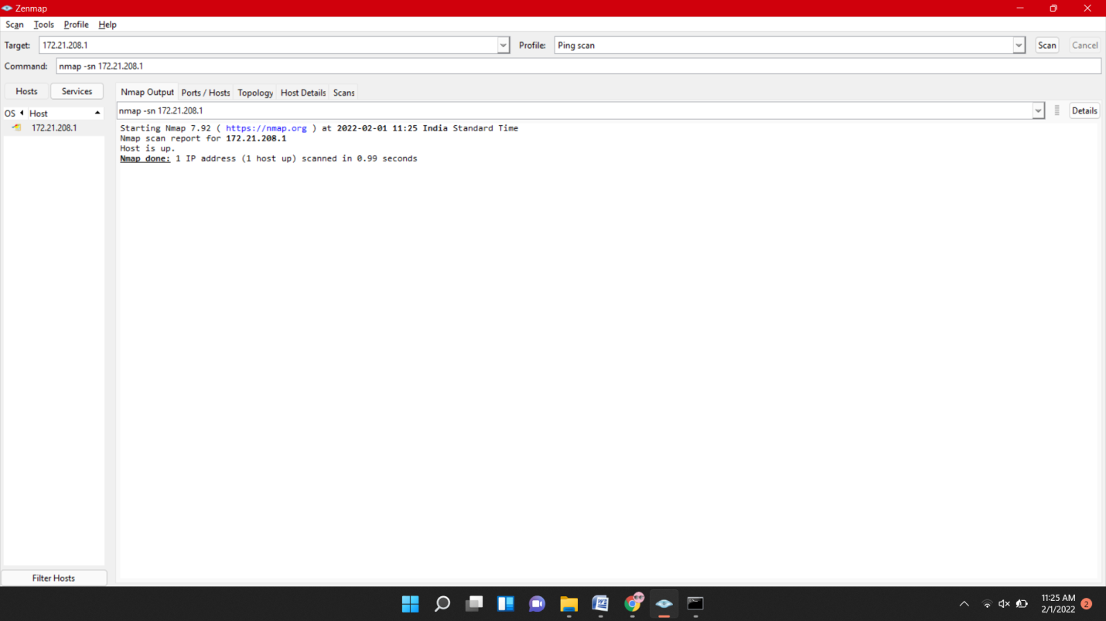

|  |  |
| --- | --- |
| 1. Scan a range of IPs | nmap 192.168.1.1-20 |

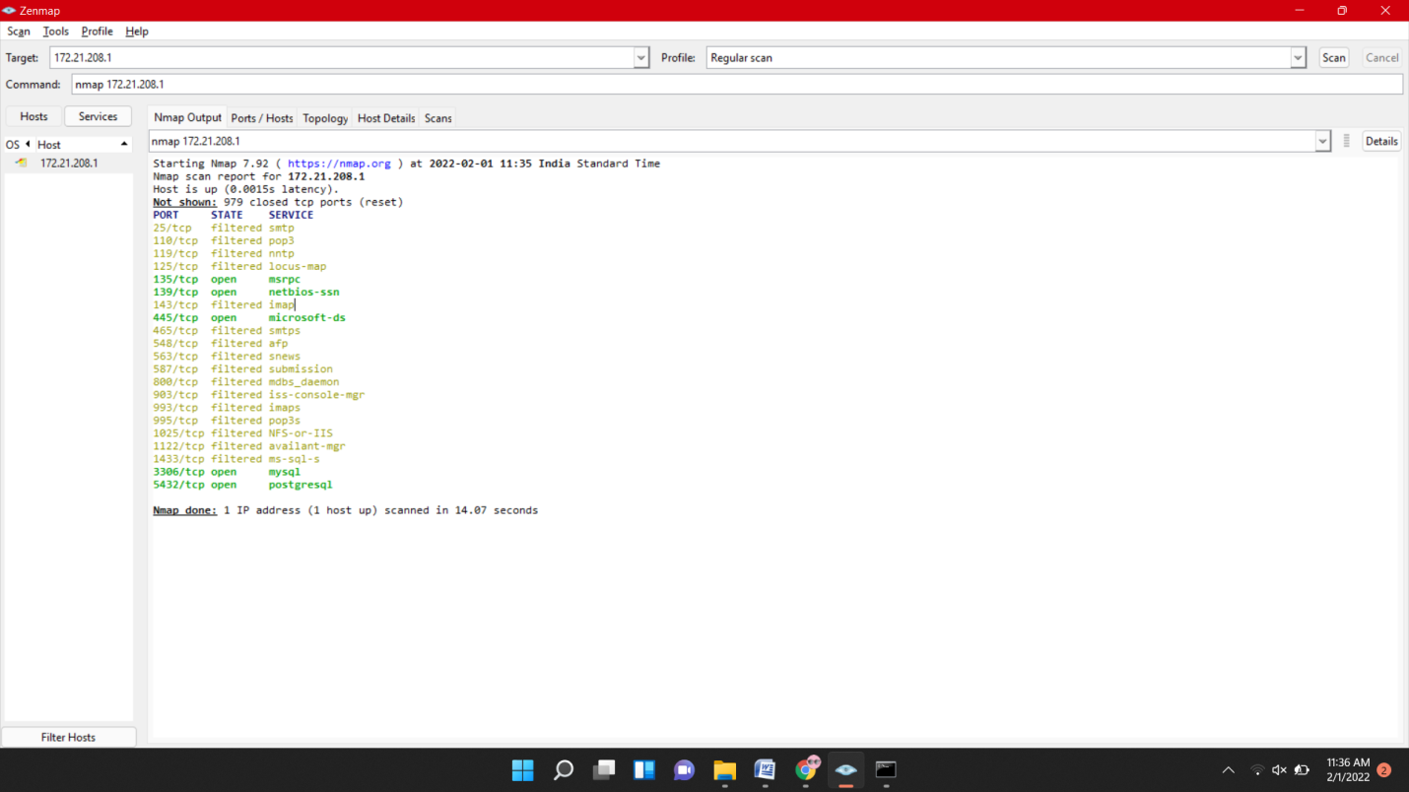

1. Scan subnets:

nmap -T4 -A -v 172.21.208.1/20

