## Nmap NULL Scan Example

The following example shows a NULL scan against linuxhint.com port 80. Remember Nmap NULL, Xmas and FIN scans can’t distinguish between open and filtered ports, in many scenarios.

sudo -sN -p 80 -v nmap linuxhint.com

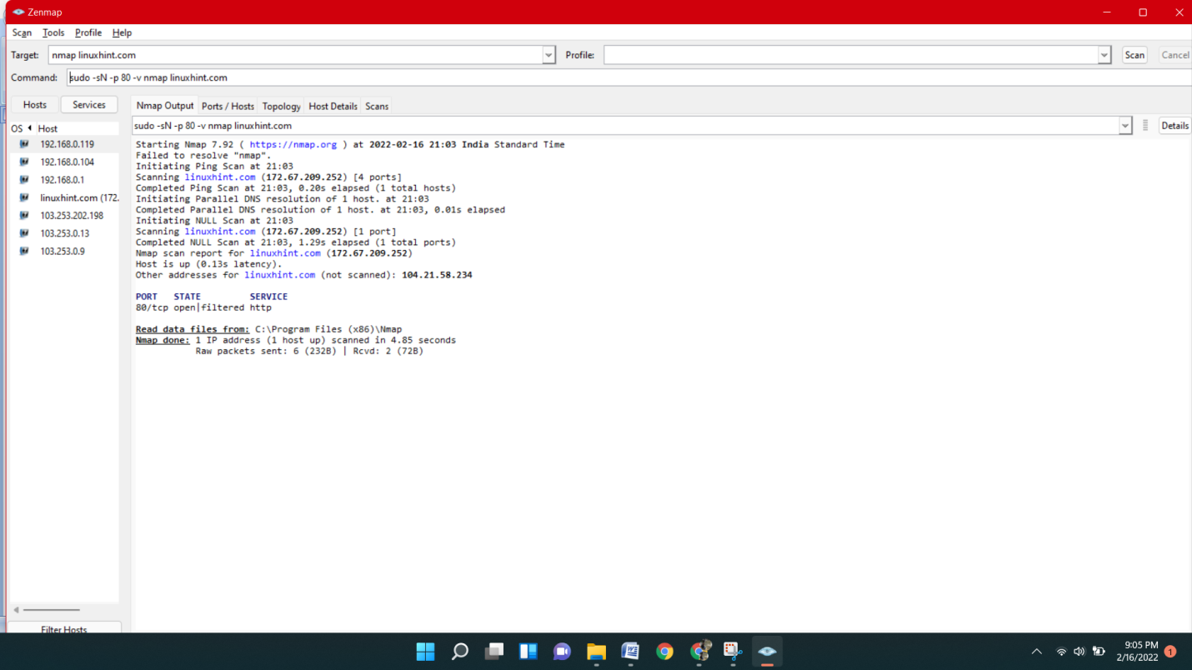

1. nmap -sV --script vulners 103.253.202.198

 It develops a signature and scan your enterprise to enumerate hosts running the application and check them for the vulnerability.

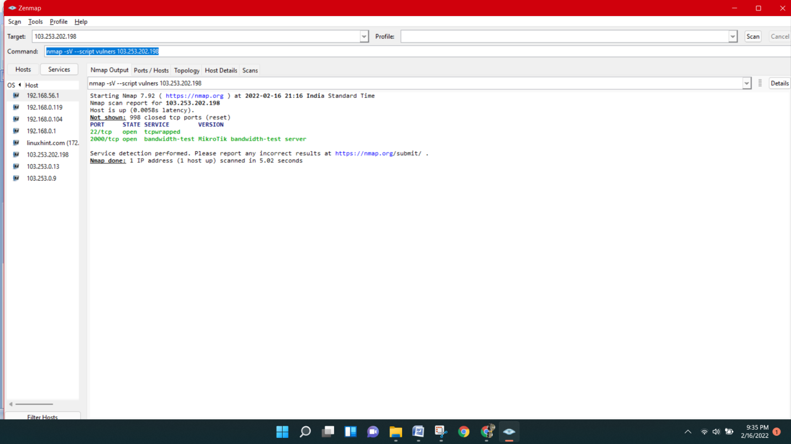

## Finding Zombie for Idle Scan

The following example shows how to search for a zombie candidate to execute an Idle scan by scanning the last octet of the 10.100.100.X network by using the NSE script ipidseq

