Final Data Science Capstone Project
Predicting the Air Quality Index (AQI) of Indian Monitoring Stations Using Machine Learning
Dataset: station_day_clean.csv (86,754 records, 109 stations, 21 states, 2015-2020)
Tools: Python (pandas, scikit-learn, seaborn, matplotlib), Jupyter Notebook, Power BI
Candidate Detail | Information
Candidate Name | UTSAV KANT JHA
Internship Platform | Yuva Intern
Internship Role | Data Analyst
Submission Date | 27/10/2026

Contents
1. Executive Summary
2. Problem Definition
3. Data Description
4. Data Preparation and Feature Engineering
5. Exploratory Data Analysis
6. Methodology
7. Results and Model Evaluation
8. Error Analysis and Robustness Checks
9. AQI Category Classification
10. Power BI Dashboard
11. Key Insights and Recommendations
12. Limitations
13. Future Scope
14. Conclusion
Appendix: Project Files and Reproducibility

1. Executive Summary
Air pollution is one of the most serious public-health challenges in India, and the Air Quality Index (AQI) is the number used to communicate it to citizens and policy makers. This capstone project builds an end-to-end data science solution on the cleaned station-day air-quality dataset (86,754 daily records from 109 monitoring stations in 21 states, 2015-01-01 to 2020-07-01). The project predicts the AQI of a station-day from 11 pollutant readings plus calendar and location information, and identifies which factors drive poor air quality.
Key results
- Best model: Gradient Boosting regression reached R² = 0.946, MAE = 17.5 AQI points and RMSE = 27.9 on the unseen 20% test set, compared with R² = 0.876 for the Linear Regression baseline.
- Accuracy in practice: 72.0% of test predictions are within 20 AQI points of the actual value and 84.4% are within 30 points.
- Main driver: PM2.5 is by far the most important variable (correlation with AQI = 0.86), followed by PM10 and CO.
- Seasonality: Winter (mean AQI 239.2) and post-monsoon (230.7) are far worse than the monsoon (114.0).
- Category prediction: A Random Forest classifier predicts the AQI category with 80.1% accuracy, and 99.4% of its predictions are within one category of the truth.
- Robustness: The model keeps R² = 0.909 when trained on 2015-2019 and tested on 2020, and R² = 0.917 on stations it has never seen.
Based on these findings the report recommends focusing control measures on fine particulate matter (PM2.5), preparing seasonal action plans for October to February, prioritising the worst-affected states, and using the model as a quick AQI estimation and early-warning tool. Limitations (data imbalance towards Delhi, no weather variables, no real-time forecasting) and future improvements are discussed in Sections 12 and 13.

2. Problem Definition

2.1 Background
The AQI converts concentrations of several pollutants into a single number between 0 and 500 and groups days into six categories: Good, Satisfactory, Moderate, Poor, Very Poor and Severe. Monitoring stations record many pollutants every day, but decision makers need a fast, interpretable estimate of how bad the air is, and an understanding of which pollutants and seasons matter most.

2.2 Problem Statement
Can the daily AQI of a monitoring station be predicted accurately from the measured pollutant concentrations together with date and location information, and which factors contribute most to high AQI values?

2.3 Objectives
- Clean, validate and enrich the station-day data with useful engineered features.
- Explore patterns in AQI across time (year, month, season), geography (state) and pollutants.
- Build and compare regression models that predict AQI, and a classifier that predicts the AQI category.
- Evaluate models with appropriate metrics (R², MAE, RMSE, accuracy, F1-score) and test their robustness.
- Analyse errors and limitations, and convert the findings into practical recommendations.
- Present the results through a report, a Jupyter Notebook and an interactive Power BI dashboard.

2.4 Scope
In scope | Out of scope
Daily station-level data, Jan 2015 - Jul 2020 | Hourly or real-time data
11 pollutants + calendar + state information | Meteorological variables (temperature, wind, humidity)
Regression (AQI value) and classification (AQI category) | Multi-day forecasting of future AQI
Interpretation, insights and recommendations | Causal source apportionment of pollution

2.5 Requirements
- Data: station_day_clean.csv (cleaned in earlier tasks of the internship).
- Software: Python 3, pandas, NumPy, scikit-learn, matplotlib, seaborn, Jupyter Notebook, Power BI Desktop.
- Reproducibility: fixed random seed (42) and a documented train/test split.

2.6 Expected Outcomes
- A validated predictive model with R² above 0.90 on unseen data.
- A ranked list of the pollutants and factors that drive AQI.
- Data-driven recommendations for seasonal and regional air-quality management.

3. Data Description
The dataset station_day_clean.csv contains 86,754 rows and 19 columns, covering 2015-01-01 to 2020-07-01. Each row is one station on one day. The data had been cleaned in earlier tasks of this internship; it was re-validated here and has 0 missing values and 0 duplicate rows.
Column(s) | Type | Description
StationId | Text | Monitoring station code (109 stations)
Date | Date | Day of the reading (day-month-year)
PM2.5, PM10 | Numeric | Fine and coarse particulate matter (µg/m³)
NO, NO2, NOx, NH3 | Numeric | Nitrogen compounds and ammonia
CO, SO2, O3 | Numeric | Carbon monoxide, sulphur dioxide, ozone
Benzene, Toluene | Numeric | Volatile organic compounds
AQI | Integer | Air Quality Index value (8 to 500) - regression target
AQI_Bucket | Category | Good / Satisfactory / Moderate / Poor / Very Poor / Severe - classification target
Year, Month, Season | Numeric / Text | Calendar information (Winter, Summer, Monsoon, Post-Monsoon)
State | Text | State code of the station (21 states / UTs)

Overall the average AQI is 176.8 (median 133.0, standard deviation 119.0), with a maximum of 500 which is the upper limit of the index. The mean being well above the median shows that the distribution is right-skewed: a number of very polluted days pull the average up.

4. Data Preparation and Feature Engineering

4.1 Data cleaning and validation
- Missing values: 0 (no imputation required).
- Duplicate rows: 0; no duplicate station-date combinations.
- Data types: Date converted from text to datetime (day-first format); numeric pollutants confirmed as float; categorical columns confirmed as text.
- Consistency check: every AQI value falls inside the range of its AQI_Bucket (for example Good = 8-50, Severe = 401-500).

4.2 Feature engineering
New features were created to give the models extra information beyond the raw readings:
New feature | How it is created | Reason
PM_ratio | PM2.5 divided by PM10 | Share of fine particles, which are more harmful
NOx_NO2_gap | NOx minus NO2 | Proxy for fresh combustion (vehicle) emissions
Month_sin, Month_cos | Sine and cosine of the month | Lets the model understand that December and January are neighbours
DayOfWeek, IsWeekend | From the date | Detects weekday/weekend traffic patterns
DayOfYear | From the date | Fine-grained seasonal position
Season and State dummies | One-hot encoding | Converts categories to numbers (4 seasons + 21 states)

The final feature matrix has 44 columns. StationId was not used as a feature because its 109 values would add too many columns and would let the model simply memorise stations; State is used instead. AQI_Bucket was excluded from the regression features because it is derived directly from the target AQI (this would be data leakage).

5. Exploratory Data Analysis

5.1 Distribution of AQI
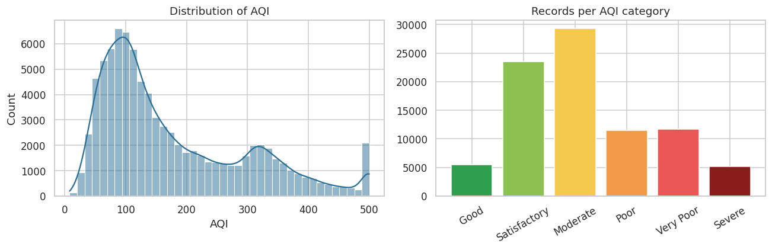
Figure 1: Distribution of AQI values and number of records per AQI category
Moderate is the most common category (33.8%), followed by Satisfactory (27.2%). Only 6.3% of station-days have Good air, while 32.7% of days are Poor, Very Poor or Severe. In other words, roughly one day in three has air quality that is unhealthy for the general population.

5.2 Trends over years and months
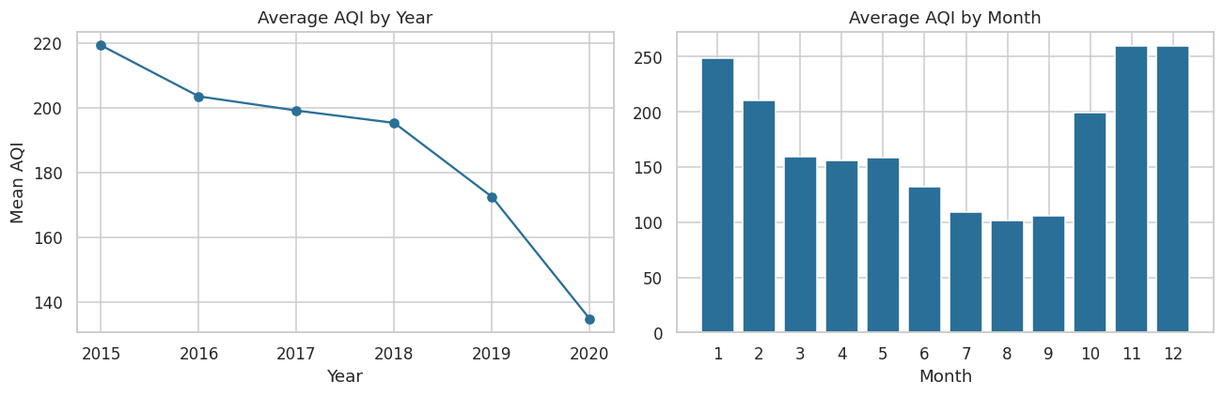
Figure 2: Average AQI by year (left) and by month (right)
The yearly average AQI fell steadily from 219.2 in 2015 to 172.5 in 2019 and 134.9 in 2020. Two cautions apply: 2020 contains only January to July (the cleaner months) and the number of records grew sharply after 2017, so the comparison is indicative rather than exact. Within a year, AQI is highest from November to January (about 259.4 in November and 259.6 in December) and lowest in July-September (about 101.8 in August).

5.3 Seasonal pattern
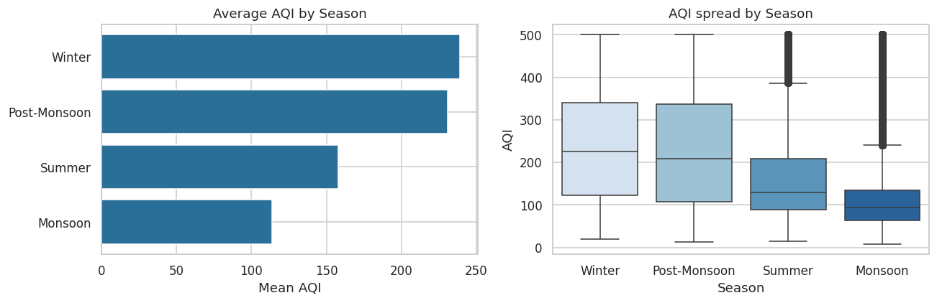
Figure 3: Average AQI and AQI spread by season
Winter (239.2) and Post-Monsoon (230.7) are more than twice as polluted as the Monsoon (114.0). Monsoon rain washes particles out of the air, while cold, still winter air traps pollutants close to the ground. Winter also shows the widest spread, meaning it has the most extreme days.

5.4 State-wise pattern
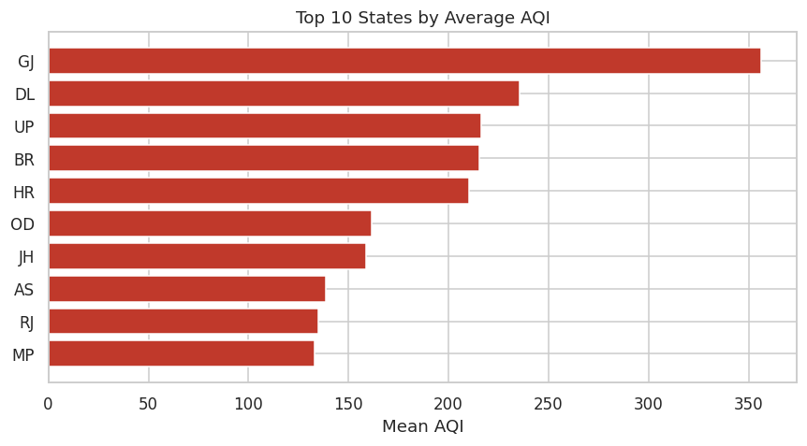
Figure 4: Top 10 states by average AQI
Gujarat has the highest average AQI (356.3), followed by Delhi (235.4), Uttar Pradesh (216.1), Bihar (215.2) and Haryana (210.2). Mizoram (34.8), Meghalaya (53.8) and Kerala (79.8) have the cleanest air. Note that Gujarat has only 1,332 records, so its average rests on fewer stations and days than Delhi's 36,010.

5.5 Relationship between pollutants and AQI
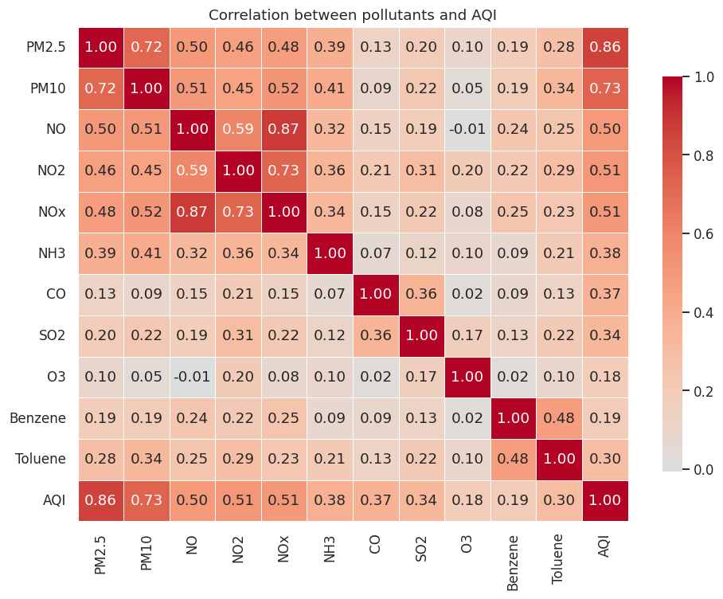
Figure 5: Correlation heatmap of pollutants and AQI
PM2.5 has the strongest correlation with AQI (0.86), then PM10 (0.73), and then NO2 (0.51), NOx (0.51) and NO (0.49). Ozone has the weakest relationship (0.18). PM2.5 and PM10 are themselves strongly correlated (0.72), which is expected because fine particles are part of PM10.
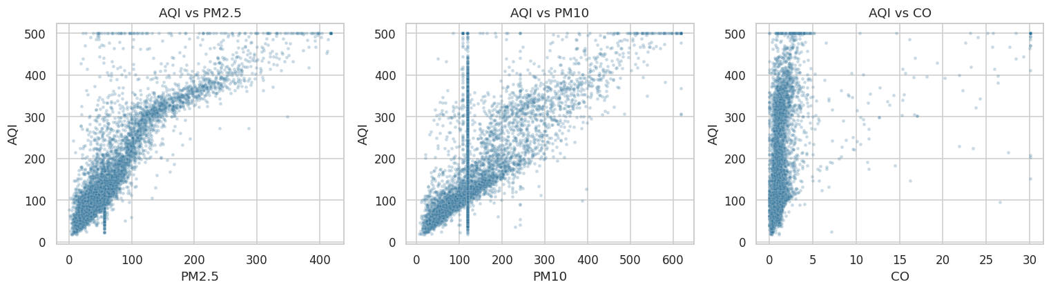
Figure 6: AQI against PM2.5, PM10 and CO (random sample of 6,000 records)
AQI rises almost linearly with PM2.5 at low and medium levels; the spread widens at high values because other pollutants then take over as the worst pollutant on those days.

5.6 Pollutant profile of each AQI category
AQI category | PM2.5 | PM10 | NO2 | CO | SO2 | O3
Good | 18.2 | 53.8 | 13.5 | 0.49 | 6.7 | 20.4
Satisfactory | 33.0 | 82.9 | 21.7 | 0.79 | 8.3 | 29.3
Moderate | 56.8 | 130.2 | 33.3 | 1.16 | 11.6 | 39.5
Poor | 95.8 | 189.3 | 42.5 | 1.70 | 13.9 | 43.0
Very Poor | 162.2 | 234.3 | 52.5 | 2.25 | 14.9 | 44.5
Severe | 252.7 | 356.6 | 68.5 | 5.69 | 21.7 | 42.1
Table 1: Average pollutant concentration within each AQI category
Average PM2.5 rises from 18.2 on Good days to 252.7 on Severe days, a 14-fold increase, while ozone barely changes between the Poor and Severe categories. This confirms that particulate matter, not ozone, characterises the worst days.

6. Methodology

6.1 Modelling approach
Two supervised learning problems were solved with the same feature matrix:
- Regression: predict the numerical AQI value.
- Classification: predict the AQI category (six classes).

6.2 Train-test split
The data was split randomly into 69,403 training rows (80%) and 17,351 test rows (20%) with random_state = 42. The test set was never used for training or tuning. Additional validation (time-based split, station-grouped cross-validation, 5-fold cross-validation) is reported in Section 8.

6.3 Models compared
Model | Why it was chosen | Key settings
Linear Regression | Simple, interpretable baseline | Standardised features
Decision Tree | Captures non-linear rules, easy to explain | max_depth = 12, min_samples_leaf = 5
Random Forest | Averages many trees, reduces overfitting | 60 trees, min_samples_leaf = 2, max_features = 0.4
Gradient Boosting | Builds trees sequentially to correct errors | 400 iterations, learning rate 0.08

6.4 Evaluation metrics
- R² (coefficient of determination): share of the variation in AQI explained by the model (1.0 is perfect).
- MAE (mean absolute error): average size of the prediction error, in AQI points.
- RMSE (root mean squared error): like MAE but penalises large errors more strongly.
- Accuracy, precision, recall, F1-score and confusion matrix: used for the classifier.

7. Results and Model Evaluation

7.1 Model comparison
Model | Test R² | Test MAE | Test RMSE | Train R²
Linear Regression | 0.876 | 30.71 | 42.24 | 0.877
Decision Tree | 0.925 | 20.59 | 32.81 | 0.947
Random Forest | 0.942 | 18.02 | 29.03 | 0.986
Gradient Boosting | 0.946 | 17.54 | 27.95 | 0.959
Table 2: Regression performance on the 20% test set (best model highlighted)
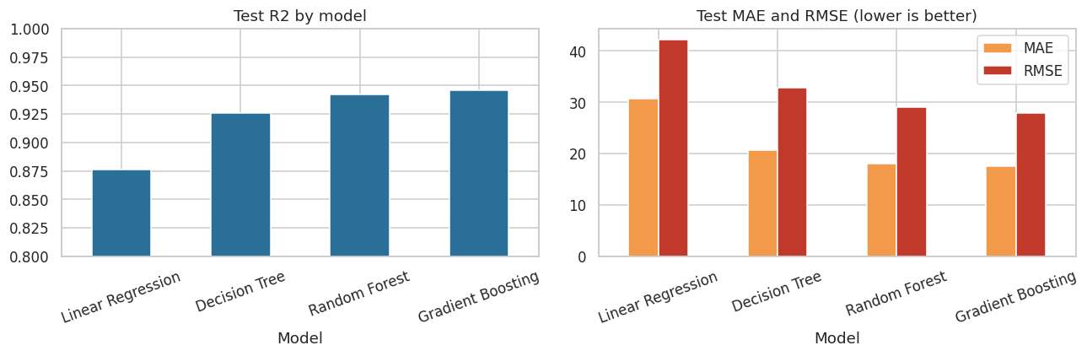
Figure 7: Comparison of models by R² (left) and by MAE and RMSE (right)
Moving from the linear baseline to tree-based models gives a large improvement: R² rises from 0.876 to 0.925 (Decision Tree), 0.942 (Random Forest) and 0.946 (Gradient Boosting), while MAE drops from 30.7 to 17.5. This shows that the relationship between pollutants and AQI is non-linear (the AQI formula is piece-wise, so a straight line cannot capture it). Random Forest fits the training data almost perfectly (train R² = 0.986) but is slightly worse on test data, a sign of mild overfitting; Gradient Boosting has a smaller train-test gap and the best test scores, so it was selected as the final model.

7.2 Actual versus predicted AQI
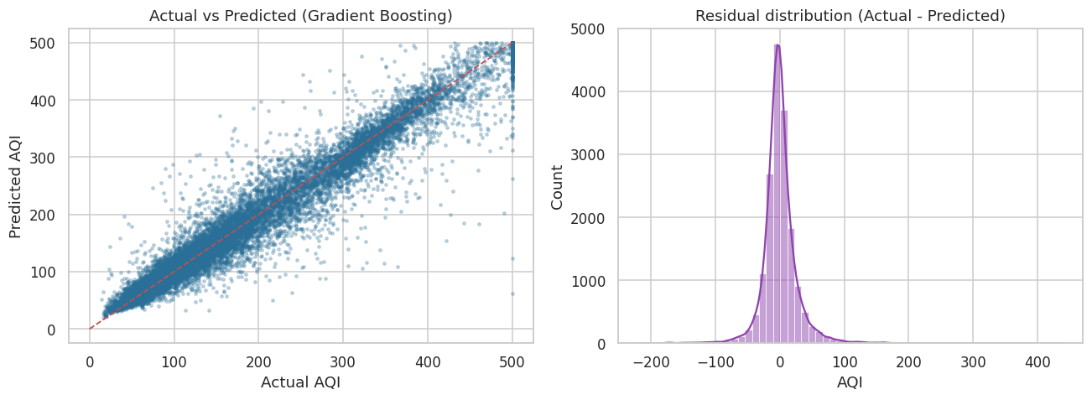
Figure 8: Actual vs predicted AQI (left) and residual distribution (right) for Gradient Boosting
The points follow the diagonal closely and the residuals are centred on zero (mean error 0.31, standard deviation 27.9), so the model is not systematically over- or under-predicting. 45.9% of predictions are within 10 AQI points, 72.0% within 20 points and 84.4% within 30 points of the true value.

7.3 Feature importance
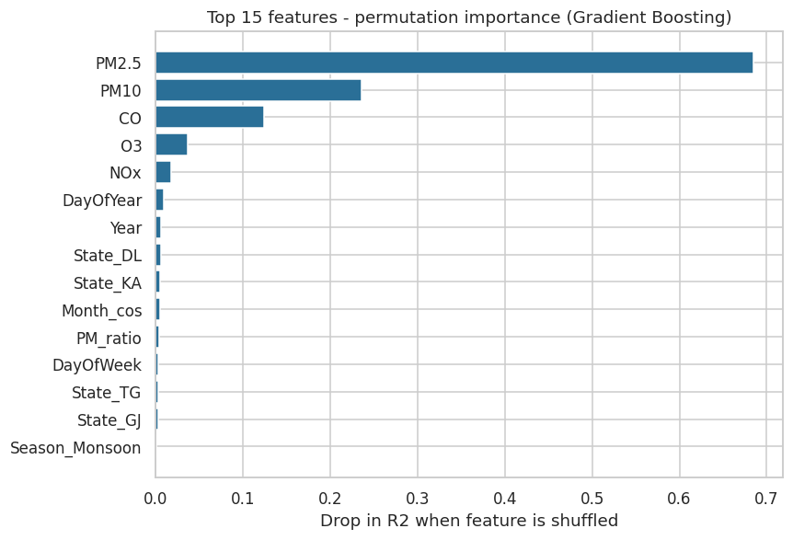
Figure 9: Top 15 features by permutation importance (drop in R² when the feature is shuffled)
PM2.5 dominates (importance 0.685); shuffling it alone reduces R² by about 0.68. PM10 (0.236) and CO (0.124) come next, followed by O3 and NOx with much smaller contributions. Calendar and state features add only small amounts, meaning the pollutant readings carry almost all of the predictive information. The engineered features helped the model in small ways (DayOfYear and Month_cos appear in the top ten).

8. Error Analysis and Robustness Checks

8.1 Where does the model make larger errors?
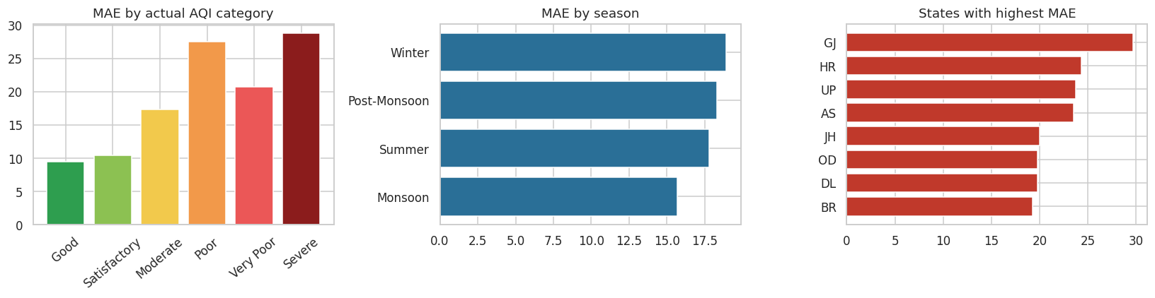
Figure 10: Mean absolute error by actual AQI category (left), season (middle) and state (right)
- By AQI level: error is smallest for clean days (MAE 9.5 for Good, 10.4 for Satisfactory) and largest for the Poor (27.5) and Severe (28.8) categories. High-AQI days are rarer and more variable, so the model has fewer similar examples to learn from.
- By season: errors are similar across seasons, from 15.7 in the Monsoon to 18.9 in Winter, so the model works consistently all year.
- By state: Gujarat (MAE 29.7), Haryana (24.4) and Uttar Pradesh (23.7) have the highest errors. These states have far fewer records than Delhi, so the model has seen less of them.
- Worst single error: 437.7 AQI points, an isolated outlier; such cases are extremely rare compared with the 17,351 test predictions.

8.2 Robustness checks
A random split can be optimistic because neighbouring days of the same station look alike. Three tougher tests were therefore run on the final model:
Validation test | What it checks | R² | MAE
Random 80/20 split (main result) | Performance on random unseen rows | 0.946 | 17.5
Time-based split (train 2015-2019, test 2020) | Can the model handle future data? | 0.909 | 19.1
Station-grouped 5-fold CV (mean) | Can it handle stations it never saw? | 0.917 | -
Standard 5-fold CV, contiguous blocks (mean ± std) | Stability across data blocks | 0.892 ± 0.037 | -
Model without PM2.5, PM10 and PM_ratio | How dependent is it on particulate readings? | 0.853 | 32.3
Table 3: Robustness results for the Gradient Boosting model
The model remains strong in every test: R² is 0.909 on the future year 2020 and 0.917 on unseen stations. The contiguous-block cross-validation gives a lower mean (0.892) with more variation across folds (0.037) because the data is sorted by station and date, so each fold removes a whole block of stations and years; the weakest fold is still above 0.83. When PM2.5 and PM10 are removed, R² drops to 0.853 and MAE almost doubles to 32.3, which confirms how much of the prediction depends on particulate matter.

8.3 Possible reasons for the remaining error
- AQI is calculated from pollutant sub-indices using specific averaging windows (for example 24-hour averages for PM and 8-hour averages for CO and O3); the daily values in this dataset do not contain that detail.
- Some states (for example Gujarat and Assam) have far less data than Delhi.
- The categories Poor and Very Poor overlap in pollutant levels, making boundary days hard to separate.
- Weather conditions (wind, humidity, temperature) that influence pollution levels are not in the dataset.

9. AQI Category Classification
Because public alerts are based on categories, a Random Forest classifier (60 trees, balanced class weights, stratified 80/20 split) was trained to predict AQI_Bucket directly. It reaches an overall accuracy of 80.1%, macro F1-score of 0.788 and weighted F1-score of 0.801.
AQI category | Precision | Recall | F1-score | Test records
Good | 0.798 | 0.765 | 0.781 | 1,095
Satisfactory | 0.822 | 0.848 | 0.835 | 4,712
Moderate | 0.833 | 0.824 | 0.829 | 5,867
Poor | 0.678 | 0.661 | 0.669 | 2,293
Very Poor | 0.791 | 0.790 | 0.791 | 2,345
Severe | 0.819 | 0.833 | 0.826 | 1,039
Table 4: Classification report for the AQI category model
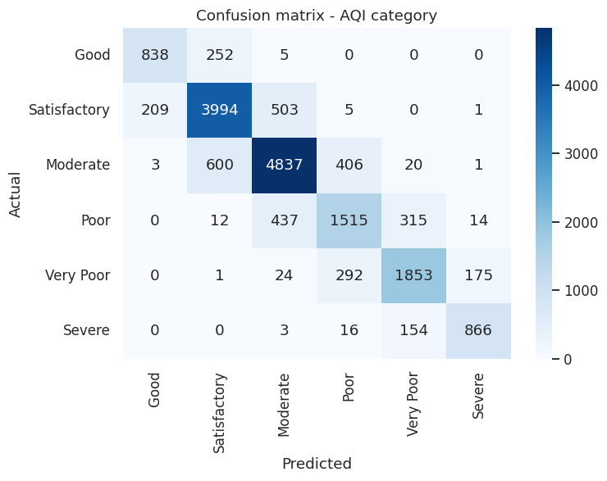
Figure 11: Confusion matrix of the AQI category classifier
The model performs well on Satisfactory, Moderate and Severe days (F1 about 0.83) and least well on the Poor category (F1 = 0.669), which sits between Moderate and Very Poor and is therefore the easiest to confuse. Importantly, 99.4% of all predictions are at most one category away from the true category, so serious misclassifications (for example predicting Good when the air is Severe) are practically absent.

10. Power BI Dashboard
An interactive Power BI dashboard was built on station_day_clean.csv and on model_predictions.csv (the test-set predictions exported from the notebook). It has three pages that move from description to explanation to model performance. Slicers for State, Year and Season filter every visual on a page.
Page | Content | Purpose
1. Overview | KPI cards (average AQI, maximum AQI, stations, most polluted state); monthly AQI trend; state-wise AQI; slicers | Quick picture of air quality
2. Pollutant Analysis | Feature importance; pollutant vs AQI relationship; AQI category distribution | Explain what drives AQI
3. Model Performance | R², MAE, RMSE cards; actual vs predicted AQI; model comparison table | Show how reliable the model is

10.1 Page 1: Overview
[ INSERT SCREENSHOT HERE ]
Power BI Dashboard - Page 1: Overview
Paste your Page 1 screenshot here, then delete this instruction text
Figure 12: Dashboard page 1 - Overview

10.2 Page 2: Pollutant Analysis
[ INSERT SCREENSHOT HERE ]
Power BI Dashboard - Page 2: Pollutant Analysis
Paste your Page 2 screenshot here, then delete this instruction text
Figure 13: Dashboard page 2 - Pollutant analysis

10.3 Page 3: Model Performance
[ INSERT SCREENSHOT HERE ]
Power BI Dashboard - Page 3: Model Performance
Paste your Page 3 screenshot here, then delete this instruction text
Figure 14: Dashboard page 3 - Model performance

11. Key Insights and Recommendations

11.1 Key insights
- Fine particles drive the AQI. PM2.5 has a correlation of 0.86 with AQI and is the top predictor; average PM2.5 rises from 18.2 to 252.7 µg/m³ between Good and Severe days.
- Air quality is strongly seasonal. Winter and Post-Monsoon average AQI (239.2 and 230.7) is more than double the Monsoon level (114.0); November and December are the worst months.
- One day in three is unhealthy. 32.7% of station-days fall in Poor, Very Poor or Severe, while only 6.3% are Good.
- Gujarat and the Gangetic belt are the hotspots. Gujarat and the northern Gangetic states (Delhi, Uttar Pradesh, Bihar, Haryana) have the highest average AQI (all above 200), whereas north-eastern and southern states are among the cleanest.
- A positive trend, with caution. Average AQI dropped from 219.2 (2015) to 172.5 (2019). The lower 2020 value (134.9) covers only January to July and may also reflect the reduced activity during the early-2020 lockdown, which this project did not test.
- The model is accurate and robust. R² = 0.946 with MAE of 17.5 points, and similar performance on future data and unseen stations.

11.2 Recommendations
# | Recommendation | Supporting evidence
1 | Prioritise PM2.5 reduction (dust control, vehicle emission checks, restrictions on open burning) because it moves AQI more than any other pollutant. | PM2.5 importance 0.68; correlation 0.86
2 | Prepare a seasonal action plan that starts in October and runs to February, with stricter measures in November-December. | Winter 239.2, Post-Monsoon 230.7 vs Monsoon 114.0
3 | Focus intervention budgets on the highest-AQI states and add monitoring stations in under-sampled hotspots (e.g. Gujarat, Haryana). | State ranking (Fig. 4); higher model error where data is sparse (Fig. 10)
4 | Use the model as a quick AQI estimator and early-warning tool, especially to flag Poor and worse days to the public. | Category accuracy 80.1%; 99.4% within one category
5 | Keep PM2.5 and PM10 sensors working with priority at every station; if they fail the estimate becomes much weaker. | R² falls to 0.853 and MAE almost doubles without PM features
6 | Re-train the model periodically with new data and extend it with weather variables to improve accuracy. | Remaining error on high-AQI days (Section 8)

12. Limitations
- Data imbalance: Delhi accounts for 41.5% of all records, so overall patterns are weighted toward Delhi and results for smaller states are less certain.
- Uneven time coverage: most data is from 2018-2020; 2015-2017 has far fewer stations, and 2020 covers only seven months.
- AQI is derived from the pollutants: a strong relationship between pollutant readings and AQI is expected by design. The model is therefore best seen as an accurate AQI estimator rather than a forecaster of future pollution.
- No weather variables: wind speed, humidity, temperature and rainfall strongly influence pollution but were not available.
- Higher error on extreme days: Poor and Severe days have larger prediction errors because they are rarer and more variable.
- Cleaning decisions inherited: the dataset had already been cleaned in earlier tasks; any choices made then (such as treatment of missing values and outliers) carry into this project.
- Correlation is not causation: the analysis shows associations, not the sources that cause pollution.

13. Future Scope
- Add meteorological data (temperature, wind, humidity, rainfall) and satellite or traffic data as features.
- Build a true forecasting model (next-day or next-week AQI) using lag features or time-series models such as ARIMA, Prophet or LSTM.
- Tune hyperparameters systematically (grid or Bayesian search) and test XGBoost or LightGBM.
- Handle class imbalance for Poor/Severe days with resampling or cost-sensitive learning.
- Balance the data across states or train separate models for high-pollution regions.
- Deploy the model as a simple web app or API connected to live station feeds, with automatic alerts.
- Study the effect of specific events such as the 2020 lockdown or crop-burning season with a proper causal design.

14. Conclusion
This capstone project took the cleaned station-day air-quality data through the full data science cycle: problem definition, data validation and feature engineering, exploratory analysis, model building and comparison, error and robustness analysis, classification, and an interactive dashboard. The final Gradient Boosting model predicts AQI with R² = 0.946 and an average error of 17.5 AQI points, stays reliable on future data and unseen stations, and the classifier identifies the correct AQI category 80.1% of the time. The analysis shows that fine particulate matter and the winter/post-monsoon season are the central problems, and the recommendations translate these findings into practical actions. With weather data and forecasting methods added, the work can be extended into a decision-support tool for air-quality management.

Appendix: Project Files and Reproducibility
File | Description
Capstone_AQI_Prediction.ipynb | Jupyter Notebook with all code: loading, feature engineering, EDA, models, evaluation, error analysis, classification, exports
station_day_clean.csv | Input dataset
model_predictions.csv | Test-set actual and predicted AQI with station, state, season and error (used in Power BI)
feature_importance.csv | Top 15 feature importances (used in Power BI page 2)
model_comparison.csv | Regression metrics of all four models (used in Power BI page 3)
figures (PNG) | All charts used in this report

Reproducibility: random_state = 42 is used for the train-test split and all models. Libraries: pandas, NumPy, scikit-learn 1.8, matplotlib, seaborn. Running the notebook from top to bottom regenerates every number and figure in this report.
Note on Random Forest size: the Random Forest uses 60 trees to keep run time short; increasing this number changes the scores only marginally.

