YUVA INTERN
TASK 2: HANDS-ON DATA LAB IMPLEMENTATION
Pizza Orders Analysis: Environment Setup, Data Manipulation, Visualization and Basic Analysis
Candidate Detail | Information
Candidate Name | UTSAV KANT JHA
Internship Platform | Yuva Intern
Internship Role | Data Analyst
Submission Date | 14/10/2026
Files submitted | This report, YuvaIntern_Task2.ipynb (notebook) and pizza_orders.csv (dataset)

1. Objective
Task 2 has two objectives:
- Set up a data science environment with Python, Jupyter and the required libraries.
- Complete practical exercises in data manipulation, visualization and basic analysis.
To do this, I built my own small dataset of pizza-shop orders in Jupyter Notebook, saved it as a CSV file, and then inspected, cleaned, analysed and visualized it. Every code cell below was run by me in my own notebook, and the screenshot under each cell shows its real output.

2. Tools and Libraries
Tool | Purpose | Where I used it
Python | Programming language for the analysis | All cells in the notebook
Jupyter Notebook | Runs code cell by cell with output below | Code, output and charts in one place
Pandas | Tables (DataFrames), cleaning, grouping | Reading CSV, cleaning, groupby, pivot_table
NumPy | Numerical operations, random data, NaN | Creating the dataset, np.where for order type
Matplotlib | Basic charts | Bar chart, line chart, histogram
Seaborn | Statistical charts | Box plot of order value by size

3. Environment Setup Verification
All libraries were already installed, so this first cell checks that the notebook kernel can import each of them and prints the installed versions.
import sys
import pandas as pd
import numpy as np
import matplotlib
import matplotlib.pyplot as plt
import seaborn as sns

print("Python version:", sys.version.split()[0])
print("Pandas version:", pd.__version__)
print("NumPy version:", np.__version__)
print("Matplotlib version:", matplotlib.__version__)
print("Seaborn version:", sns.__version__)
print("Environment verification completed successfully.")
Output=
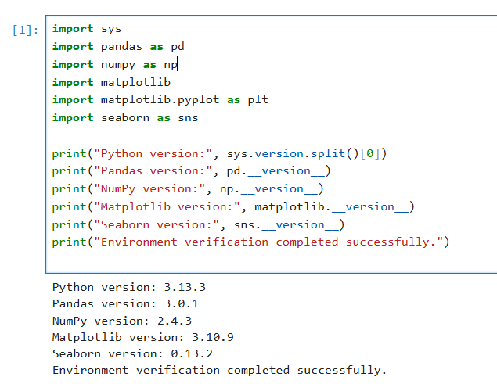

Observation: The cell ran without any import error, which confirms that Python, Pandas, NumPy, Matplotlib and Seaborn are working in my Jupyter environment. The version numbers printed above are the ones installed on my computer.

4. Dataset Creation
I created a fictional dataset of 60 pizza orders from 1 September 2026 onward, with 6 columns (Order_ID, Order_Date, Pizza, Size, Quantity, Rating) plus Unit_Price calculated from pizza type and size. A fixed random seed makes the data the same on every run. I deliberately added 3 missing ratings and 2 duplicate rows so that I could practise data cleaning later. The data is saved to pizza_orders.csv.
rng = np.random.default_rng(42) # fixed seed -> same data every run
n = 60

pizzas = ["Margherita", "Pepperoni", "Veggie Supreme", "BBQ Chicken", "Paneer Tikka"]
base_price = {"Margherita": 8, "Pepperoni": 10, "Veggie Supreme": 9,
"BBQ Chicken": 12, "Paneer Tikka": 11}
size_extra = {"Small": 0, "Medium": 3, "Large": 6}

orders = pd.DataFrame({
"Order_ID": np.arange(1001, 1001 + n),
"Order_Date": pd.date_range("2026-09-01", periods=n, freq="D"),
"Pizza": rng.choice(pizzas, n),
"Size": rng.choice(["Small", "Medium", "Large"], n, p=[0.3, 0.45, 0.25]),
"Quantity": rng.integers(1, 5, n),
"Rating": rng.integers(3, 6, n).astype(float),
})
orders["Unit_Price"] = orders["Pizza"].map(base_price) + orders["Size"].map(size_extra)

# Deliberately add 3 missing ratings and 2 duplicate rows to practise cleaning
orders.loc[[7, 23, 41], "Rating"] = np.nan
orders = pd.concat([orders, orders.iloc[[10, 30]]], ignore_index=True)

orders.to_csv("pizza_orders.csv", index=False)
print("Rows, columns:", orders.shape)
orders.head()
Output=
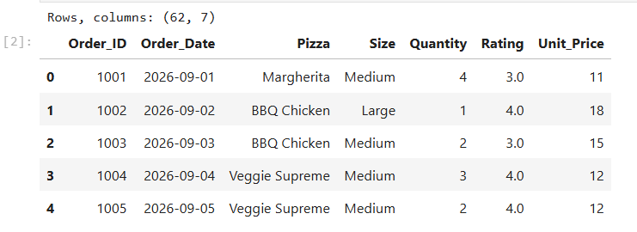

Observation: The table has 62 rows and 7 columns: 60 unique orders plus the 2 duplicate rows I added on purpose. Each row is one order and each column is one attribute of that order.

5. Data Inspection
Before any analysis, I read the CSV back into a DataFrame and checked its size, column names, data types and summary statistics.
df = pd.read_csv("pizza_orders.csv", parse_dates=["Order_Date"])

print("First five rows:")
print(df.head())
print("\nLast five rows:")
print(df.tail())
print("\nShape (rows, columns):", df.shape)
print("\nColumns:", list(df.columns))
print("\nData types and non-null counts:")
df.info()

Output=
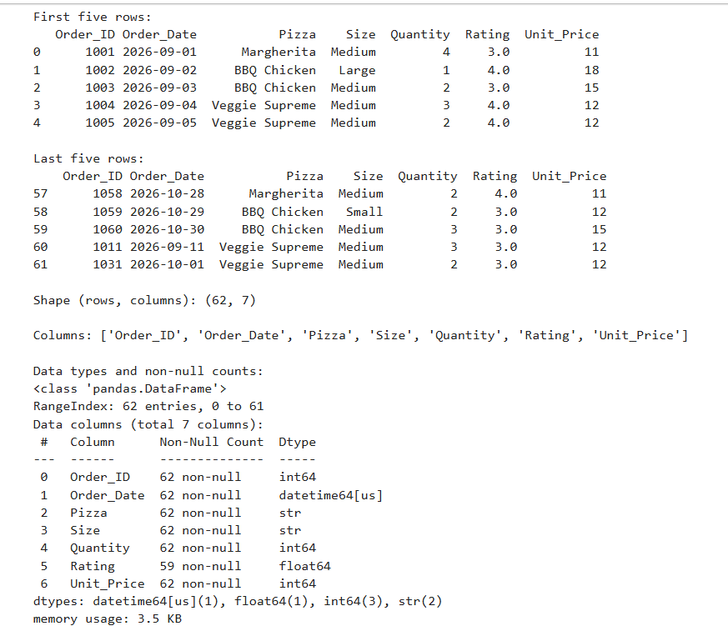

df.describe()
Output=
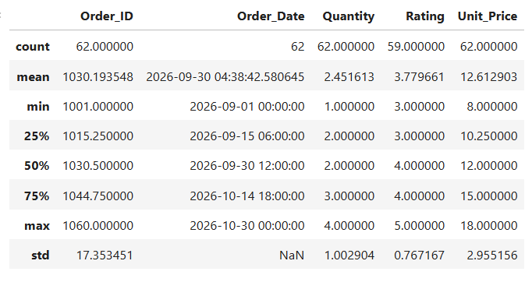

Observation: The data has 62 rows and 7 columns. Rating has only 59 non-null values, so 3 ratings are missing; every other column is complete. Order_Date was correctly read as a date type because I used parse_dates. The average Rating is about 3.78 and Unit_Price ranges from 8 to 18.

6. Data Cleaning
This step finds the problems I planted in the data, fixes them, and then checks again.
print("Missing values before cleaning:")
print(df.isna().sum())
print("\nDuplicate rows before cleaning:", df.duplicated().sum())
print("Rows before cleaning:", len(df))

clean = df.drop_duplicates().copy()
median_rating = clean["Rating"].median()
clean["Rating"] = clean["Rating"].fillna(median_rating)

print("\nMedian rating used to fill missing values:", median_rating)
print("Rows after cleaning:", len(clean))
print("Missing values after cleaning:", clean.isna().sum().sum())
print("Duplicate rows after cleaning:", clean.duplicated().sum())

Output=
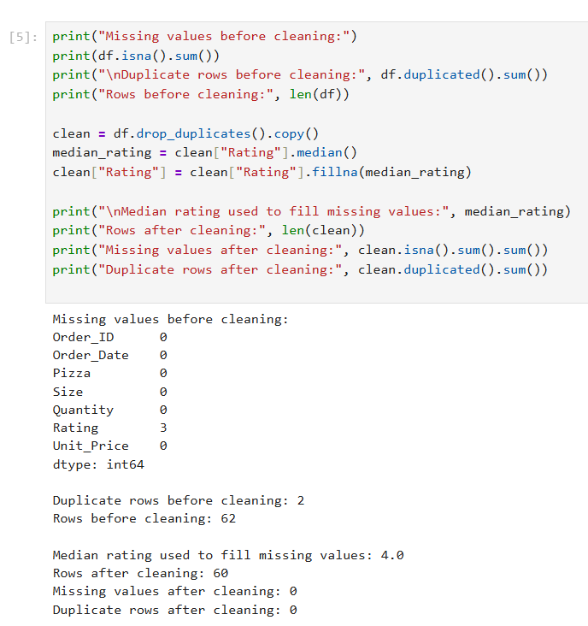

Observation: 2 duplicate rows were found and removed, so the data went from 62 rows to 60 rows. The 3 missing ratings were filled with the median rating, 4.0. After cleaning, there are no missing values and no duplicates.
Why median: Ratings are whole numbers between 3 and 5, and the median is not pulled by extreme values. This is a demonstration choice. In a real project I would first find out why the values are missing.

7. Data Manipulation and Basic Analysis

7.1 Revenue and summary numbers
I created a new column, Revenue = Quantity x Unit_Price, and calculated basic statistics.
clean["Revenue"] = clean["Quantity"] * clean["Unit_Price"]

print("Total revenue:", clean["Revenue"].sum())
print("Average revenue per order:", round(clean["Revenue"].mean(), 2))
print("Median revenue per order:", clean["Revenue"].median())
print("Highest order value:", clean["Revenue"].max())
print("Lowest order value:", clean["Revenue"].min())
Output=
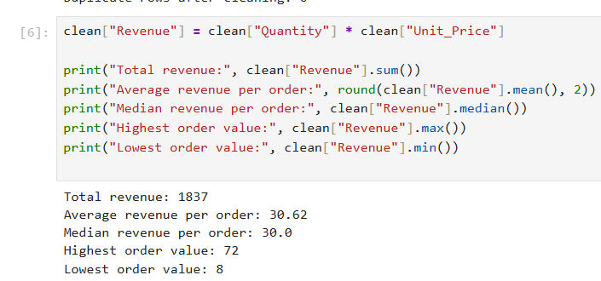

Observation: Total revenue is 1837 and the average order is worth 30.62. The highest order is 72 (Order 1015, BBQ Chicken, 4 pizzas at 18 each) and the lowest is 8. The median order value is 30, close to the mean of 30.62, so most orders are around that value.

7.2 Filtering, sorting and a derived column
big_orders = clean[clean["Revenue"] > 50]
print("Orders with revenue above 50:", len(big_orders))
print(big_orders[["Order_ID", "Pizza", "Size", "Quantity", "Revenue"]])

print("\nTop 5 orders by revenue:")
top5 = clean.sort_values("Revenue", ascending=False).head(5)
print(top5[["Order_ID", "Pizza", "Size", "Quantity", "Revenue"]])

clean["Order_Type"] = np.where(clean["Revenue"] >= 40, "High value", "Regular")
print("\nOrder types:")
print(clean["Order_Type"].value_counts())

Output=
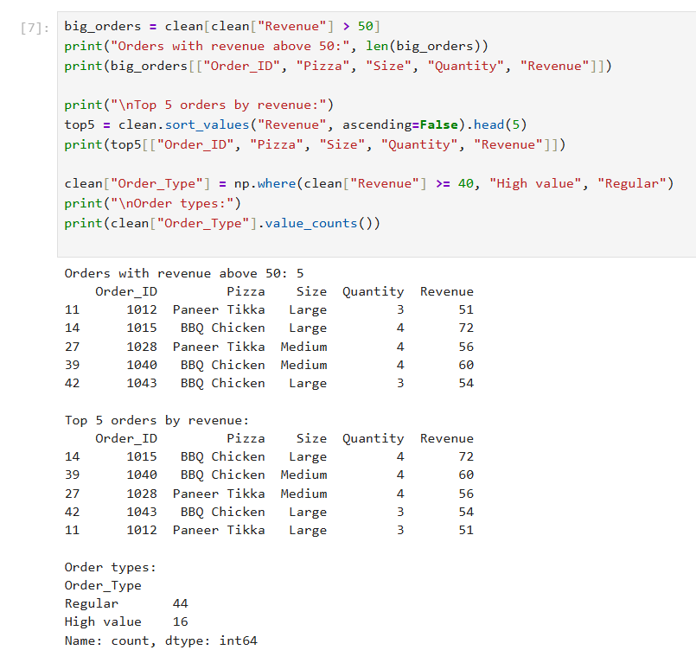

Observation: Only 5 orders are worth more than 50. With my rule of 40 or more as 'High value', 16 orders are high value and 44 are regular. The threshold of 40 is my own choice for this exercise, not a business rule.

7.3 Grouping and pivot table
pizza_summary = clean.groupby("Pizza").agg(
Orders=("Order_ID", "count"),
Total_Qty=("Quantity", "sum"),
Total_Revenue=("Revenue", "sum"),
Avg_Rating=("Rating", "mean")
).sort_values("Total_Revenue", ascending=False).round(2)
print(pizza_summary)

print("\nRevenue by pizza and size:")
print(clean.pivot_table(index="Pizza", columns="Size", values="Revenue",
aggfunc="sum", fill_value=0))

print("\nOrder value by size:")
print(clean.groupby("Size")["Revenue"].agg(["count", "mean", "median"]).round(2))

Output=
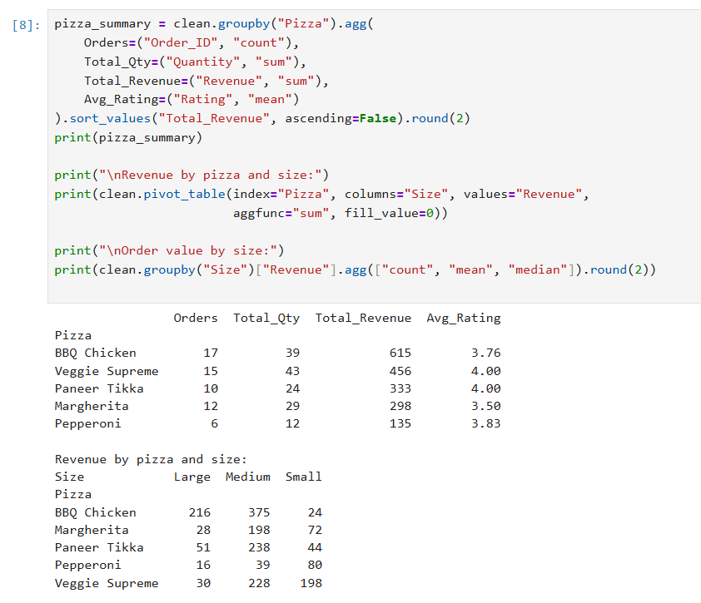
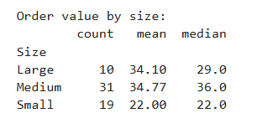

- BBQ Chicken earns the most revenue (615), about one third of total revenue.
- Veggie Supreme sells the most pizzas (43 units).
- Pepperoni has the lowest revenue (135) and only 6 orders.
- Average ratings are between 3.50 (Margherita) and 4.00 (Veggie Supreme and Paneer Tikka).
- Small orders average 22, while Medium (34.77) and Large (34.10) are close to each other. Only 10 orders are Large, so that group is small.

8. Data Visualization

8.1 Bar chart: revenue by pizza
A bar chart fits here because I am comparing one number (revenue) across categories (pizza types).
rev = clean.groupby("Pizza")["Revenue"].sum().sort_values(ascending=False)

plt.figure(figsize=(8, 4.5))
plt.bar(rev.index, rev.values, color="#2E75B6")
plt.xlabel("Pizza")
plt.ylabel("Total revenue")
plt.title("Total Revenue by Pizza Type")
plt.xticks(rotation=20)
plt.tight_layout()
plt.show()

Output=
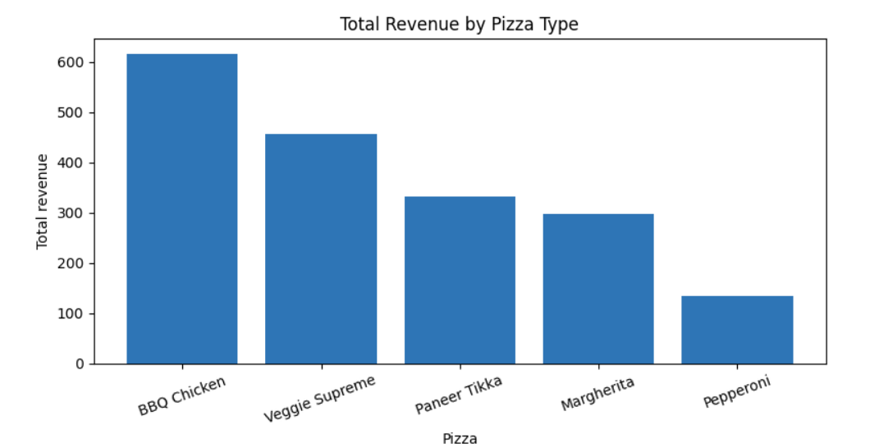

Finding: BBQ Chicken is clearly the top earner at 615, and Pepperoni is the lowest at 135.

8.2 Line chart: weekly revenue trend
A line chart shows how revenue changes over time. I grouped the orders by week.
weekly = clean.set_index("Order_Date")["Revenue"].resample("W").sum()
print(weekly)

plt.figure(figsize=(8, 4.5))
plt.plot(weekly.index, weekly.values, marker="o")
plt.xlabel("Week ending")
plt.ylabel("Weekly revenue")
plt.title("Weekly Revenue Trend")
plt.xticks(rotation=20)
plt.grid(alpha=0.3)
plt.tight_layout()
plt.show()

Output=
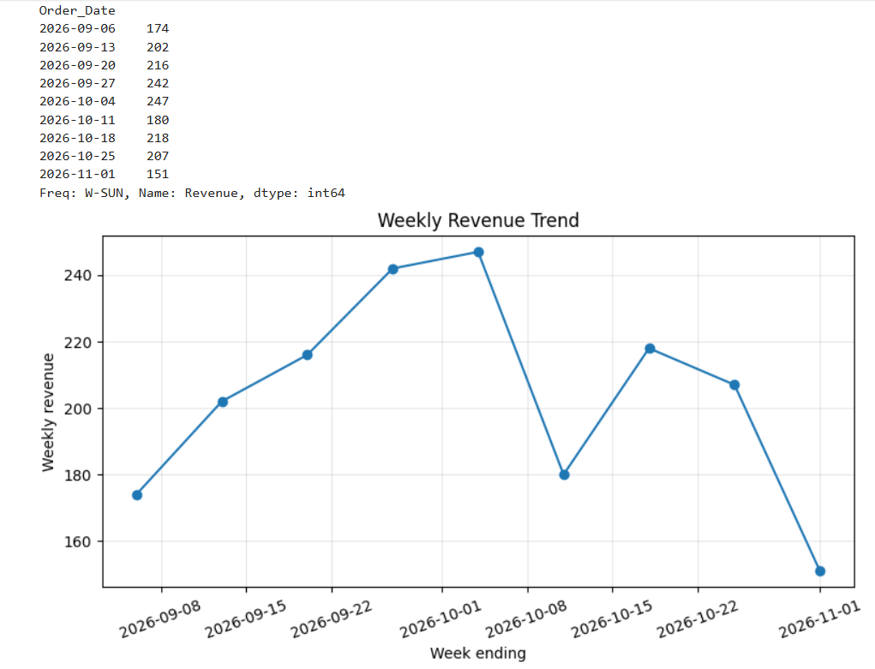

Finding: Weekly revenue peaked at 247 in the week ending 4 October 2026. The first and last weeks contain fewer days of data (the data starts on 1 September and ends on 30 October), so their totals are lower for that reason and should not be read as a real drop.

8.3 Histogram: distribution of order value
plt.figure(figsize=(8, 4.5))
plt.hist(clean["Revenue"], bins=8, edgecolor="black")
plt.xlabel("Order value")
plt.ylabel("Number of orders")
plt.title("Distribution of Order Value")
plt.tight_layout()
plt.show()

Output=

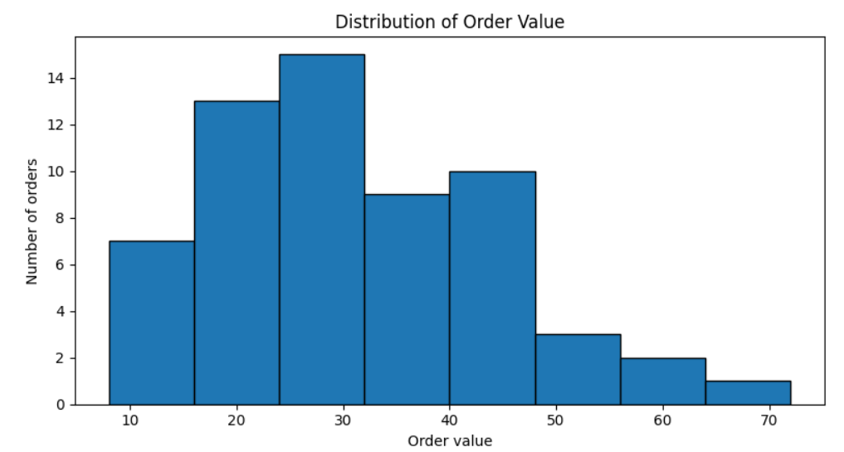

Finding: Half of the orders are between about 21.5 and 40.5 (the middle 50%), with a median of 30. A few large orders, such as 72 and 60, stretch the right side, which is why the mean (30.62) is slightly above the median.

8.4 Box plot: order value by size
plt.figure(figsize=(8, 4.5))
sns.boxplot(data=clean, x="Size", y="Revenue", order=["Small", "Medium", "Large"])
plt.xlabel("Pizza size")
plt.ylabel("Order value")
plt.title("Order Value by Pizza Size")
plt.tight_layout()
plt.show()

Output=

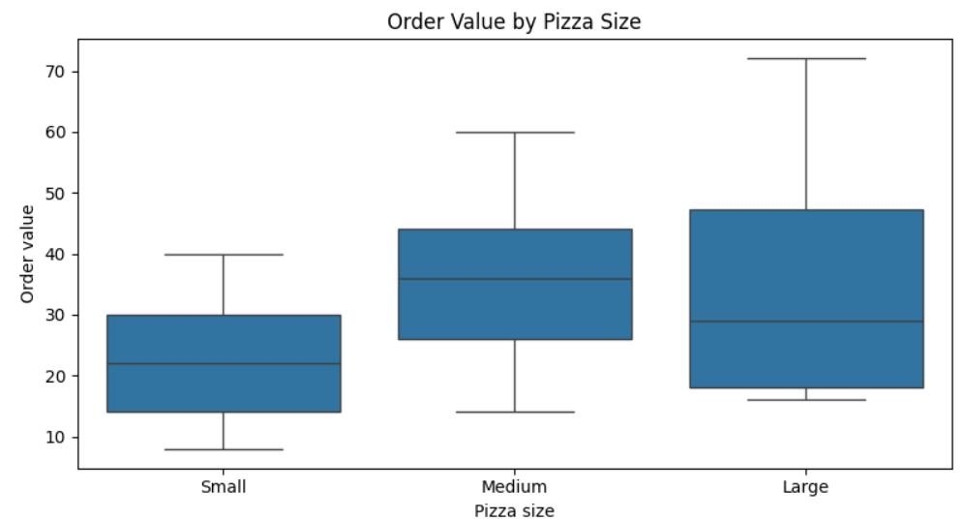

Finding: The median order value is 22 for Small, 36 for Medium and 29 for Large. Large is lower than Medium partly because it has only 10 orders, so its box is less reliable. A high point in a box plot is not automatically an error; it needs to be checked in context.

9. Findings and Practical Interpretation
- The cleaned dataset has 60 orders and total revenue of 1837, with an average order value of 30.62.
- BBQ Chicken brings in about a third of revenue; Pepperoni brings in the least.
- Medium and Large pizzas generate much higher order values than Small ones.
- Only 5 orders are above 50, so most revenue comes from many mid-sized orders, not a few very big ones.
Practical use: a pizza shop owner could use this kind of summary to decide which pizza to promote, which one to review or reprice, and which size to push. Because the data is fictional and small, these are examples of how the method works, not real business conclusions.

10. Limitations and Good Practices
- The dataset is small, fictional and generated by code, so the results describe only this sample.
- Charts show patterns but do not prove cause and effect.
- Missing values should not be filled automatically without checking why they are missing.
- I kept the raw DataFrame (df) separate from the cleaned one (clean) so the original values stay available.
- Use straight quotes (" ") in Python code. Curly quotes copied from Word documents cause a SyntaxError.
- A fixed random seed makes the notebook reproducible.

11. Conclusion
In this task I set up and verified a Python and Jupyter environment, created my own dataset and saved it to a CSV file, inspected and cleaned it, calculated revenue metrics, used filtering, sorting, groupby and pivot tables, and drew four different charts with an explanation of each. The full notebook (YuvaIntern_Task2.ipynb) and the dataset (pizza_orders.csv) are included with this submission so that every result can be reproduced.

