YUVA INTERN
TASK 2
HANDS-ON DATA LAB IMPLEMENTATION
Practical Report: Environment Setup, Data Manipulation,
Visualization and Basic Analysis

Candidate Detail | Information
Candidate Name | UTSAV KANT JHA
Internship Platform | Yuva Intern
Internship Role | Data Analyst
Submission Date | 13/10/2026

Prepared against the two objectives shown in the Task 2 instructions.

1. Objective
The objective is to set up and verify a Python-based data analysis environment using Jupyter Notebook and relevant libraries, then perform practical exercises in data manipulation, visualization, and basic analysis. Each exercise includes code, the result, an explanation of what the result means, and a note about its practical use.

2. Task Objectives and Methodology
The task screenshot identifies two objectives: (1) set up Python, Jupyter, and required libraries; and (2) complete hands-on exercises in data manipulation, visualization, and basic analysis. A small illustrative student dataset is used throughout so the calculations can be checked consistently. The sample records are fictional.
- Environment verification using the Python kernel in Jupyter Notebook.
- Dataset creation and inspection using Pandas.
- Data-quality checks and a separate before/after cleaning example.
- Numerical summaries, filtering, sorting, and a derived category.
- Charts and evidence-based interpretation of the results.

3. Tools and Libraries
Tool / library | Purpose | Example in this task
Python | Runs analysis instructions. | Calculates mean and filters records.
Jupyter Notebook | Runs code cell-by-cell and displays output alongside code. | Keeps code, output, charts, and explanations together.
Pandas | Works with tabular data. | Creates DataFrames and filters rows.
NumPy | Supports numerical operations. | Provides NaN and conditional labels.
Matplotlib | Creates charts. | Builds the bar chart and histogram.
Seaborn | Provides statistical charts. | Builds a box plot to examine spread.

The libraries were already installed. Therefore, the first practical cell verifies the active environment instead of repeating the installation process.

4. Environment Setup Verification
Run this cell in Jupyter Notebook. It verifies that the current notebook kernel can import the required libraries. Version numbers depend on the installed environment.
import sys
import pandas as pd
import numpy as np
import matplotlib
import matplotlib.pyplot as plt
import seaborn as sns
print("Python version:", sys.version.split()[0])
print("Pandas version:", pd.__version__)
print("NumPy version:", np.__version__)
print("Matplotlib version:", matplotlib.__version__)
print("Seaborn version:", sns.__version__)
print("Environment verification completed successfully.")
OUTPUT=
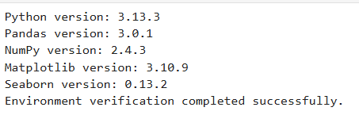
NOTE= I have already install all library.This screenshot is jupyter notebook to easily verify and understand.

5. Important Pandas DataFrame Operations

Operation | Python code | Purpose
Display dataset | df | Shows all data
First 5 rows | df.head() | Displays first 5 rows
Last 5 rows | df.tail() | Displays last 5 rows
Dataset information | df.info() | Shows column types and non-null counts
Statistical summary | df.describe() | Shows numerical statistics
Select a column | df['Name'] | Displays names
Filter data | df[df['Marks'] > 80] | Students scoring above 80
Average marks | df['Marks'].mean() | Calculates average marks
Find missing values | df.isnull().sum() | Counts missing values per column
Note= I can try these examples one by one.
6. Dataset Creation
The dataset contains five fictional students and three variables: Name, Age, and Marks. Each row is one observation and each column is one attribute.
Import pandas as pd
data = {
“Name”: [“Aman”, “Riya”, “Rahul”, “Priya”, “Neha”],
“Age”: [21, 22, 20, 23, 21],
“Marks”: [78, 85, 67, 92, 74]
}
df = pd.DataFrame(data)
print(df)
OUTPUT=
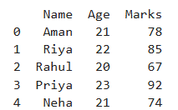
Note= This is the example of pandas dataset creation how create dataset in pandas.
Interpretation: Pandas stores related values in a DataFrame, making it easy to inspect, filter, sort, summarize, and visualize the information. This dataset is for demonstration only, not real student data.

7. Data Inspection
Inspecting a dataset before analysis helps an analyst understand its size, column names, data types, missing values, and numerical ranges.
print("First five rows:")
print(df.head())
print("\nShape (rows, columns):", df.shape)
print("\nColumns:", list(df.columns))
print("\nData types and non-null counts:")
df.info()
print("\nDescriptive statistics:")
print(df.describe())
print("\nMissing values by column:")
print(df.isna().sum())
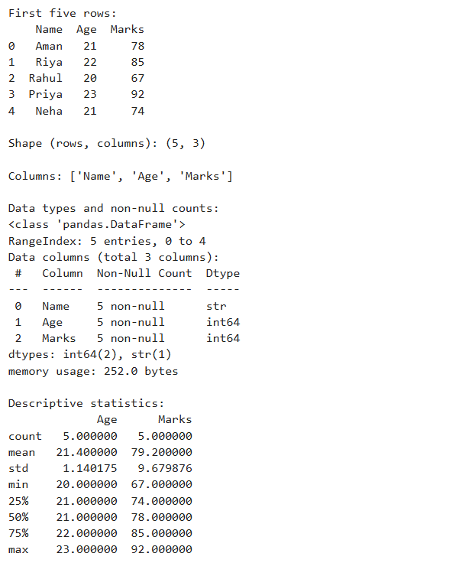
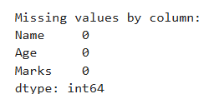
Note= two screenshots are attached according to questions.
The mean of Marks is 79.2
The median is 78.
The mean is slightly higher than the median because higher scores, such as 92, pull the average upward.
Since the dataset has only five records, these values describe this sample and should not be generalized to all students.
Examples=
import pandas as pd

data = {
'Name': ['Amit', 'Rahul', 'Priya'],
'Age': [20, 21, 19],
'Marks': [85, 90, 78]
}

df = pd.DataFrame(data)

print(df.head())
print(df.shape)
print(df.info())
print(df.describe())

output=
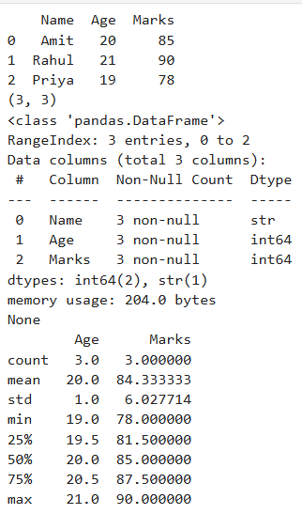

8. Data Quality Checks and Cleaning
To demonstrate cleaning concretely, a separate mini-dataset is intentionally created with a duplicate row and a missing mark. The original dataset remains unchanged.
dirty_df = pd.DataFrame({
"Name": ["Aman", "Riya", "Riya", "Rahul"],
"Marks": [78, 85, 85, np.nan]
})
print("Before cleaning:")
print(dirty_df)
print("Duplicate rows:", dirty_df.duplicated().sum())
print("Missing values:")
print(dirty_df.isna().sum())
clean_df = dirty_df.drop_duplicates().copy()
clean_df["Marks"] = clean_df["Marks"].fillna(clean_df["Marks"].median())
print("\nAfter cleaning:")
print(clean_df)
Output=
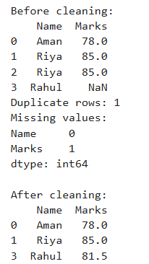
Interpretation and limitation: filling a missing value with the median is a demonstration choice, not a universal rule. In a real project, investigate why the value is missing and choose a treatment appropriate to the data and business context.

9. Data Manipulation and Basic Analysis

9.1 Mean, maximum, minimum and range
average_marks = df["Marks"].mean()
highest_marks = df["Marks"].max()
lowest_marks = df["Marks"].min()
score_range = highest_marks - lowest_marks
print("Average marks:", round(average_marks, 2))
print("Highest marks:", highest_marks)
print("Lowest marks:", lowest_marks)
print("Range:", score_range)
Output=
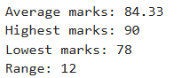
Interpretation:
The average is 79.2.
Priya has the highest mark (92), while Rahul has the lowest (67).
The difference between the maximum and minimum is 25 marks. This describes the spread but does not explain the cause of the differences.

9.2 Filtering records
above_70 = df[df["Marks"] > 70]
print(above_70)
print("Students scoring above 70:", len(above_70))
Output=
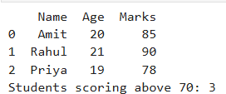
Expected count: 4 students. Rahul is excluded because 67 is not greater than 70. Filtering is useful when an analyst needs to focus on records that satisfy a clear condition.

9.3 Sorting and a derived category
sorted_df = df.sort_values("Marks", ascending=False)
print(sorted_df)
df["Result"] = np.where(
df["Marks"] >= 75, "Meets threshold", "Below threshold"
)
print(df[["Name", "Marks", "Result"]])
Output=
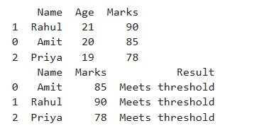
Interpretation: sorting places the highest scores first. The Result column demonstrates a rule-based classification: scores of 75 or more are labelled 'Meets threshold'. This is only a learning example, not an official grading rule.

10. Data Visualization
Charts communicate comparisons and distributions visually. The chart type should match the analytical question, and each chart should be followed by a clear explanation.

10.1 Bar chart — compare student marks
plt.figure(figsize=(7, 4))
plt.bar(df["Name"], df["Marks"])
plt.xlabel("Student")
plt.ylabel("Marks")
plt.title("Student Marks Comparison")
plt.ylim(0, 100)
plt.tight_layout()
plt.show()
Output=
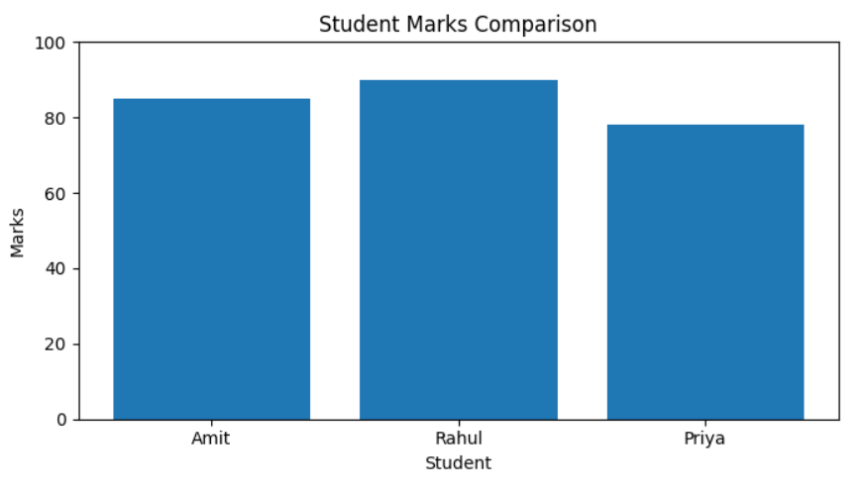
Finding: Priya has the highest bar at 92, and Rahul has the lowest at 67.
A bar chart is appropriate because it compares a numeric measure across categories (students).

10.2 Histogram — inspect mark distribution
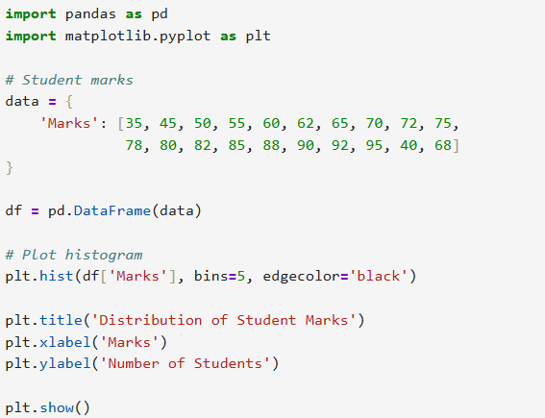
Output=
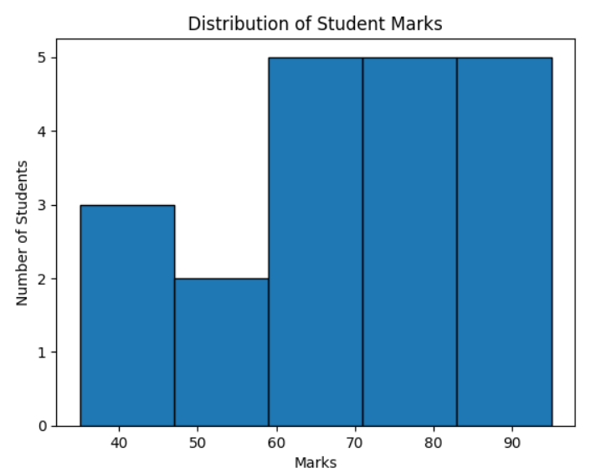

10.3 Box plot — inspect spread
plt.figure(figsize=(7, 3.5))
sns.boxplot(x=df["Marks"])
plt.xlabel("Marks")
plt.title("Spread of Student Marks")
plt.tight_layout()
plt.show()
Output=
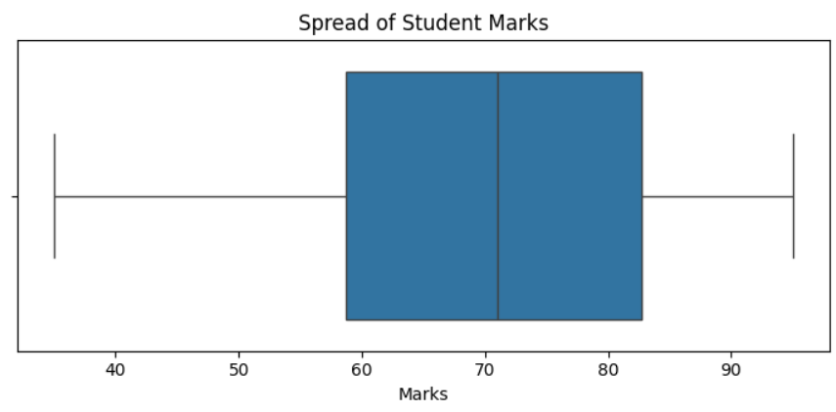
Finding: the box plot summarizes the middle spread and range of marks. A high or low value should not automatically be labelled an error; possible outliers must be investigated in context, especially when the dataset is small.

11. Findings and Practical Interpretation
- The sample contains 5 students and 3 original columns.
- The mean mark is 79.2 and the median is 78; in this sample the mean is slightly higher.
- Priya has the highest mark (92), Rahul has the lowest (67), and the range is 25 marks.
- Four students score more than 70.
- The bar chart compares individual scores; the histogram and box plot summarize distribution and spread.
- The separate cleaning example demonstrates identifying a duplicate row and a missing value.
Possible practical use: a teacher could use the scores to identify students who may need support and then review topic-level performance. Marks alone do not explain why one student scored lower, so further context is needed before making decisions.

12. Limitations and Good Practices
- The dataset is small and fictional; it does not represent a real student population.
- Charts show patterns but do not by themselves establish cause and effect.
- Missing values should not be filled automatically without considering why they are missing.
- Use clear variable names, chart titles, and axis labels.
- Keep raw data separate from cleaned data so original values remain available.
- Keep code and outputs together in the notebook and record the actual library versions for reproducibility.
- Do not include confidential or personally identifiable information without authorization.

13. Conclusion
This practical demonstrates a basic data-analysis workflow: verifying the Python environment, creating a structured dataset, inspecting its structure and summary statistics, checking data quality, manipulating rows and columns, and visualizing results. The examples explain not only how to run the code but also what the outputs mean and what their limitations are. This forms a foundation for more advanced analysis with larger datasets and real business questions.

14. Final Submission Evidence Checklist
Important: the charts embedded in this report are generated from the sample data shown here. They are report figures, not screenshots of your own Jupyter session. Before submitting, run the cells in your notebook and add genuine screenshots of your actual outputs.
- Screenshot 1: environment verification with actual Python and library versions.
- Screenshot 2: dataset creation cell and displayed DataFrame.
- Screenshot 3: inspection outputs including shape, data types, describe, and missing-value check.
- Screenshot 4: before-and-after data cleaning output.
- Screenshot 5: calculations and filtered records.
- Screenshot 6: bar chart, histogram, and box plot displayed in Jupyter Notebook.
Final check: compare your notebook outputs with this report and correct any differences before submission. If the platform requires the notebook file as well, submit the .ipynb file in addition to this DOCX report.

