DATA SCIENCE FUNDAMENTALS
ASSESSMENT
Task 1 – Data Analyst Internship

Internship Platform | YuvaIntern
Internship Role | Data Analyst
Task | Task 1 – Data Science Fundamentals Assessment
Candidate Name | UTSAV KANT JHA
Submission Date | 06/10/2026

Prepared as a structured assessment report covering Python basics, statistical foundations, data types, practical data analysis, and industry best practices.

1. Introduction to Data Science
Data Science is an interdisciplinary field that combines programming, statistics, mathematics, data analysis, visualization, and domain knowledge to extract useful information from data. The objective is to convert raw data into meaningful findings that can support informed business and analytical decisions.
A typical Data Science lifecycle includes problem definition, data collection, data preparation, exploratory analysis, modeling or analysis, evaluation, communication of results, and deployment or monitoring where applicable.

1.1 Data Science Lifecycle
- Define the problem: clearly identify the business or analytical question.
- Collect data: obtain relevant data from reliable sources.
- Clean and prepare data: handle missing values, duplicates, incorrect formats, and inconsistent records.
- Explore the data: summarize distributions, relationships, trends, and patterns.
- Analyze or model: apply appropriate statistical or analytical methods.
- Evaluate results: check whether findings are reliable and relevant to the objective.
- Communicate insights: use reports, tables, charts, and clear explanations.
- Take action and monitor: apply insights where appropriate and monitor outcomes.

1.2 Common Applications
- Customer and sales analysis
- Fraud and anomaly detection
- Marketing and customer segmentation
- Financial and operational reporting
- Demand and forecasting analysis
- Healthcare and scientific research
- Recommendation and personalization systems

2. Python Basics for Data Science
Python is widely used in Data Science because it has a readable syntax and a large ecosystem of libraries for data manipulation, statistics, visualization, and machine learning.

2.1 Variables and Data Types
A variable is a name used to store a value. Python determines the type of a variable from the value assigned to it.
Example:
name = "Data Analyst"
age = 21
salary = 35000.50
is_active = True

2.2 Main Built-in Data Types
Data Type | Example | Use
int | 25 | Whole numbers
float | 25.5 | Decimal numbers
str | "Python" | Text
bool | True | Logical values
list | [10, 20, 30] | Ordered, changeable collection
tuple | (10, 20, 30) | Ordered, immutable collection
set | {10, 20, 30} | Unique unordered values
dict | {"name": "Amit"} | Key-value pairs

2.3 Operators
- Arithmetic: +, -, *, /, %, //, **
- Comparison: ==, !=, >, <, >=, <=
- Logical: and, or, not
- Assignment: =, +=, -=, *=, /=

2.4 Conditional Statements
age = 21
if age >= 18:
print("Adult")
else:
print("Minor")

2.5 Loops
for number in range(1, 6):
print(number)
The loop prints numbers from 1 to 5. Loops are useful when the same operation must be repeated for multiple values or records.

2.6 Functions
def calculate_total(price, quantity):
return price * quantity
total = calculate_total(500, 3)
print(total)

Output=1500
Functions improve code reuse, readability, and maintainability.

2.7 Python Collections
- List: useful for ordered collections that may change.
- Tuple: useful for ordered values that should remain unchanged.
- Set: useful when unique values are required.
- Dictionary: useful for storing and retrieving values using keys.

3. Statistical Foundations
Statistics provides methods for collecting, summarizing, analyzing, and interpreting data. In Data Science, descriptive statistics are commonly used to understand a dataset before deeper analysis.

3.1 Mean, Median and Mode
- Mean: arithmetic average = sum of observations / number of observations.
- Median: middle value after sorting the observations.
- Mode: value that occurs most frequently.
Example dataset: 10, 20, 20, 30, 40
Mean = (10 + 20 + 20 + 30 + 40) / 5 = 24
Median = 20
Mode = 20

3.2 Variance and Standard Deviation
Variance measures the average squared deviation from the mean. Standard deviation is the square root of variance. A larger standard deviation generally indicates greater spread in the observations.
For a population:
Variance = Σ(x − μ)² / N
Standard Deviation = √Variance

3.3 Percentiles
A percentile indicates the value below which a given percentage of observations falls. For example, the 75th percentile is the value below which approximately 75% of the observations fall.

3.4 Probability Basics
Probability measures the likelihood of an event. Its value ranges from 0 to 1, where 0 represents an impossible event and 1 represents a certain event.
P(A) = Number of favorable outcomes / Total number of possible outcomes

3.5 Correlation
Correlation measures the strength and direction of a linear relationship between two variables. Its coefficient commonly ranges from -1 to +1. A value near +1 indicates a strong positive linear relationship, a value near -1 indicates a strong negative linear relationship, and a value near 0 indicates little linear association.
Correlation does not by itself prove that one variable causes another.

4. Data Types and Data Structures

4.1 Common Analytical Data Types
Type | Example | Typical Handling
Numerical | Age, revenue, quantity | Arithmetic/statistical operations
Categorical | City, product category | Grouping, encoding, frequency analysis
Ordinal | Low, Medium, High | Preserve meaningful order
Datetime | 2026-10-03 | Time-based grouping and trends
Text | Customer feedback | Text processing/NLP where required

4.2 Structured Data
Structured data is organized into a consistent format, such as rows and columns in a relational database or spreadsheet. It is generally easier to query and analyze.

4.3 Data Quality Issues
- Missing values
- Duplicate records
- Incorrect data types
- Inconsistent spelling or categories
- Invalid values
- Extreme or unusual observations
- Incorrect dates or units

5. Basic Data Analysis with Python
The following practical example demonstrates how Python can be used to calculate simple descriptive statistics.
import statistics
sales = [120, 150, 180, 160, 200]
mean_sales = statistics.mean(sales)
median_sales = statistics.median(sales)
stdev_sales = statistics.stdev(sales)
print("Mean:", mean_sales)
print("Median:", median_sales)
print("Standard Deviation:", round(stdev_sales, 2))

Output=
Mean: 162
Median: 160
Standard Deviation: 30.33
Expected interpretation: the mean represents the average sales value, the median represents the central observation after sorting, and the standard deviation indicates how spread out the sample observations are.

5.1 Pandas Example
import pandas as pd
data = {
"Product": ["A", "B", "C", "D"],
"Sales": [120, 150, 180, 160]
}
df = pd.DataFrame(data)
print(df)
print(df["Sales"].mean())
print(df["Sales"].sum())

Output=
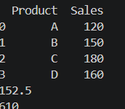
Pandas is commonly used for tabular data. A DataFrame represents data in rows and columns and supports filtering, grouping, aggregation, cleaning, and transformation.

5.2 Simple Data Cleaning Example
df = df.drop_duplicates()
df["Sales"] = pd.to_numeric(df["Sales"], errors="coerce")
df["Sales"] = df["Sales"].fillna(df["Sales"].median())
The example removes duplicate rows, converts the Sales column to numeric values, and fills missing Sales values with the median. In a real project, the chosen treatment should depend on the business context and the reason for missingness.

6. Data Visualization Fundamentals
Visualization helps analysts communicate patterns and comparisons quickly. The chart type should match the analytical question.
Chart | Suitable Use | Example
Bar chart | Compare categories | Sales by product
Line chart | Show trends over time | Monthly revenue
Histogram | Show numerical distribution | Customer age
Scatter plot | Explore relationship | Advertising spend vs sales
Box plot | Compare spread and potential outliers | Salary by department

6.1 Example Visualization Code
import matplotlib.pyplot as plt
products = ["A", "B", "C", "D"]
sales = [120, 150, 180, 160]
plt.bar(products, sales)
plt.xlabel("Product")
plt.ylabel("Sales")
plt.title("Sales by Product")
plt.show()

Output=
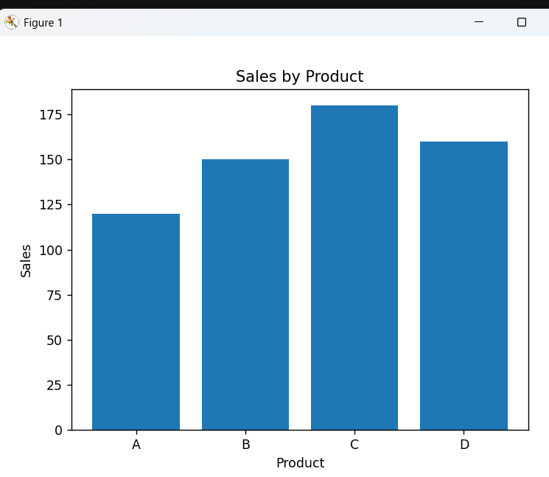

7. Industry Best Practices
- Use meaningful variable and column names.
- Keep code modular and avoid unnecessary repetition.
- Add comments where they improve understanding.
- Validate data before analysis.
- Keep raw data separate from cleaned or transformed data.
- Document assumptions, transformations, and analytical decisions.
- Use reproducible workflows and record important package/environment information.
- Choose visualizations that communicate the intended message clearly.
- Avoid misleading scales, unsupported conclusions, and unnecessary chart decoration.
- Protect confidential or personally identifiable information.
- Do not treat correlation as proof of causation.
- Communicate limitations and uncertainty honestly.

7.1 Reproducibility
A reproducible analysis allows another analyst to understand and, where possible, repeat the workflow. This can be supported by organized folders, documented steps, consistent code, fixed input data versions where appropriate, and clear descriptions of assumptions.

7.2 Responsible Data Analysis
Analysts should consider data privacy, fairness, data quality, sampling limitations, and the possibility of misleading interpretations. Conclusions should remain supported by the available evidence.

8. Practical Fundamentals Assignment
The following mini-assignment demonstrates the fundamentals requested in Task 1 using a small sample dataset.

8.1 Sample Dataset
Employee | Department | Experience | Monthly Sales
A | Sales | 1 | 25000
B | Sales | 2 | 32000
C | Marketing | 3 | 28000
D | Sales | 4 | 40000
E | Marketing | 5 | 45000

8.2 Questions and Answers
- What is the average Monthly Sales? Answer: (25000 + 32000 + 28000 + 40000 + 45000) / 5 = 34,000.
- What is the median Monthly Sales? Answer: After sorting, 25,000, 28,000, 32,000, 40,000, 45,000; therefore the median is 32,000.
- Which department appears in the sample? Answer: Sales and Marketing.
- What is the highest Monthly Sales? Answer: 45,000.
- What is one useful insight? Answer: In this small sample, employees with higher experience tend to have higher monthly sales, but this small dataset alone is not enough to establish causation.

8.3 Python Solution
import pandas as pd
df = pd.DataFrame({
"Employee": ["A", "B", "C", "D", "E"],
"Department": ["Sales", "Sales", "Marketing", "Sales", "Marketing"],
"Experience": [1, 2, 3, 4, 5],
"Monthly_Sales": [25000, 32000, 28000, 40000, 45000]
})
print("Average:", df["Monthly_Sales"].mean())
print("Median:", df["Monthly_Sales"].median())
print("Highest:", df["Monthly_Sales"].max())
print(df.groupby("Department")["Monthly_Sales"].mean())

Output=
Average: 34000.0
Median: 32000.0
Highest: 45000

Department

Marketing 36500.000000
Sales 32333.333333

9. Key Learnings
- Data Science combines programming, statistics, analytical thinking, and domain knowledge.
- Python provides a practical programming foundation for data analysis.
- Statistics helps summarize data and understand variation and relationships.
- Correctly identifying data types improves the quality of analysis.
- Data cleaning is essential before drawing conclusions.
- Visualization helps communicate patterns and findings.
- Industry best practices improve reliability, readability, reproducibility, and responsible use of analytical results.

