
mbX Pro -- internal technical reference
Step 9
mbx_ezviz_all_levels_all_treatments.sh
Auto-detect categorical columns, run mbX::ezviz() for every level x variable
Pipeline step 9 -- the first multi-variable cross-product step.

1. Purpose and scope
For every categorical metadata column (auto-detected), generate one stacked-bar visualization per taxonomic level (1-7) using mbX::ezviz(). The script handles QIIME2 #q2:types directives, skips ID-like columns, and sanitizes filesystem-unfriendly variable names.

2. Inputs and outputs

2.1 Inputs (data structures)
Name | Source | Format | Required
<mbX_pro_outputs_dir> | User CLI | Directory containing 7_taxonomy_csv/ | yes
--variables LIST | User flag | Override auto-detection with explicit list | no
--threshold F | User flag | ezviz aggregation threshold (default 0.5%) | no
--levels LIST | User flag | Subset (default all 7) | no

2.2 Outputs (data structures)
Path (relative to output dir) | What it contains | Read by
9_visualization_entire/<Variable>/ezviz_<level>_<Variable>.png | Stacked-bar PNG (one per variable x level) | report
9_visualization_entire/mbx_ezviz_info.txt | K=V manifest of variables x levels generated | report

2.3 Downstream consumers
These steps depend on this script's outputs:
- Step 18 (final report) embeds these PNGs as base64.

3. Complete parameter reference
Parameter | Default | Decision rule / where it comes from
--variables LIST | (auto) | Override the categorical-detection step. Useful when the user wants to plot only ONE variable.
--threshold F | 0.5 | Pass-through to ezviz threshold argument. Taxa with relative abundance below this percentage are aggregated into 'Others'. 0.5% is mbX's default.
--levels LIST | all 7 | Same as ezclean.

4. Algorithm walkthrough

4.1 Categorical column detection (R-based)
An R script reads the metadata file (handling tab/comma delimiters), skips the optional #q2:types directive row if present, then evaluates each column with the following rules:
- Skip the first column (sample-id).
- Skip the column if every value is numeric (suppressWarnings(as.numeric()) returns no NAs).
- Skip if every value is unique (free-text / IDs / dates).
- Skip if there is only one unique value (no variation).
- Require at least one group with >= 2 samples (single-sample groups give degenerate plots).
The R script prints surviving column names between MBX_CATS_BEGIN / MBX_CATS_END sentinels on stdout. Bash captures them and iterates.

4.2 Variable name sanitisation
Some legitimate categorical column names contain spaces or special characters that filesystems handle poorly (`Sample Type`, `Site/Region`). A sanitiser replaces spaces with underscores, strips parens/brackets/slashes, and collapses repeated underscores.

4.3 ezviz invocation
For every (variable, level) pair, write a temp R script that:
library(mbX); library(ggplot2)
setwd("9_visualization_entire/<sanitized_variable>")
p <- ezviz("<level-7.csv>", "<metadata.txt>", "<level_letter>",
"<original_variable>", threshold = 0.5)
ggsave("ezviz_<level_name>_<sanitized_variable>.png",
plot = p, width = 10, height = 7, dpi = 300)
ezviz returns a ggplot object rather than auto-saving. We must ggsave() with explicit dimensions to ensure publication-ready output. Idempotency: if the PNG already exists, the temp R script is not even generated.

5. Flow diagram
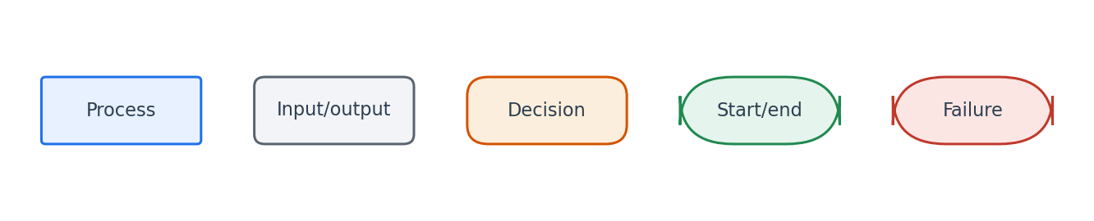
Flowchart symbol legend (used in every chapter).
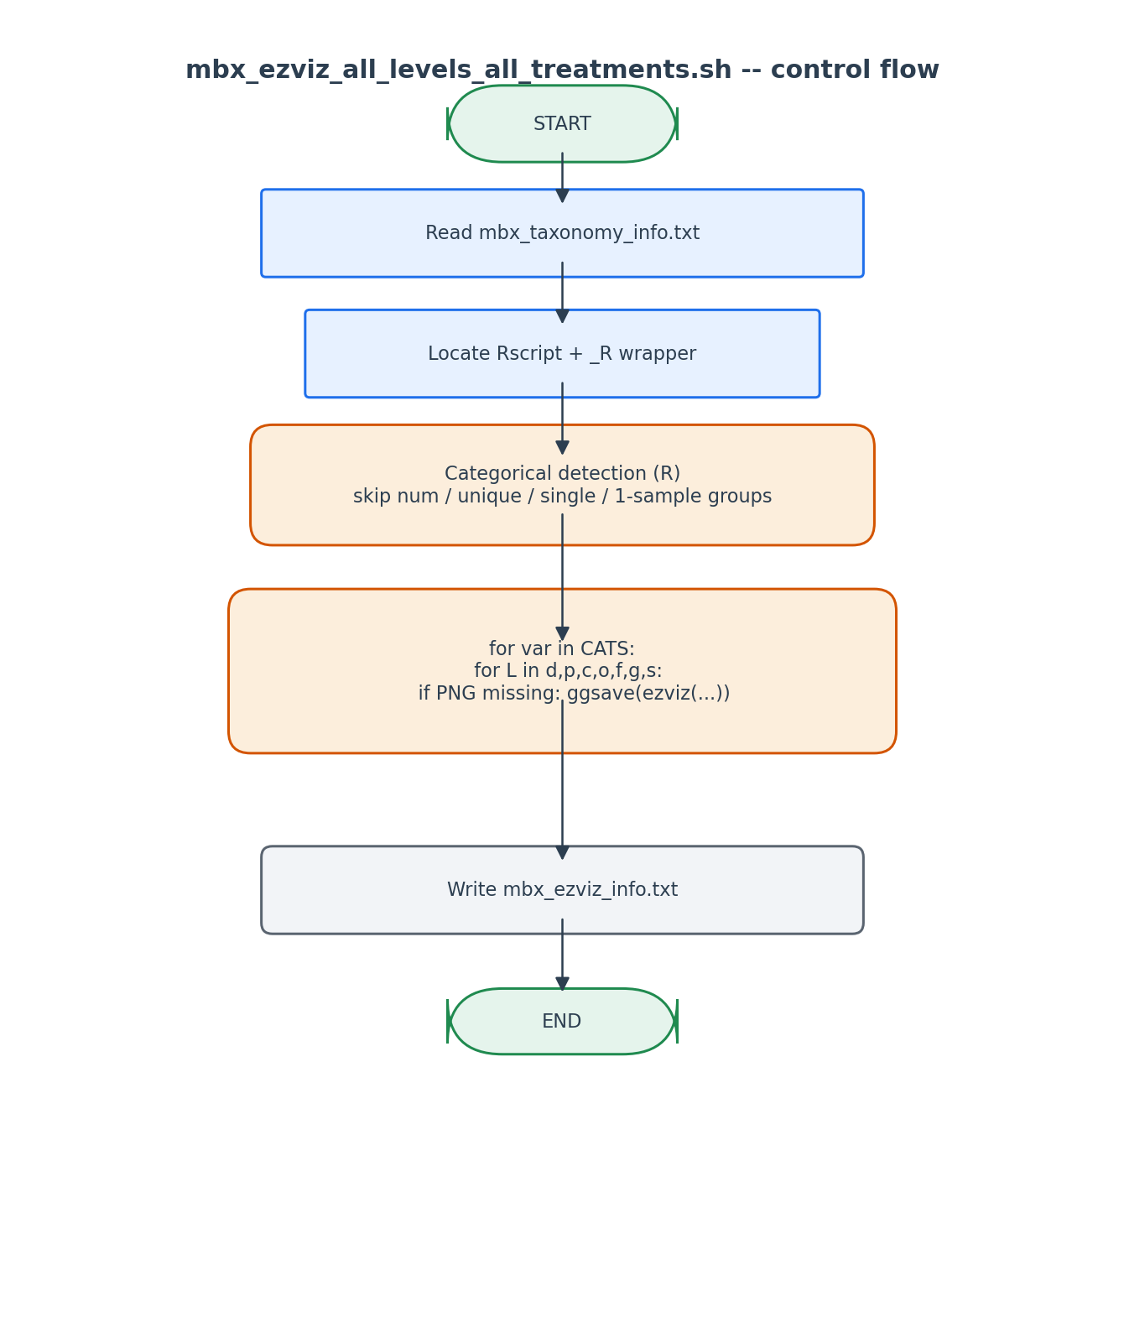
Categorical detection runs once; the level x variable cross-product runs ezviz once per cell.

6. Edge cases and caveats

All-numeric metadata column
Skipped automatically (numeric variables would yield gradient bar plots that are misleading). User can force inclusion via --variables but ezviz will still treat the values as factor levels.

Variable names with slashes
'Site/Region' would create a sub-sub-directory. The sanitizer replaces / with _ to produce 'Site_Region'.

7. Implementation notes

Why R returns ggplot, not a saved file
ezviz is designed for interactive use first; auto-saving in R packages is considered a side-effect. Our script makes the side-effect explicit via ggsave with controlled dimensions.

Sentinel-based stdout parsing
We do not parse R output by line number. Instead R prints `MBX_CATS_BEGIN` then column names then `MBX_CATS_END`. Bash uses awk between these markers. This is robust to extra messages from ggplot or library load.

8. Testing checklist
Things to verify before considering this script production-ready:
- Run with metadata containing 1 numeric + 2 categorical columns -> verify only the 2 categorical columns get plot dirs.
- Run with --variables 'sample-id' (intentionally broken) -> verify the script refuses or warns.
- Run twice -> verify second run skips all (PNGs already exist).

