
mbX Pro -- internal technical reference
Step 10
mbx_ezstat_all_levels_all_treatments.sh
Per-taxon statistical tests + box-plots, every level x every variable
Pipeline step 10 -- the descriptive-statistics step.

1. Purpose and scope
Run mbX::ezstat() once per (categorical variable x taxonomic level) combination. ezstat computes Kruskal-Wallis (omnibus), Dunn pairwise (BH-adjusted), and CLD (Compact Letter Display) summaries, and plots a box plot per significant taxon (p <= 0.05). Output is XLSX + PNG directories suitable for direct insertion into supplementary material.

2. Inputs and outputs

2.1 Inputs (data structures)
Name | Source | Format | Required
<mbX_pro_outputs_dir> | User CLI | Directory containing 7_taxonomy_csv/ | yes
--variables LIST / --levels LIST | User flags | Same as ezviz | no

2.2 Outputs (data structures)
Path (relative to output dir) | What it contains | Read by
10_stats/<Var>/ezstat_KW_<level>_by_<Var>.xlsx | Kruskal-Wallis omnibus per taxon | report
10_stats/<Var>/ezstat_pairwise_<level>_by_<Var>.xlsx | Dunn pairwise comparisons (BH-adjusted) | report
10_stats/<Var>/ezstat_CLD_Summary_<level>_by_<Var>.xlsx | Compact letter display per taxon | report
10_stats/<Var>/Boxplots_<Var>/ | PNG per significant taxon (one per p<=0.05 hit) | report
10_stats/mbx_ezstat_info.txt | K=V manifest | report

2.3 Downstream consumers
These steps depend on this script's outputs:
- Step 18 (final report) embeds the KW xlsx as a stats table and a sampling of significant boxplots.

3. Complete parameter reference
Parameter | Default | Decision rule / where it comes from
--variables / --levels | (auto / all) | Identical to ezviz.

4. Algorithm walkthrough

4.1 ezstat() vs ezviz()
ezstat is similar to ezviz in input shape but writes ALL files internally (no ggsave needed). Output files are deterministic-named, so the bash wrapper only needs to setwd() into the output directory and call ezstat().

4.2 The skip-check
The wrapper checks for `ezstat_KW_<level>_by_<var>.xlsx` (the FIRST file ezstat produces). If present, the entire (var, level) cell is skipped. This is conservative -- a partially-completed run that produced KW but not pairwise/CLD will be incorrectly skipped. Mitigation: delete the entire variable directory to force regeneration.

4.3 Statistics performed (inside ezstat)
- Kruskal-Wallis: non-parametric omnibus test for >= 3 groups; collapses to Mann-Whitney U for 2 groups.
- Dunn pairwise: post-hoc test for KW. p-values BH-adjusted.
- CLD (Compact Letter Display): groups receive shared letters when no pairwise contrast separates them at p<=0.05.
- Box plot per significant taxon: ggplot with per-group quartiles + outliers + sample-count overlay.

5. Flow diagram
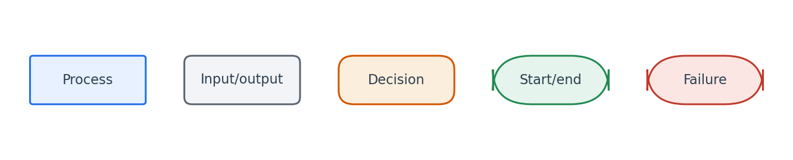
Flowchart symbol legend (used in every chapter).
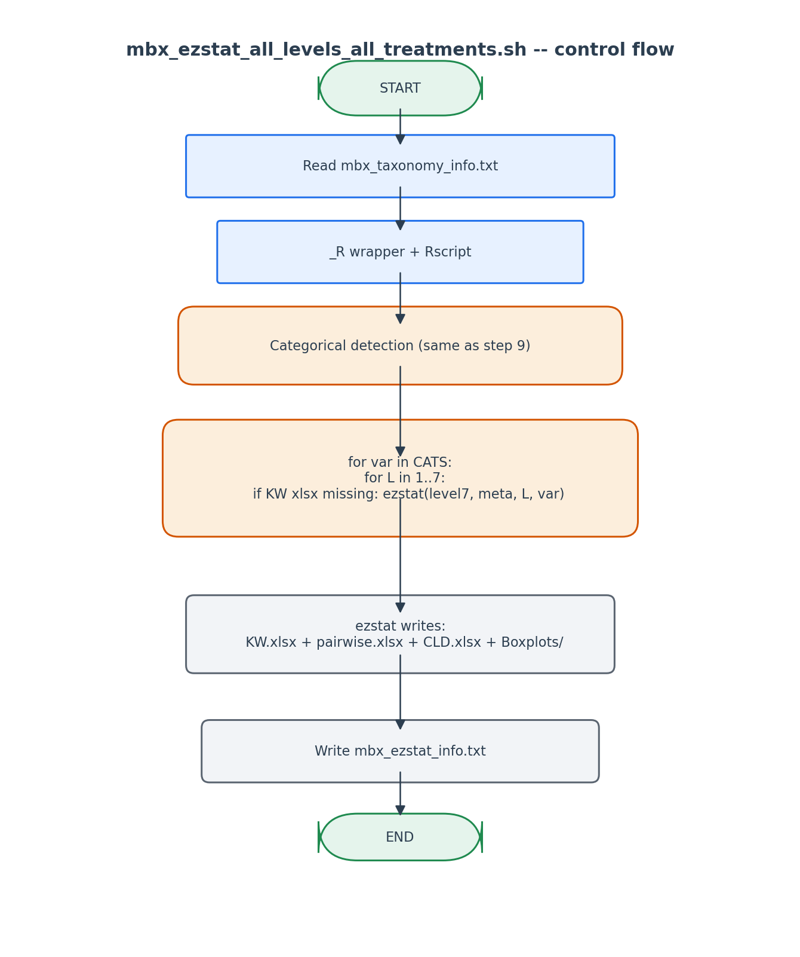
Per-cell control flow mirrors ezviz; ezstat handles all I/O internally.

6. Edge cases and caveats

Single-group variable
Already excluded by categorical detection. KW requires >= 2 groups.

Group with 1 sample
Categorical detection requires >= 2 samples per group. ezstat would otherwise produce NaN p-values.

Partial-completion skip false-positive
If KW exists but pairwise was never written, the cell is skipped. Workaround: rm the entire variable directory and re-run.

7. Implementation notes

Per-cell R session isolation
Same pattern as ezviz: each cell runs in its own _R invocation. A failure in one cell does not break the others.

ezstat handles file output internally
Unlike ezviz, ezstat is opinionated about its outputs. We do not need to capture and save anything from R's stdout -- just check existence after.

8. Testing checklist
Things to verify before considering this script production-ready:
- Run with 3 categorical variables x 7 levels -> verify 21 cell-directories exist.
- Confirm KW + pairwise + CLD + Boxplots/ all present in one selected cell.
- Confirm Boxplots/ directory contains one PNG per significant taxon (p<=0.05).
- Re-run -> verify all cells skipped.

