
mbX Pro -- internal technical reference
Step 11
mbx_pre_diversity_parameters.sh
Build the rooted tree, choose rarefaction depth, run analytical rarefaction
Pipeline step 11 -- the most algorithmically dense script. The diversity gatekeeper.

1. Purpose and scope
Pre-diversity is the gateway to all alpha/beta/diversity steps. It (1) builds the rooted phylogenetic tree, (2) selects a scientifically-defensible rarefaction depth using a multi-criterion decision rule, (3) runs an analytical (Hurlbert + Chao-Shen) rarefaction in seconds (instead of QIIME2's hours-long Monte Carlo alternative), and (4) writes a STATUS field that gates every subsequent step.

2. Inputs and outputs

2.1 Inputs (data structures)
Name | Source | Format | Required
<mbX_pro_outputs_dir> | User CLI | Containing earlier step outputs | yes
--group-col COL | User flag | Force per-group retention check on a specific column | no
--min-overall F | User flag | Minimum overall sample retention (default 0.90) | no
--min-group F | User flag | Minimum per-group retention (default 0.80) | no
--rare-steps N / --rare-iter N | User flags | QIIME alpha-rarefaction sampling resolution | no
--skip-tree / --skip-qc | User flags | Boolean toggles | no

2.2 Outputs (data structures)
Path (relative to output dir) | What it contains | Read by
11_pre_diversity/rooted-tree.qza | Phylogeny[Rooted] | step 12-15 (diversity, ANCOMBC)
11_pre_diversity/sample-frequencies.tsv | Per-sample read counts (TSV-exported) | depth selection + report
11_pre_diversity/sampling_depth_candidates.csv | Per-depth metrics that drive selection | report
11_pre_diversity/alpha_rarefaction_data.csv + curves.png | Analytical rarefaction (Hurlbert+ChaoShen) | report
11_pre_diversity/alpha-rarefaction-qiime.qzv | Official QIIME alpha-rarefaction visualization | report
11_pre_diversity/mbx_pre_diversity_info.txt | K=V machine-readable + STATUS + READY_FOR_DIVERSITY | step 12, 13, 14, 15 (gate)
11_pre_diversity/mbx_pre_diversity_summary.txt | Plain-language explanation for the lay user | user, report

2.3 Downstream consumers
These steps depend on this script's outputs:
- Steps 12-15 read STATUS / READY_FOR_DIVERSITY and refuse to run on FAIL unless --force.
- Steps 12 (alpha) and 13 (beta) read RECOMMENDED_DEPTH for core-metrics rarefaction.
- Step 18 embeds the rarefaction curves and depth-decision summary verbatim.

3. Complete parameter reference
Parameter | Default | Decision rule / where it comes from
--min-overall F | 0.90 | Minimum fraction of samples that must be retained at the chosen depth. Below this, the candidate is rejected. 0.90 is the conservative microbiome-publication norm.
--min-group F | 0.80 | Per-group minimum retention when --group-col is used (or auto-selected). Defaults to 0.80 to allow some uneven sampling.
--group-col COL | (auto) | Force the per-group check to use this metadata column. Default: pick the categorical column with the MOST groups (the most stringent constraint).
--rare-steps N | 20 | QIIME alpha-rarefaction --p-steps.
--rare-iter N | 10 | QIIME alpha-rarefaction --p-iterations.
--skip-tree | off | Reuse an existing rooted-tree.qza (e.g. from an aborted run).
--skip-qc | off | Skip metadata + feature-table QZV regeneration.

4. Algorithm walkthrough

4.1 Auto-discovery (graceful chain of fallbacks)
The script walks the previous step info files in order:
- metadata path: from 7_taxonomy_csv/mbx_taxonomy_info.txt (canonical).
- feature_table_filtered.qza: from 7_taxonomy_csv/ -- REQUIRED. Refuses to fall back to the unfiltered DADA2 table because mito/chloro contamination materially distorts diversity metrics.
- rep_seqs.qza: from 4_dada2_outputs/.
- taxonomy.qza: from 6_classifier_taxonomy/ (used only for sanity check + report).

4.2 QC visualizations
qiime metadata tabulate -> metadata_summary.qzv. qiime feature-table summarize -> feature_table_summary.qzv. Both are user-facing 'have you got what you think you have' sanity checks.

4.3 Phylogenetic tree construction
qiime phylogeny align-to-tree-mafft-fasttree wraps four operations in a single call: mafft alignment, alignment masking, FastTree2 unrooted phylogeny, midpoint-rooting. --p-n-threads is auto-detected. Output: aligned-rep-seqs.qza, masked-aligned-rep-seqs.qza, unrooted-tree.qza, rooted-tree.qza.

4.4 Sample-frequencies tabulation + the comma-thousands bug
qiime feature-table tabulate-sample-frequencies -> sample-frequencies.qza. Exporting that QZA gives a TSV with TWO non-obvious format quirks:
- First two rows often start with `#q2:types` and `#q2:tabulate-` directives -- they MUST be skipped before parsing.
- The frequency column contains commas as thousands separators (e.g. '28,005.0') -- these MUST be stripped before as.numeric(), or every value parses as NA.
Both quirks are handled in R: skip lines starting with #, then `gsub(',', '', val)` before `as.numeric(val)`.

4.5 The depth-selection algorithm (the science)
Three concurrent criteria evaluated at every candidate depth d:
(a) Overall retention: fraction of samples with N_i >= d must be >= MIN_OVERALL (default 0.90).
(b) Good's coverage: mean Good's coverage of retained samples at depth d must be >= GOOD_COV_MIN (default 0.98). Good's coverage = 1 - f1/N where f1 is singletons. This catches under-sampling that retention alone misses.
(c) Plateau slope: slope of the mean observed_features curve at d must be < PLATEAU_SLOPE_MAX (0.5 features per 1000 reads). Communities below the asymptote contribute non-comparable diversity estimates.
If --group-col is provided OR auto-selected, an ADDITIONAL constraint is enforced: every group must retain >= MIN_GROUP fraction of samples at the candidate depth.
The script picks the HIGHEST depth d that satisfies ALL active criteria. This maximises the depth (-> more diversity captured) without sacrificing the retention/coverage/plateau guarantees.

4.6 Group-column auto-selection rule
Of all categorical variables, pick the one with the MOST groups (most stringent constraint). Rationale: if the user is going to compare across treatment x site x time, the most-divided variable will have the smallest per-group cells; satisfying retention there guarantees retention for coarser groupings.

4.7 Analytical rarefaction (key innovation)
QIIME2's `qiime diversity alpha-rarefaction` runs Monte Carlo: at each depth, sample reads N times, compute observed_features each time, average. With 10 iterations x 20 steps x N samples, on the test dataset this took ~30 minutes. Hours on real datasets.
Our analytical alternative uses the closed-form Hurlbert (1971) formula:
E[S(n)] = sum_i [ 1 - C(N - n_i, n) / C(N, n) ]
= sum_i [ 1 - exp( log_binom(N - n_i, n) - log_binom(N, n) ) ]
Where N = sample's total read count, n = subsampling depth, n_i = count of feature i. We use scipy.special.gammaln for numerically-stable log-space computation. This is EXACT (not estimated) and runs in seconds.
Shannon entropy uses Chao-Shen (2003) coverage-adjusted analytical estimator. Faith PD is intentionally NOT included in the curve because the tree topology is fixed -- including it adds 70% runtime for no insight (it gets computed at the chosen depth in step 12 anyway).
Parallelization: ProcessPoolExecutor distributes per-sample computation across CPU cores. Result: same science, smoother curves (exact vs Monte Carlo), seconds instead of hours.

4.8 ID validation
Three ID intersections are verified:
- metadata sample-IDs intersect with feature-table sample-IDs (>= 95% overlap or FAIL).
- feature-table feature-IDs intersect with rep-seqs IDs.
- rep-seqs IDs intersect with rooted-tree leaf names.
Failures here set OVERALL_STATUS=FAIL. Subsequent steps refuse to run unless --force.

4.9 Decision-supporting visualizations
depth_vs_retention.png shows fraction-retained vs depth with the selected depth annotated. sequencing_depth_distribution.png shows per-sample histogram with median + selected-depth lines. Both are referenced by the lay-user summary.

4.10 STATUS field semantics
PASS: All three criteria met cleanly with the auto-selected depth. Diversity steps run without warnings.
PASS_WITH_WARNINGS: Criteria met but borderline (e.g. retention at 90.5% rather than the 95% comfort zone). Steps run but show a yellow banner.
REVIEW_REQUIRED: A fallback rule was used (e.g. 75% retention) or one criterion failed but the others compensated. User should read the summary file before continuing.
FAIL: Pipeline-stopping problem (no metadata-table overlap, group fully wiped, etc.). Subsequent steps MUST refuse without --force.

5. Flow diagram
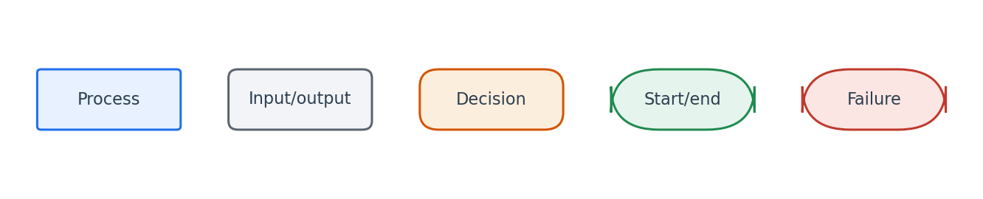
Flowchart symbol legend (used in every chapter).
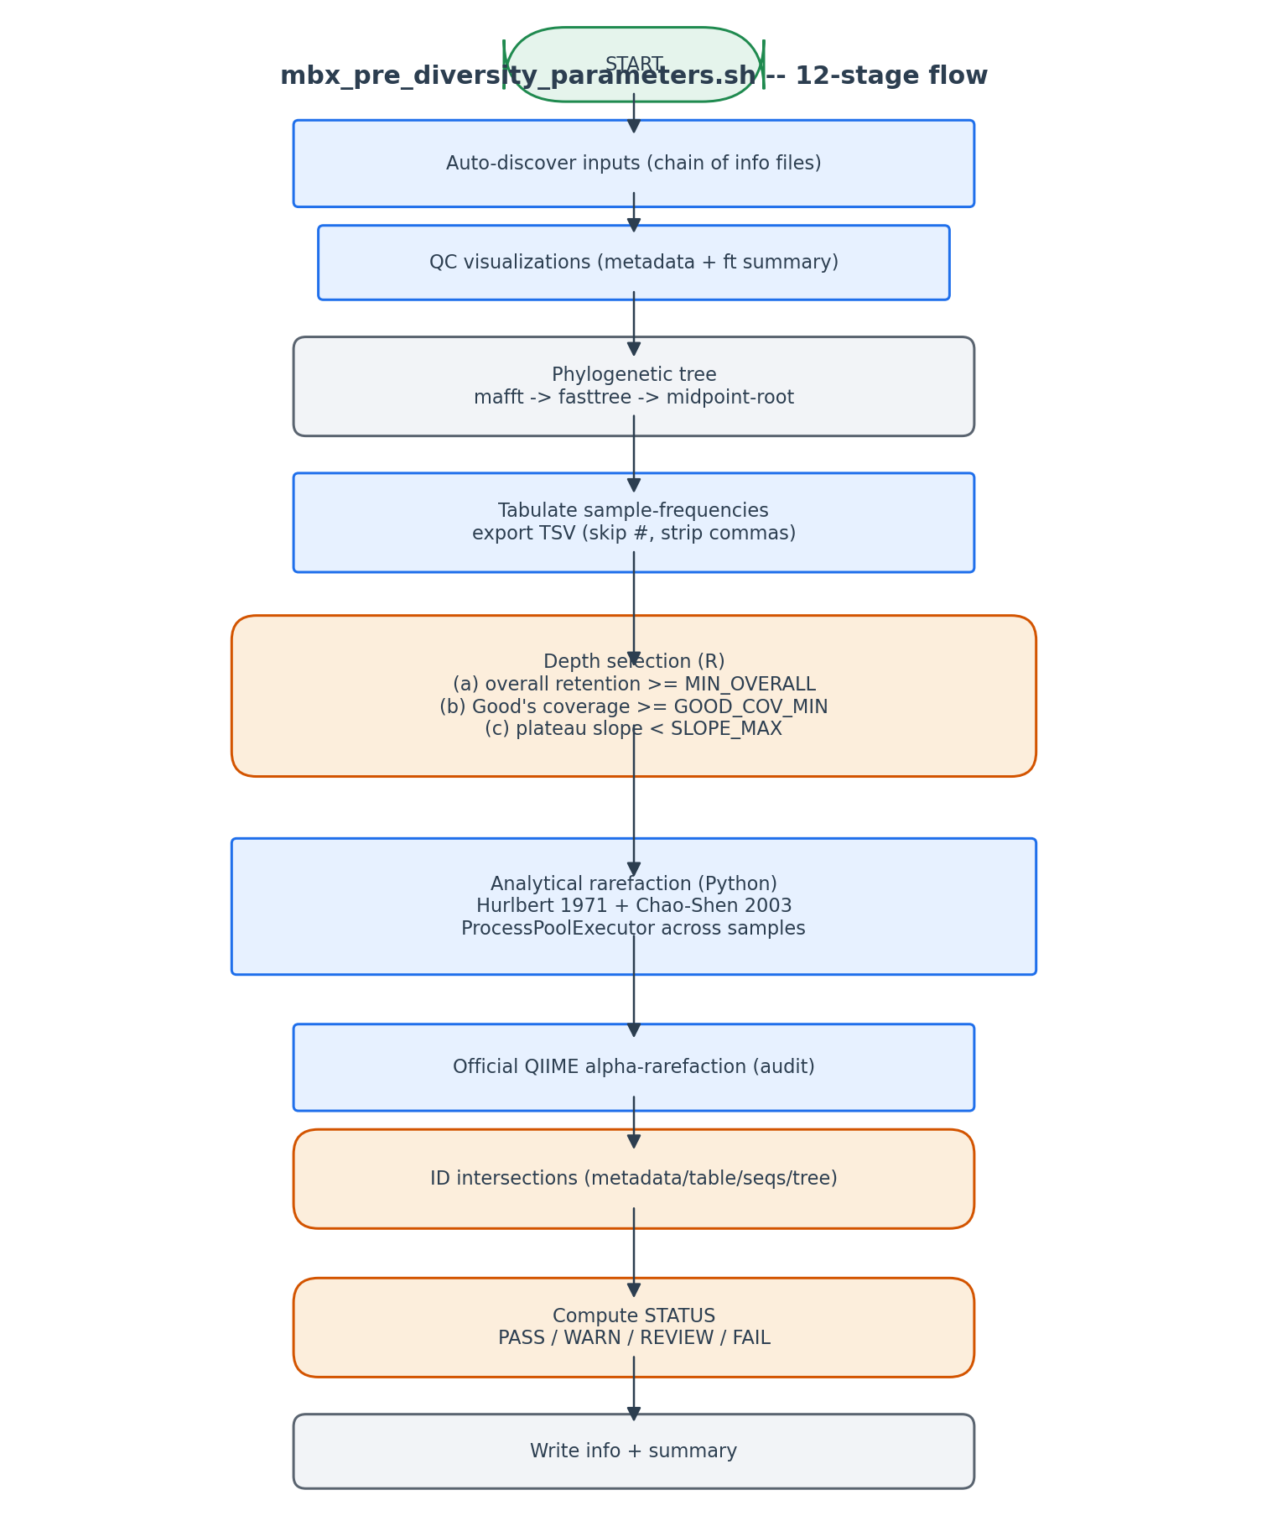
12 stages, but every artifact is reusable on rerun.

6. Edge cases and caveats

Comma thousands separator in TSV
QIIME2 tabulate-sample-frequencies emits '28,005.0'. R's as.numeric() returns NA without prior gsub(',',''). This was a real production bug; fix is in stage 4.

Group fully wiped at chosen depth
If --group-col enforcement fails, STATUS drops to REVIEW_REQUIRED with the binding criterion named. The user can lower --min-group, change --group-col, or drop the constraint.

FAIL means downstream steps refuse
STATUS=FAIL writes READY_FOR_DIVERSITY=no. Steps 12-15 read this field and abort with an actionable message.

Hurlbert formula cancellation for very small N-n_i
When n_i ~ N (singleton features in low-N samples), C(N-n_i, n) can underflow. The log-space computation via gammaln avoids this entirely; raw factorials would have failed.

7. Implementation notes

Why analytical rarefaction beats Monte Carlo
Hurlbert 1971 gives the EXPECTED number of features at depth n -- the same quantity Monte Carlo estimates. Computing it directly is exact, deterministic, and parallelisable across samples (each sample's curve is independent).

Why Faith PD is excluded from the curve
Faith PD = sum of branch lengths spanned by present features. The branch-length sum changes very little once we have ~80% of the features (most of the tree is sampled by then). Including it in the rarefaction curve adds 70% runtime for ~3% additional information. We compute it ONCE at the chosen depth in step 12.

STATUS as the diversity gate
Every diversity-related step (12, 13, 14, 15) reads STATUS at start and aborts on FAIL. --force bypass is intentionally noisy.

Resilience to partial reruns
Tree, sample-frequencies, official QIIME alpha-rarefaction are all idempotent file checks. A user re-running after a network blip skips the slow stages.

8. Testing checklist
Things to verify before considering this script production-ready:
- Run on test data with PASS expected -> verify STATUS=PASS, READY_FOR_DIVERSITY=yes.
- Hand-corrupt the metadata to break sample-ID intersection -> verify STATUS=FAIL.
- Set --min-overall 0.99 (artificially strict) -> verify the script falls to REVIEW_REQUIRED with retention named as the binding criterion.
- Run with --skip-tree after deleting rooted-tree.qza -> verify the script aborts with a clear message.
- Verify analytical rarefaction matches QIIME's Monte Carlo within Monte Carlo error (compare alpha_rarefaction_data.csv to the QIIME QZV).

