
mbX Pro -- internal technical reference
Step 12
mbx_alpha_diversity_run.sh
Compute 5 alpha-diversity metrics + per-variable Kruskal-Wallis stats + boxplots
Pipeline step 12 -- the first proper diversity step.

1. Purpose and scope
Rarefy the filtered feature table at the depth chosen by step 11, compute five canonical alpha-diversity metrics (ASVs/Features, Shannon, Simpson, Faith PD, Pielou Evenness), join them with the metadata into a single tidy alpha_diversity.xlsx, and run Kruskal-Wallis + Dunn pairwise + CLD per categorical variable (plus boxplots) for every metric.

2. Inputs and outputs

2.1 Inputs (data structures)
Name | Source | Format | Required
<mbX_pro_outputs_dir> | User CLI | Containing 11_pre_diversity/ | yes
--metrics LIST | User flag | Subset of metrics (default all 5) | no
--depth N | User flag | Override RECOMMENDED_DEPTH from step 11 | no
--force | User flag | Bypass STATUS=FAIL gate | no

2.2 Outputs (data structures)
Path (relative to output dir) | What it contains | Read by
12_alpha_diversity_results/all_alpha_outputs/<metric>_vector.qza | Raw QIIME2 alpha-vector artifacts (5 of them) | audit/report
12_alpha_diversity_results/all_alpha_outputs/exported/<metric>/alpha-diversity.tsv | TSV exports for joining | report
12_alpha_diversity_results/alpha_diversity.xlsx | Tidy table: sample-id + 5 metrics + every metadata column | report
12_alpha_diversity_results/stats_for_alpha_diversity/<Var>/{KW,Pairwise,CLD}_<metric>_by_<Var>.xlsx | Per-variable per-metric stats | report
12_alpha_diversity_results/boxplots_for_alpha_diversity/<Var>/boxplot_<metric>_by_<Var>.png + panel | Per-variable boxplots, one per metric + a 5-panel summary | report
12_alpha_diversity_results/mbx_alpha_diversity_info.txt | K=V manifest | step 13 (beta), 18 (report)

2.3 Downstream consumers
These steps depend on this script's outputs:
- Step 13 (beta) chains from this info file for metadata path + STATUS check.
- Step 18 embeds alpha_diversity.xlsx + a sample of the boxplots.

3. Complete parameter reference
Parameter | Default | Decision rule / where it comes from
--metrics LIST | ASVs,Shannon,Simpson,Faith,Pielou | Comma-separated metric names. Subsetting saves time on Faith PD which requires the tree.
--depth N | (read from step 11) | Override RECOMMENDED_DEPTH. Required for sensitivity analyses.
--force | off | Bypass STATUS=FAIL gate from step 11. Use only when you understand WHY the gate fired.

4. Algorithm walkthrough

4.1 Step-11 gate
Read OVERALL_STATUS and READY_FOR_DIVERSITY from `11_pre_diversity/mbx_pre_diversity_info.txt`. If STATUS=FAIL or READY_FOR_DIVERSITY=no, abort with the relevant message UNLESS --force is provided. PASS_WITH_WARNINGS is allowed (the user has been warned).

4.2 Rarefaction
qiime feature-table rarefy on the filtered table at RECOMMENDED_DEPTH. Output: `rarefied_table.qza`. Idempotent (skip if exists).

4.3 Per-metric computation
Five QIIME2 calls run in sequence:
ASVs / Features: qiime diversity alpha --p-metric observed_features
Shannon: qiime diversity alpha --p-metric shannon
Simpson (1 - Simpson): qiime diversity alpha --p-metric simpson
Pielou's Evenness: qiime diversity alpha --p-metric pielou_e
Faith Phylogenetic D: qiime diversity alpha-phylogenetic --p-metric faith_pd (requires tree)
Each output is a SampleData[AlphaDiversity] artifact. We then `qiime tools export` each to TSV (sample-id\tvalue). Idempotent: each metric's QZA AND its TSV existence is checked separately.

4.4 Tidy joining (R)
An R helper reads the metadata file (handles delimiter detection + #q2:types skip), reads each of the 5 TSVs, joins them by sample-id, and emits alpha_diversity.xlsx with a uniform column ordering: sample-id, ASVs_or_Features, Shannon_Index, Simpson_Diversity, Faith_Phylogenetic_Diversity, Pielou_Evenness, then every metadata column.

4.5 Per-variable statistics
For every categorical variable (auto-detected with the same R logic as step 9/10), we run, for each metric:
- Kruskal-Wallis (omnibus across groups). Holm correction across metrics so the user does not have to worry about the multiple-metrics inflation.
- Dunn pairwise (BH-adjusted within each variable).
- CLD computation: groups receive shared letters when no contrast separates them at q<=0.05.
Output: KW_<metric>_by_<Var>.xlsx, Pairwise_<metric>_by_<Var>.xlsx, CLD_Summary_<metric>_by_<Var>.xlsx, plus a Summary_KW_all_metrics_by_<Var>.xlsx that stacks all 5 KW results into one sheet.

4.6 Boxplots
ggplot per (variable, metric) -> PNG. Plus a 5-panel patchwork combining all metrics for a single variable, useful for slides.

5. Flow diagram
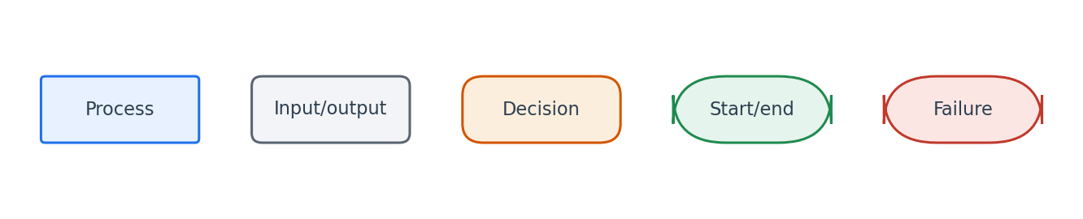
Flowchart symbol legend (used in every chapter).
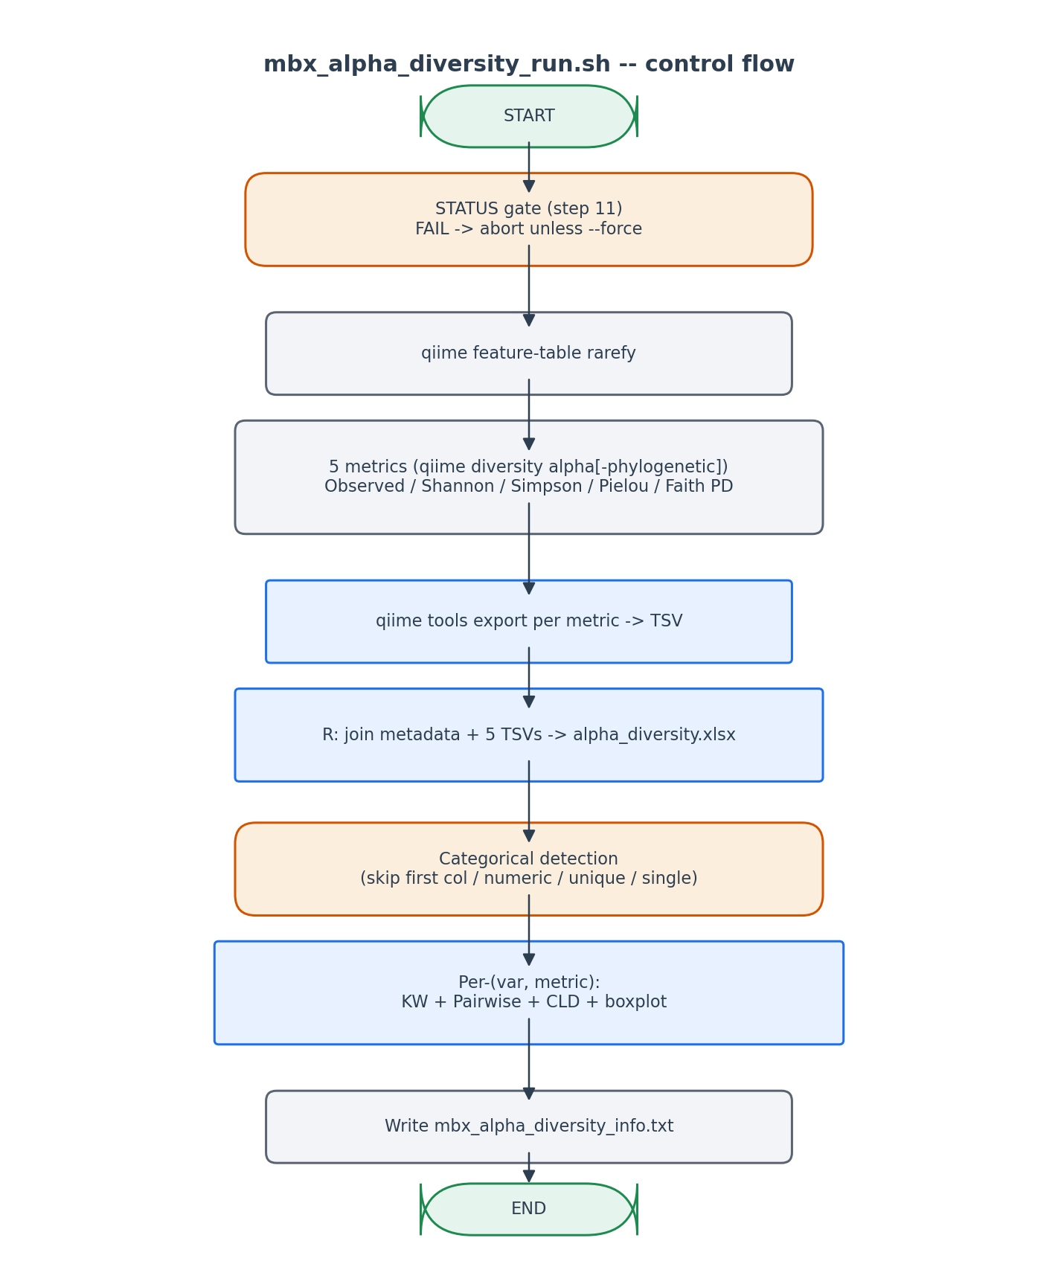
5 metrics x N variables x stats + plots, all driven by step 11's depth.

6. Edge cases and caveats

Faith PD requires the tree
If rooted-tree.qza is missing or has fewer leaves than the rarefied table, Faith PD fails. The script reports the metric as failed but continues with the other 4.

Missing samples after rarefaction
qiime feature-table rarefy drops samples below depth. The TSV exports therefore have FEWER samples than metadata. The R join uses left-join on metadata so dropped samples appear with NA metric values -- visually obvious in the XLSX.

Single-group variable
Already excluded by categorical detection.

7. Implementation notes

Why Holm correction across metrics
5 metrics x N variables = many KW tests. Holm is conservative but uniformly more powerful than Bonferroni and safe to use without distributional assumptions. Holm is applied PER variable across the 5 metrics, not across all variables.

Why a 5-panel patchwork
Reviewers commonly ask 'show me everything for this variable on one figure'. The patchwork combines all 5 boxplots with a shared variable label.

8. Testing checklist
Things to verify before considering this script production-ready:
- Run with PASS status -> verify all 5 metrics + alpha_diversity.xlsx produced.
- Run with --metrics ASVs,Shannon -> verify only those 2 metrics computed.
- Run with --depth 2000 -> verify rarefaction at 2000 reads (ignoring step 11's recommendation).
- Hand-edit STATUS=FAIL in step 11 info file -> verify abort.
- Re-run -> verify rarefied_table.qza skip and per-metric skip both fire.

