
mbX Pro -- internal technical reference
Step 13
mbx_beta_diversity_run.sh
Beta diversity, PCoA, PERMANOVA, PERMDISP, Adonis, distance heatmaps, UPGMA
Pipeline step 13 -- the most reviewer-targeted output stage.

1. Purpose and scope
Compute four canonical beta-diversity distance matrices (Bray-Curtis, Jaccard, Weighted UniFrac, Unweighted UniFrac), then for every categorical variable produce: PCoA plots (per metric + 4-panel summary), PERMANOVA + PERMDISP + pairwise PERMANOVA tables, distance-to-centroid boxplots, plus a global Adonis table, distance heatmaps, and UPGMA dendrograms across all samples.

2. Inputs and outputs

2.1 Inputs (data structures)
Name | Source | Format | Required
<mbX_pro_outputs_dir> | User CLI | Containing 12_alpha_diversity_results/ | yes
--metrics LIST | User flag | Subset of 4 distance metrics | no
--permutations N | User flag | PERMANOVA/PERMDISP permutation count (default 999) | no

2.2 Outputs (data structures)
Path (relative to output dir) | What it contains | Read by
13_beta_diversity_results/results_by_categorical_variables/<Var>/PCoA_*.png | Per-variable PCoA per metric + 4-panel | report
13_beta_diversity_results/results_by_categorical_variables/<Var>/PERMANOVA_results_<Var>.xlsx | 1 sheet, 4 rows (one per metric) | report
13_beta_diversity_results/results_by_categorical_variables/<Var>/Pairwise_PERMANOVA_<Var>.xlsx | Only when k>2 groups | report
13_beta_diversity_results/results_by_categorical_variables/<Var>/PERMDISP_results_<Var>.xlsx | Per-metric dispersion test | report
13_beta_diversity_results/results_by_categorical_variables/<Var>/Boxplot_DistanceToCentroid_*.png | Visualizes PERMDISP | report
13_beta_diversity_results/all_samples_beta_diversity/Adonis_multivariable_PERMANOVA.xlsx | Type III + univariate Adonis with all metadata columns | report
13_beta_diversity_results/all_samples_beta_diversity/Distance_heatmap_<Metric>.png | Clustered heatmap, all samples | report
13_beta_diversity_results/all_samples_beta_diversity/UPGMA_dendrogram_<Metric>.png | All-sample dendrogram | report
13_beta_diversity_results/working_dir_beta_diversity/ | Distance matrices + PCoA QZAs + exports | audit
13_beta_diversity_results/mbx_beta_diversity_info.txt | K=V manifest | step 14 (ANCOMBC), 18 (report)

2.3 Downstream consumers
These steps depend on this script's outputs:
- Step 14 chains via this file. Step 18 embeds many of the figures and tables.

3. Complete parameter reference
Parameter | Default | Decision rule / where it comes from
--metrics LIST | BC,Jaccard,WUF,UUF | Comma-separated metric tokens. WUF = Weighted UniFrac, UUF = Unweighted UniFrac. Subsetting halves runtime when the user only wants Bray-Curtis.
--permutations N | 999 | PERMANOVA / PERMDISP permutation count. 999 is QIIME2 default; 9999 for publication-grade p-values.

4. Algorithm walkthrough

4.1 The dual-R conda-env interaction (CRITICAL)
This script needs TWO different R installations to coexist:
System R: /opt/homebrew/bin/Rscript or /usr/local/bin/Rscript -- has openxlsx, ggplot2, vegan, pheatmap installed by step 8. Compiled extensions are .so on Apple Silicon.
Conda R: $CONDA_PREFIX/lib/R -- used by QIIME2's q2-composition via rpy2. Compiled extensions are .dylib.
Two wrappers solve the cross-env pollution:
_R() { env -u R_LIBS_USER -u R_HOME ... "$RSCRIPT" "$@"; }
_QIIME() { R_HOME="$CONDA_R_HOME" qiime "$@"; }
_R is used for our R scripts (vegan, plotting). _QIIME ensures qiime's embedded rpy2 finds the matching .dylib R extensions. Without this dual-wrapper, q2-composition fails with 'methods.dylib not found'.

4.2 Distance matrices
qiime diversity beta on the rarefied feature table -> Bray-Curtis and Jaccard. qiime diversity beta-phylogenetic with the rooted tree -> Weighted/Unweighted UniFrac. Each output is a DistanceMatrix QZA.

4.3 PCoA + Emperor
qiime diversity pcoa per matrix; qiime emperor plot per matrix. The Emperor QZV is kept as supplementary; we ALSO export the PCoA coordinates for our own ggplot rendering (so the report has a uniform ggplot-styled figure rather than a raw Emperor screenshot).

4.4 Per-variable hypothesis tests
For each categorical variable:
- qiime diversity beta-group-significance (PERMANOVA, default 999 permutations).
- If groups > 2: qiime diversity beta-group-significance --p-pairwise -> Pairwise_PERMANOVA xlsx (BH adjusted).
- qiime diversity beta-group-significance --p-method permdisp.
- ggplot distance-to-centroid boxplot from PERMDISP-exported distances.
- ggplot PCoA: 4 plots (one per metric) + a 4-panel patchwork.
All four distance metrics are tested, and the script records which metric gave the strongest signal (lowest q-value) per variable -- helpful for the report's 'biological summary'.

4.5 Global Adonis (multivariable PERMANOVA)
vegan::adonis2 in R, called with formula `distance ~ var1 + var2 + ...` for ALL detected categorical variables. Type III sequential SS gives variable-controlling-for-others. Univariate Adonis is also run per variable. Results combined into one XLSX with 4 sheets (one per metric).
This single output answers the most common reviewer question: 'when you control for covariate X, does Y still drive the microbiome?'

4.6 Distance heatmaps + UPGMA
pheatmap on the symmetric distance matrix with hierarchical clustering on both axes. Samples are auto-coloured by the most-divisive categorical variable (annotation_col). UPGMA dendrogram via hclust(method='average') -- complementary view of the same data.

5. Flow diagram
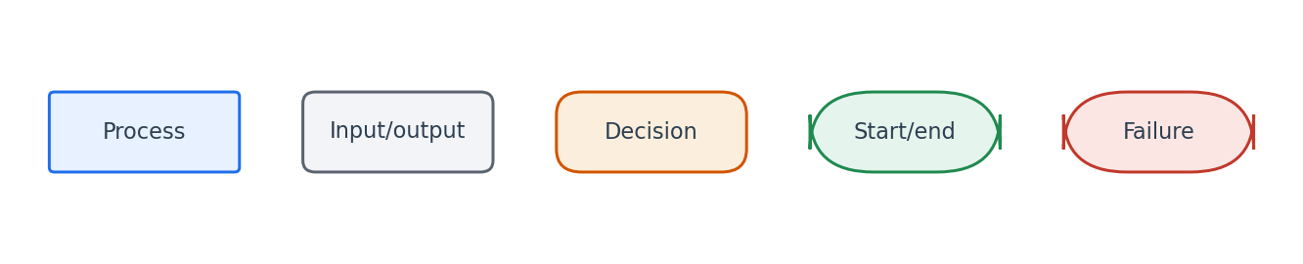
Flowchart symbol legend (used in every chapter).
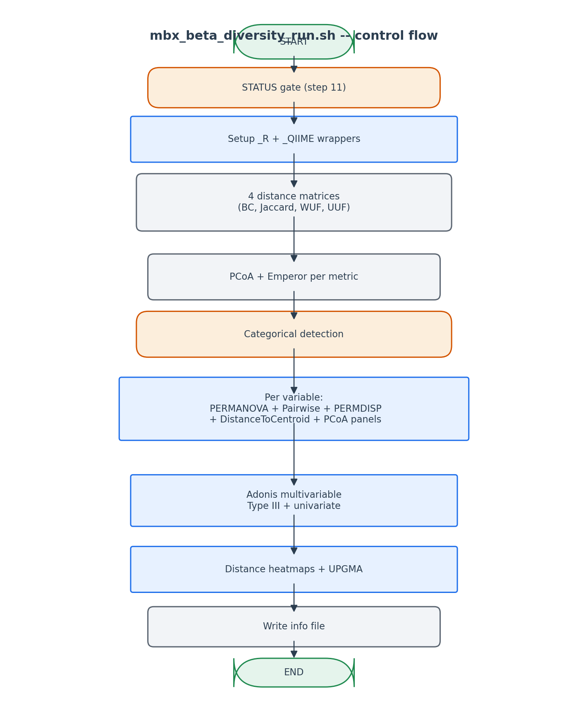
Distance matrices feed every test; per-variable + global tests run in parallel.

6. Edge cases and caveats

Two-group variable
Pairwise PERMANOVA is skipped (no pairs to compare beyond the omnibus). The PERMANOVA result IS the only contrast.

PERMDISP fails when one group has < 3 samples
vegan::betadisper requires >= 3 samples per group. Captured and reported as 'PERMDISP not computed for this variable -- one or more groups too small'.

Adonis with collinear variables
Adonis handles this internally (degenerate terms get NA). The XLSX flags those rows.

7. Implementation notes

Per-metric output mirroring
Every per-variable directory has parallel files for all 4 metrics. This pattern simplifies the report builder -- it can iterate metrics blindly.

Why not just rely on Emperor
Emperor's plots are interactive but cannot be embedded in a static report. We re-render via ggplot to get colored, captioned, dimension-labelled (% variance) PCoA plots.

8. Testing checklist
Things to verify before considering this script production-ready:
- Verify 4 distance matrices produced.
- Verify per-variable PERMANOVA xlsx has 4 rows when all 4 metrics requested.
- Verify Pairwise_PERMANOVA absent when variable has only 2 groups, present when >= 3.
- Verify Adonis xlsx has 4 sheets named after the metrics.
- Verify all_samples_beta_diversity/ contains exactly 4 heatmap PNGs and 4 dendrogram PNGs.

