
mbX Pro -- internal technical reference
Step 14
mbx_ancombc2_run.sh
ANCOMBC2 differential abundance at multiple taxonomic levels
Pipeline step 14 -- the rigorous compositional-aware DA step.

1. Purpose and scope
Differential abundance via ANCOMBC2 (Lin & Peddada 2024). The script tests every categorical variable at every requested taxonomic level (phylum -> species), running with pairwise=TRUE AND global=TRUE so users get reference-free omnibus results PLUS all pairwise contrasts with mdFDR correction. Crucially, it does NOT modify the user's QIIME2 conda env.

2. Inputs and outputs

2.1 Inputs (data structures)
Name | Source | Format | Required
<mbX_pro_outputs_dir> | User CLI | Containing 13_beta_diversity_results/ | yes
--levels LIST | User flag | Default: phylum,class,order,family,genus,species (skip domain) | no
--variables LIST | User flag | Override auto-detection | no
--alpha F | User flag | Significance level (default 0.05) | no
--prv-cut F | User flag | Prevalence cutoff (default 0.10) | no
--lib-cut N | User flag | Library-size cutoff (default 1000) | no

2.2 Outputs (data structures)
Path (relative to output dir) | What it contains | Read by
14_differential_abundance_ANCOMBC2/ANCOMBC2_<level>/ancombc2_<Var>/ancombc2_primary_<Var>.xlsx | Per-taxon LFC + se + W + p + q for each category contrast | report
14_differential_abundance_ANCOMBC2/ANCOMBC2_<level>/ancombc2_<Var>/ancombc2_pairwise_<Var>.xlsx | Pairwise contrasts with mdFDR | report
14_differential_abundance_ANCOMBC2/ANCOMBC2_<level>/ancombc2_<Var>/ancombc2_global_<Var>.xlsx | Reference-free global test | report
14_differential_abundance_ANCOMBC2/ANCOMBC2_<level>/ancombc2_<Var>/ancombc2_structural_zeros_<Var>.xlsx | Taxa structurally zero in some groups | report
14_differential_abundance_ANCOMBC2/ANCOMBC2_<level>/ancombc2_<Var>/{volcano,heatmap}*.png | Volcano + significant-taxa heatmap | report
14_differential_abundance_ANCOMBC2/Summary_all_levels_all_variables.xlsx | Cross-level summary (count of significant taxa) | report
14_differential_abundance_ANCOMBC2/working_dir_differential_abundance/ | Collapsed tables, RDS objects, run logs | audit

2.3 Downstream consumers
These steps depend on this script's outputs:
- Step 15 (PICRUSt) optionally reads ANCOMBC2 genus-level outputs to compute genus x pathway correlations.
- Step 16 (ML) reads to highlight DA taxa with high feature importance.
- Step 18 embeds the per-variable summaries.

3. Complete parameter reference
Parameter | Default | Decision rule / where it comes from
--alpha F | 0.05 | Significance threshold for the q-value column. Lower = stricter.
--prv-cut F | 0.10 | Prevalence cutoff. Taxa present in <10% of samples are filtered before testing. ANCOMBC2 default.
--lib-cut N | 1000 | Library-size cutoff. Samples with <1000 reads are excluded from the test (standard for ANCOMBC2).
--levels LIST | p,c,o,f,g,s | Domain (d) is excluded by default because it has too few groups for meaningful DA.

4. Algorithm walkthrough

4.1 The smart-Rscript locator (cost-weighted)
ANCOMBC2 needs ANCOMBC + microbiome + phyloseq -- all heavy Bioconductor packages. Compiling them on Apple Silicon takes 10-20 minutes apiece. The script picks the BEST Rscript based on installation cost rather than mere presence:
Cost rule: Missing CRAN package = 1 point. Missing Bioconductor package = 100 points.
Tie-breaker: Earlier in the candidate list wins. Conda's R is listed FIRST because the qiime2-amplicon-2025.4 env ships ANCOMBC pre-installed.
Short-circuit: A candidate with 0 missing wins immediately.
This avoids the worst case of compiling 5 Bioc packages from source on system R when conda's R already has them. Saves 30-90 minutes on first run.

4.2 Reference-level convention
For every categorical variable, the reference level is set to the alphabetically-first level (R's default for factor()). Running with pairwise=TRUE and global=TRUE means the reference choice only affects how coefficients are LABELLED -- the global test is reference-free, and every pairwise contrast is computed regardless of which level was the reference.
Documented prominently because reviewers often ask 'why is treatment X the reference?' and the answer is 'it does not matter -- you have all contrasts plus the global test'.

4.3 Table collapse
qiime taxa collapse --p-level <N> on the filtered feature table for each requested level. Output: feature_table_collapsed_L<N>.qza. ANCOMBC2 needs RAW counts per taxonomic level.

4.4 Phyloseq construction
An R helper builds a phyloseq object from each collapsed table + taxonomy + metadata. ANCOMBC2 takes phyloseq directly.

4.5 ANCOMBC2 invocation
ANCOMBC2 args used:
formula: ~ <variable> (one variable at a time).
p_adj_method: holm (per-variable Holm correction).
prv_cut: 0.10 by default.
lib_cut: 1000 by default.
group: <variable>.
struc_zero: TRUE -- detect structural zeros.
neg_lb: TRUE.
global: TRUE -- omnibus test.
pairwise: TRUE -- all pairwise contrasts.
alpha: 0.05.

4.6 Output rendering
Five XLSX files per (variable, level): primary (model output table), pairwise, global, structural_zeros, summary. Two PNGs: volcano (LFC vs -log10(q)), heatmap (DA taxa across groups). The full ANCOMBC2 result object is also pickled to RDS in the working dir for audit.

5. Flow diagram
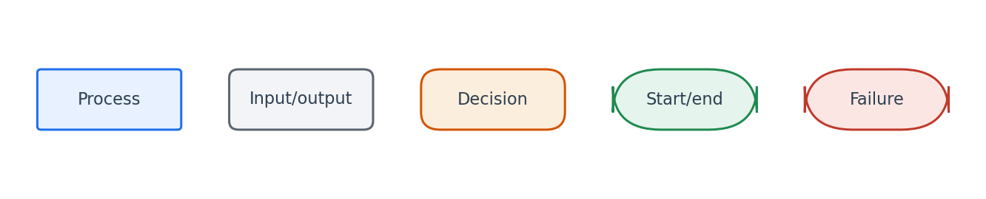
Flowchart symbol legend (used in every chapter).
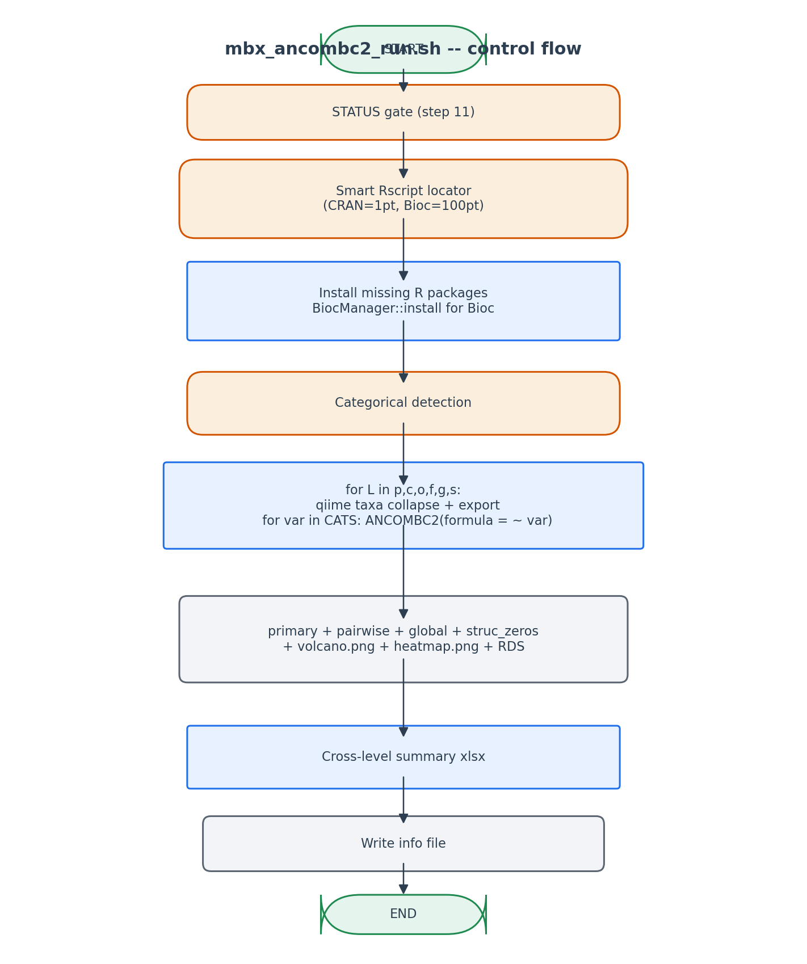
Smart Rscript discovery + collapse + per-cell ANCOMBC2 + cross-cell summary.

6. Edge cases and caveats

ANCOMBC2 fails on small group
When a group has < 3 samples after lib_cut filtering, ANCOMBC2 returns NA for that contrast. We report it in the run log without aborting.

Structural zeros vs sampling zeros
ANCOMBC2 distinguishes them. Structural zeros (taxon completely absent in a group) are reported in the dedicated XLSX so users know which 'absences' are biologically meaningful vs sequencing-depth artifacts.

Cross-platform R compilation
On Apple Silicon, igraph and ANCOMBC need C++ compilation. The smart locator picks conda's R when system R lacks them, sidestepping the compile cost.

7. Implementation notes

Why not run all variables in a single ANCOMBC2 call
ANCOMBC2 does support multi-covariate formulas, but the per-variable runs give cleaner pairwise contrasts and easier-to-interpret tables. Multi-covariate analysis is captured by step 13's Adonis instead.

Why exclude domain
Domain has typically 1-3 levels (Bacteria/Archaea/Eukaryota). DA testing on this level is statistically uninformative for 16S microbiome studies.

8. Testing checklist
Things to verify before considering this script production-ready:
- Verify all 6 levels (p..s) produce ANCOMBC2 outputs.
- Verify pairwise xlsx has C(k,2) row groups for k-group variables.
- Verify global xlsx exists for every (level, variable).
- Verify volcano + heatmap PNGs for at least one cell.
- Re-run -> verify the cross-level summary xlsx is regenerated but per-cell RDS is reused.

