
mbX Pro -- internal technical reference
Step 15
mbx_picrust_run.sh
PICRUSt2 functional prediction with NSTI filtering and DA + correlation
Pipeline step 15 -- the most complex environment-management script.

1. Purpose and scope
Predict metagenomic content from 16S marker genes via PICRUSt2 (Douglas et al. 2020). Generates KO, EC, COG, MetaCyc pathway abundance tables, applies NSTI filtering with audit reporting, runs Kruskal-Wallis differential abundance per categorical variable, produces stacked-bar / heatmap / functional PCoA plots, computes DA-genera x DA-pathway correlation matrices, and emits a self-contained HTML report. PICRUSt2 lives in its OWN conda env to protect QIIME2.

2. Inputs and outputs

2.1 Inputs (data structures)
Name | Source | Format | Required
<mbX_pro_outputs_dir> | User CLI | Containing 14_differential_abundance_ANCOMBC2/ (optional) | yes
--nsti F | User flag | NSTI filter threshold (default 2.0) | no
--picrust-env-path PATH | User flag | Override auto-discovery of PICRUSt2 conda env | no
--threads N | User flag | Default = auto-detected | no
--variables LIST | User flag | Override auto-detection | no

2.2 Outputs (data structures)
Path (relative to output dir) | What it contains | Read by
15_picrust2/all_picrust2_outputs/{KO,EC,COG}_metagenome/ | Functional metagenome predictions per database | report
15_picrust2/all_picrust2_outputs/pathways_metacyc/ | MetaCyc pathway abundances | report
15_picrust2/all_picrust2_outputs/nsti/ | Per-ASV NSTI tables + filtering summary | report
15_picrust2/all_picrust2_outputs/place_seqs/ | Phylogenetic placement results + log | audit
15_picrust2/picrust2_<Var>/DA_*_KW_<Var>.xlsx + pairwise.xlsx | KW + Dunn DA per database per variable | report
15_picrust2/picrust2_<Var>/stacked_bar_top20_metacyc_<Var>.{png,pdf} | Top-20 pathway stacked bar | report
15_picrust2/picrust2_<Var>/heatmap_DA_pathways_<Var>.{png,pdf} | LFC heatmap with q-stars | report
15_picrust2/picrust2_<Var>/PCoA_BrayCurtis_FUNCTIONAL_<Var>.{png,pdf} | Functional beta diversity | report
15_picrust2/picrust2_<Var>/correlation_DAgenera_x_DApathways_<Var>.{tsv,png,pdf} | Spearman correlation matrix | report
15_picrust2/picrust2_report.html | Self-contained HTML report | user
15_picrust2/Summary_picrust2_NSTI.xlsx | Per-sample NSTI + sample reliability flags | report

2.3 Downstream consumers
These steps depend on this script's outputs:
- Step 18 embeds the picrust2_report.html links + the NSTI table.

3. Complete parameter reference
Parameter | Default | Decision rule / where it comes from
--nsti F | 2.0 | Drop ASVs with NSTI > F. NSTI = Nearest Sequenced Taxon Index = phylogenetic distance to nearest reference. Default 2.0 is appropriate for gut/soil. Rumen/termite-gut may need higher (3.0) because of fewer reference genomes.
--picrust-env-path PATH | (auto) | Bypass env discovery. Useful on shared HPC.
--threads N | auto | Pass-through to picrust2_pipeline.py --processes.

4. Algorithm walkthrough

4.1 Conda env management (independent of QIIME2)
PICRUSt2 has dependency conflicts with QIIME2 (different scikit-learn). To avoid corrupting the user's QIIME2 env, this script does the following:
- Search every conda/mamba install for an env containing place_seqs.py in bin/.
- Order: env named exactly $PICRUST_ENV (default 'mbx_picrust2'), then 'picrust2', then any env name ending in 'picrust2' or 'picrust'.
- If none found, create env via mamba create -n mbx_picrust2 -c bioconda picrust2. Falls back to conda create on machines without mamba.
- Invoke picrust2 commands by PREPENDING the env's bin/ to PATH for that single command (no `conda activate`, no `conda run`).
PATH-prefixing works because picrust2's shebangs are absolute env-python paths. This sidesteps both `conda run`'s --no-capture-output awkwardness and mamba run's flag-rejection issues.

4.2 PICRUSt2 pipeline
picrust2_pipeline.py runs in 4 internal stages: place_seqs (ASV placement onto reference tree), hsp.py (hidden state prediction for 16S copy number + KO/EC/COG/MetaCyc), metagenome_pipeline.py (per-sample functional abundance), pathway_pipeline.py (MetaCyc pathway from EC). Each stage emits its own log.

4.3 NSTI filtering with audit
After placement, every ASV has a NSTI score. The script:
- Logs per-sample mean NSTI. Flags samples with mean NSTI > 1.0 (predictions unreliable).
- Drops ASVs with NSTI > --nsti.
- Records: how many ASVs dropped, what % of total reads they represented, which samples lost most reads.
- Flags samples that lost > 50% of reads after filtering -- these become ineligible for downstream DA.
All audit numbers are written to nsti_filtering_summary.txt and Summary_picrust2_NSTI.xlsx -- the latter has a per-sample reliability flag column.

4.4 DA per variable per database
Kruskal-Wallis + Dunn pairwise per (variable, database) on functional abundances. BH-corrected within each database. 4 databases x N variables = 4N tests per variable group.

4.5 Visualizations
Stacked bars of top-20 MetaCyc pathways grouped by variable (mirrors the taxonomy bar plots). LFC heatmaps with q-value star overlay (visual consistency with ANCOMBC2 heatmaps). Functional PCoA on Bray-Curtis distance between MetaCyc pathway samples -- LABELLED 'functional beta diversity' so users do not confuse it with the taxonomic PCoA.

4.6 Genus x pathway correlation
If step 14 (ANCOMBC2) produced genus-level DA results, the script computes Spearman correlation between every DA genus and every DA pathway. Output: TSV + heatmap. This is the most reviewer-requested cross-step output: it ties microbial taxa to predicted function.

4.7 Self-contained HTML report
A standalone picrust2_report.html with embedded plots (base64), provenance, parameter tables, and the documented LIMITATION of 16S-based functional prediction (printed prominently as a caveat).

5. Flow diagram
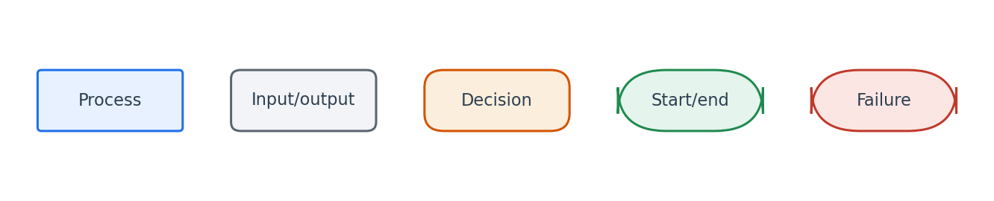
Flowchart symbol legend (used in every chapter).
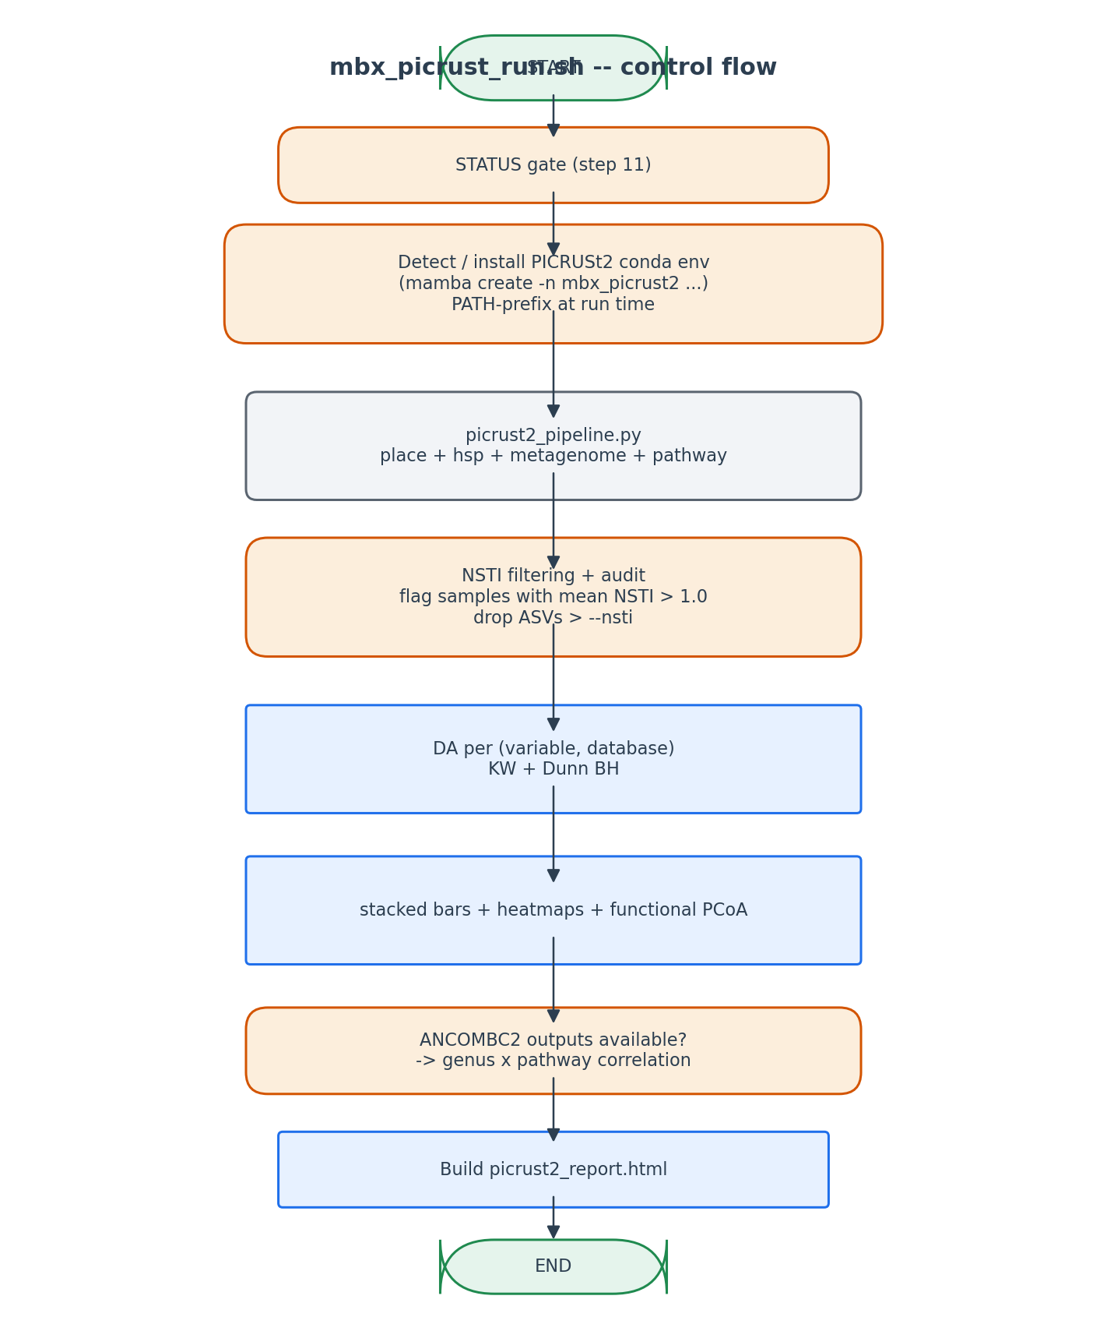
Isolated conda env + 4-stage pipeline + per-variable DA + correlation.

6. Edge cases and caveats

PICRUSt2 placement fails for an ASV
Some ASVs fail phylogenetic placement (very divergent sequences). They are reported in the place_seqs log and excluded from downstream calculations.

Sample with mean NSTI > 1.0
Flagged in Summary_picrust2_NSTI.xlsx with a 'reliability=low' indicator. The user is warned in the HTML report and the sample is highlighted in red on functional PCoA.

ANCOMBC2 outputs absent
Genus x pathway correlation step is skipped with a friendly note in the report. Other PICRUSt2 outputs are unaffected.

Apple Silicon mamba post-link issues
Some PICRUSt2 dependencies trigger post-link script failures on M-series. The script tries mamba first (which handles these better) before falling back to conda.

7. Implementation notes

Functional prediction caveat
All visualizations are subtitled 'Predicted functional profiles -- inferred from 16S rRNA data'. The HTML report has a prominent caveat box explaining that PICRUSt2 inference is NOT a substitute for shotgun metagenomics.

Why correlation only on DA-genera x DA-pathways
Computing the full N_taxa x N_pathways correlation is O(taxa * pathways) and produces a giant uninterpretable matrix. Restricting to differentially-abundant items (from steps 14 and 15) yields a focused, biologically interpretable matrix.

8. Testing checklist
Things to verify before considering this script production-ready:
- Verify mbx_picrust2 conda env exists after first run.
- Verify NSTI filter actually drops ASVs and the count is logged.
- Verify all 4 databases have output files.
- Verify HTML report opens in browser and shows embedded plots.
- Verify correlation file is empty when ANCOMBC2 outputs are missing (graceful degradation).

