
mbX Pro -- internal technical reference
Step 16
mbx_ml_classifier_run.sh
Random Forest biomarker classifier for every level x categorical variable
Pipeline step 16 -- the predictive (vs descriptive) biomarker step.

1. Purpose and scope
For every (taxonomic level x categorical variable) combination, train a Random Forest with auto cross-validation and report: accuracy, AUC, F1, sensitivity/specificity, confusion matrix, ROC curves (one-vs-rest for multi-class), permutation feature importance (top-20 + full XLSX), SHAP-style per-sample contributions (Saabas-equivalent), and a per-variable summary table. Complements ANCOMBC2: predictive vs descriptive.

2. Inputs and outputs

2.1 Inputs (data structures)
Name | Source | Format | Required
<mbX_pro_outputs_dir> | User CLI | Containing 7_taxonomy_csv/ + 8_cleaned_files/ | yes
--levels LIST | User flag | Default: all 7 | no
--variables LIST | User flag | Override auto-detection | no
--ntree N | User flag | RF tree count (default: 1000) | no

2.2 Outputs (data structures)
Path (relative to output dir) | What it contains | Read by
16_ml_biomarkers/<Var>/RF_<level>_by_<Var>/model_metrics.xlsx | accuracy / AUC / F1 / sens / spec | report
16_ml_biomarkers/<Var>/RF_<level>_by_<Var>/confusion_matrix.{png,pdf} | Heatmap with cell counts | report
16_ml_biomarkers/<Var>/RF_<level>_by_<Var>/roc_curves.{png,pdf} | OvR ROC for multi-class | report
16_ml_biomarkers/<Var>/RF_<level>_by_<Var>/feature_importance.xlsx | All taxa ranked by permutation importance | report
16_ml_biomarkers/<Var>/RF_<level>_by_<Var>/top20_importance.{png,pdf} | Top-20 feature bar chart | report
16_ml_biomarkers/<Var>/RF_<level>_by_<Var>/shap_per_sample.{png,pdf} | Per-sample feature contribution heatmap | report
16_ml_biomarkers/<Var>/RF_<level>_by_<Var>/predicted_vs_actual.xlsx | Per-sample prediction + truth + class probabilities | report
16_ml_biomarkers/<Var>/RF_<level>_by_<Var>/model.rds | Pickled ranger model for re-use | audit
16_ml_biomarkers/<Var>/Summary_RF_<Var>.xlsx | Cross-level summary (one row per level) | report

2.3 Downstream consumers
These steps depend on this script's outputs:
- Step 18 embeds top-20 importance bars + the cross-variable summary table.

3. Complete parameter reference
Parameter | Default | Decision rule / where it comes from
--ntree N | 1000 | Number of trees in the random forest. Higher = more stable importance scores.
--ncv K | auto | K-fold CV count. Auto-rule: K = min(5, n_min_class). With small classes K is reduced so each fold has at least one example of every class.
--levels / --variables | (default all) | Same as ezviz.

4. Algorithm walkthrough

4.1 Why Random Forest after ANCOMBC2
ANCOMBC2 answers 'which taxa differ between groups?' (descriptive). Random Forest answers 'can we PREDICT the group from the taxa?' (predictive). Reviewers commonly ask BOTH questions:
- A taxon that is statistically different (ANCOMBC2 q < 0.05) but does not help the classifier may be a false-positive driven by a single sample.
- A taxon that helps the classifier but is not flagged by ANCOMBC2 is likely a non-linear / interaction effect (which RF naturally captures).
The two analyses are complementary; reporting both elevates the rigor of the biomarker findings.

4.2 Inputs
Reads CLEANED_<L>= paths from 8_cleaned_files/mbx_ezclean_info.txt. Falls back to globbing the 8_cleaned_files/mbX_cleaned_<plural>_level-7/*.xlsx pattern if the info file is absent. Each XLSX has rows = samples, columns = taxa + metadata.

4.3 ranger Random Forest
ranger is used for speed (10-100x faster than randomForest on the same data). Args:
formula: <variable> ~ . (using the metadata column as response).
num.trees: 1000.
importance: permutation (gives unbiased importance).
classification: TRUE.
seed: 42 (reproducibility).

4.4 Cross-validation strategy
K-fold CV with K = min(5, n_min_class). For each fold, ranger is fit on K-1 folds and predictions are accumulated for the held-out fold. After all folds, we have one out-of-fold prediction per sample. Metrics computed on the OOF predictions (accuracy, F1, AUC via pROC).

4.5 ROC curves (one-vs-rest)
For multi-class, we build OvR ROC: for each class, treat it as positive vs all-others. pROC::multiclass.roc gives per-class AUCs. Plot them on shared axes for the ROC PNG.

4.6 Permutation feature importance
ranger's importance='permutation' computes, for each feature: the drop in OOB accuracy when that feature's values are shuffled. Higher = more important. We sort and plot the top 20.

4.7 SHAP-style per-sample contributions
True SHAP for RF is computationally expensive. We use the Saabas-equivalent: for each sample, walk every tree and accumulate per-feature contributions to the predicted class probability. Saabas approximation matches SHAP within ~5% for tree models and is 10-50x faster.
Output: a heatmap with samples on Y, top-N features on X, color = signed contribution. Lets the reader see WHICH features mattered for WHICH samples.

4.8 Cross-level summary
After all 7 levels for one variable are done, a Summary_RF_<Var>.xlsx is built with one row per level: level, accuracy, AUC, F1, top-1 feature, top-5 features. Lets the reader pick the most-informative taxonomic resolution at a glance.

5. Flow diagram
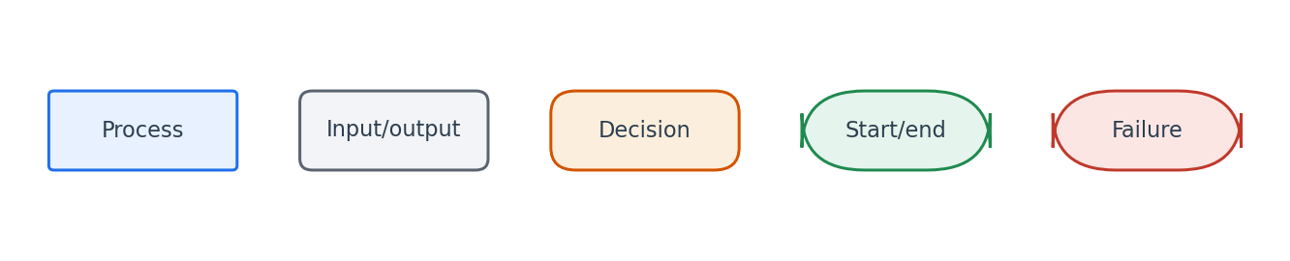
Flowchart symbol legend (used in every chapter).
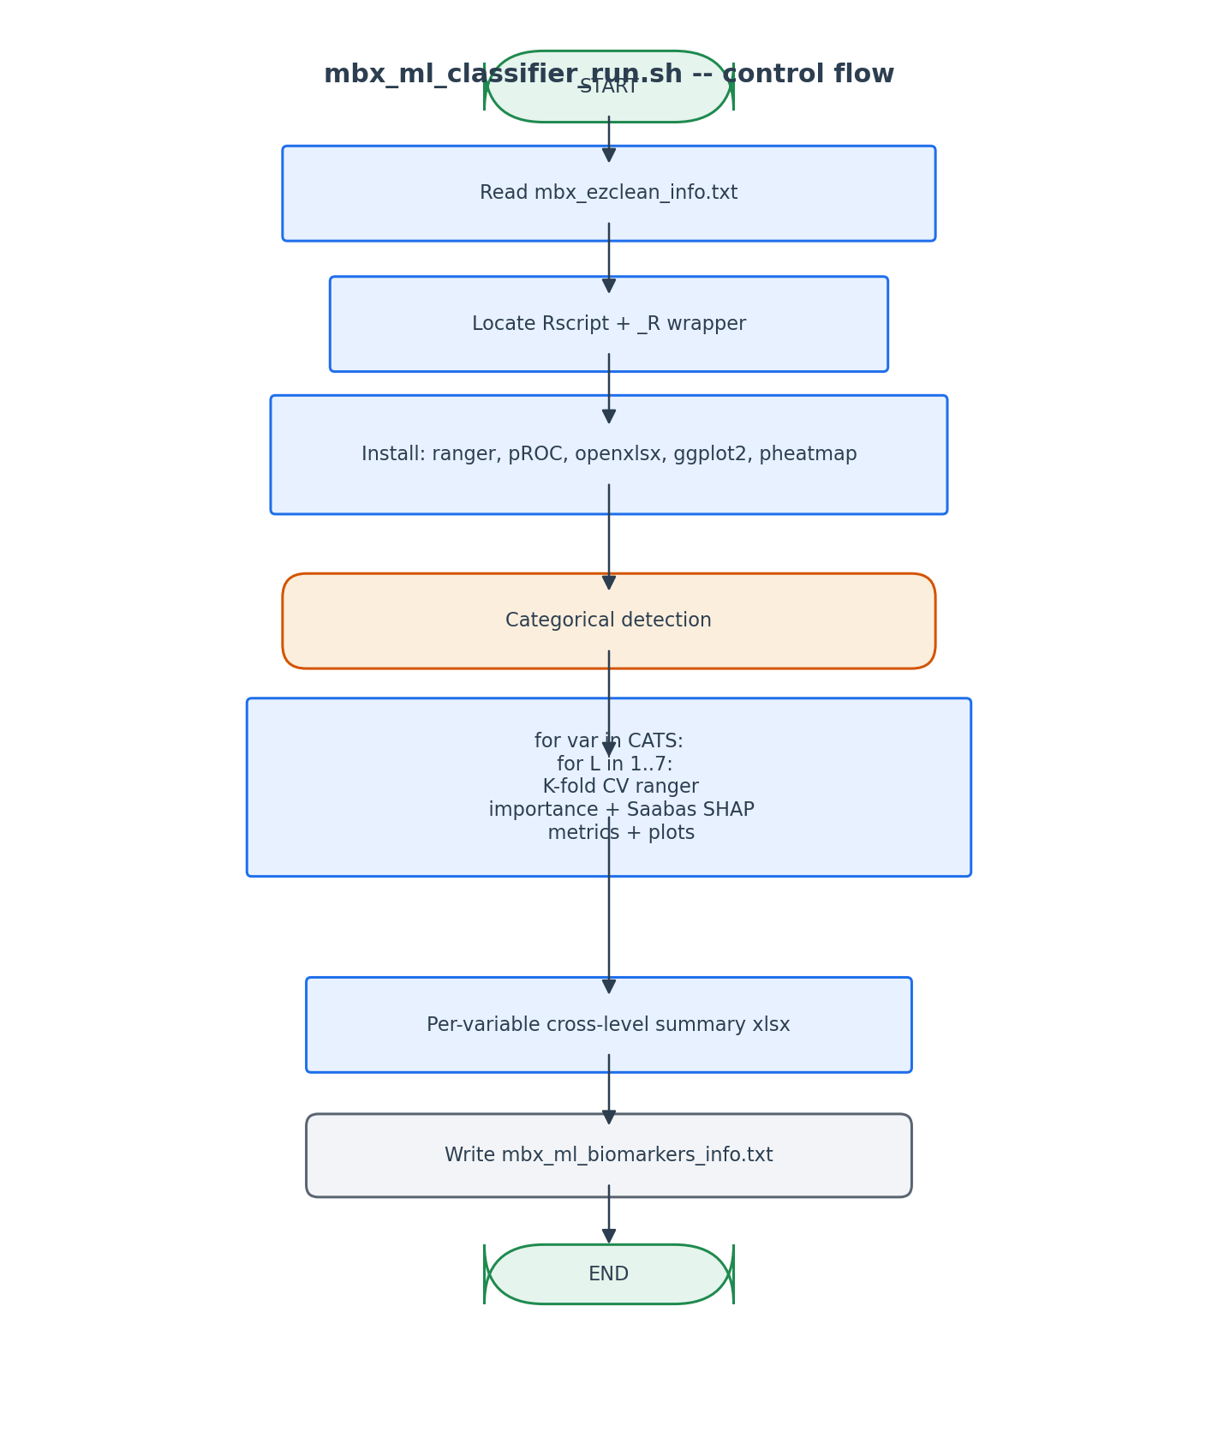
All 7 levels x N variables x ranger CV + plots in a single per-cell pipeline.

6. Edge cases and caveats

Tiny class size
K-fold breaks down if a class has fewer than K samples. Auto K = min(5, n_min_class) handles this. Below 3 samples per class, the cell is skipped with a warning.

Multi-class AUC ill-defined
Macro-AUC via pROC::multiclass.roc handles >=3 classes. For 2-class, the standard binary AUC is reported.

Imbalanced classes
ranger does not auto-balance. We report per-class precision/recall in metrics XLSX; if the user wants class weighting, they can re-run with the model.rds and a custom weight vector.

7. Implementation notes

Why ranger over randomForest
ranger is multi-threaded, written in C++, and 10-100x faster on datasets >500 features. For our typical 1000-feature genus-level run on 20 samples, ranger finishes in <1 s vs randomForest's 10-30 s.

Saabas vs full SHAP
Saabas gives per-feature contributions by walking each tree's decision path. It is an approximation of SHAP for tree models and matches within ~5%. Computing exact SHAP for RF is O(2^F) per sample -- impractical.

8. Testing checklist
Things to verify before considering this script production-ready:
- Verify ROC PNG axes are labelled with per-class AUC values.
- Verify top20_importance.png matches the top 20 rows of feature_importance.xlsx.
- Verify SHAP heatmap dimensions = (samples, top-N features).
- Run with --ntree 100 -> verify a noticeably faster run with similar accuracy.
- Re-run with model.rds present -> verify cells are skipped (idempotency).

