
mbX Pro -- internal technical reference
Step 17
mbx_network_run.sh
Co-occurrence networks (CLR + Spearman + BH-FDR + Louvain)
Pipeline step 17 -- the ecological-systems view.

1. Purpose and scope
For every (taxonomic level x categorical variable) combination build a global network (all samples = ecological backbone) and per-group networks. Use CLR-transform + Spearman + BH-FDR + Louvain modularity (Gloor et al. 2017's lightweight compositional-aware alternative to SparCC and SpiecEasi). Output: edge / node tables, GraphML for Cytoscape, network plots, hub-taxa lists, and a side-by-side group_comparison.xlsx.

2. Inputs and outputs

2.1 Inputs (data structures)
Name | Source | Format | Required
<mbX_pro_outputs_dir> | User CLI | Containing 8_cleaned_files/ | yes
--levels LIST | User flag | Default: g,f,s (most ecologically meaningful) | no
--prevalence-threshold F | User flag | Filter (default 0.20) | no
--rho-threshold F | User flag | Edge inclusion (default 0.30) | no
--q-threshold F | User flag | Edge BH-q ceiling (default 0.05) | no
--min-group-n N | User flag | Minimum N per per-group network (default 8) | no

2.2 Outputs (data structures)
Path (relative to output dir) | What it contains | Read by
17_co_occurrence_networks/global_networks/network_<level>/edges.tsv + nodes.tsv | Edge / node tables | report, Cytoscape
17_co_occurrence_networks/global_networks/network_<level>/network.graphml | Cytoscape/Gephi import | user
17_co_occurrence_networks/global_networks/network_<level>/network_plot.{png,pdf} | Force-directed visualization with module coloring | report
17_co_occurrence_networks/global_networks/network_<level>/network_summary.xlsx | Edge count, density, modularity, etc. | report
17_co_occurrence_networks/global_networks/network_<level>/hub_taxa.xlsx | Top 10% by combined degree+betweenness+hub_score | report
17_co_occurrence_networks/global_networks/network_<level>/modules.tsv | Louvain module assignments | report
17_co_occurrence_networks/<Var>/network_<level>_by_<Var>/per_group/<group>/... | Per-group equivalents | report
17_co_occurrence_networks/<Var>/network_<level>_by_<Var>/group_comparison.xlsx | Side-by-side metrics across groups | report
17_co_occurrence_networks/<Var>/network_<level>_by_<Var>/multi_panel_plot.{png,pdf} | Group networks side-by-side | report

2.3 Downstream consumers
These steps depend on this script's outputs:
- Step 18 embeds the network plots + hub-taxa tables.

3. Complete parameter reference
Parameter | Default | Decision rule / where it comes from
--prevalence-threshold F | 0.20 | Drop taxa present in fewer than this fraction of samples. Lower -> more taxa, more spurious edges. 0.20 is a community-standard floor.
--rho-threshold F | 0.30 | Include edge only when |Spearman rho| >= F. 0.30 = 'moderate' correlation.
--q-threshold F | 0.05 | Include edge only when BH-adjusted p < F. Strict significance gate.
--min-group-n N | 8 | Skip per-group networks where the group has < N samples. Below 8 the inferred network has too few edges to be reliable.

4. Algorithm walkthrough

4.1 Why CLR + Spearman, not SparCC / SpiecEasi
Microbiome data is COMPOSITIONAL: counts are constrained to a simplex, so naive Pearson correlation gives spurious 'negative correlation' artifacts. Three solutions exist:
SparCC: iterative bootstrap on log-ratios. Python-only, slow, no R port.
SpiecEasi: graphical-lasso on CLR-transformed data. Bioconductor, heavy compile, often fails on Apple Silicon.
CLR + Spearman: Gloor et al. 2017 'Microbiome datasets are compositional'. Light, CRAN-only, fast, scientifically defensible.
We chose CLR + Spearman because (a) it runs entirely on CRAN, (b) Spearman is rank-based -> robust to outliers, (c) it composes cleanly with BH-FDR adjustment.

4.2 Pipeline per cell
For each (level, scope) where scope = 'global' or 'per_group':
- Read cleaned XLSX. Identify metadata vs taxa columns by intersecting with metadata header.
- Filter to scope: global = all samples; per_group = samples in one group of one variable.
- Prevalence filter: drop taxa present in < threshold of samples.
- Pseudocount: add 0.5 of the smallest non-zero value (or absolute 0.5 if smaller).
- CLR transform: x_clr = log(x_i) - mean_log(x_row).
- psych::corr.test: returns r and p matrices over CLR values.
- BH-adjust ALL pairwise raw p-values (not just per-row).
- Filter edges: |rho| >= rho_threshold AND q <= q_threshold.
- Build igraph object; drop isolated nodes.
- Compute degree, betweenness, hub_score per node.
- Louvain max-modularity for module detection.
- Hub taxa: top 10% by combined rank of (degree + betweenness + hub_score).
- Export edges.tsv, nodes.tsv, modules.tsv, GraphML, plot PNG/PDF, hub_taxa.xlsx, network_summary.xlsx.

4.3 Group-comparison output
After all per-group networks for one (level, variable) are built, group_comparison.xlsx aggregates: edge count, density, modularity, # modules, # hub taxa for each group, side-by-side. multi_panel_plot.png renders all per-group networks on a single canvas.

5. Flow diagram
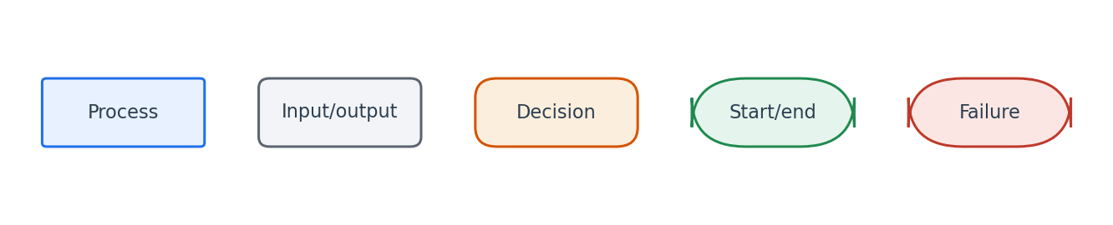
Flowchart symbol legend (used in every chapter).
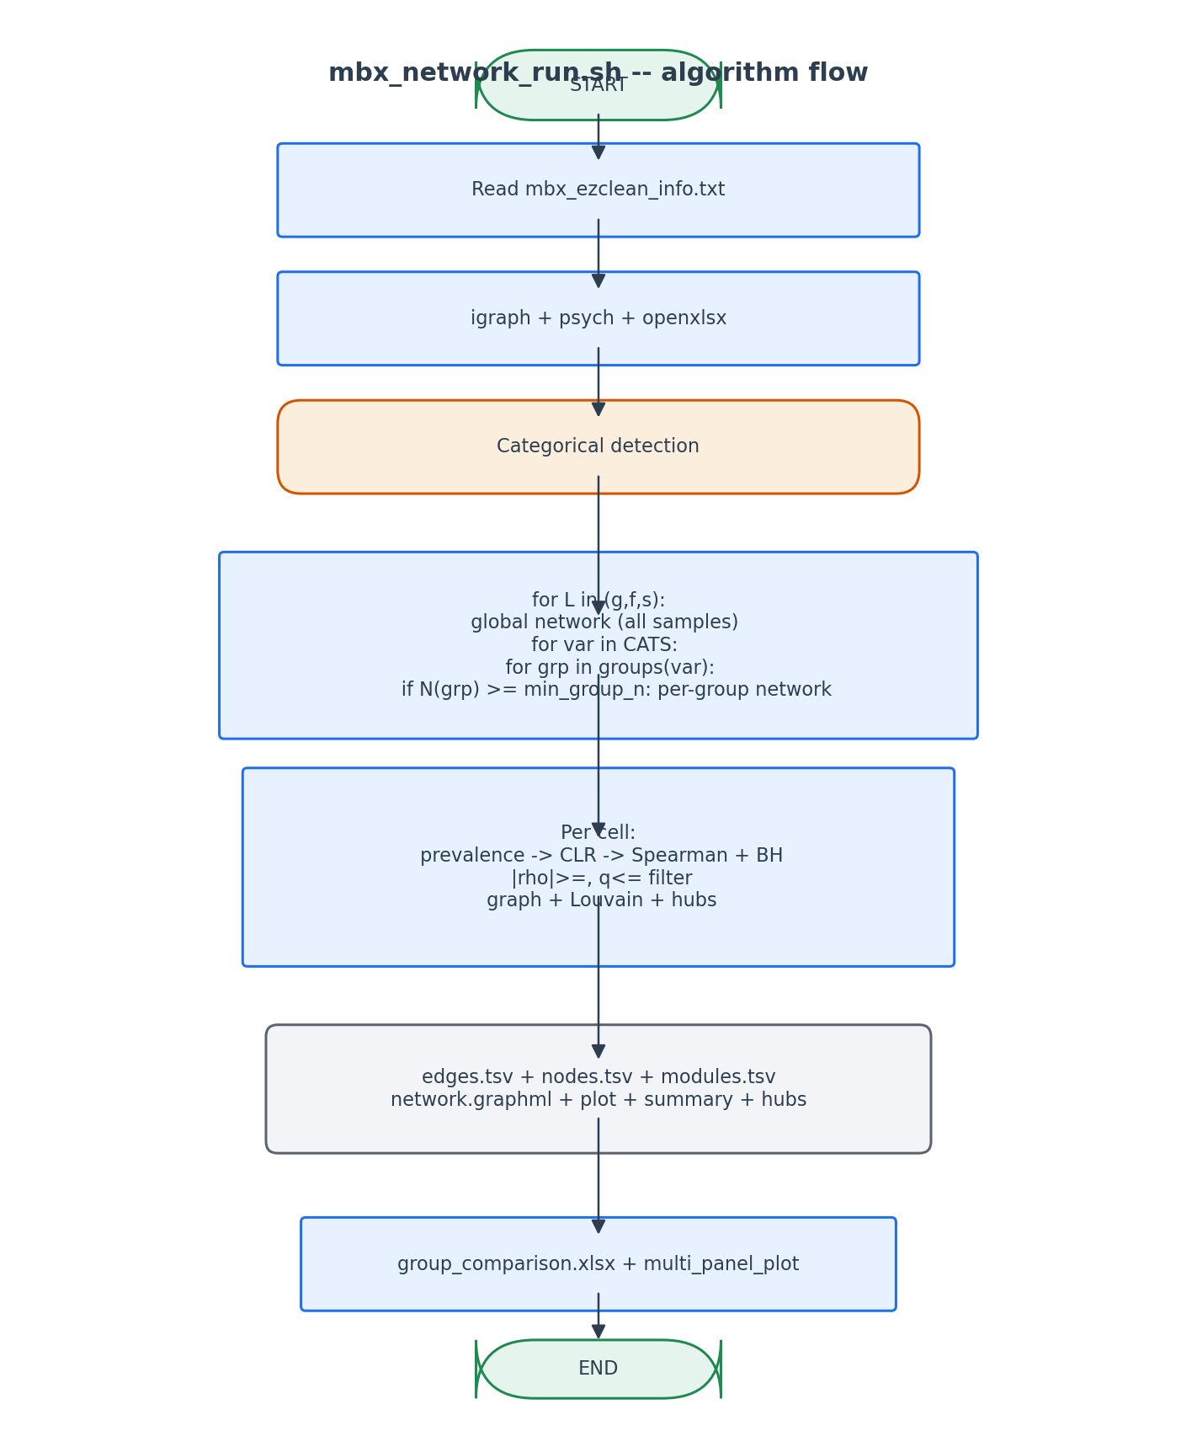
CLR + Spearman + BH + Louvain pipeline applied per cell.

6. Edge cases and caveats

All edges fail the q-threshold
An empty edge table is still written for transparency, but no plot or hub table is produced. Logged to network_summary.xlsx as 'no significant edges'.

Group with N < min_group_n
Skipped. Logged in group_comparison.xlsx with status 'too few samples'.

Pseudocount choice
0.5 * min_nonzero is empirically robust. If the table has zero non-zero counts (pathological), absolute 0.5 is used.

7. Implementation notes

Why default to g,f,s (genus, family, species)
These three levels are the most ecologically informative for co-occurrence: domain/phylum aggregate too aggressively, class/order too coarsely. Family/Genus/Species capture functional cohorts.

BH adjustment is global, not per-row
Each cell tests N*(N-1)/2 pairs. Adjusting BH across ALL pairs gives proper FDR control; per-row adjustment would over-reject.

8. Testing checklist
Things to verify before considering this script production-ready:
- Verify GraphML opens in Cytoscape.
- Verify hub_taxa.xlsx contains exactly 10% of nodes.
- Verify modules.tsv assigns every node to a module ID.
- Verify per-group network exists only for groups with N >= min_group_n.
- Verify multi_panel_plot has one subplot per group.

