
mbX Pro -- internal technical reference
Step 0
mbx_primer_identifier.sh
Auto-detect 16S rRNA primers from raw FASTQ files
Pipeline step 0 -- the very first thing that runs.

1. Purpose and scope
Determine which forward and reverse primers were used during library preparation by sampling a representative number of reads and matching them against a built-in database of 30 published 16S rRNA primers. The result drives the trim-left parameters of step 4 (DADA2). If primers cannot be identified above the user-tunable rate, the pipeline falls back to default trim-left=20 and the user can pass --forward-primer / --reverse-primer manually.

2. Inputs and outputs

2.1 Inputs (data structures)
Name | Source | Format | Required
<fastq_dir> | User CLI argument | Directory containing *.fastq.gz files (paired or single-end) | yes
--samples N | User flag | Integer (default 10000) | no
--mismatches N | User flag | Integer 0-5 (default 2) | no
--offset N | User flag | Integer 0-30 (default 15) | no
--min-rate F | User flag | Float 0-1 (default 0.10) | no
--no-search-parent / --no-search-child | User flag | Boolean toggle | no
MBX_OUT_DIR | Env var (set by orchestrator) | Absolute path | no

2.2 Outputs (data structures)
Path (relative to output dir) | What it contains | Read by
0_primer_handling/mbx_primer_info.txt | Key=value file with detected primers + diagnostic data | step 5 (classifier_arranger), step 3 (dada2_parameter_finder)

2.3 Downstream consumers
These steps depend on this script's outputs:
- Step 3 (mbx_dada2_parameter_finder.sh) reads FORWARD_PRIMER_SEQUENCE / REVERSE_PRIMER_SEQUENCE to set trim-left.
- Step 5 (mbx_classifier_arranger.sh) reads the same fields to invoke `qiime feature-classifier extract-reads`.
- Step 18 (mbx_final_report.sh) reads the entire info file for the report's `Primer detection` section.

3. Complete parameter reference
The script is parameter-light by design -- the user typically passes only the FASTQ directory. Every flag has a sensible default tuned to standard Illumina 16S libraries.
Parameter | Default | Decision rule / where it comes from
--samples N | 10000 | Number of reads to sample PER FILE. Reads are taken from the start of the file (NOT randomly) -- this is intentional because Illumina FASTQ records do not have temporal order to worry about, and sequential sampling is dramatically faster than random seek over gzip.
--mismatches N | 2 | Maximum allowed IUPAC-aware mismatches between read prefix and candidate primer. 2 is generous for V3-V4 (19-20 bp primers) and matches Cutadapt's typical 0.1 error-rate setting. Increase to 3 if detection fails.
--offset N | 15 | Maximum left-shift of the primer when sliding it along the read. Some sequencing facilities leave a few bases of adapter or random padding before the primer. 15 covers every protocol we have encountered.
--min-rate F | 0.10 | Minimum fraction of sampled reads that must match the same primer for it to be reported. Below this fraction, the primer is reported as 'None'. 0.10 = 10% is intentionally conservative -- a true primer pair typically matches >70%.
MBX_OUT_DIR (env) | (unset) | When set by the orchestrator, the script reuses that exact directory as OUT_ROOT and derives TIMESTAMP from its name. When unset, the script generates its own timestamp and creates a sibling output directory.

4. Algorithm walkthrough

4.1 Preflight
After argument parsing the script verifies that python3 is on PATH and the FASTQ directory exists. python3 is a hard dependency because all heavy lifting is delegated to an embedded Python heredoc.
MBX_OUT_DIR is checked. If set, OUT_ROOT is reused directly; otherwise OUT_ROOT becomes <parent_of_FASTQ>/mbX_pro_outputs_<TIMESTAMP>. This contract is what guarantees that the orchestrator's single-shared-directory invariant holds.

4.2 File discovery (Bash 3.2 safe)
Discovery uses three concentric search rings with deduplication via a temp file (no associative arrays). Each candidate directory is added to dirs.txt only if its absolute path is not already present (grep -qxF).
- Ring 1: <fastq_dir> itself (always).
- Ring 2: parent directory of <fastq_dir> (unless --no-search-parent).
- Ring 3: every direct child directory of <fastq_dir> (unless --no-search-child).
Within each ring, `find -maxdepth 1 -iname '*.fastq.gz'` lists files. Each file's absolute path is compared against seen.txt to deduplicate. The result is files.txt.

4.3 R1 / R2 split
Each filename is matched case-insensitively against 'r1' and 'r2' (regex). Files matching neither tag are skipped with a warning. The presence of any R2 file flips READ_TYPE to 'paired'; otherwise 'single'.

4.4 Python primer engine -- IUPAC table
The Python heredoc starts by defining the IUPAC expansion dictionary. Each ambiguous base maps to a frozenset of unambiguous bases:
M -> {A,C} R -> {A,G} W -> {A,T}
S -> {C,G} Y -> {C,T} K -> {G,T}
B -> {C,G,T} D -> {A,G,T} H -> {A,C,T}
V -> {A,C,G} N -> {A,C,G,T}
U -> {T} (RNA -> DNA)
Lowercase keys mirror uppercase keys for tolerant matching.
An RC_TABLE for str.translate then implements reverse complementation in O(n) without dictionary lookups.

4.5 Built-in primer database
PRIMER_DB is a list of dicts (name, seq, region, dir). 30 published 16S primer entries cover V1-V2, V1-V3, V1-V9, V3, V3-V4 (incl. PRK universal), V3-V5, V4 (original + EMP-Parada/Apprill), V4-V5, V5-V7, V6-V7, V6-V8.
After defining the DB, every sequence is scrubbed: the Cyrillic look-alike `\u041d` (Cyrillic Capital En) -> ASCII 'N' (a copy-paste hazard from primer Excel sheets), and uppercased. MIN_PRIMER_LEN and MAX_PRIMER_LEN are computed at module load -- used later as the consensus diagnostic window width.

4.6 The match function
iupac_mismatches(read_prefix, primer) walks both sequences in lockstep. At each position, the script checks whether the read base belongs to IUPAC[primer_base]; if not, increments mm. Returns the total mismatch count.
slide_match(read, primer, max_mm, max_offset) tries every left-shift from 0 to max_offset. For each shift, it slices read[offset:offset+len(primer)] and calls iupac_mismatches. The minimum mismatch (and the offset that achieved it) is tracked. Returns (matched, best_offset). matched is True iff best_mm <= max_mm. A 0-mismatch hit short-circuits the loop.

4.7 Scoring all primers
score_primers(reads, primers, max_mm, max_offset, as_rc) returns a dict keyed by primer name. Each entry records: matched count, total reads scanned, rate (matched/total), modal_offset (the most common offset that produced a hit), and as_rc flag.
Two passes are run on the R1 reads -- one with as_rc=False (testing primer 5'->3' as written) and one with as_rc=True (testing reverse-complement). For paired-end runs the same two passes are run on R2 reads.

4.8 Three-orientation hypothesis testing (key innovation)
Different sequencing facilities and chemistries produce three subtly different read orientations. The script tests all three and picks the highest combined match rate:
Orientation A (RC): R1 starts with forward primer 5'->3'; R2 starts with reverse-complement of reverse primer.
Orientation B (DIRECT): R1 starts with forward primer 5'->3'; R2 starts with reverse primer 5'->3' (no RC).
Orientation C (SWAP): R1 starts with reverse primer; R2 starts with forward primer (some facilities label R1/R2 swapped).
Each orientation's score is the sum of best-forward-primer rate + best-reverse-primer rate. Whichever orientation has the highest sum wins. orientation_note records which orientation was selected for the report.

4.9 Consensus diagnostic
consensus_bases(reads, length) computes the per-position modal base across all sampled reads. The window length is dynamically sized to MAX_PRIMER_LEN + max_offset (e.g. 22 + 15 = 37 nt). This fixes a former bug where the window was hard-coded to 40 nt and could mis-diagnose short primers.
The consensus is printed both to stdout (prefixed [DIAG]) and embedded in the output file, so a user reading mbx_primer_info.txt can see exactly what the read prefix looks like.

4.10 Output formatting
fmt_primer(label, best, direction_str) returns a list of key=value strings. When best is None, the function emits a comment block explaining how to relax thresholds, plus the same key=None lines so downstream parsers do not fail.
The full output file contains: a 10-line metadata header (date, FASTQ dir, sampling counts, mismatches, offset, min-rate, orientation, consensus); the READ_TYPE line; FORWARD_PRIMER_* block (7 lines); REVERSE_PRIMER_* block (7 lines for paired; 1 line for single).

5. Flow diagram
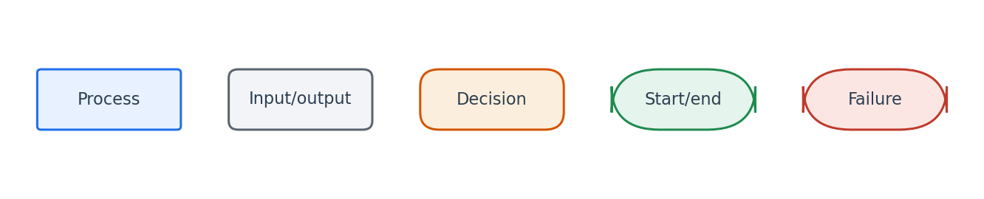
Flowchart symbol legend (used in every chapter).
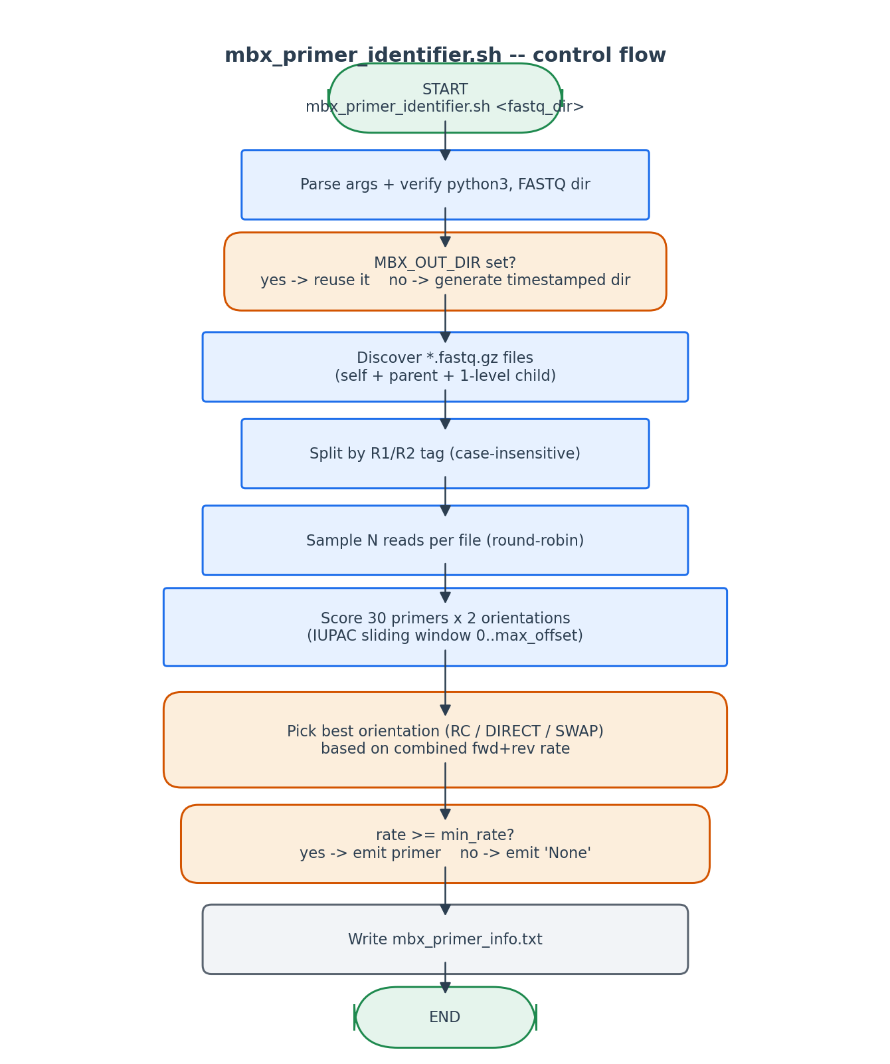
Control flow of mbx_primer_identifier.sh.

6. Edge cases and caveats

Pre-trimmed primers
Many sequencing facilities trim primers before delivery. In that case all primers will fall below --min-rate and the script reports 'None'. The user must then pass --forward-primer/--reverse-primer manually OR live with the trim-left=20 default.

Very short reads
Reads shorter than the longest primer + max_offset are skipped silently in slide_match (the window slice is empty).

Cyrillic look-alikes in the primer DB
After the database literal definition, every sequence is post-processed to replace Cyrillic Capital En (\u041d) with ASCII 'N'. This is a defensive measure against copy-paste from primer Excel sheets.

Single-end data
READ_TYPE='single' branches at multiple points: only one consensus is computed, only the forward primer is reported, and the REVERSE_PRIMER_NAME line shows 'N/A (single-end)' so downstream parsers can detect this case.

Match-rate ties
If two primers tie on rate, max() returns whichever appears first in PRIMER_DB. The DB is ordered with EMP-Parada/Apprill listed BEFORE the original 515F/806R variants, so a tie favours the more current EMP version.

7. Implementation notes

PID-based temp directory cleanup
trap 'rm -rf "$WORK_DIR"' EXIT ensures the temp work-dir is removed on every exit path including ctrl-C. WORK_DIR is generated via mktemp -d, which is safe (only the .R suffix mktemp variant has the macOS XXXXXX bug).

Environment-var contract with the Python heredoc
Twelve MBX_* environment variables are exported before the heredoc. This avoids quoting and shell-injection problems entirely -- the Python script reads os.environ directly. The heredoc is enclosed in single-quoted PYEOF markers so $-expansion does not trigger inside the Python source.

Why sliding-window instead of exact prefix
Exact prefix matching at offset 0 fails as soon as ANY adapter or padding base is present. Sliding 0..max_offset covers every protocol with a single uniform algorithm. The performance cost is negligible because each read's window is only 22 + 15 = 37 nt and only 30 primer candidates are tested.

8. Testing checklist
Things to verify before considering this script production-ready:
- Run with a known-primer FASTQ set (515F/806R EMP) and confirm match rate > 70 %.
- Run with --no-search-parent and verify only the FASTQ directory is searched.
- Run with --mismatches 0 -- detection should still succeed with primer-pristine data.
- Run with primers already trimmed -- confirm the script reports 'None' AND prints the 'pre-trimmed' tip.
- Run with the orchestrator setting MBX_OUT_DIR -- confirm output lands in MBX_OUT_DIR/0_primer_handling/, NOT a fresh timestamped dir.
- Confirm that `qiime feature-classifier extract-reads` accepts the resulting primer sequences without modification.

