
mbX Pro -- internal technical reference
Step orchestrator
mbXPro
End-to-end single-command orchestration of every pipeline step
The mbXPro command -- the lay-user-facing front door.

1. Purpose and scope
Provide a single command (mbXPro <fastq_dir> <metadata_file>) that runs every pipeline step (0 -> 18) in the correct order, into a SINGLE shared output directory, with full logging, idempotent resume, optional step-skipping, and a final summary. The user does not need to know any internal command, parameter, or file path.

2. Inputs and outputs

2.1 Inputs (data structures)
Name | Source | Format | Required
<fastq_dir> | User CLI | Directory containing raw FASTQ | yes
<metadata_file> | User CLI | QIIME2 metadata | yes
--resume | User flag | Reuse the most-recent existing output dir | no
--out PATH | User flag | Force a specific output dir | no
--from N / --to N | User flags | Step range | no
--skip LIST | User flag | Comma-separated step IDs to skip | no
--forward-primer / --reverse-primer | User flags | Manual primer override (skip step 0) | no
--no-pdf | User flag | HTML-only step 18 | no
--threads N | User flag | Override auto-detection | no
--keep-going | User flag | Continue past failed steps | no

2.2 Outputs (data structures)
Path (relative to output dir) | What it contains | Read by
mbX_pro_outputs_<TS>/ | Single shared output dir, all 18 step subdirectories | user
mbX_pro_outputs_<TS>/_pipeline_log/pipeline_master.log | Full run log (tee'd from every step) | audit
mbX_pro_outputs_<TS>/_pipeline_log/<step>.log | Per-step log files | audit
mbX_pro_outputs_<TS>/mbXPro_run_info.txt | Provenance: invocation, timestamps, versions | audit

2.3 Downstream consumers
These steps depend on this script's outputs:
- Step 0/1 reuse MBX_OUT_DIR (set by this orchestrator).
- Step 18 reads the entire output tree to build the final report.

3. Complete parameter reference
Parameter | Default | Decision rule / where it comes from
--resume | off | Find the most-recent mbX_pro_outputs_* dir alongside <fastq_dir>. Use it as MBX_OUT_DIR. Idempotent steps skip themselves automatically.
--out PATH | (auto) | Force a specific output directory. Overrides both auto-create and --resume.
--from N / --to N | 0/18 | Run only steps in the inclusive range [from, to]. Earlier steps must already exist if from > 0.
--skip LIST | (empty) | e.g. --skip 15,16,17 to skip PICRUSt + ML + networks (the three slowest optional steps).
--forward-primer / --reverse-primer | (unset) | When set, step 0 is skipped and these primers are passed directly to step 3 / step 5.
--keep-going | off | Continue running subsequent steps even if one fails. Default is abort-on-first-failure.

4. Algorithm walkthrough

4.1 Single shared output directory (the invariant)
The orchestrator creates EXACTLY ONE output directory per run. It exports MBX_OUT_DIR as an environment variable. Steps 0 and 1 (which would otherwise generate their own timestamps) check this variable and reuse it. Result: every step's output lands in the same directory.

4.2 Pre-flight checks
- Verify <fastq_dir> exists and contains *.fastq.gz files.
- Verify <metadata_file> exists and is readable.
- Verify QIIME2 conda env is active (qiime in PATH).
- Verify Rscript is on PATH.
- Verify all 19 step scripts are installed in PATH.
- Auto-detect CPU thread count.

4.3 Output dir resolution
Three modes:
Default: create <parent_of_FASTQ>/mbX_pro_outputs_<TS>/.
--resume: find the latest mbX_pro_outputs_* matching the parent. Reuse it.
--out X: use X regardless. Create if missing.

4.4 Step-level idempotency
step_already_done(id) checks for a per-step sentinel file (typically the info file written at the END of that step). When sentinel exists, the step is skipped with a [SKIP] line. The user can `rm` a single sentinel to force re-run of just that step.

4.5 run_step()
For each step:
- Print a banner with step id + title.
- Open _pipeline_log/<id>_<name>.log via `tee -a`.
- Time the run (date +%s).
- Invoke the step script with the full command.
- On non-zero exit, abort (or continue with --keep-going).
- Append per-step status to mbXPro_run_info.txt.

4.6 STEP_*_CMD definitions
Each step's command is built once with the appropriate arguments. For example:
STEP3_CMD="mbx_dada2_parameter_finder.sh \
\"$ARTIFACT_QZA\" \
--forward-primer \"$FWD_PRIMER\" \
--reverse-primer \"$REV_PRIMER\""
Every command is recorded in mbXPro_run_info.txt for auditing.

4.7 Final summary
After all steps, print a wall-time summary, per-step status, and the path to the final report. If step 18 ran successfully, print a clickable hyperlink (file:// URL) to mbX_pro_final_report.html.

5. Flow diagram
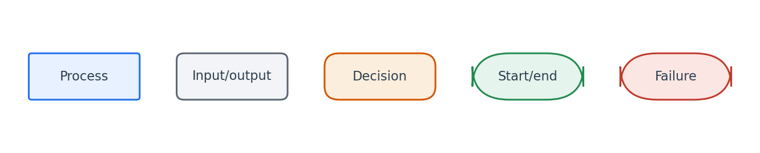
Flowchart symbol legend (used in every chapter).
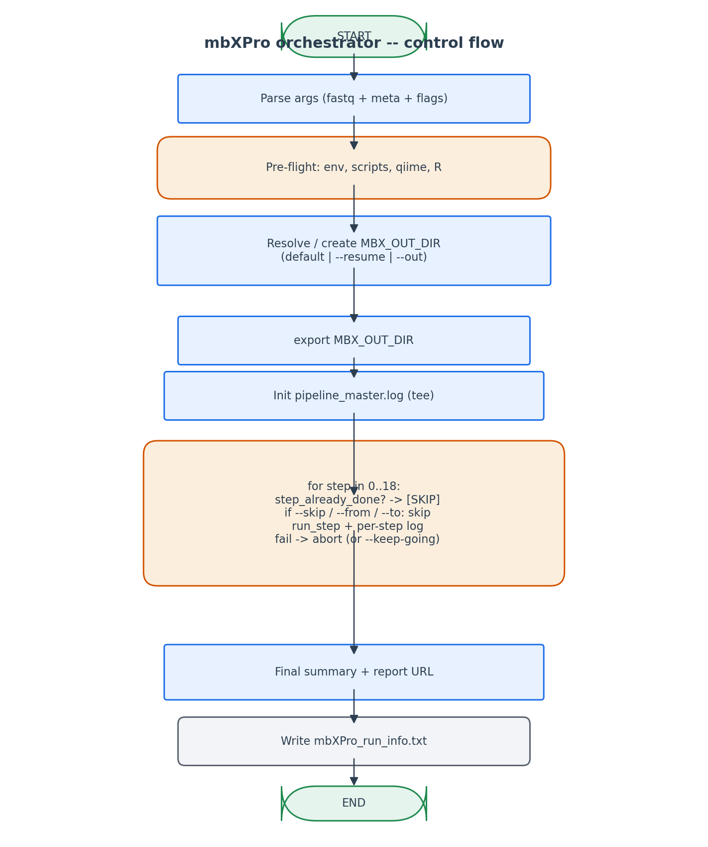
Single shared output dir + per-step idempotency + clean failure semantics.

6. Edge cases and caveats

--resume picks up wrong directory
If multiple mbX_pro_outputs_* exist alongside <fastq_dir>, --resume picks the most-recently-modified. The user can force a specific one via --out instead.

Step succeeds but sentinel missing
step_already_done relies on the per-step info file existing. If a step finishes everything but crashes during info-file write, the next --resume re-runs the entire step. Acceptable trade-off: safer than running on incomplete state.

--from 5 with steps 0-4 missing
Each step has its own auto-discovery of inputs (e.g. step 5 reads step 0/4 outputs). Running --from 5 with prior outputs missing causes that step's pre-flight to abort, not the orchestrator's. Pre-flight messages are descriptive ('feature_table.qza not found').

--keep-going + late failure
If step 4 fails but --keep-going is set, the orchestrator runs step 5 anyway. Step 5 will likely fail at its own pre-flight. The final summary clearly reports which steps ran vs failed.

7. Implementation notes

Logging via exec + tee
exec > >(tee -a logfile) 2>&1 redirects ALL stdout AND stderr to both terminal and log file. This works on bash 3.2 (no `&>>` ambiguity) and captures every echo / printf without per-call decoration.

env -u for child env-var scrubbing
Step scripts that need `_R` (system R, not conda R) do their own env stripping. The orchestrator does NOT strip globally because qiime needs the conda env intact. Each step is responsible for its own env hygiene.

Why not use Snakemake / Nextflow
Both are excellent but require their own runtime + DSL. mbX Pro's audience is lay users who run one command. A bash orchestrator with idempotent step-level checks gives the same correctness with zero extra dependency.

8. Testing checklist
Things to verify before considering this script production-ready:
- Run mbXPro <fastq> <meta> -> verify all 18 steps produce outputs in a SINGLE timestamped directory.
- Re-run with --resume -> verify every step is skipped (idempotent).
- Hand-delete one step's info file -> verify --resume re-runs ONLY that step.
- Run with --from 12 --to 15 -> verify only steps 12-15 ran.
- Run with --skip 15,16,17 -> verify those three steps not in the log.
- Run with --keep-going + a deliberately broken step -> verify subsequent steps still attempt.
- Verify mbXPro_run_info.txt has per-step exit codes + timestamps.
- Verify --help output is not truncated (the awk-script fix from past iteration).

