
mbX Pro -- internal technical reference
Step 1
create_manifest.sh
Build a QIIME2-format paired/single-end manifest TSV
Pipeline step 1 -- the bridge between filesystem and QIIME2.

1. Purpose and scope
Discover paired R1/R2 (or single-end) FASTQ files inside a user-supplied directory, extract per-sample IDs, validate that every paired-end sample has BOTH R1 and R2, and write a QIIME2-compatible manifest file with absolute filepaths.

2. Inputs and outputs

2.1 Inputs (data structures)
Name | Source | Format | Required
<fastq_dir> | User CLI argument | Directory containing *.fastq.gz | yes
--no-search-parent | User flag | Boolean toggle | no
--no-search-child | User flag | Boolean toggle | no
MBX_OUT_DIR (env) | Set by orchestrator | Absolute path | no

2.2 Outputs (data structures)
Path (relative to output dir) | What it contains | Read by
1_manifest_file/manifest.txt | Tab-separated QIIME2 manifest. Header is 'sample-id\tforward-absolute-filepath\treverse-absolute-filepath' (paired) or 'sample-id\tabsolute-filepath' (single-end) | step 2 (artifact_creator.sh)

2.3 Downstream consumers
These steps depend on this script's outputs:
- Step 2 (artifact_creator.sh) reads the manifest header to detect paired vs single-end and runs `qiime tools import` with the matching --input-format.

3. Complete parameter reference
Apart from search-ring toggles there are no tunable parameters. Sample ID extraction is rule-based and deterministic.
Parameter | Default | Decision rule / where it comes from
--no-search-parent | off | Disables Ring 2 (parent of <fastq_dir>). Useful when the parent contains FASTQ files from an unrelated run.
--no-search-child | off | Disables Ring 3 (children of <fastq_dir>). Useful when the FASTQ directory contains output sub-folders that incidentally hold .fastq.gz files.
MBX_OUT_DIR (env) | (unset) | Same contract as step 0: when set by the orchestrator, the manifest lands in MBX_OUT_DIR/1_manifest_file/.

4. Algorithm walkthrough

4.1 Bash 3.2-safe associative array replacement
macOS Bash 3.2 has no `declare -A`. We need a mapping sample_id -> R1 path and another sample_id -> R2 path. The script implements this with a temp-directory file-based key/value store:
WORK_DIR=$(mktemp -d)
mkdir -p "$WORK_DIR/R1" "$WORK_DIR/R2"
# Each "slot" is a file named after the sample ID:
echo "$path" > "$WORK_DIR/R1/$sample_id"
# Reading is just `cat`:
r1=$(cat "$WORK_DIR/R1/$sample_id")
Duplicate detection is automatic: if the slot file already exists when the script tries to write, that means two FASTQ files mapped to the same (sample_id, R1|R2) tuple -- a fatal error.

4.2 File discovery
Identical algorithm to step 0: three concentric rings (self, parent, immediate children). Files are deduplicated via the seen.txt approach so that overlapping ring memberships do not double-process a file.

4.3 R1/R2 detection
_detect_read() runs `grep -qiE 'r1'` then `grep -qiE 'r2'` on the basename. The case-insensitive flag means both Sample_R1.fastq.gz and sample-r1-001.fastq.gz match.
Files matching neither pattern are added to the UNDETECTED counter and skipped. If PROCESSED reaches 0, the script aborts with an actionable error.

4.4 Sample ID extraction (two-strategy fallback)

Strategy 1: anchored sample regex
Match `s(ample)?[-_]?[0-9]+` case-insensitively. This catches every Illumina-naming convention: S1, S1234, Sample-1, sample_42, SAMPLE-99.

Strategy 2: filename-cleanup
If Strategy 1 returns empty, fall back to a Perl pipeline that strips: .fastq.gz, R1/R2 tags, leading and trailing .-_ characters.
id=$(printf '%s' "$nm" | perl -pe '
s/\.fastq\.gz$//i;
s/r[12]//gi;
s/[._-]+$//;
s/^[._-]+//;
chomp;
')
The result is uppercased via `tr '[:lower:]' '[:upper:]'` (avoids the Bash 4-only ${var^^}).

4.5 Validation -- paired-end
After processing, the script collects every unique sample ID from R1/ and R2/ via `sort -u`. For each ID, it verifies BOTH R1/$sid and R2/$sid exist; missing IDs accumulate in MISSING[].
If MISSING is non-empty, the script aborts with a per-sample list. This catches the most common user error: 'I deleted one of the R2 files by accident'.

4.6 Manifest emission
The manifest is written sample-by-sample, alphabetically sorted. The header line is the QIIME2-required format (paired or single). The script ends with a printout of the suggested `qiime tools import` command -- helpful for users running the steps individually.

5. Flow diagram
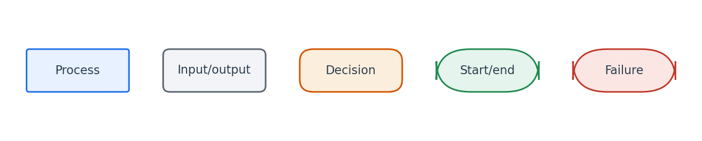
Flowchart symbol legend (used in every chapter).
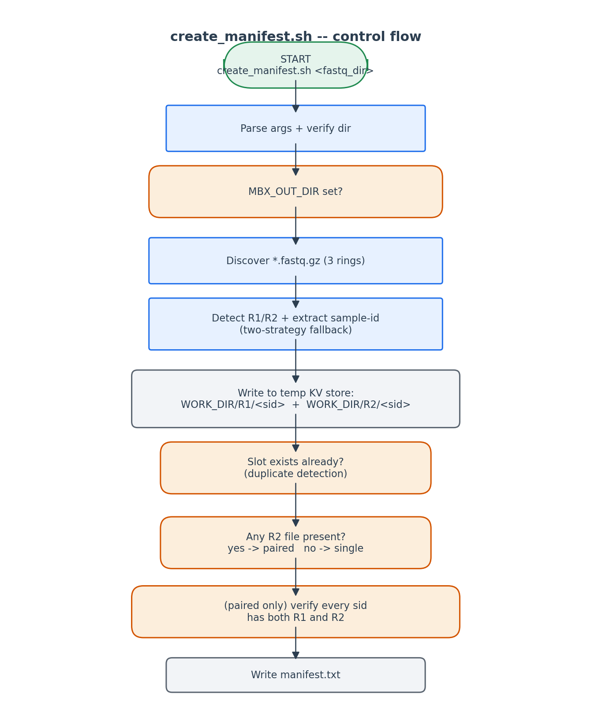
Control flow of create_manifest.sh.

6. Edge cases and caveats

Mixed-case R1/R2 in same run
Some facilities use 'R1', others 'r1'. The case-insensitive grep handles both.

Numeric sample IDs
The regex `s[-_]?[0-9]+` matches s1 / s_1 / s-1. Plain numeric IDs like '42.fastq.gz' fall to Strategy 2 cleanup, which yields '42'.

Lane-stamped Illumina names
S1_L001_R1_001.fastq.gz -> Strategy 1 matches 'S1' before the lane suffix; the lane and read-number suffixes are silently dropped.

BOM characters in pasted filenames
Not currently stripped here -- this is handled later in step 4 metadata validation. If a filename starts with U+FEFF the regex still matches.

Symbolic links
Symlinks are followed transparently because `find -L` is the default for `find` in macOS. The absolute path written to the manifest is the symlink path, not the target -- this is what the user asked for and is what QIIME2 accepts.

7. Implementation notes

Why two strategies?
Strategy 1 (`s[-_]?[0-9]+`) is precise but misses non-conventional names like 'CTRL_A.fastq.gz'. Strategy 2 (cleanup) catches those but is sometimes too greedy. Running them in order gives precision-first, recall-fallback behaviour.

Sorting
`sort -u` on the slot filenames provides both deduplication and deterministic ordering. The manifest is therefore byte-identical when the same FASTQ set is re-processed.

Why no associative array
`declare -A` is Bash 4+. macOS ships Bash 3.2.57 by default. The temp-directory KV store is the standard workaround documented in CLAUDE.md and used by every script in this pipeline that needs an associative mapping.

8. Testing checklist
Things to verify before considering this script production-ready:
- Run with paired-end Illumina data and confirm the manifest header has 3 columns.
- Run with single-end data (only R1 files) and confirm the header has 2 columns.
- Manually delete one R2 file before running and confirm the script aborts with the missing-file error.
- Place two R1 files for the same sample-id in different sub-folders and confirm the duplicate-detection error fires.
- Verify that `qiime tools import` accepts the resulting manifest without modification.

