
mbX Pro -- internal technical reference
Step 2
artifact_creator.sh
Import the manifest into a QIIME2 .qza artifact + summary .qzv
Pipeline step 2 -- the first pure-QIIME2 wrapper.

1. Purpose and scope
Run `qiime tools import` on the manifest produced by step 1, then `qiime demux summarize` to produce a quality-summary visualization. The script automatically detects paired vs single-end from the manifest header so the user does not have to set a flag.

2. Inputs and outputs

2.1 Inputs (data structures)
Name | Source | Format | Required
<manifest.txt> | From step 1 | Tab-separated, sample-id + filepaths | yes
--dry-run | User flag | Boolean toggle | no

2.2 Outputs (data structures)
Path (relative to output dir) | What it contains | Read by
2_first_artifact_file/Paired_End_artifact.qza | QIIME2 SampleData[PairedEndSequencesWithQuality] artifact (or Single_End_artifact.qza for single-end) | step 3 (mbx_dada2_parameter_finder.sh)
2_first_artifact_file/Paired_End_artifact.qzv | Visualization with per-position read-quality summary | step 3 (mbx_dada2_parameter_finder.sh)

2.3 Downstream consumers
These steps depend on this script's outputs:
- Step 3 (mbx_dada2_parameter_finder.sh) reads both .qza and .qzv to extract per-position quality statistics for trunc-len selection.
- Step 4 (mbx_dada2_run.sh) operates on the .qza directly via the path stored in dada2_parameters.txt.

3. Complete parameter reference
The script is parameter-free. All decisions are derived from the manifest header.
Parameter | Default | Decision rule / where it comes from
--dry-run | off | Print every command that WOULD be executed but skip the actual run. Useful when the user wants to inspect commands before committing to a slow run.

4. Algorithm walkthrough

4.1 Pre-flight checks
- Verify <manifest.txt> exists.
- Verify `qiime` is on PATH (catches the most common user mistake -- forgetting to activate the conda env).
- Print `qiime info` version line for provenance.
- Validate that the manifest has at least one data row (header-only files indicate a failed step 1).
- Walk the manifest and verify every filepath listed exists -- catches 'data on USB drive that is not mounted' before QIIME2 produces a less-helpful error.

4.2 Read-type detection
The first line of the manifest is read. If it contains `forward-absolute-filepath` -> paired-end; if only `absolute-filepath` -> single-end. Anything else triggers a fatal error with the expected header format printed.

4.3 Output-directory derivation
The manifest path is expected to look like `.../mbX_pro_outputs_*/1_manifest_file/manifest.txt`. The script derives the parent of `1_manifest_file/` as `MBX_OUT_DIR` (note: this is a LOCAL variable inside this script -- not the env-var contract used by step 0/1). Then it creates `MBX_OUT_DIR/2_first_artifact_file/`.
If the manifest's parent folder is NOT named `1_manifest_file/`, a warning fires but the script proceeds. This permits running step 2 stand-alone on a hand-crafted manifest.

4.4 QIIME2 invocation
Two QIIME2 commands run in sequence:
Step 1: qiime tools import --type SampleData[PairedEndSequencesWithQuality] (or single-end variant) --input-format PairedEndFastqManifestPhred33V2 --input-path <manifest> --output-path <qza>
Step 2: qiime demux summarize --i-data <qza> --o-visualization <qzv>
If step 1 fails, step 2 is skipped and the user gets the QIIME2 error verbatim plus a 4-bullet 'common causes' list (missing files, corrupted gzip, wrong Phred encoding, disk full).
If step 2 fails after step 1 succeeded, the user is told the .qza is OK and given a copy-paste retry command for just the summarize call.

5. Flow diagram
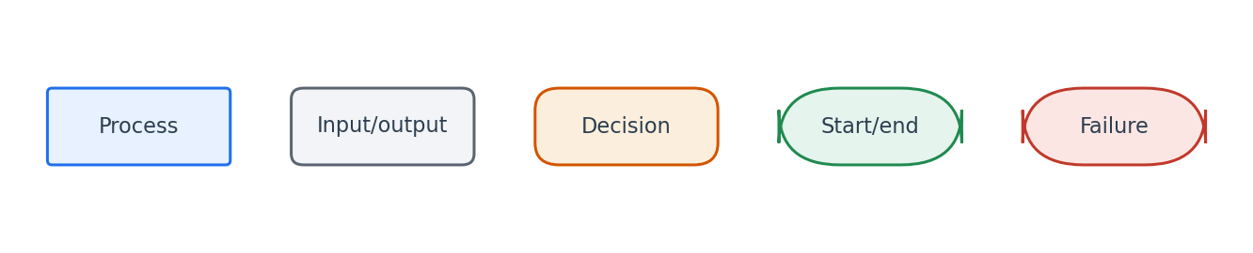
Flowchart symbol legend (used in every chapter).
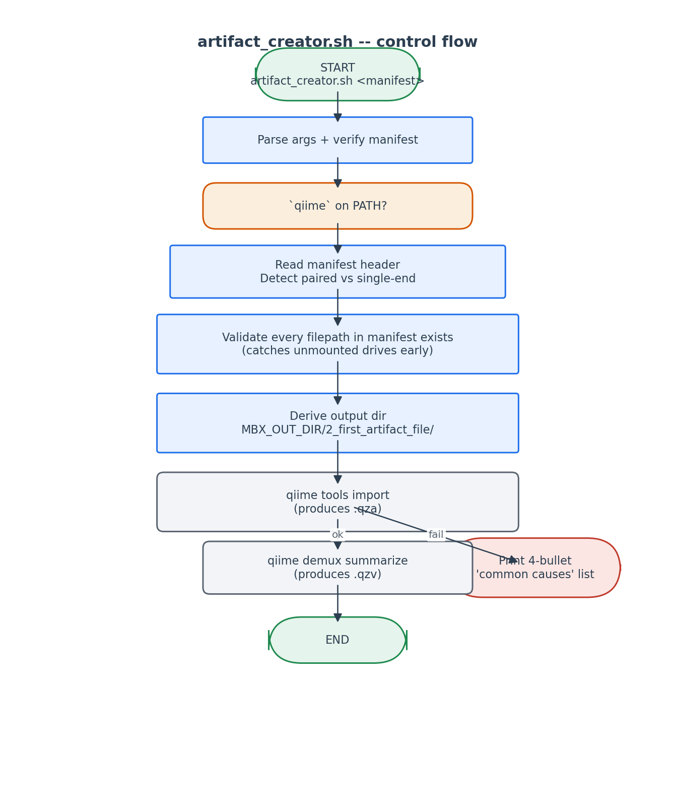
Control flow of artifact_creator.sh.

6. Edge cases and caveats

Manifest with zero data rows
An empty manifest is a sign of a failed step 1. The script aborts before invoking qiime, which would produce a confusing error.

Phred33 vs Phred64
PairedEndFastqManifestPhred33V2 / SingleEndFastqManifestPhred33V2 is hard-coded. Modern Illumina output is always Phred33. Phred64 (Illumina <1.8, 2011 and earlier) is not supported.

.qzv generation can fail when .qza succeeded
The summarize step needs slightly more memory. If only .qzv fails, the user can re-run just `qiime demux summarize` on the existing .qza.

7. Implementation notes

Why detect read-type from manifest header (not from filenames)
The manifest is the canonical 'this is what the user actually has' declaration. If the user hand-edited the manifest to remove R2, we trust that and import as single-end.

File-existence pre-check
QIIME2's own error message for a missing file is buried inside Python tracebacks. We surface it earlier with a per-file warning + summary error.

8. Testing checklist
Things to verify before considering this script production-ready:
- Run on a paired-end manifest -> verify Paired_End_artifact.qza is produced.
- Run on a single-end manifest -> verify Single_End_artifact.qza is produced.
- Hand-corrupt one FASTQ file (truncate gzip) -> verify the script's error message includes 'corrupted or not properly gzipped'.
- Run with --dry-run -> verify no output files are written.

