
mbX Pro -- internal technical reference
Step 3
mbx_dada2_parameter_finder.sh + create_dada2_parameters_txt.sh
QC the demux artifact and compute optimal DADA2 parameters
Pipeline step 3 -- the most parameter-intensive auto-tuning stage.

1. Purpose and scope
This step is split across two scripts that run as a unit. mbx_dada2_parameter_finder.sh is the orchestrator: it runs seven QIIME2 QC commands then delegates to create_dada2_parameters_txt.sh, an embedded Python algorithm that derives the four DADA2 parameters (--p-trunc-len-f, --p-trunc-len-r, --p-trim-left-f, --p-trim-left-r) from quality scores in the demux artifact. Both scripts are documented together because they are inseparable in practice.

2. Inputs and outputs

2.1 Inputs (data structures)
Name | Source | Format | Required
<artifact.qza> | From step 2 | QIIME2 SampleData[PairedEndSequencesWithQuality] artifact | yes
--forward-primer SEQ | User flag (or env from step 0) | IUPAC primer string 5'->3' | no
--reverse-primer SEQ | User flag (or env from step 0) | IUPAC primer string 5'->3' | no
--amplicon-length N | User flag | Integer (insert length hint) | no
--min-overlap N | User flag | Integer (default 12) | no
--max-ee-f F | User flag | Float (default 2.0) | no
--max-ee-r F | User flag | Float (default 2.0) | no

2.2 Outputs (data structures)
Path (relative to output dir) | What it contains | Read by
3_dada2_parameters/exported_demux_summary/ | qiime tools export of the demux QZV (forward-seven-number-summaries.csv etc.) | step 4 / report
3_dada2_parameters/extracted_qza/ | qiime tools extract of the QZA (raw FASTQ access) | audit/debug
3_dada2_parameters/extracted_qzv/ | qiime tools extract of the QZV | audit/debug
3_dada2_parameters/demux_read_counts.qza | Per-sample read count artifact | step 4 / report
3_dada2_parameters/demux_read_counts.qzv | Visualization of the above | report
3_dada2_parameters/dada2_parameters.txt | Recommended DADA2 parameters + ranked alternatives + Input artifact path + provenance | step 4 (mbx_dada2_run.sh)

2.3 Downstream consumers
These steps depend on this script's outputs:
- Step 4 (mbx_dada2_run.sh) reads dada2_parameters.txt to get trunc-len-f/r, trim-left-f/r, and the path to the input artifact.
- Step 18 (mbx_final_report.sh) embeds dada2_parameters.txt verbatim plus the per-sample read-count summary.

3. Complete parameter reference
Two layers of parameters: the bash wrapper's (mostly pass-through) flags, and the Python algorithm's environment variables. The Python internals are ALL exposed via env vars so power users can tune without editing source.
Parameter | Default | Decision rule / where it comes from
--forward-primer SEQ | (empty) | If provided, --p-trim-left-f = len(primer). If empty, --p-trim-left-f = 20 (the ASSUME_PRIMER_LENGTH default). The auto-orchestrator typically pre-fills this from step 0.
--reverse-primer SEQ | (empty) | Same logic for --p-trim-left-r.
--amplicon-length N | (unset) | If supplied, the Python engine SKIPS k-mer alignment-based insert estimation and uses N directly as median/p99/requirement. Useful when the user knows the exact 16S region length (e.g. V4 = 253 nt).
--min-overlap N (MIN_OVERLAP) | 12 | Minimum bp the post-truncation forward and reverse reads must overlap to merge. The candidate ranker enforces (trunc_f + trunc_r - insert_requirement) >= MIN_OVERLAP. 12 is DADA2's recommended default.
--max-ee-f F (MAX_EE_F) | 2.0 | Per-read maximum expected errors after truncation. EE = sum_i 10^(-Q_i/10). The cumulative EE walk identifies the longest length where EE <= max-ee. 2.0 is DADA2 default; raise to 5.0 for very low-quality data.
--max-ee-r F (MAX_EE_R) | 2.0 | Same logic for reverse reads.
READS_PER_SAMPLE (env) | 1000 | Number of read pairs sampled PER SAMPLE for the parameter search. 1000 x 20 samples = 20k pairs is empirically enough to converge on the same answer as scanning the full FASTQ.
INSERT_SAMPLE_PAIRS (env) | 2500 | Subset of the sampled pairs that go through k-mer-based pair alignment for insert-length estimation. Capped because the alignment is the slowest single step.
MIN_PAIR_PASS_RATE (env) | 0.80 | After candidate enumeration, candidates whose suffix-matrix pair-pass rate is below 0.80 are dropped first. Relaxed automatically if no candidate passes.
MIN_FORWARD_PASS_RATE (env) | 0.90 | Forward-only pass-rate floor.
MIN_REVERSE_PASS_RATE (env) | 0.84 | Reverse-only pass-rate floor (lower than forward because Illumina R2 is intrinsically lower-quality on the 3' end).
LENGTH_SLACK (env) | 1 | Within the eligible candidates, the script considers all candidates whose effective_f + effective_r is within LENGTH_SLACK of the maximum. Among those it tie-breaks on pair-pass rate and balance. SLACK=1 means literally 'longest combined length OR one bp shorter'.
TOP_CANDIDATES (env) | 20 | Number of ranked alternatives to print at the bottom of dada2_parameters.txt for the auditor.

4. Algorithm walkthrough

4.1 The bash wrapper -- 7 QIIME2 calls
Step 1 (peek) verifies the artifact type. Steps 2-3 export and extract the QZA + QZV (two different operations: export gives human-readable CSV/HTML inside the QZV, extract gives raw FASTQ inside the QZA). Step 4 calls `qiime demux tabulate-read-counts` to produce a per-sample read-count artifact, step 5 visualizes it, step 6 exports + extracts that artifact, step 7 hands off to the Python parameter recommender.
All 7 outputs land in subdirectories of 3_dada2_parameters/. The user can audit any of them post-hoc. The QZVs are dragged into https://view.qiime2.org for interactive inspection.

4.2 The Python algorithm -- conceptual overview
The recommender solves an optimization problem:
Given paired reads with quality scores, find
(trunc_f, trunc_r, trim_f, trim_r)
such that:
1. trunc_f + trunc_r - estimated_insert_length >= min_overlap
2. fraction(reads passing EE<=max_ee at trunc_f) >= min_forward_pass
3. fraction(reads passing EE<=max_ee at trunc_r) >= min_reverse_pass
4. fraction(pairs where BOTH pass) >= min_pair_pass
and we PREFER the longest effective length (= trunc - trim_left).

4.3 Stage A -- Manifest scan + read sampling
QzaFastqSource() opens the .qza zipfile, locates data/MANIFEST inside it, and parses the per-sample direction (forward/reverse) and filename. sample_pairs() then opens R1 and R2 in lockstep via gzip.open and yields ReadPair(forward_seq, reverse_seq, forward_qual, reverse_qual). Quality strings are converted to integer arrays (q = ord(ch) - 33) up-front so the inner loop is pure integer math.
Sampling stops at READS_PER_SAMPLE per sample (default 1000). With 20 samples that is 20k pairs -- enough to estimate quantiles with negligible Monte Carlo error.

4.4 Stage B -- Insert length estimation (k-mer seed-and-extend)
best_pair_alignment(forward, reverse, kmer=13, min_overlap=40) implements a fast k-mer chain alignment:
- Build positions: dict mapping every 13-mer of the forward read to its starting indices.
- For each 13-mer in the reverse-complemented R2, look up matching positions and increment a Counter[shift] where shift = i - j.
- Take the 12 most common shift values; for each, compute matches/comparable identity over the implied overlap region.
- Score = identity * comparable. Best score wins.
- Reject overlaps shorter than min_overlap (40 bp).
- Return (insert_length, identity, overlap).
estimate_insert_length() runs alignment on up to INSERT_SAMPLE_PAIRS pairs, keeps those with identity >= 0.90, applies an IQR outlier filter (then a fallback ±50bp filter if too many were dropped), and returns median, p95, p99. The 99th percentile is used as the 'requirement' downstream -- a conservative choice that protects against unusually long inserts.
If --amplicon-length is provided, the entire alignment stage is bypassed: median/p95/p99/requirement are all set to that value.

4.5 Stage C -- Trim-left decision
decide_trim() chooses --p-trim-left-f and --p-trim-left-r:
Primer provided: trim_left = len(primer). primer_match_counts() additionally walks the sample reads and counts how many have <= 15% IUPAC-mismatches in the primer-length prefix -- this match count is reported to the user as a sanity check.
Primer NOT provided: trim_left = ASSUME_PRIMER_LENGTH (default 20). The 'unknown-primer' source string is recorded in the output.

4.6 Stage D -- Per-read max-trunc walk
max_trunc_from_read(seq, qual, trim_left, max_ee) walks position by position from trim_left to len(qual). At each position, it accumulates expected error EE += 10^(-q/10). The largest position where EE <= max_ee is returned. The walk also short-circuits at the first 'N' base.
This single 1D function is the entire quality model. It is conservative (Q40 contributes 0.0001, Q20 contributes 0.01, Q10 contributes 0.1) and matches DADA2's own filterAndTrim() expectation-based filter exactly.

4.7 Stage E -- The suffix matrix
build_suffix_matrix() is the heart of the algorithm. It pre-computes, for every (max_f_len, max_r_len) pair, how many sampled pairs have BOTH max_trunc_f >= forward_index AND max_trunc_r >= reverse_index.
Implementation:
- Create matrix[i][j] = count of pairs whose (f_max, r_max) == (i, j).
- Convert to suffix sums: matrix[i][j] -> sum over (i' >= i, j' >= j).
- This is done in two passes: first column-suffix (bottom-up) then row-suffix (right-to-left). Both passes are O(M*N).
- Also compute f_pass_counts[i] = number of pairs with f_max >= i, and similarly r_pass_counts[j].
Now ranking N x M candidate (trunc_f, trunc_r) combinations is O(N*M) instead of O(N*M*pairs). For typical Illumina data (max_f=300, max_r=250, 20k pairs) this is ~10^4 candidates rather than ~10^9.

4.8 Stage F -- Candidate enumeration + ranking
rank_candidates() iterates trunc_f from trim_f+50 to max_f_len, trunc_r from trim_r+50 to max_r_len. For each (trunc_f, trunc_r):
- Compute overlap = trunc_f + trunc_r - insert_requirement.
- Skip if overlap < MIN_OVERLAP.
- Compute pair_pass = matrix[trunc_f][trunc_r] / N.
- Skip if pair_pass == 0.
- Record forward_pass = f_pass_counts[trunc_f] / N, reverse_pass = r_pass_counts[trunc_r] / N.
- Append a Candidate dataclass entry.
Ranking proceeds in three filtered tiers:
Tier 1: Eligible = candidates passing all three pass-rate floors (0.80 / 0.90 / 0.84). If empty, move to Tier 2.
Tier 2: Eligible = candidates passing only MIN_PAIR_PASS_RATE. If empty, Tier 3.
Tier 3: Eligible = ALL candidates (graceful degradation -- something is better than nothing).
Within the eligible set, find max(effective_f + effective_r). Take the 'near-longest' subset = candidates within LENGTH_SLACK of that max. Sort the subset by (pair_pass DESC, |effective_f - effective_r| ASC, overlap DESC, length DESC) and pick #1.
The 'balance' tiebreaker (smaller |F-R| difference preferred) is the subtle but important step: it prevents pathological recommendations like (trunc_f=300, trunc_r=50) when (200, 200) would also pass.

4.9 Output emission
write_output() produces a self-documenting .txt with these blocks: header (input QZA, sample count, total pair count), the four parameters one-per-line in QIIME2-compatible form, primer-handling provenance, quality+overlap estimates, the ready-to-run `qiime dada2 denoise-paired` command, and a top-N candidate table for auditing.

5. Flow diagram
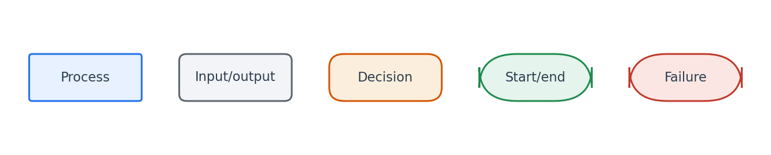
Flowchart symbol legend (used in every chapter).
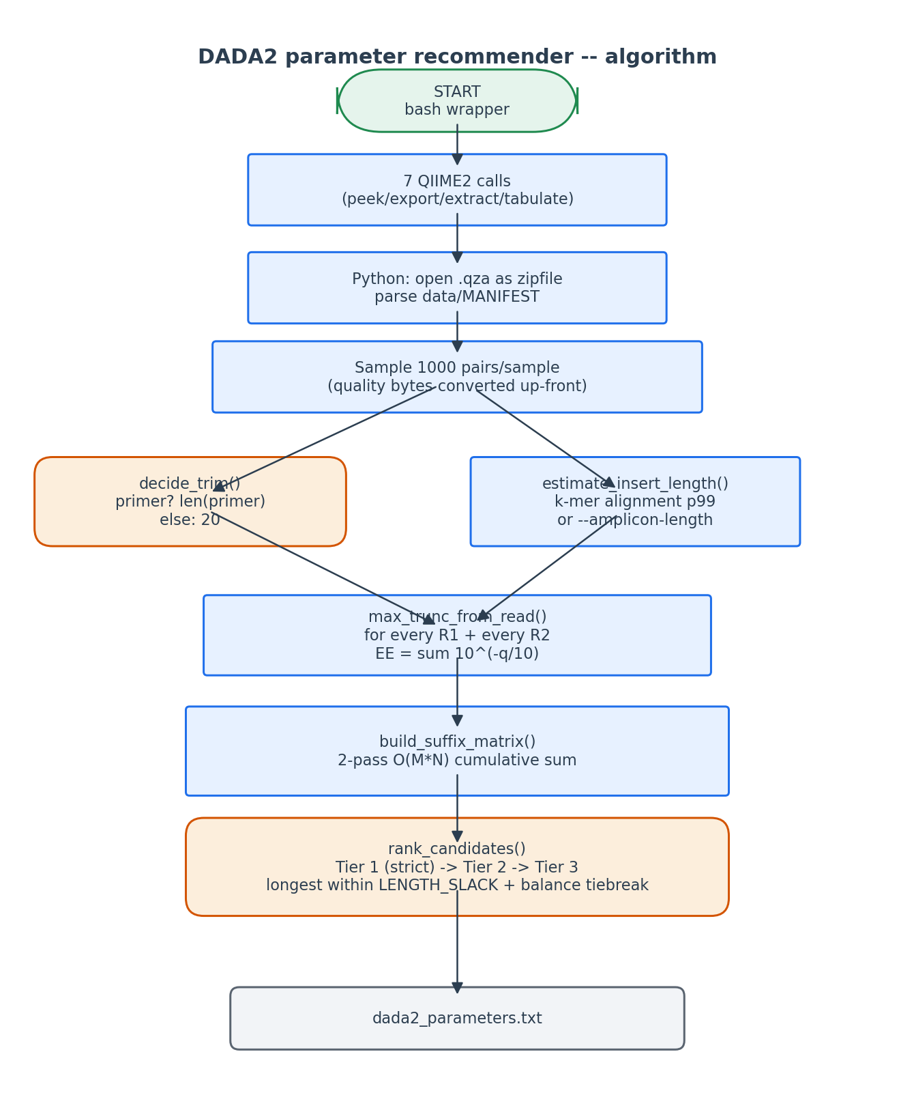
Two-stage flow: bash QIIME2 calls (top) feed the Python recommender (middle), which writes the parameter file.

6. Edge cases and caveats

Insert length cannot be inferred
If <8 pairs align with identity >= 0.90, estimate_insert_length() falls back to median ±50 bp filter. If still too few, it dies with a request for --amplicon-length. Common cause: reads do not actually overlap (e.g. V1-V9 long-read data).

All candidates fail strict tier
Tiers 2 and 3 progressively relax constraints. The third tier accepts ANY candidate. The user is still notified via the pass-rate columns in the candidate table.

Amplicon shorter than 2 * trim_left + 50
The candidate-enumeration `for trunc_f in range(trim_f+50, max_f_len+1)` will yield no candidates. Will trigger 'No candidate truncation lengths' error -- the user must drop `--min-overlap` and/or use a shorter primer.

Mixed-length sample pools
If individual samples have very different read lengths (e.g. one re-run sample), max_f_len and max_r_len reflect the global maximum. Candidates beyond an individual sample's max are still considered for that sample but yield max_trunc capped at the sample's actual length, naturally bringing the score down.

--p-trim-left equal across all samples
DADA2 enforces that trim-left is identical for every sample in a run. This is a QIIME2 limitation, not ours. If samples have different primer-trim conventions, pre-process them separately.

7. Implementation notes

dataclasses for clarity
ManifestEntry, ReadPair, InsertEstimate, TrimInfo, Candidate are all @dataclass-typed. This is purely for readability: the algorithmic intent is much clearer when each function takes/returns named fields rather than tuples.

Why pre-convert quality strings to bytes
Python's str -> int conversion on Illumina quality strings is expensive when done in the inner loop. We pay the cost once per pair when reading the FASTQ and use byte-array indexing in max_trunc_from_read.

The 'effective length' metric
effective_f = trunc_f - trim_f. This is the actual amplicon length contributing to the merged read after primer trimming. We optimize EFFECTIVE length, not raw trunc-len, because two recommendations with the same trunc-len but different trim-left have different merged-read lengths.

Why two scripts and not one
create_dada2_parameters_txt.sh is intentionally standalone -- power users can run it on any QIIME2 paired-end .qza without going through the bash wrapper's QC steps. The wrapper exists to bundle the QC steps with the parameter computation for the lay user.

8. Testing checklist
Things to verify before considering this script production-ready:
- Run with a known-good demux artifact and verify the recommended trunc-len matches DADA2's own forward/reverse FilterAndTrim recommendation (typically within 1-2 bp).
- Run with --amplicon-length 253 -> verify the candidate table reflects insert_requirement = 253.
- Run on artificially low-quality data (max-ee 2 fails for all candidates) -> verify Tier 3 fallback and that warnings appear in the report.
- Run with primers explicitly provided (--forward-primer/--reverse-primer) -> verify trim-left equals primer length.
- Run with --dry-run from the wrapper -> verify the wrapper prints all 7 commands without invoking them.

